NCAC-24
January 10-11, 2019
Washington, DC

Members Present: Michael Newman (MS State), Matt Raven (MI State), Tracy Kitchel, (OH State), Jason Ellis (KS State), Mark Balschweid (Nebraska), Jon Simonsen (Missouri), Brian Myers (Florida), Mark Russell (Purdue), Leslie Edgar (Georgia), Tracy Rutherford (Texas A&M), Harry Boone (West Virginia), Laslo Kulcsar (PA State), John Ewing (PA State), Daniel Foster (PA State), Bobby Torres (Arizona), Rob Terry (OK State), Jonathan Velez (OR State), Misty Lambert (IA State), Todd Brashears (Texas Tech), Scott Burris (Texas Tech), Bruce Miller (UT State), Frank Hodnett, (NM State)

Administrative Advisor Present: Kris Boone (OH State)

Guests Present Throughout: Steve Brown (US Department of Education), Doug Steele (APLU), Wendy Fink (APLU)

The meeting was called to order on January 10, 2019 by chair Michael Newman.

Welcome and Introductions

The meeting began with introductions of the participants and their home departments.
Michael Newman introduced our administrative advisor, Kris Boone and our APLU host, Doug Steele. Doug Steele provided comments to the group and talked about opportunities for us to reclaim our voice in the public sector. Wendy Fink provided an overview of APLU and its structure (see handouts below). Relative to this committee and our focus on Agricultural Education research, Wendy shared we should be working with the Experiment Station Section through APLU.

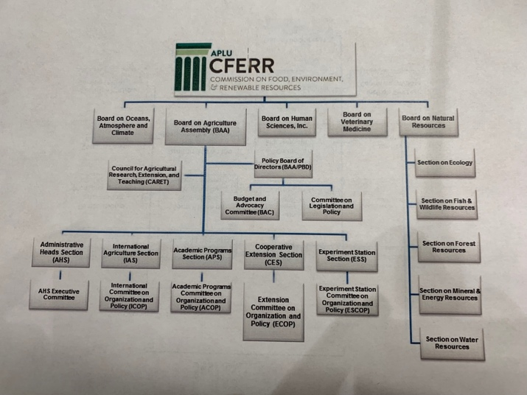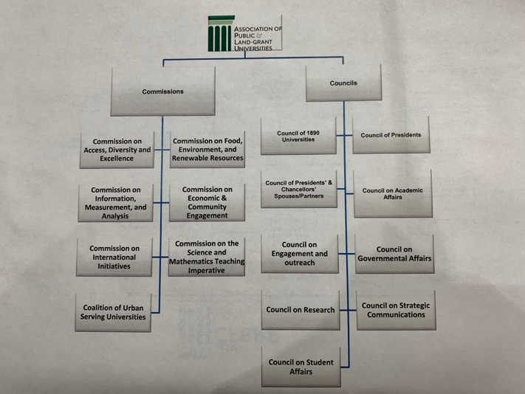

Doug Steele shared our opportunities with AFRI (expanded definition of the social component of grants via the latest Farm Bill) and the expanded definitions Sally Rocky Foundation for Food and Agriculture Resources.
Kris Boone recommended organizing more USDA research committees so our Experiment State Directors can see our work and so that we are not considered a social science add-on to a grant.

Doug Steele encouraged us to look at our internal capacity (serving on grant panels) and asking about our role of key influencers in terms of external capacity.

Michael Newman discussed the possibility of moving our committee from a NCAC to a National Research Support Program (but we don’t have much information about the NRSP).

Matt Raven discussed the strategy of joining other research committees with USDA outside our own discipline.

Brian Myers talked about how we can do more local level lobbying with our Experiment Station Directors.

Wendy Fink shared that the Academic Programs Section has a matching grant (up to $5000) regarding innovative practices in the classroom. There was a lack of proposals from this last year’s grant cycle.

Group recessed at 9:50AM.

Group Reconvened at 10:02AM.

Meeting with Hunt Shipman

Michael Newman turned to the program over the Hunt Shipman with Cornerstone, APLU’s Lobbyist. He shared that some of the current funding priorities (Smith-Lever, NIFA, etc.) all live in AFRI. He talked about the “one ask” approach to simplify the messaging when working with CARET delegates on advocacy. The House committee had asked for a consolidation of funding lines. As a part of that proposed consolidation, APLU considered rolling many of these items into one line. Hunt also talked to the group about the difference between authorization in a bill and actual, appropriated funding.

Hunt walked us through the process of how we could get funding for a National Center of Agricultural Education Research. One approach would be to work through the National Research Support Program (referenced earlier in our meeting). He recommended that, within the COP process, to have discussions with everyone with a well-developed proposal by around 2021 or 2022 in particular with the Farm Bill chair.

Business Meeting

Tracy Kitchel presented the minutes of the last meeting earlier in the week via email. No additions or corrections were made to the minutes. The minutes were considered approved.

Michael Newman shared updates regarding a website. Our contact has been very busy. As we looked at partnering with AAAE, but AAAE is currently considering new website options. Discussion also ensued about the perception that this committee could look like a subset of AAAE, around which some voiced concern. He also shared the research capacity spreadsheet project Michael Retallick was working on and the possibility of integrating that with the website project.

Michael Newman discussed the option of developing a National Research Support Program. Many members expressed unfamiliarity with NRSP. The group discussed an exploratory committee to review the plausibility of developing an NRSP. ACTION: Michael appointed George Wardlow, Mark Russell, Leslie Edgar (chair), Jason Ellis to be on this committee. The committee should report by March 2019 and discuss the appropriateness of NRSP as a vehicle to further our research agenda. Based on the findings, between March and May 2019, members could discuss this possibility locally with our Associate Deans.

ACTION: Kris Boone is going to explore if we need an “S” designation to our committee so that our southern region Ag Ed projects are appropriately allocated to this committee.

From the previous conversation, the group discussed having monthly and quarterly meetings.

The committee broke for lunch at 11:56AM.

The committee reconvened at 1:09PM.

Joe Shultz and Katie Naessens

Michael Newman introduced Joe Shultz and Katie Naessens from the Senate Agriculture Committee. They shared an overview of the Fill Bill and the process of how the bill is developed.

- Joe discussed an overview of the Farm Bill and how it is developed.
- Joe talked about “mandatory dollars” (set of money set aside that does not need to be authorized); the other side is the “appropriated dollars” (money designated to ab authorized, but must go through the authorization process on annual process)
- Mandatory funds for research increased from last bill to current
- New funding for urban agriculture
- New funding for an advanced research program to address grand challenges (ran thru chief scientists’ office as opposed to NIFA) - AGARDA
- New farm and ranch stress assistance program
- New international agriculture funding will be routed thru NIFA
- Foundation for Ag Research (FFAR) received mandatory funding. It is up and running.
- National liaison position with USDA funded as a part of the new Farm Bill
- When things are funded, we can influence USDA implementing the order of their programs by writing a letter to the USDA Secretary
- Ideas on funding for Ag Ed Research
  - Farm Bills are consensus-drive process (make sure its bipartisan)
  - The Farm Bill is more about moving dollars than getting new (when you add to one you take from another)
  - Building relationships outside our traditional partners
  - Talk about the success you’ve had – do your Representatives and Senators know?

The committee took a quick break and reconvened at 2:13PM.

Business Meeting

The committee engaged in a reflective conversation from our guest speakers.

A group of Matt Raven, Tracy Kitchel, Jonathan Velez, Leslie Edgar and Kris Boone to develop a list of possible topics and issues. This group will report tomorrow morning. ACTION ITEM

Daniel Foster presented the Supply and Demand Report for Agricultural Education. The report is also being shared electronically.

The committee took a break and reconvened at 3:45PM.

Scott Angle

Scott Angle, Director of NIFA, shared an update regarding NIFA:

- He shared that the current furlough will have effects on universities regarding grant funding of awarded grants and grant proposals. Let USDA know if you have grant funded positions where you may need to lay them off due to lack of funding to see if they can help.
- They have received 156 offers to move NIFA. The next steps will be to identify about 5 locations as finalists. Because of the move, current employees are looking for new positions; the vacancies will lead to a lag in response.
- He discussed where some of the research projects in NIFA are heading in relation to our departments and units
  - More focus on creating a workforce for agriculture
  - Rural broadband (and then what can you do with that?)
    - How do you teach them to use new technologies?
  - Public-private partnerships
Dr. Angle provided advice when engaging with NIFA staff:
- Find program area staff and build a relationship and call them
  - From that, they will share their advice
- Volunteer to be a part of grant panel

Dr. Angle was asked what can we do?
- How do we ensure to meet workforce demands?
- Put some ideas on table around our disciplines – specific ideas.
  - What areas could NIFA support to improve Ag Ed in this country?

Meeting was adjourned at 4:31PM to be reconvened tomorrow morning at 8:30AM.

Scott Stump

Scott Stump, Assistant Secretary, Office of Career, Technical, and Adult Education, introduced himself. Scott noted there’s “energy” in the adult education space (and there is also funding). He encouraged us to look at the Workforce Innovation and Opportunity Act.

He spoke to the group about Perkins V and encouraged us strongly to be a part of the stakeholder table.

- Perkins V was more of an update than an overhaul
- We are not releasing FAQ or guidance documents with the intent of giving states ultimate flexibility
- 50% of students have taken a CTE course; only 20% concentrate
- A local needs assessment will be required every two years for programs
- Technical skills attainment is gone in Perkins V (states will have to ask if that’s important)
- Emphasized workforce needs/job openings across CTE areas
- March 2020 deadline for states to file their Perkins V plan
  - He encouraged us to be at the table to help our states develop the plan to recruit CTE teachers
- He encouraged us to look at stackable credentials: cte.ed.gov
- He cited an example from Colorado State about using Perkins funds to provide support of a faculty member at CSU to visit new teachers
- Opportunities with Perkins V for middle school career exploration and upskilling current employees

There are $1.4 million in grants per year for identifying, supporting and evaluating CTE and aligning it to workforce needs. Not state driven in terms of submission; eligible applicants are LEAs, higher education. Does require 50% matching funds. Looking for scalable models and a focus on rural areas. He is encouraging us to play roles in evaluation. This will be posted at cte.ed.gov and the Federal Register.
In the next 5 year, there will be efforts to stand up a research network of CTE. Vanderbilt and ACTE will provide leadership. The website is cteresearchnetwork.org.

The group went on a break and reconvened at 9:45AM

Business

Matt Raven reported on the committee that (virtually) met yesterday evening. The group (that was charged with developing topics that could be “sellable” in finding new funding and support) surfaced the following broad areas or themes:

- Developing a knowledgeable food systems workforce
- Informed exchange between food systems and their stakeholders (factual and emotional)
- What do our departments need to do to evolve in order to survive?

The group decided a quarterly(ish) approach: looking at meetings in March, May at AAAE, summer, mid-fall.

At our AAAE May meeting, we are looking at an agenda of 1. finalize issues from the committee reported this morning from Matt’s committee, 2. potential multi-state projects 3. make a decision of what NRSP should be for us and 4. if we developed a next Farm Bill ask, what would that be?

ACTION: By the first quarterly meeting (March), Matt Raven will clean up the list shared earlier in the morning and then that will be shared with the entire NCAC-24 committee via email. The NCAC-24 committee members will then discuss with their faculty.

ACTION: Michael Newman and Kris Boone will work on developing a list of current multi-state projects that connect with our committee.

The group discussed the next January meeting. It is tentatively scheduled to be held at Las Cruces, New Mexico. We will keep open the possibility of going wherever the new NIFA site will be. Looking at the next DC location for this meeting in 2021, because of inauguration in 2020 (staff will likely not be available to meet with us). For 2020, our meeting is tentatively scheduled for January 9-10, 2020.

Our new NIFA contact is Irma Lawrence.

Todd Brashears discussed that he is open to help any of us regarding our needs related to DC and connections in DC. He also shared that he and Alexa Lamm are going to have classes on grantsmanship (face-to-face in DC) for faculty and doctoral students.
Michael was congratulated for his work in preparing for our meeting.

Meeting adjourned at 10:53.

NCAC-24
May 15, 2018 – 8AM-12PM EST
Charleston, South Carolina

Present: Michael Newman, Neil Knobloch, Bobby Torres, Brian Myers, Mike Retallick, Mark Balschweid, Harry Boone, Rick Rudd, Rob Terry, Steve Fraze, Scott Burris, Daniel Foster, Jon Simonsen, Tracy Kitchel, Kris Boone, Jason Emmert, Jonathan Velez, Matt Raven, Kellie Enns, Jon Ulmer

The meeting was called to order on May 15, 2018 by chair Michael Newman.

Introductions

The meeting began with introductions of the participants.

The chair asked for any additions to the agenda. None were provided.

Minutes of January Meeting

The minutes were presented and reviewed. Mark Balschweid reported that Claire Gill and Wes Harrison reviewed the multi-state project on science/ag literacy and sent their report to Karen Plaut. Rob Terry moved and Bobby Torres seconded the motion to accept the minutes. Motion passed.

Kris Boone reminded the group to always have a meeting authorization with USDA. The question was asked whether or not we could have more than one meeting authorized, but Kris was going to check.

National Benchmarking/Indicators of Faculty Success

Mark Balschweid asked for reactions regarding the Indicators document:

- Rick Rudd talked about how he used the indicators with promotion and tenure process at Virginia Tech and he received positive feedback from his Dean’s group
- Mark Balschweid reminded us of the impetus of the document
- Jason Emmert discussed how the document was used to help the faculty talk through a merger between the units. They felt it was a useful framework.
- Mike Retallick shared with his faculty and it was well-received and there was no push-back.
- Bobby Torres discussed that his faculty felt like it helped them feel on par with other faculty and ties them with the national scene.

Next steps were discussed:

- Possibly use the language for AAAE awards
- Share the results through the experiment station
- Consider how we can present this as a stand-alone document
  - Consider re-ordering
  - Consider having narrative descriptions as examples
- Consider sharing this with the academic program section in APLU
- Has great potential for promotion and tenure – candidates have anxiety with external letters – this could be common language
  - Making sure this is a template that can be modified for each institution
  - To consider that the metrics are a community effort (what might be expected of our unit in totality), too, and not that every person has to contribute to every indicator

Action Steps: One person needs to take the document, add context for what it is and where it comes from, and to update the layout and design. Brian Myers agreed to update that document.

Website for NCAC-24
The discussion began at our January meeting, but without resolution. Reminder of the issue: that there’s confusion between the connection between AAAE and NCAC-24. There’s not a complete overlap between the two groups. Currently NCAC-24 document is “parked” on the AAAE website as a committee. There was discussion of what we would call the website. There was a template designed through Purdue (Roger Tormoehlen). Another issue surfaced with the maintenance of it. There’s a need to connect with Christine Hamilton at NCAC.

Actions Steps: Michael Newman will connect with Christine to get the conversation started with NCAC about having a website.

Discussion around a committee name change ensued. The discussion evolved to that conversation around the role of an NCAC versus a NCRA. A white paper was constructed (A Call to Action for Increasing Human and Institutional Capacity in Food and Agriculture) that get at this larger discussion.

The discussion moved backed to the name change.

Rick Rudd moved and Matt Raven seconded the motion to appoint a small committee appointed by the chair to study and recommend a name change for NCAC 24. Motion passed. Matt Raven (lead), Rick Rudd, Tracy Kitchel, Daniel Foster, Kris Boone are appointed to the committee.

The chair called for a 14-minute break at 9:11AM. The meeting will resume at 9:25AM.

Meeting was called back to order at 9:27AM.

Research Capacity Template

Mike Retallick discussed issues with moving forward: 1) where do we put the document (re; website conversation) and 2) how do we manage and develop a dynamic template (re: software systems). $90/month for 500 users through Wild Apricot.

Discussion continued that perhaps we could charge an institutional membership (e.g. $100/institution) to support the website and the capacity template service. The group talked about rolling membership into registration. The other question is where does the money sit? One option is to create a sub-account with AAAE.

Bobby Torres and Rob Terry seconded to establish a membership fee of $100 per institution. Discussion was held and motion passed.

Action Item: Michael Newman and Mike Retallick will follow-up with options regarding website and template hosting, including discussions with AAAE about financial and web hosting. Mike Retallick will distribute the template.

USDA Education Roadmap

Mark Balschweid followed up with Edwin Lewis and Edwin shared that the roadmap will be internal facing at present.

Planning for January 2019 Meeting in Washington, DC (January 10-11)

Reminder that our goal would be to rotate between DC and university-hosted sites every other year. Our next meeting will be in Washington, DC.

Discussion ensued about who we wanted:

- There are 1500 openings in USDA
- Todd Brashears will be working with USDA and may be a connection
- Michael Newman has talked to Wendy Fink about our upcoming meeting
- Riley Padgett with National FFA
- Cornerstone
- Short session before the meeting with new department chairs
  - Likely an informal event
- Ray Starling at the White House
- Scott Stump with USDE
- Consider USAID: Sam Alvis; Jon Ulmer is working on a large USAID grant

Other
- Ag Youth Organization Coordinator update from Rob Terry via Riley Padgett: The intern position is part of the House version of the Farm Bill regarding the duties of the position. There seems to be a large commitment to school-based agricultural education through this position.

Meeting adjourned

