NCAC-24 Notes for May Meeting
May 21, 2019 - Des Moines, Iowa

Those Present: Kellie Enns, Tracy Kitchel, Scott Burris, Steve Brown, Daniel Foster, Becki Lawver, Jason Ellis, Rob Terry, Brian Myers, Bobby Torres, Alexa Lamm, Joey Blackburn, Jonathan Velez, Jon Simonsen, Mark Russell, Neil Knobloch, Shannon Arnold, George Wardlow, Mike Retallick, Matt Raven, Michael Newman, Kris Boone (via Zoom), Mark Balschweid

Chair Michael Newman called the meeting to order.

Michael Newman reviewed the minutes and asked for changes. None were noted and they were therefore approved as presented.

Special Presentation
Neil Knobloch was invited to talk about a new initiative. At North Central AAAE, we will have a joint conference on Learner-Centered Teaching with Historically Black Colleges and Universities. The conference will start on Thursday morning and lead right into the NC AAAE conference, which starts that evening.

Sub-Committee Reports
Michael Newman discussed the background on why we have sub-committees (as designated at our January 2019 meeting). The sub-committee members reviewed their group tasks. Kris Boone talked about the possibility of demonstrating our work as relevant through utilize RA and ERA committees through USDA. The sub-committee report review continued. Jason Ellis asked if we could invite non-administrators to NCAC-25 to that committee to bolster the work of Ag Comm? Since the January 2019, Scott felt challenged to work with his faculty on developing their research capacity and suggested we should focus more on that than what we call ourselves. Tracy followed up that we should focus on developing our “product” further and help our faculty be better collaborators.

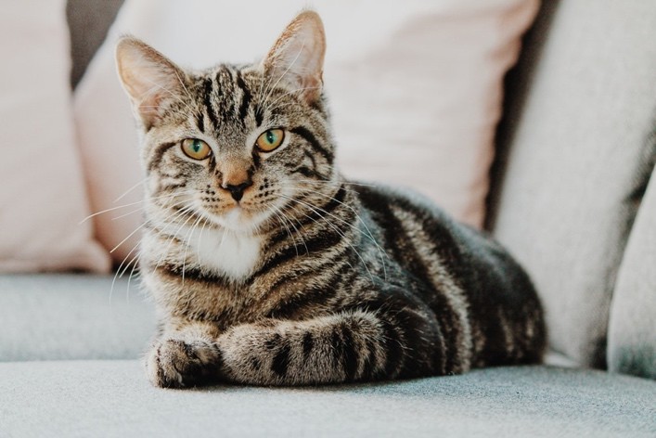
The meeting had a quick humorous respite due to Kris Boone’s cat on Zoom.

Mike Retallick reiterated the point of issue with capacity (we don’t have high research appointments). Mark Balschweid shared that this committee is a think tank group. George challenged us that we need also need to continue to move forward and accomplish goals.

The committee recessed until 9:35AM.

We reconvened with identifying members for working groups. The conversation started with the bigger picture of what should emerge first (e.g. does our identity emerge first before we do the other pieces).

Jason moved and Mark seconded to change the name of NCAC-24 to “Agriculture, Food, and Natural Resource Human Sciences.” Discussion occurred related to specific wording, the relevancy of changing the name, etc. Matt Raven moved to amend the motion by striking out “Human Sciences” and inserting “Applied Behavioral Sciences.” Discussion occurred. Amendment passes. Reverted back to the original motion as amended. Further discussion occurred. Motion passed.

The committee spent time populating the work group:

- Mike Retallick agreed to work with Mark Russell on his work group task. Michael Newman suggested they meet and discuss identifying others in that group, some of whom do not need to be administrators.

- Jason Ellis recommends a sub-working committee of Leslie Edgar, Mike Retallick, Mark Balschwied, and Tracy Kitchel.

- Matt Raven, Shannon Arnold, and Neil Knobloch agreed/volunteered to work with George Wardlow.

- Brian Myers, Tracy Rutherford, Travis Park and Mark Balschweid agreed to/were volunteered to work with Leslie Edgar on her working group.

Michael Newman recommended these groups report back during a summer conference call meeting.

New Mexico State University is hosting the January meeting on January 9-10.

The meeting ended at 10:27AM.

