NCERA 216 Meeting Reports
June 17 and June 19, 2020 9:00 AM - Noon
Zoom Meeting: https://ksu.zoom.us/j/95751738811

1. Chair-elect Debra Bolton called the meeting to order on June 17, 2020.
2. Roll call posted in Zoom chat:
- Rubén Martinez, Julian Samora Research Institute, Michigan State University
- Bertha Mendoza, Kansas State University
- Sal Valadez, LiUNA MKLDC Diversity Initiative, St. Louis, MO
- Athena Ramos, University of Nebraska Medical Center
- Verónica Peréz, Cambio Center, University of Missouri
- Kimberly Grader, Iowa State University
- Yoshira Donaji,
3. Approval of October 2019 Meeting
4. Old business –Five-year report submitted January 21, 2020 – Ruben asked that Debra send to whole group and assure that all are in NIMSS
5. New business
a. Strategic Areas Reports
b. Review of our strategic areas?
- Changing the way we work, collaborate, and advocate for our target populations
c. How can we promote research partnerships?
d. How can we assure reporting for work collaborations and individual research?
- Reporting Template (Attached)
6. Elections to be addressed at Friday’s meeting:
a. New officers for next two years
b. Executive Board Members

c. Strategic Area Leaders
7. Anything else for the good of the cause?
8. Adjournment
Friday, June 19, 2020 at 9:00 a.m. https://ksu.zoom.us/j/97571243757

Chair-elect Debra Bolton called the meeting to order on June 19, 2020.
2. Roll call posted in Zoom chat:
- Rubén Martinez, Julian Samora Research Institute, Michigan State University
- Bertha Mendoza, Kansas State University
- Sal Valadez, LiUNA MKLDC Diversity Initiative, St. Louis, MO
- Athena Ramos, University of Nebraska Medical Center
- Verónica Peréz, Cambio Center, University of Missouri
- Kimberly Grader, Iowa State University
- Yoshira Donaji,
3. Election of Officers – A full slate of officers was presented by Chair-elect Bolton.
NCERA 216 Slate of Officers 2020-2022
June 17, 2020 and June 19, 2020
Officers Slate:
Chair: Debra Bolton dbolton@ksu.edu
Vice Chair: Athena Ramos aramos@unmc.edu
Sec/Comm Coord: Bertha Mendoza bmendoza@ksu.edu
Webinar Co-Coordinators:
Veronica Perez-Picasso vrp279@mail.missouri.edu
Jordan Ayala jksy8c@mail.umkc.edu
Executive Board Members
Stephen Jeanetta jeanettas@missouri.edu
Rubén Martinez mart1097@msu.edu
Bertha Mendoza bmendoza@ksu.edu
Ness Sandoval ness.sandoval@slu.edu
Maria Rodriguez-Alcala rodriguezalcalam@missouri.edu
Daisy Barron-Collins daisybcollins@missouristate.edu
Topical Group Co-Chairs
Entrepreneurship and Business
Co-Chairs Maria Rodriguez-Alcala rodriguezalcalam@missouri.edu
The second co-chair is still missing.
Member: Corrinne Valdivia valdiviac@missouri.edu
Families and Education
Co-Chairs: Bertha Mendoza bmendoza@ksu.edu
Daisy Barron-Collins daisybcollins@missouristate.edu

Building Latinx and Immigrant-Friendly Communities
Co-Chairs: Stephen Jeanetta jeanettas@missouri.edu
Corinne Valdivia valdiviac@missouri.edu
Athena Ramos aramos@unmc.edu
Building Diversity-Competent Organizations
Co-Chairs: Rubén Martinez ruben.martinez@ssc.msu.edu
Gerardo Martinez martinezgr@umkc.edu
Member: Alejandra Gudiño gudinoa@missouri.edu
Demographics and Change
Co-Chairs: Onésimo Sandoval jsandov3@slu.edu
Sal Valadez salvaladez85@gmail.com
Member: Debra Bolton dbolton@ksu.edu
Sal Valdez moved to accept the slate of officers and committee chairs as presented. Athena Ramos seconded. The slate passed, unanimously by the members of NCERA 216
Chair, Debra Bolton reminded NCERA 216 members about getting reports in so that she can file a report in NIMSS for the annual meetings of June 17 and 19, 2020.
Member, Ruben Martinez reminded members that it’s critical to keep energy around our goals in advancing research, policy, and practice in entrepreneurship, families and education, building Latinx and immigrant-friendly communities, building equitably-represented competent organizations, and assisting our institutions in promoting change in their demographics.
Meeting adjourned.

Reporting Template for NIMSS: (The chair needs this for our overall NCERA 216 report)
Reporting focuses on intended activities, outputs, and short-term outcomes. Committees, practitioners, and researchers should build information around activity milestones, as identified in the original proposal.
Please indicate significant evidence of linkages both internal to the project/committee and to external peer groups, stakeholders, clientele, and other multistate activities.
The report should also reflect on the items that stakeholders want to know, or want to see. Committees, practitioners, and researchers should describe plans for the coming year in no more than one or two short paragraphs. If the committee is filing an annual report, the accomplishments will cover only the current year of the project; for termination reports, list accomplishments from the entire span of the project.
  - Short-term Outcomes: Quantitative, measurable benefits of the research outputs as experienced by those who receive them. Examples include the adoption of a technology, the creation of jobs, reduced cost to the consumer, less pesticide exposure to farmers, or access to more nutritious food.
  - Outputs: Defined products (tangible or intangible) delivered by a research project. Examples of outputs are reports, data, information, observations, publications, and patents.
  - Activities: Organized and specific functions or duties carried out by individuals or teams using scientific methods to reveal new knowledge and develop new understanding.
  - Milestones: Key intermediate targets necessary for achieving and/or delivering the outputs of a project, within an agreed timeframe. Milestones are useful for managing complex projects. For example, a milestone for a biotechnology project might be "To reduce our genetic transformation procedures to practice by “month, year."
Reports from NCERA 216 Members - 2020:

Kimberly Greder, Professor and Extension State Specialist
Human Development and Family Studies
Iowa State University
Publications
Hammons, A., Villegas, E., Olvera, N., Greder, K., Fiese, B. & Teran-Garcia, M. (2020). The Evolving Family Mealtime: Findings from Focus Group Interviews with Low-income Hispanic Mothers. JMIR Pediatrics and Parenting.
Bruna, K., McNelly, C. A., Greder, K., Rongerude, J. (2020). Youth Dialogue and Design for Educational Possibility: Eliciting Youth Voice in Community Development. Journal of Community Practice. DOI: 10.1080/10705422.2020.1757006. First published online May 3, 2020. https://doi.org/10.1080/10705422.2020.1757006.
Rongerude, J., Richardson Bruna, K., Greder, K., and McNelly, C. Design Dialogues How-to Series, DDC 0001A–0001K, Iowa State University, Ames, Iowa.
Greder, K., Levings, J., Alcivar-Zuniga, M., Schott, M., Allen, B., Gonzales, R., Bruna, K., Dorado-Robles, N., and Martinez, A. (2020). ¡Salir Adelante! Caminos a Nuestro Futuro (Pathways for our Future). Iowa State University, Ames, Iowa.
Activities:
Pilot data collected in 2019 was used to inform the creation of ¡Salir Adelante! Caminos a Nuestro Futuro (Pathways for our Future), a curriculum focused on promoting career and college readiness among Latinx youth and their families. During six, 2-hour workshop sessions, families gain information and access to resources, develop skills, and explore strategies to create paths for successful futures. The curriculum is family orientated, experiential, culturally responsive, based on individual and family strengths, and on research findings, and communicates that education is more than academics.

Bertha Mendoza, Extension Specialist – Nutrition

Summer Meals Program in Garden City, Kansas. This is our sixth consecutive year where I assist Hispanic Churches to provide summer meals to low income families from neighborhoods where Hispanic children live. Children 1-18 are allowed to have a hot meal, over 900 meals were served. Bridging the gap between State and Federal programs by providing training to Spanish speaking volunteers so they can feed children in need.

In collaboration with Ogallala Commons, an eight-state community development effort, I provided technology classes to Hispanic families in two counties in Southwest Kansas. More than thirty families participated. I Facilitated conversations between government officials and the Hispanic community where their opinions were taken into consideration for budget planning. Participants also learned about the importance of the 2020 Census and the benefits of getting counted. Participated radio interviews to inform the Hispanic community about the importance of the census.
I assisted college students with enrollment as well as seeking financial information to pay for their education. Identified local resources for parents, who want to support their children while attending college but lack the basic knowledge, serving as a bridge between families and college resources.
Graduated more than 300 Hispanic participants including youth and adults, in the nutrition programs SNAP-Ed and EFNEP.
Participated in the on-going Inclusion and Diversity taskforce for K-State Research and Extension. My role is to make recommendations to ensure that historically-excluded identities receive equitable representation in institutions and communities while being treated with dignity and respect.

Martinez, Rubén
NCERA 216
Annual Report
2019-2020

Publications

Journals

2019 “Motivations for Entrepreneurship among Mexican Americans and White Americans,” International Journal of Social Science and Business, 4(1): 1-12. (w/B. Avila).

Chapters

2019 "Criminal Justice, Disconnected Youth, and Latino Males in the United States and in Michigan." In Lynn Scott and Curtis Stokes (Eds.), Minorities and the Criminal Justice System. (Pp. 211-156). East Lansing, MI: MSU Press. (w/B. Avila & B. Lewis).

Encyclopedia Articles

2019 “Rodolfo ‘Corky’ Gonzales.” Latinos in the Political System: An Encyclopedia of Latinos as Voters, Candidates, and Office Holders. (Pp. 211-213). Santa Barbara, CA: ABC-CLIO.

2019 “Jose Angel Gutierrez.” Latinos in the Political System: An Encyclopedia of Latinos as
Voters, Press Candidates, and Office Holders. (219-221). Santa Barbara, CA: ABC-CLIO.

Reports and Research Newsletter

2019. Martinez, R. (Editor). NEXO: The Official Newsletter of the Julian Samora Research Institute. [Two issues: Spring, XXII (2); Fall issue XXIII(1)]

2019. A Summary Report of the Black-Brown Dialogues Summit II: Expanding Community September 7, 2018. Julian Samora Research Institue, MSU (w/R. Davila).

Foreword

2019. “Foreword,” In Gutierrez, J. A., Tracking King Tiger: Reies Lopez Tijerina and the FBI. Latinos in the United States Series. East Lansing, MI: MSU Press.

Volume in Book Series

2019. Gutierrez, J. A., Tracking King Tiger: Reies Lopez Tijerina and the FBI. Latinos in the United States Series. East Lansing, MI: MSU Press.

Book Reviews

“Review of Cultural Impact on Conflict Management in Higher Education.” Teachers College Record. July 18, 2019. https://www.tcrecord.org, ID Number: 22977.

“Review of Hispanics in the U.S. Criminal Justice System.” NEXO, Fall 2019, 23(1): 5.

“Éxito Educativo: A Bilingual Pathway to College Program,” Western Social Science Association News, 2019, 51(1): 9.

Presentations

National Professional Meetings

Martinez, R. & Davila, R., “Black Brown Dialogues, Envisioning an Inclusive Michigan,” Race in 21st Century America, the 11th National Conference, April 1, 2019, East Lansing, MI

Martinez, R., Santiago, O. J., Espino, D. V., & Avila, B. “Ethnic differences in factors influencing attitudes toward suicide and physician-assisted suicide among elders.” Gerontological Society of America (GSA) 2019 Annual Scientific Meeting, November 16, 2019, Austin, TX.
Martinez, R., “Welcoming Remarks,” JSRI 30th Anniversary Celebration Conference, November 1, 2019, East Lansing, Michigan.

Martinez, R., & Coronado, J., “Éxito Educativo: A Pathway to College for Latina/o High School Students,” JSRI 30th Anniversary Celebration Conference, October 31, 2019, East Lansing, Michigan.

Martinez, R., “Labor Needs on the Dairy Farm—From the Worker’s Perspective,” JSRI 30th Anniversary Celebration Conference, November 1, 2019, East Lansing, Michigan.

Martinez, R. “A Return to the Past in the Farmworker Regulatory Environment,” Panel Moderator, JSRI 30th Anniversary Celebration Conference, November 1, 2019, East Lansing, Michigan.

State or Regional Professional Meetings

Martinez, R., “Race Equity Issues on Dairy Farms: A Focus on ‘Milkers,’” Michigan Family Farms Conference, Kalamazoo, MI, February 9, 2019.

Kayitsinga, J., & Martinez, R., “Management Culture of Employees on Dairy Farms,” Michigan InterAgency Service Committee, March 5, 2019

Martinez, R., “Measuring Racial Equity in Food Systems,” Michigan Racial Equity in the Food System, April 5, 2019

Martinez, R., “History and Present of Black & Brown Communities,” Kalamazoo’s Black & Brown Unity and Healing, El Concilio and ISAAC, October 25, 2019, Kalamazoo, MI.

Martinez, R. “Caring for Diverse Communities at End of Life,” CRN Diversity Academy, November 19, 2019, Grand Rapids, MI.

On-campus

“Latinos and the Diverse Workplace,” Invited Presentation, Managing Diversity in the Workplace Course, Department of Management, Eli Broad College of Business, April 3, 2019 3

“Welcome to MSU,” Dia de la Familia, MSU Admissions Office, March 23, 2019

“Communication Issues on Dairy Farms,” MSU VetMed VOICE, March 28, 2019

“The Status of Latinos at MSU,” ChiLA Fall Open House, October 10, 2019

Community Presentations

“Minority Communities,” The 19th Annual Dr. Martin Luther King, Jr. Corporate Breakfast, Urban League of West Michigan, January 21, 2019.
“Remembering César Chavez,” César Chavez Luncheon Celebration, Latinx Technology & Community Center, Flint, MI, March 25, 2019.

“The Dimensions of Urban Sustainability,” Flint Resiliency Week, Shine Your Light, March 28, 2019

“Éxito Educativo: A Bilingual Pathways to College Program,” 26th Annual Conference of Dia de la Mujer, MSU OCAT, April 6, 2019.

“Propaganda and the Dangers of Coded Language,” Tendaji Talk – Flint, MI, October 8, 2019

“Spanish and Mexican History in the U.S.: An Overview,” Cristo Rey Church Community Presentations, October 13, 2019.

“Past and Present of Black & Brown Communities,” Kalamazoo’s Black & Brown Unity and Healing, TRHT, El Concilio and ISAAC, October 25, 2019, Kalamazoo, MI.

Community Outreach and Service

Éxito Educativo, bilingual pathways to college program, delivered in Lansing and Wyoming, MI (served 45 families)

Farm Management Courses I & II, bilingual community education courses delivered in South Haven, MI (served 8 Latino farmers)

Diversity Assessment and Engagement Program, a ten-month diversity leadership program for mid- and senior-level administrators that emphasizes building diversity-competent organizations (served 5 participants)

Amigos de los Campesinos de Michigan, Board Member

Lansing for César E. Chávez, Lansing, MI (1) Hispanic American Council, Kalamazoo, MI

Michigan BioTrust Community Values Advisory Board (2) Michigan Good Food Steering Committee

Racial Equity Subcommittee, Michigan Good Food Steering Committee

Blue Cross Blue Shield Central Michigan Community Advisory Committee, Mid-Michigan

International Center for Higher Education and Philanthropy, Board of Directors

Everett Dance Program, Lansing School District, Lansing, MI

Michigan Alianza Latina para Mejoramiento y Avance, Board Member

Dr. Daisy I. Barrón
Multicultural Education & Diversity
Reading, Foundations, and Technology Department
Latino Studies
School of Social Work
Missouri State University

PUBLICATION
Barrón, D. (2020). Our Esencia is Our Courage. Hispanic Outlook on Education Magazine, 30(7), 19.

Barrón, D. (2020). ¿Que dijeron? What do they say? Bilingualism, Adaptation & Hispanic women/Latinas in Higher Education. Journal of Latinos and Education, 19 (2).
Barrón, D., Palacios, J., Enriquez, S., Torres, T. (2019). Narratives of Latinas/Hispanic Women in the Midwest. Cambio Center Proceedings, Columbia, Missouri.
Barrón, D. (2019). Bilingualism. Revista OCIO, 21(6), 4-5.



PUBLICATIONS IN PROGRESS
Barrón, D. (2020). Overcoming Barriers to Hispanic women/Latinas Leaders in Higher Education. Book IGI Global Book Publishing House in revision to be published October, 2020.

Barrón, D. (2020). A Perspective of Multicultural Education. Book Kendall Hunt Publishing House (in progress) contributors and for me as editor to turn in the manuscript August 2020 to be published November 2020.

Barrón, D., Palacios, J. (2020). The Brown Tinted Glass Ceiling? A mixed-methods study of Hispanic women/Latinas in Higher Education. Manuscript (in progress) Journal of Diversity in Higher Education.

Barrón, D. Hart, J. (2020). Jefa at a University? ¡Igualada! A Qualitative Study of Hispanic Women/ Latinas Leaders in Higher Education. Manuscript (in progress) to the Innovative Higher Education.

Barrón, D. (2020). ¡Mi Esencia es mi Valor! Essence & Courage portraiture of Hispanic women/Latinas navigating Higher Education Institutions. Manuscript (in progress) to the Qualitative Research Journal, Sage.



CONFERENCE
Barrón, D. (2020). Diseño Mixto En Investigación Educacional Sobre Hispanas/Latinas En Los Estados Unidos. WEBINAR Universidad César Vallejo & Missouri State University

Barrón, D. (2020). ¡Mi Esencia es mi Valor! Essence & Courage portraiture of Hispanic women/Latinas navigating Higher Education Institutions. American Association of Hispanics in Higher Education. Costa Mesa, CA.
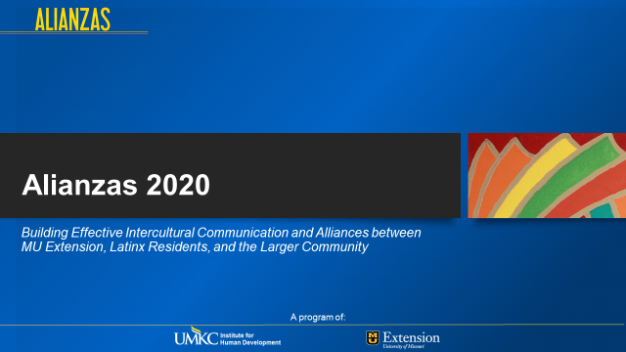
In response to the increasing Latinx population in Missouri, Alianzas was created in 2001 with UMKC to enhance the ability of University of Missouri Extension and its partners to respond to the needs of Latinx immigrants and the Missouri communities that receive them.
Alianzas is a statewide program housed at the UMKC/Institute for Human Development (IHD), its focus is the implementation of outreach programs that focus on a community-based, collaborative learning approach. We provide trainings on cultural value differences, technical Assistance, Information Dissemination and community outreach.

Broad focus: Underserved populations –focused on community inclusion and social belonging for Latinos and all, we are striving to improve overall quality of life in Missouri.
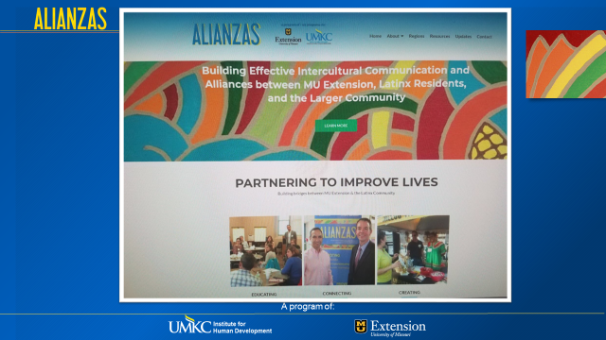
Alianzas collaborated one more time with Binational Health Week (BHW), which it has evolved into one of the largest mobilization efforts in the Americas to improve the health and well-being of the underserved Latino population that lives in the United States and Canada. During BHW, federal, state and local government agencies, community-based organizations and thousands of volunteers come together in the month of October to conduct a series of health promotion and health education activities including workshops, insurance referrals, vaccinations and medical screenings.BHW main partners include the Secretariats of Health and Foreign Affairs of Mexico. This year we had it again at the Buchannan County/Saint Joseph, MO in where more than 80 families came to receive free health screening and groceries.
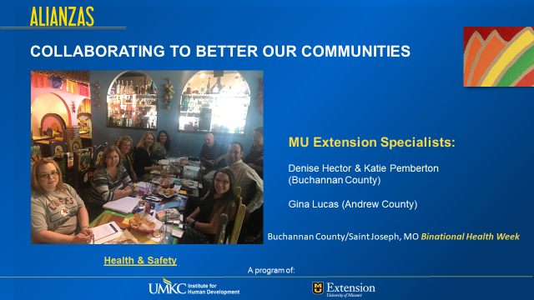

Alianzas provided in Spanish, the acclaimed leadership training: The 7 Habits of Highly Effective People, to 40 Latinx community leaders for the Catholic Diocese of Jefferson City, MO. They came from six different counties and received the tools to apply its principles and becoming better leaders in their respective personal and professional lives.
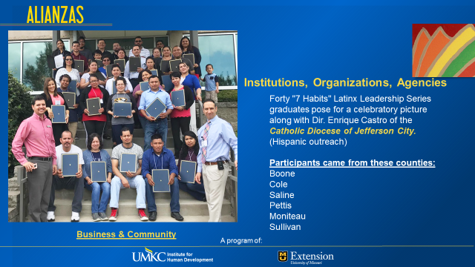

Alianzas provided in Spanish, the acclaimed leadership training: The 7 Habits of Highly Effective People, to 40 Latinx community leaders for the Catholic Diocese of Jefferson City, MO. They came from six different counties and received the tools to apply its principles and becoming better leaders in their respective personal and professional lives.
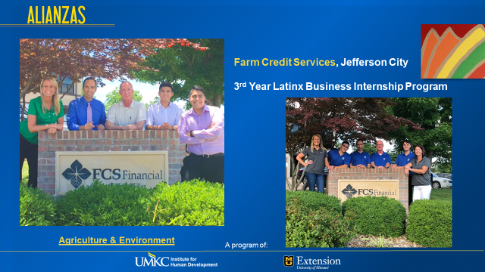

We just finished our 4ht. year collaborating with FCS Financial that provides a great 8 weeks Internship program to first generation Latino students. Alianzas in conjunction with their HR department recruits and interview potential candidates for their all paid internship.
Three-fold mission on this internship are the following:
- Provide an excellent opportunity to Latino students develop their professional skills and getting to know the loan-farm industry.
- Increase the awareness of the Latino cultural values within FCS organization. FCS wishes to become a more diverse and inclusive organization.
- Reach out to Latino farmers within the state of Missouri.

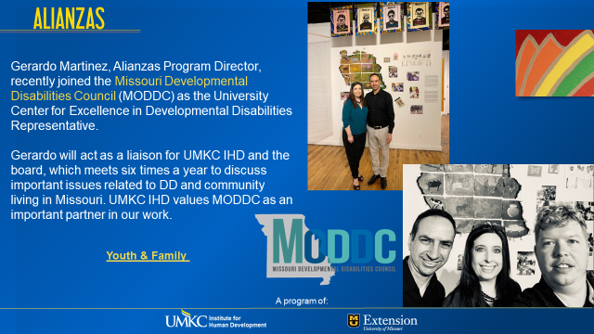
This year, Gerardo Martinez, Alianzas Program Director, recently joined the Missouri Developmental Disabilities Council (MODDC) as the University Center for Excellence in Developmental Disabilities Representative. Gerardo is currently acting as a liaison for the University of Missouri Kansas City (UMKC)- the Institue for Human Development (IHD) and the board, which meets six times a year to discuss important issues related to DD and community living in Missouri. UMKC IHD values MODDC as an important partner in our work. Alianzas has served over 100 Latinx individuals with special needs during this year.
ALIANZAS GAVE SEVEN PRESENTATIONS ON LATINO CULTURAL VALUES AND CULTURAL SENSITIVITY TO SEVERAL ORGANIZATIONS AND INSTITUTIONS IN MISSOURI. MORE THAN 200 PROFESSIONALS GAIN TOOLS AND BEST PRACTICES ON HOW TO BE MORE EFFECTIVE WORKING WITH LATINOS.
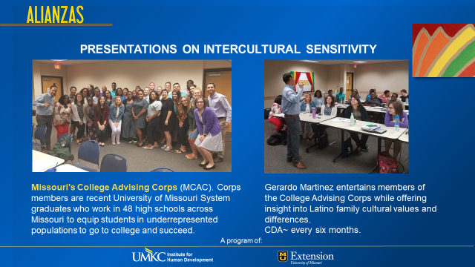
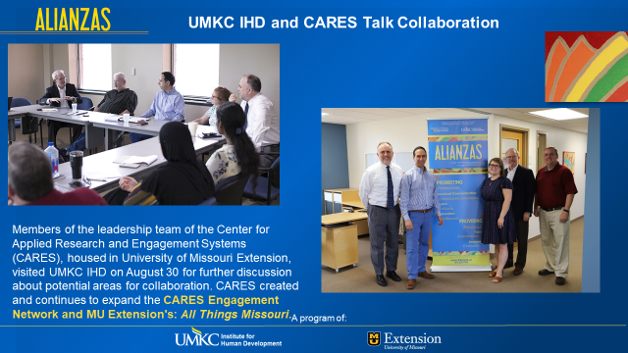

The University of Missouri System has four campuses throughout our state. Alianzas has been collaborating with their Latino initiatives in order to support and learn from each other. Our goal is to find ways to increase our recruitment of new Latino students.

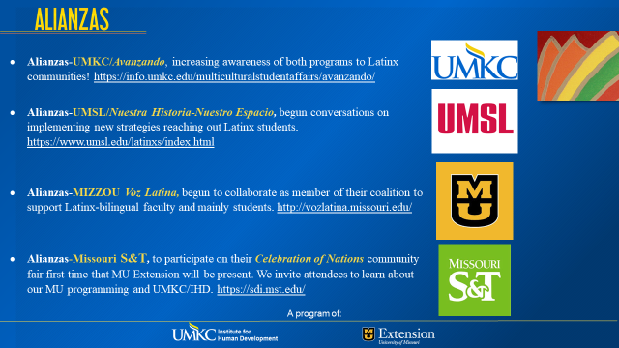

Debra J. Bolton, Ph.D.
Publications
Bolton, Debra J. (2020). In press. Finding home: Displaced African Women in Rural Southwest Kansas. Chapter 2. Intervening Connections: Mapping the networks of support of Women in 21st Century Communities. Cloete, E., Mariah E. Crystal, and Martha N. Bannikov, Eds. Lexington Press.

Bolton, Debra J. and Charlotte Olsen (2018). Build Intercultural Relationships for Better Understanding of Your Neighbor. Extension Publication, MF 3340 and MF 3341

Krug, D., Bolton, D. J. and C. Olsen. (2018). Everyday Mindfulness. Extension publication MF 3424 and MF 3425

Bolton, Debra J. and Francisco Hernandez. (2017). Applying Global Perspectives on Fragility to Improve U.S. Communities. Advances in Anthropology, 7, 22-33.

Bolton, Debra J. (2019) “Sense of Place in a New Homeland”. Southern Plains Conference of the Center of the Study of the American West, West Texas A & M University.

Project Fund Awards
2019 National Geographic Research and Exploration “Extending the Pathway to STEM for Underrepresented Females”: $7,541
2019 Center for Engagement and Community Development: 2nd Co-hort, “Creating a Pathway to STEM for Females of Color” $5,700
2017 National Geographic Research and Exploration “Creating a Pathway to STEM for Females of Color” ($7,000) https://www.nationalgeographic.org/find-explorers/BDBA5F59/debra-j-bolton

Recognition
Kansas Geographic Alliance and the Kansas Council for the Social Studies, Geographic Educator of the Year: 2019 https://www.k-state.edu/ksuniteweekly/announcement/?id=56386

Chair, NCERA 216 for 2020 to 2022 (Elected at annual meeting, June 19, 2020.

Invited Presentations
National Education Association and Kansas Education Association – Racial and Social Justice Conference, two presentations: Let their Voices Be Heard: Immigrants of Kansas and The Faces of Displacement: Understanding What Happens to Communities During and After Conflicts
Fort Hays State University Social Work Program, February 16, 2019: Intercultural Learning and Development in the “Help” Sectors.
Black Student Union Leadership Conference, February 19, 2019: Your Identity, Your Life, and Your Culture
Tilford Conference on Race and Ethnicity, November 4, 2019, Adaptive and Culturally Relevant Approaches to Teaching Students of Historically Underrepresented Identities.
Geography Colloquium: Finding Home: Displaced African Women in Rural Southwest Kansas

United Methodist Health Ministries Clergy, April 26, 2019: Intercultural Learning and Development for Clergy and Lay Clergy

Indigenous Peoples Day, October 14, 2019 – Health and Well-Being in Native Communities
Julian Samora Research Institute 30th Anniversary Conference – October 31, 2019: How to Create and Execute a STEM Program Focused on Females of Color in High School
Multicultural Summit in Garden City, Kansas, October 8, 2019: Full Integration of Newcomers to Your Community: Health, Education, Well-being, and Social.
Service to Institution and to Community
Judge: 2019 Kansas Geography Bee
Member: Kansas State University President’s Commission on Religious and Non-religious and Spiritual Diversity

