2020 Rangelands Partnership  Annual Meeting Agenda  Online – March 30-31, 2020 | 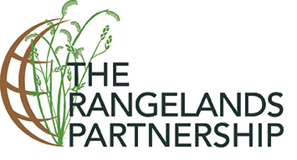
TIMES LISTED ARE PDT/MST
Monday, March 30: Join the Virtual Meeting (Phone)

10:00 am Welcome – Retta Bruegger, CSU, RP Chair
- Meeting Logistics and Zoom Tools – Retta
- Introduction of the Rangelands Partnership – Barb Hutchinson, AZ

10:20 am Lightning Round Report Discussion [Retta, Facilitator] – Please view all the state “video” reports prior to the meeting (available in Box (under Lightning Round Reports) and on the Member Site). We are planning for a lively discussion so be prepared to comment on your peer’s presentations, i.e. a highlight, common themes, question, etc. We may want to pull up websites or other web resources to look at them together.

- Alaska – Jodee Kuden
- Arizona – Andrew Briske, Joshua Grace, Ashley Hall, Ashley Wright
- California – Leslie Roche and Susan Marshall
- Colorado – Retta Bruegger
- Hawaii – Mark Thorne
- Idaho – April Hulet and Jeremy Kenyon
- Kansas – Livia Olsen and Walt Fick
- Nebraska – Mitch Stephenson
- Nevada – Amy Shannon
- New Mexico – Alex Benitez
- North Dakota – Nicole Juve and Miranda Meehan
- Oklahoma – Laura Goodman and Allison Thompson
- Oregon – Yvette Gibson
- South Dakota – Krista Ehlert and Nancy Marshall
- Utah – Beth Burritt
- Texas – Carolyn Jackson
- Washington – Tip Hudson
- Wyoming – David Kruger
- Teaching Clearinghouse and HEC Tools – Karen Launchbaugh
- Conservation Effects Assessment Project (CEAP) – Lori Metz, Grazing Lands Lead
- USFS – Judith Dyess, Assistant Director of Rangeland Management

11:50 am Welcome from WERA – Barbara Petty, Dean & Director of Extension, UIdaho

12:00 pm Break (30 minutes) – Times listed are PDT/MST

12:30 pm What’s New in Arizona Cooperative Extension – Jeff Silvertooth, Associate Dean and Director, Extension and Economic Development, University of Arizona

12:45 pm Action group updates from 2019-2020 year [Livia, Facilitator]
- Marketing & Social Media – Amber Dalke, AZ
- Collections & Content Management – Jodee, Jeanne Pfander, AZ, and Nicole
- Partnership Sustainability – Barb
- Action Groups Planning (Join an Action Group)

1:30 pm Communication with Purpose: Science for Society Panel – Theresa Crimmins (USA National Phenology Network); Elise Gornish (UA Cooperative Extension Specialist in Ecological Restoration); Rosemary Brandt (UA CALS Media Relations)

2:30 pm Break (15 minutes) – Times listed are PDT/MST

2:45 pm Introducing the Natural Resource Users Law & Policy Center (NRULPC) – George Ruyle, Co-Director, NRULPC & Professor & Range Extension Specialist (The Kemper and Ethel Marley Endowed Chair for Sustainable Rangeland Stewardship)

3:00 pm NRULPC/Law School Clinic Program – Priya Sundareshan, Director of the Natural Resource Use and Management Clinic

3:45 pm RREA Strategic Plan Webinar Project Update – Mark

4:00 pm Adjourn

TIMES LISTED ARE PDT/MST
Tuesday, March 31: Join the Virtual Meeting (Phone)

10:00 am Welcome Back and Logistics for the Day [Retta and Livia]

10:10 am RP Business Meeting [Retta and Livia, Facilitator]
- Report from the Chair, Review of 2019 Meeting Notes – Retta
- Administrative Update on WERA – Barbara
- Secretary Report – Krista
- Treasurer Report – Jeremy
- Transition to 2020/2021 Executive Team
- Announcement of Location for 2021 Meeting & Discussion of Dates
- Annual Meeting Travel Awards and Support for Officers – Retta
- NIFA Partnership Award Application Update – Barb
- Other Business

11:00 am Rangelands Gateway [Sarah Noelle, AZ, Facilitator]
- Explore the Website and Topic Format – Matt Rahr and Kim Daly, AZ
- DLIOs and State Site Content Update User Guides – Sheila Merrigan, AZ
12:00 pm Break (30 minutes) – Times listed are PDT/MST

12:30 pm Action Group Work – Breakout Rooms [Retta, Facilitator]
- Marketing and Social Media – Amber
- Collections and Collections Management – Jodee
- Partnership Sustainability & Membership – Barb and Mark
- Any others identified on first day discussion

1:15 pm Action Group Reports: Progress and Next Steps [Krista, Facilitator]

1:30 pm Socio-Ecological Systems – Emphasizing the Human Dimension (Special Keynote first presented at SRM) – Leslie, CA
- Recording of Karen Launchbaugh’s SRM Keynote

2:00 pm International Range Activities/Discussion [Barb, Facilitator]
- International Year of Rangelands and Pastoralists Progress
- International Land Coalition/Global Rangelands Initiative – a New Role for the RP
- International Rangelands Congress – IYRP Panel and Proposed Resolutions
- North America Rangelands Paper (status) – Anne Gondor, UA Research Specialist

2:15 pm Break (15 minutes) – Times listed are PDT/MST

2:30 pm Conservation Innovation Grant (CIG) Grazingland Information System [Jason Karl, ID, Facilitator]
- Introduction
- Rangelands Thesaurus Group
- Content Selection Group
- Indexing
- Mobile App Development
- Outreach
- Breakout Rooms

3:45 pm RP Focus and Next Steps for 2020-2021 [Livia, Facilitator]

4:00 pm Closing Session, Wrap-up, Adjourn [Livia, Krista]
- Meeting Evaluation

We wish to acknowledge the extraordinary support of the following:
George Ruyle and The Kemper and Ethel Marley Endowment for Sustainable Rangeland Stewardship for underwriting the meeting
and
The University of Arizona Libraries for providing additional support
Speaker Bios:

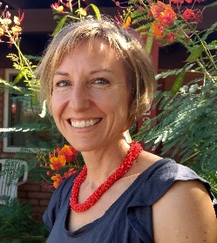
Theresa Crimmins is the Associate Director for the USA National Phenology Network. In this role, Theresa works to support the growth and use of phenology data and resources curated by the USA-NPN, involvement in Nature’s Notebook, and a broader appreciation of phenology among scientists and non-scientists alike. Theresa also maintains an active research career, including over 60 peer-reviewed publications. She has written for Scientific American and the Arizona Daily Star, and she has appeared in the PBS productions SciGirls and American Spring Live.

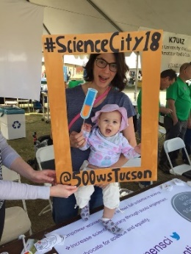
Dr. Elise Gornish is a Cooperative Extension Specialist in Ecological Restoration at the University of Arizona. Her research and outreach program focuses on plant management in arid systems. Key points in her presentation include: (1) You cannot communicate well if you do not listen; (2) Your stakeholders generally know more than you do – lets them tell you the type of information they need and the format in which they want that information; and (3) Tips on how to connect with stakeholders.

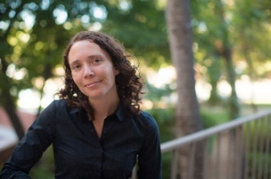
Rosemary Brandt is the Media Relations Manager for the UArizona College of Agriculture and Life Sciences. With experience in both public and commercial broadcasting, as well as academic publishing, she is skilled in publicity strategy, marketing, and fundraising. Her presentation will focus on: What makes a story newsworthy?; Best practices for working with your university communications team; and Building relationships and tips for working with the media.

