2019 WERA-103 Committee Meeting and Conference Agenda
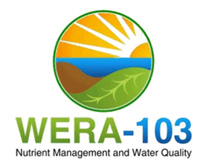
March 6 to 8, 2019
Held at: Eldorado Resort, Reno, NV

WERA-103 Committee Meeting
March 6, 2019, 7:30 am – 5:00 pm
8:30 - 9:00 Opening remarks and introductions; officer succession (Olga Walsh, Chair)
Action item: Nominate and elect 2019-20 Executive Committee
Eric Bremer – Incoming Chair
Jay Norton – Incoming Vice-Chair
Nominate/elect secretary for 2019-2020 (begins at the close of this meeting)
9:00 - 10:30 Final planning for the 2019 Western Nutrient Management Conference
10:30 - 10:45 Break
10:45 - 12:00 Future of conference and proceedings without IPNI
12:00 - 1:00 Lunch
1:00 – 1:30
Crops and Soils, WERA-103 Contributions
- Review 2018/2019 CSA news contributions
- Action item: 2019/2020 commitments from WERA members
1:30 - 2:00 Report from WERA-103 Advisor; Question and Answer (Rich Koenig)
2:00 - 3:30 WERA 103 Member Reports (Group) – Use 3 x 5 format (3 slides optional, 5 min.).
3:30 - 3:45 Break
3:45 - 5:00 Review and identify specific tasks / projects that address WERA-103 Project Objectives.
5:00 Adjourn

