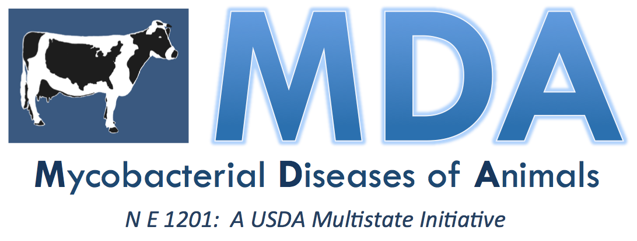
5th Annual Conference
Mycobacterial Diseases in Animals

in Conjunction with the Conference of Research Workers in Animal
Diseases

Chicago Marriott, Downtown Magnificent Mile
Chicago, Illinois

December 3-4, 2017

AGENDA

Saturday December 03
7:00 – 8:00 AM | Registration and Breakfast
Opening
8:00 – 8:30 AM | Opening Remarks and Introduction by Vivek Kapur, The Pennsylvania State University; Paul Coussens, Michigan State University; Gary Thompson, The Pennsylvania State University; Peter Johnson, USDA-NIFA
8:30 – 9:15 AM | Plenary Session 1: An introduction to and overview of Mycobacterial Diseases (Johne’s Disease and the TB Complex
9:15 – 10:00 AM | Plenary Session 2: Bovine TB in Mexican dairy (and beef) operations - Progress in disease control efforts - Alejandro Perera can probably suggest someone
10:00 – 10:30 AM Break – Posters Session
10:30 – 11:15 AM | Plenary Session 3: Develop and implement new generations of diagnostic tests for JD and TB.
11:15 AM -12:15 PM | Plenary Session 4: Increase understanding of the epidemiology and transmission of Mycobacterial diseases in animals, including predictive modeling.
12:15– 1:30 PM | Lunch – Posters Session
1:30 – 2:00 PM | Plenary Session 5: JD in small ruminants; Wild life reservoirs / risk associated with mycobacterial infections / Challenges with TB diagnostics in captive cervids
2:00 – 2:30 PM | Plenary Session 6: Zoonotic risks associated with of Mycobacterial diseases in animals
2:30 – 3:00 PM | Plenary Session 7: Public health risks associated with M. bovis in Mexico (foodborne and occupational health risks)
3:00 – 3:30 PM | Break – Posters Session
3:30 - 4:00 pm | Plenary Session 8: An introduction to the Global Research Alliance for Bovine Tuberculosis (GRAbTB) network
4:00 – 4:30 pm | Plenary Session 9: The Gates Foundation / Indian Government project to control TB
4:30 – 5:00 PM | Plenary Session 10: Extension/Outreach/Human Disease: Develop and deliver education and outreach material related to JD and TBc in electronic and print form for use by various stakeholders.
5:00 – 5:30 | Wrap-up on day
5:30 PM | Adjourn for the Day
Sunday December 04
7:00 – 8:00 AM | Registration and Breakfast
8:30 - 9:30 AM | Plenary Session 11: Identify markers for susceptibility, and understanding of host genetics.
9:30 - 10:30 AM | Plenary Session 12: Develop programs to evaluate and develop new generations of vaccines for JD and TBc.
10:30 – 11:15 AM | Needs and opportunities to address mycobacterial diseases in the Americas
11:15 AM – 12:15 PM | MDA MI – Planning our next steps
12:15 – 12:30 PM | Wrap-up
 | Adjourn

