2022 CHL Annual Meeting Notes

Date: | Friday, Aug 12, 2022
Time: | 8:30am
Attendees: | See this sheet
Call moderator/leader: | Christina Young, Jordan Oshiro, Monica Esquivel, Jean Butel
Call began at: | 8:30am
Docs related to this meeting: | - CHL Annual Meeting 2022 Planning  - CHL Center FS-CHLN Annual Meeting Agenda

Topic | Issues/Status | Plan/Suggestion/Action/ Decision
CHLN Year 2 Planning | Signature Foods - what to look at and what is the timeline?  Melissa: EFNEP data usage for foods?  Finalized voting for chair- Melissa Olfert, Monica to be “Past-Chair” and Jeannie Butel Vice Chair  Finalized monthly meeting dates, guidelines, and revised CHLN objectives | Lynne: Prepare signature foods per GMB.  Rachel: Potentially prepare “traditional” foods  Finalized voting for chair- Melissa Olfert, Monica to be “Past-Chair” and Jeannie Butel Vice Chair  Finalized monthly meeting dates, guidelines, and revised CHLN objectives
Lynne Data | The fact that shoyu is being counted as a vegetable goes to show how little vegetables are benign consumed | Continue to incorporate questions regarding CHL data/diet into CHLN working plans
GMB recap | Participants will probably dictate the logistics - Virtual v In-person  “Hopes and Fears” - setting the expectations  - What are the goals of this session?  - What to do with the action items?  - What are we providing for outputs to participants  - Wlll the participants get enough out of this to wanna come back and feel encouraged?  What are the boundaries of the model?  When do the evaluations happen?  Where is the money for the action items?  How to incentivize participation in the GMB activity?  We need to be responsible for delivering, but how?  What does eating more apple bananas instead of cabbage mean when it comes to diet quality?  Need to know what others programs in the community is doing so we donʻt duplicate efforts  - Ex: food policy council in AK and USDA food mapping | Alaska will probably have to do both physical and virtual to accommodate statewide participants  CNMI might do virtual if other islands are to be included  Dependent on the intimacy of the group; Another activity specific for the group may be appropriate  - In the planning process, expectations should be communicated  - Reconcile differences is the responsible of the core modeling team  These are the variables in the model, this boundary is conceptual  - FYI: Maps need to be Iterative  After each sequence  The pilot projects can do this  Need to have an outcome that fits all  - How to measure outcomes?  - Quantitative or qualitative?  Convergence of the different programs  - Work with whats in the community
CHL Recap | Local Advisory Committee  Timeline | Proposed CHL-Wide update meetings  CHL GMB Regional Meetings  CHL GMB Jurisdictional Meetings  - Goal may be to share updates to the models  LAC is essentially the GMB attendees?  - Also discuss the establishment or re-establishment of LAC within jurisdictions at PSC  UPDATE CHL ListServ  - ID signature foods regional: Extend Oct 2022  - For PSC, have jurisdictions determine which foods to include for Signature Foods  Completion:  - Recruit & Enroll  - (Update so time can be extended?) Identify courses where CHL FS Model  - Complete train-the-trainer GMB workshops  - (Note, tools are like the Logic model developed using the GMB models)  Next Annual Meeting location proposals?

+
- Fellowship, Gathering, Networking, Getting to know each other
- Techs, hybrid work,
- Agenda structure
- Field Trip
- Managed Chaos
- Safe space
- Logistics
- Transparency, open or safe space to communicate
- Positivity of the group, encouraging outlook, united in a cause
- Cultural sharing
- Wider perspectives

-
- More field trips
- Follow-on events/retreats/on the good time
- Alternate locations
- Guest speakers -think tank or data sharing
- Physical activity - competitions, cultural sharing
- Swag, wearable marketing, gifts
- Less powerpoints?
- Parking?

Date: | Thursday, Aug 11, 2022
Time: | 8:30am
Attendees: | See this sheet
Call moderator/leader: | Christina Young, Jordan Oshiro, Sabine Strasburger, Jean Butel
Call began at: | 8:30am
Docs related to this meeting: | - CHL Annual Meeting 2022 Planning  - CHL Center FS-CHLN Annual Meeting Agenda

Topic | Issues/Status | Plan/Suggestion/Action/ Decision
CHLN | Many of the same people are on the same sub-groups and meetings = a lot of meeting and blurring of topics and conversions  So was Helenʻs predecessor?  Chair and vice chair positions: elections (does not need to be a vote)  Publications  Multistate structure  - Student training  - What is a trainee?  Food Systems | Peter came before Helen  - Helen will provide the language to use\  - NIFA representative  - Administrative advisor is from the land grant university  Nominated: Melissa as chair; Jeanie as a vice chair  - The vice chair should be a trainee to be future chair  Usually happens after the grant is over and so they can be in two places and be amplified  This includes thesis and dissertations  Need to have a repository of trainees  Doesnʻt really have to be directly tied to the funding, they just need to have a connection with the research  - Why? Because it will come in handy esp in showcasing  - Data requests do capture who is using what  - Goal: capture CHLʻs impact (ex: national impact, international impact)  - Get the Western Region award so that you can get the National Region  - A dean needs to nominate
CHLN training | OER: Volunteers for peer review  Research: outcomes of OER work? Research on training program- students contributed to research (what research did students do that impacted CHL); how to utilize the past/existing evaluations to develop future robust evaluation)  Training Programs: CHLD (report on undergraduate research mentored by RN, MKFR, MKE)  CHL FS  CHL SI courses  CHLD scholars  CHL FST  CHL Trainees: evaluated (take inventory of trainees; research project; questions asked)  CHAP: External evaluator utilized, application as a pre-test; presentations (Products);  - Action: M’randa and Karen linked  CHL SI: limited- in form of course review evaluation system  - Utilize course evaluation system?  - Trainees encouraged to teach CHL SI- ask CHL SI instructors to share data  - Stretch | Overview  CHL OER textbook  Training program(s)  Evaluation
Policy and Extension (Jeanie) | Should the CHLN policy and extension workgroup focus on CHL food cost data?  - If so, which research question(s) would be of most interest?  An idea we want to pursue  Other research ideas for CHLN policy and extension group?  Therefore, is running out of money for food an appropriate measure of food security in our spaces?  Going straight to the source? Farms? Fish vendors? | Do we consider calling it “extension” or “work group” project?  “Food cost” working group project/task  We can still do research with the image repository with our other hats ;) - Tanisha  We ask this question in our surveys  Want to get a feel of what the availability is for local foods  Look at this in each of the jurisdictions
CHLN + EFNEP | Wrong sample size for Northern Mariana  Food Security went down for some jurisdiction during COVID  Are we comparing apples to oranges?  Online platform?  Adding questions to EFNEP?  What data was collected? What are some of the differences between these groups? How many people were measured in each of the measures?  How to overcome challenges?  How are participants interpreting the questions being asked? Lost in translation? | Impact of COVID was different everywhere  - Pre covid, Peri covid, there is no post covid = “hot mess”  - Very limited data and COVID exacerbated this  Every jurisdiction is unique and cannot be generalized  Cannot for certain demographics  Yes can  EFNEP serves a distinct populations but want to get surface data to understand this population  Do not look through the covid lens? Compare apples to apples

Date: | Wednesday, Aug 10, 2022
Time: | 8:30am
Attendees: | See this sheet
Call moderator/leader: | Christina Young, Jordan Oshiro, Sabine Strasburger, Jean Butel
Call began at: | 8:30am
Docs related to this meeting: | - CHL Annual Meeting 2022 Planning  - CHL Center FS-CHLN Annual Meeting Agenda

Topic | Issues/Status | Plan/Suggestion/Action/ Decision
CHL website (Sabine and Erik) | What devices are allowable to access CHL data with? | The “machine” aka laptop needs to have an unique account with strong passwords. Ex. personal laptop that is password protected and the computer is encrypted  Please communicate with Erik regarding “machine” requirements
NIFA + AFRI Sustainable Ag System (Mallory) | New farm bill? Federal funding? Will things shift?  White House Nutrition Conference: highlights that there is a lot of interest  - CNMI did send questions to the conference  AI centers  SAS Program: sustainable ag systems | Congress will make those decisions. Currently all of this is only offered until 2023. Suggestion: talk to congress, educate the public on what's coming from the research  Ann Stapleton is the go-to person. AI is beginning with ag and soil and is moving towards humans and free living.  Young program, continually involving, there is a priority on nutrition and food security and sustainability  - Solving todayʻs problems and the future  - Large project management and leadership  CISP: Current information and services: this is where to go to for information
Multi-State Project CHLN (Helen) | SAS grant research agenda to drive CHLN it can inform education, outreach/extension  Hatch Multistate funds- research support (focus on for reporting)  - Different institutions with similar interests  - Active commitment  Regional Proposals- need to focus on research can share how it will inform education/outreach/extension  Duplication- multistate primarily brings researchers together- need grant money to do the work  - Ex: publications- grants received, meetings, publications in both CHLN and SAS  Regional (umbrella) vs. jurisdictional plans  - NIFA approval for both  - Include only research functions of SAS grant  - Institutional: align with big picture; convey what the individual institution will do  - Reports: Umbrella and Institutional level  - What is happening at each institution  Individual Project: make titles consistent with the umbrella plan  Non-Technical Summary: consistent language across all projects; what specific individual institutions will do  Objectives/Methods: institutional specific; if integrated- focus on how research informs extension/outreach)  Classification information: consistent  W2194: Plan- research focus; alignment between regional plan & institutions; institutional projects- place/function to overall. | Revise CHLN objectives for Year 2 and forward

Date: | Tuesday, Aug 9, 2022
Time: | 8:30am
Attendees: | See this sheet
Call moderator/leader: | Christina Young, Jordan Oshiro, Sabine Strasburger
Call began at: | 8:30am
Docs related to this meeting: | - CHL Annual Meeting 2022 Planning  - CHL Center FS-CHLN Annual Meeting Agenda

Topic | Issues/Status | Plan/Suggestion/Action/ Decision
Sugar, Obesity and AN in CHL (Doug Taren) | What about total vegetable consumption?  Hypothesis testing on the individual? Ex: fiber impact; Ex: PEDs cardiac study in WV | Per DT: did not make a difference, the key is looking at dietary pattern and refined carbohydrates  Per DT: food-nomics, general changes in dietary patterns, eating one thing and not eating another thing; what diets are associated with AN
Agroforestry’s ecological diversity and nutritional diversity  (Ashley McGuigan) | Are the food crops in a agroforest native or introduced?  What about resiliency?  Beneficial/helpful plants? Strong and nutritionally beneficial plant?  Are there traditional practices of the Fijiian people to preserve food? | Yes to both, some are intentional cultivated, some are favored, there are unintentional plants  Ecological traits were selected because they are traits for recovery of the plants (ex: those that grew about a cyclone)  Looked at cassava and sweet potato. Sweet potato is a key plant  Unfortunately, a lot of traditional customs are not commonly practiced
Food Security  (Melanie Hingle) | Radio-graph: how does it relate to energy?  Proxy question for food security came from where?  Need to define food security. Need to highlight the differences among these places that are being talked about?  Manuscript Questions:  Should we use Feeding America food insecurity prevalence data for 50 U.S. States? Are there more appropriate comparisons?  Should we be more specific throughout the manuscript | Cannot be over 100%. Low score means eating too little  Came from the CDC  Maybe use a different word because this word does not adequacy apply to it? The areas where data collected are very different
CAT+food environment  (Ashley Yamanaka) | Validated scores? This is more like a profile? How to use this data?  How were the forms used decided on?  How does this contribute to CHL?  Climate change?  Need to capture popularity or use of the parks  In American Samoa, there is a malai for villagers to use  What is the definition of “park”? Ex: Alaska has a lot of land  BTG: was there an outdoor rock climbing wall? | Only CX3 score was validated. Rate the feature. Added features re: environment  Way to know if a “thing” is achieving its goal is is it being used. There was was a lot of personal opinion  Its the best there was. Recognize it might not have been the most appropriate. It was subjective.  Producing validated and appropriate tools. From this data, a more structured rubric/tool has been made. The incivilities questions were really good.  - Fyi: homeless people were “scary people” question  - Describe the type of settings  Need to capture this effect  Swimming environments/water features  This was a very complicated feature to capture and its accessibility  Per the guidelines, national and state parks cannot be counted  Not appropriate
Food Cost  (Jean Butel) | Proportional increase?  ʻ14/ʻ21 CHL vs ʻ22 USDA: what stood out?  What about the main staples that were most commonly consumed in CHL data?  Does the data reflect the advice to eat healthy and the cost to eat healthy? Affordability? | Everything increased, some places increased more than other places  Differences in availability. Ex: short grain brown rice in Hawaii vs. this same kind in D.C.  Need to strike a balance.  TFP uses NHANES data to meet dietary guidelines and is used as the basis to calculate costs.  Data can be used to investigate inflation. Farm bill required this data to be collected.  - Need to translated the TFP into our food language and environment  Elephant in the room: foods that are important to us are not in the database  Conversation topics: Can there be an add on module for local foods or can these foods be a substitute?
Diet Quality  (Yuri + Rica) | Will CHL use HEI and DASH?  PacTRAC?  Processed foods? Preservative foods? What are these foods? Is it more type than amount?  What are these signature foods?  Soy sauce as a vegetable? | Hard to say…  Blood pressure went down amongst the kids  - PacTRAC (this is a tool that is region specific) diet data was incorporated into this data set  - Pacific specific foods  Need to look at signature foods  - Common foods kids are eating: things that they can hold in their hands  - Nitrate and sodium issues  This was a CHL designation. Can assume from this that kids are not consuming vegetables.
Program Updates

Date: | Monday, Aug 8, 2022
Time: | 8:30
Attendees: | See this sheet
Call moderator/leader: | Christina Young, Jordan Oshiro, Sabine Strasburger
Call began at: | 8:30
Docs related to this meeting: | - CHL Annual Meeting 2022 Planning  - CHL Center FS-CHLN Annual Meeting Agenda

Topic | Issues/Status | Plan/Suggestion/Action/ Decision
Intro to Systems science/Group Model Building | Implicit v Explicit, deeper understanding of system  System dynamics is the use of informal maps and formal models with computer simulation to uncover and understand endogenous sources of system behavior (Richardson, 2011)  System behavior  Dynamic problem or reference mode for lead exposures for Cuyahoga County (CDC Feb 22, 2021) graphic  Informal maps  - Causal loop diagram, stock and flow diagram  Endogenous sources of system behavior  - Linear cause-effect perspective  - Reinforcing feedback loops  - Balancing feedback loops  Example of developing an endogenous explanation: travel, security, dog, car  Formal models with computer simulation…  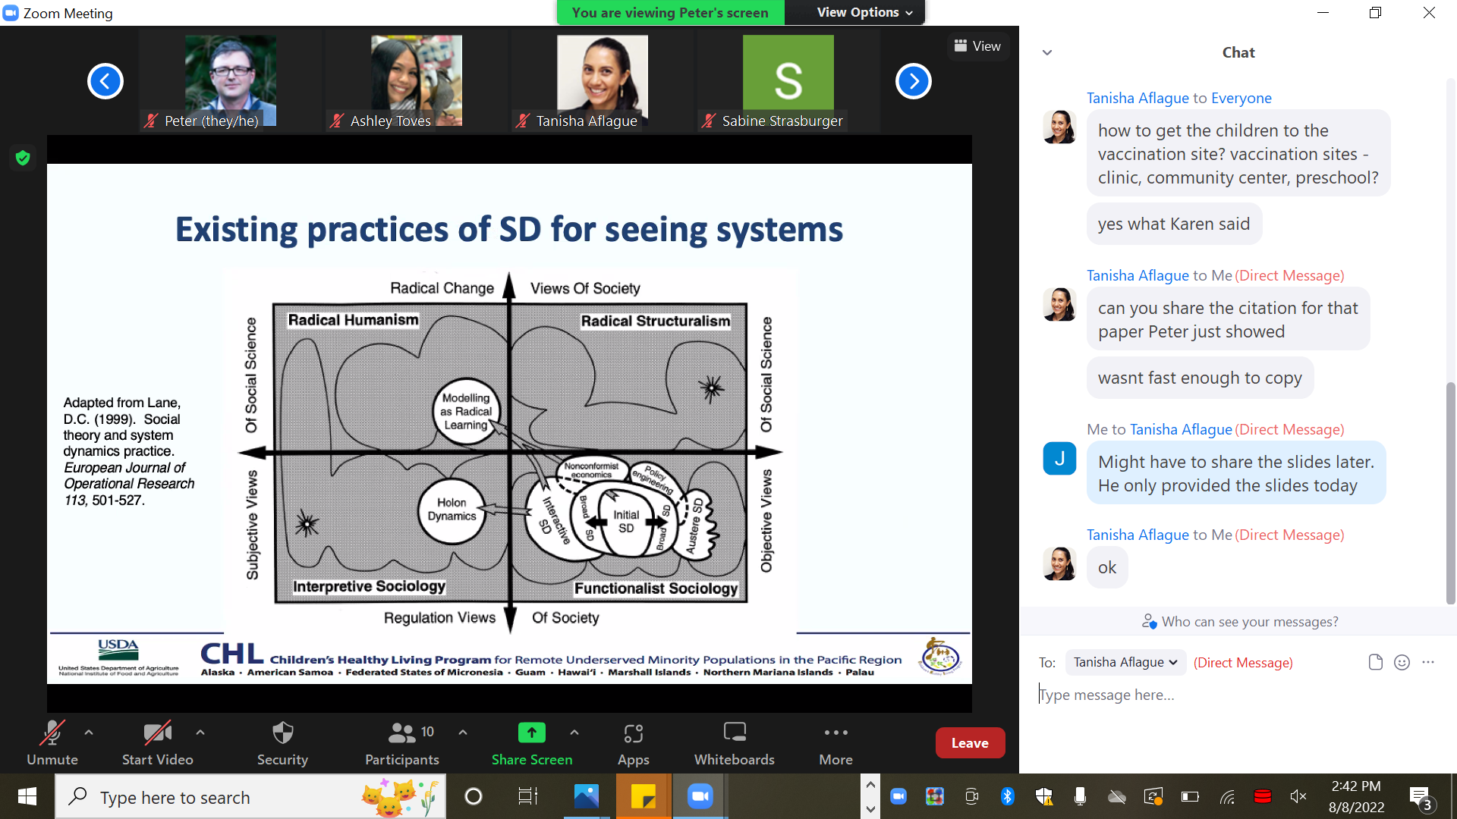  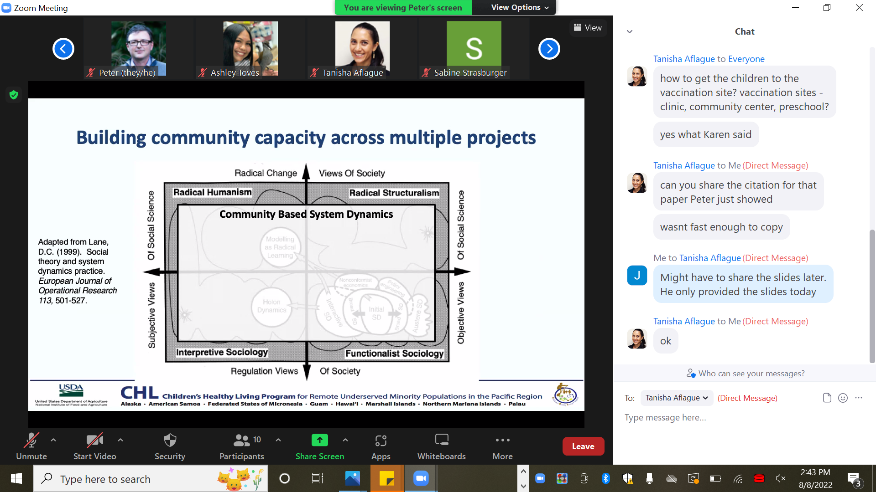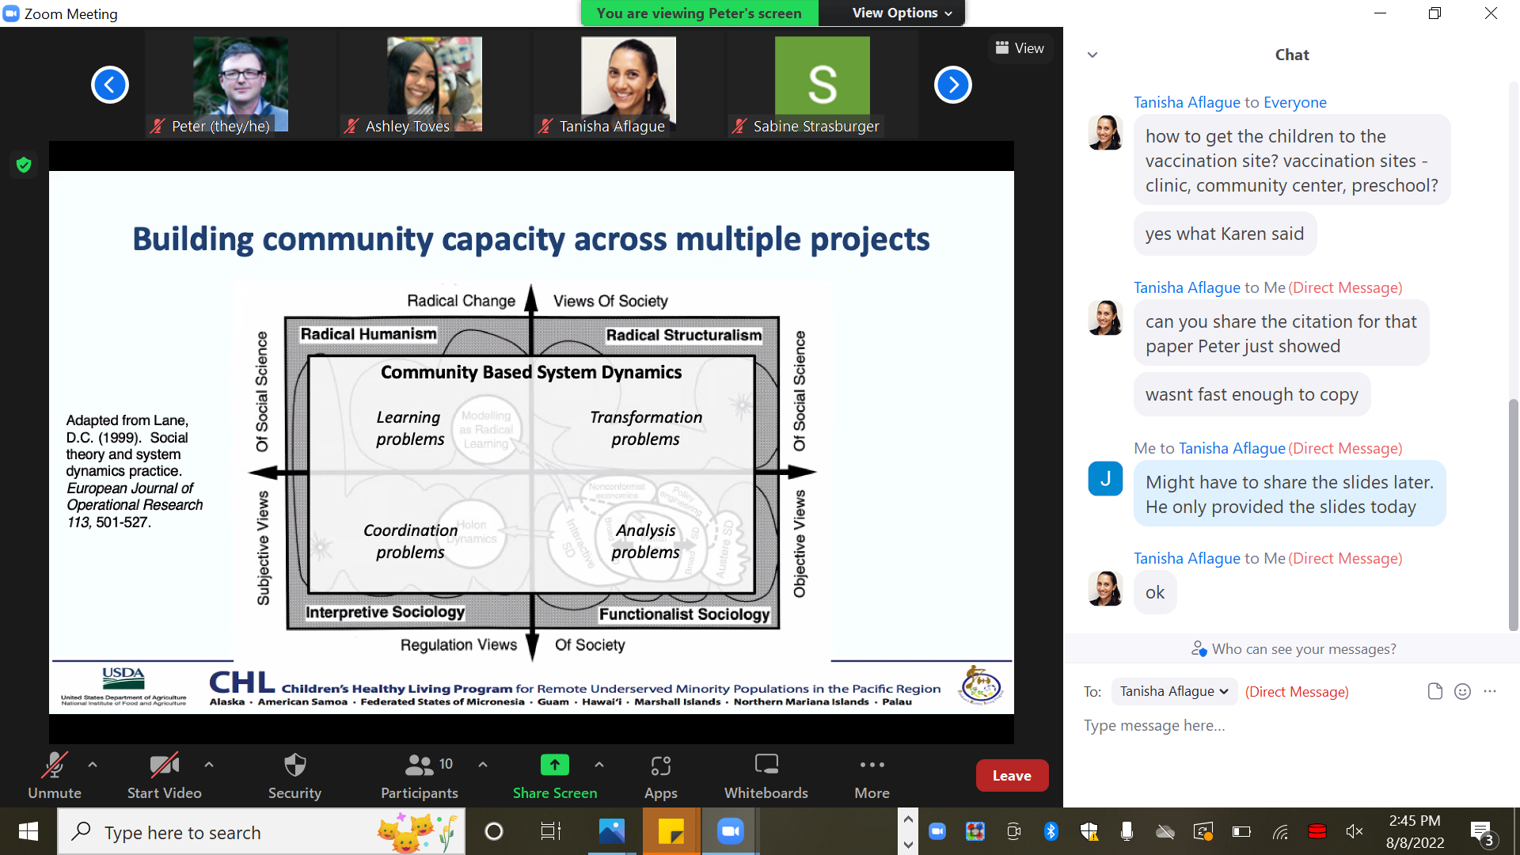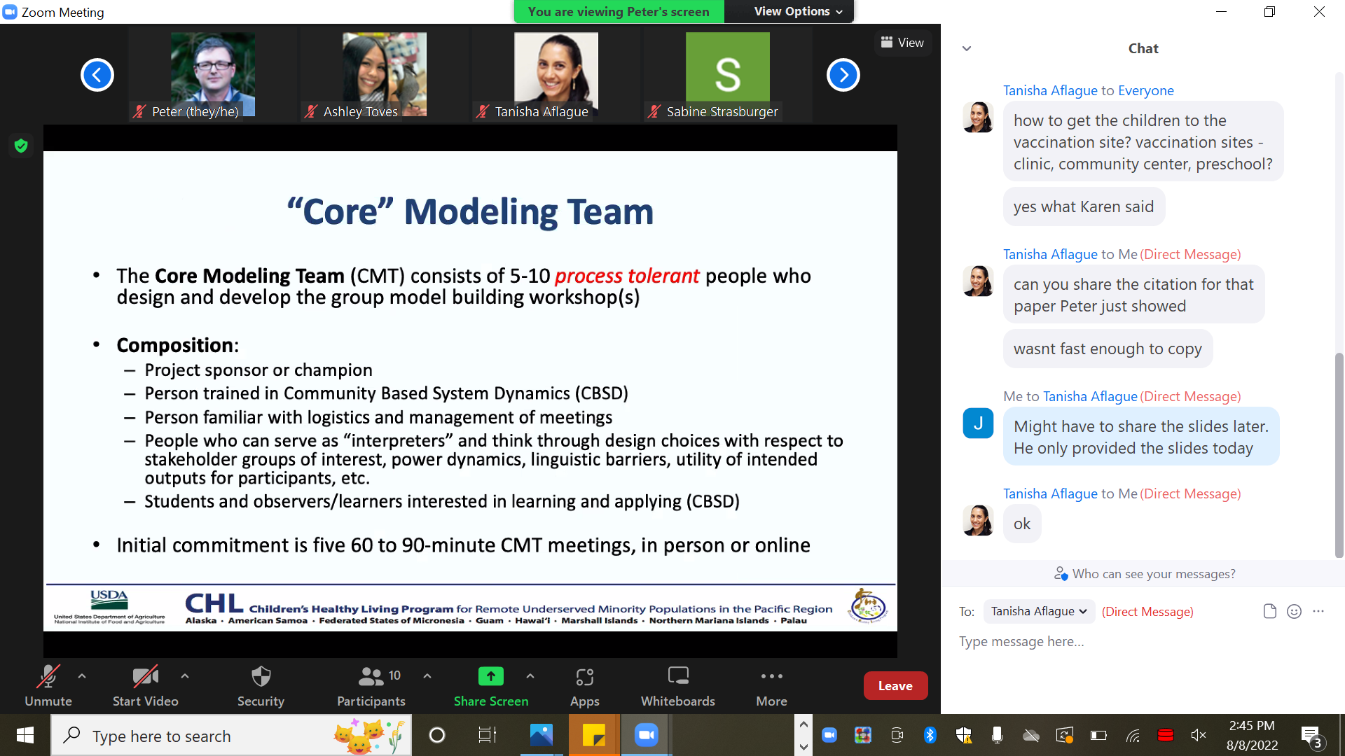  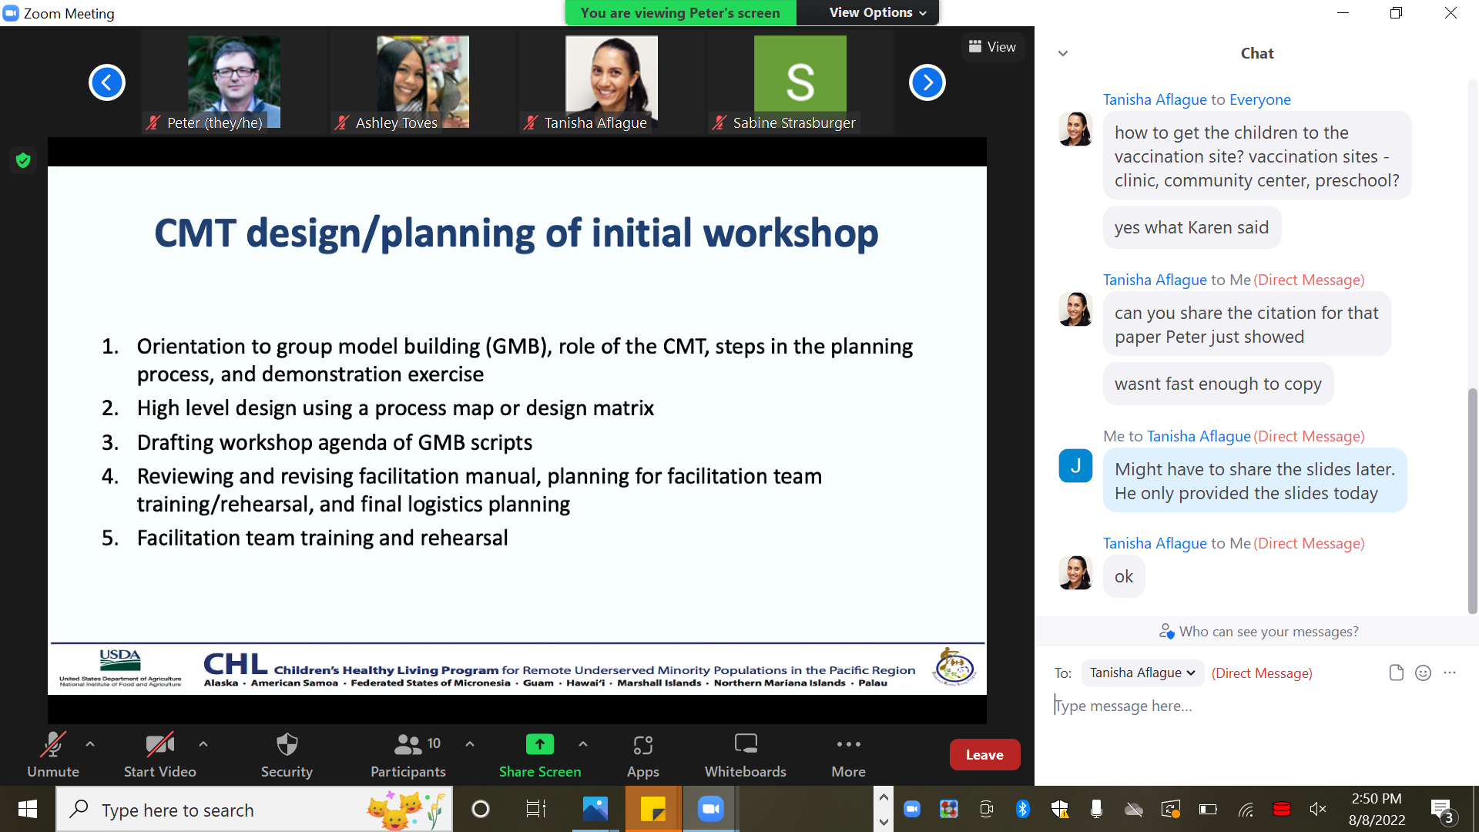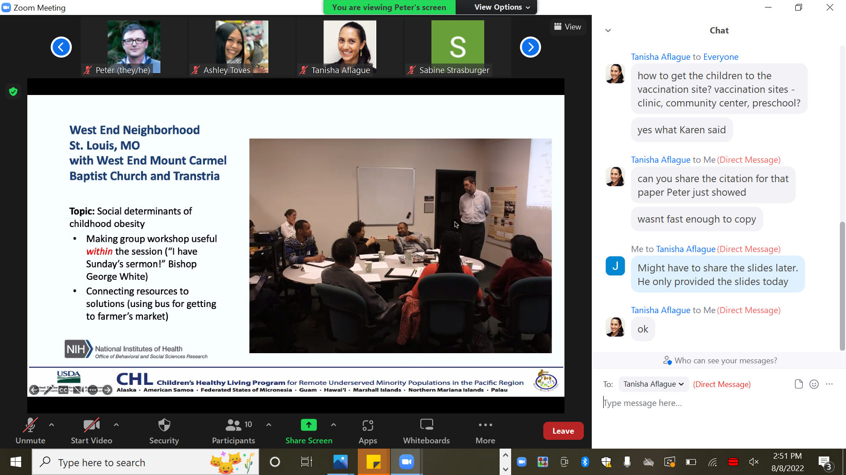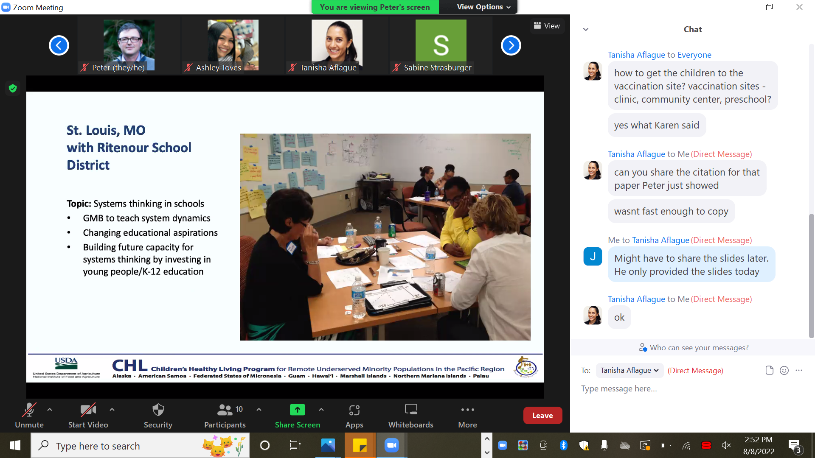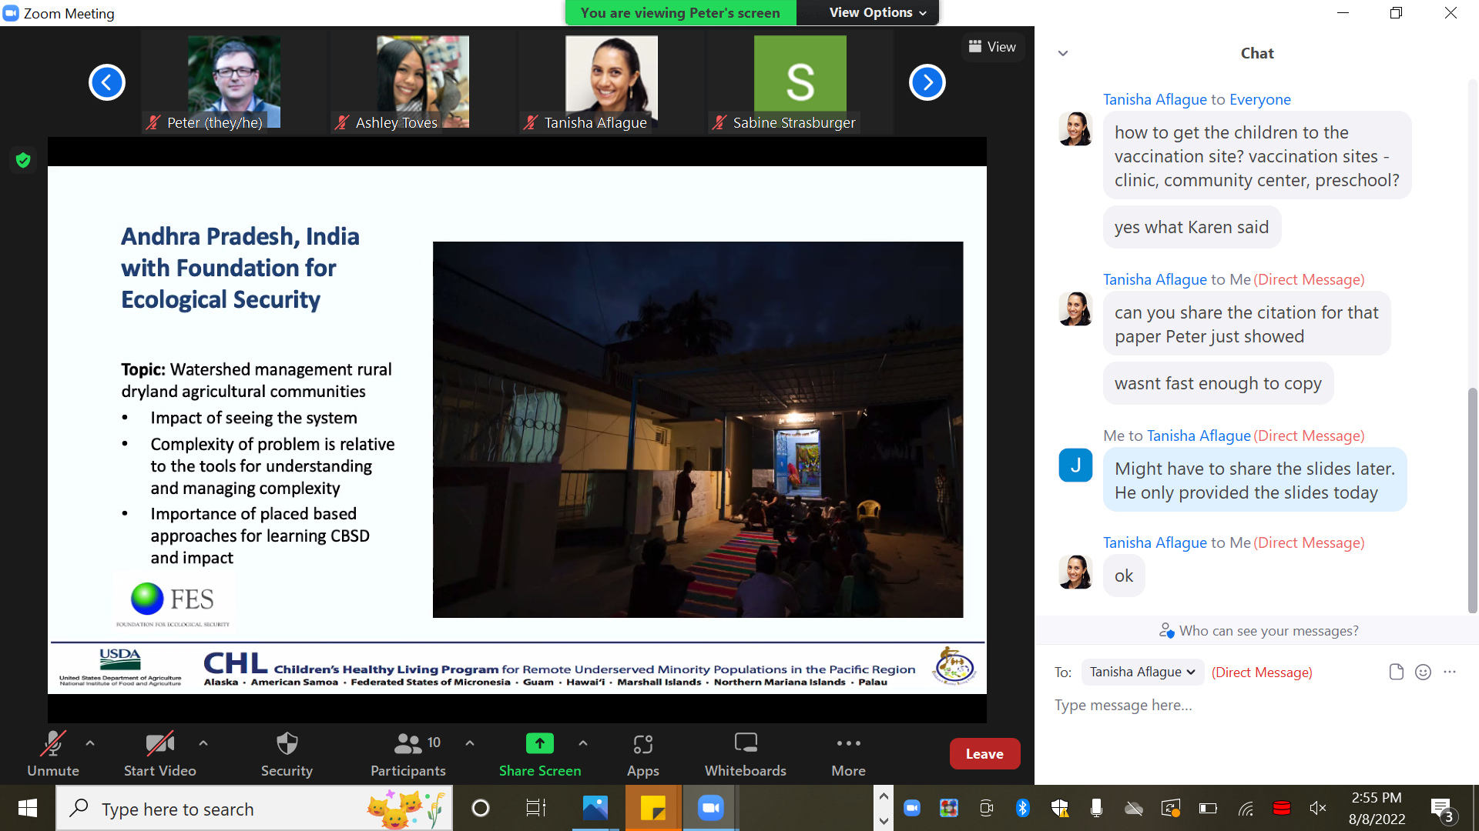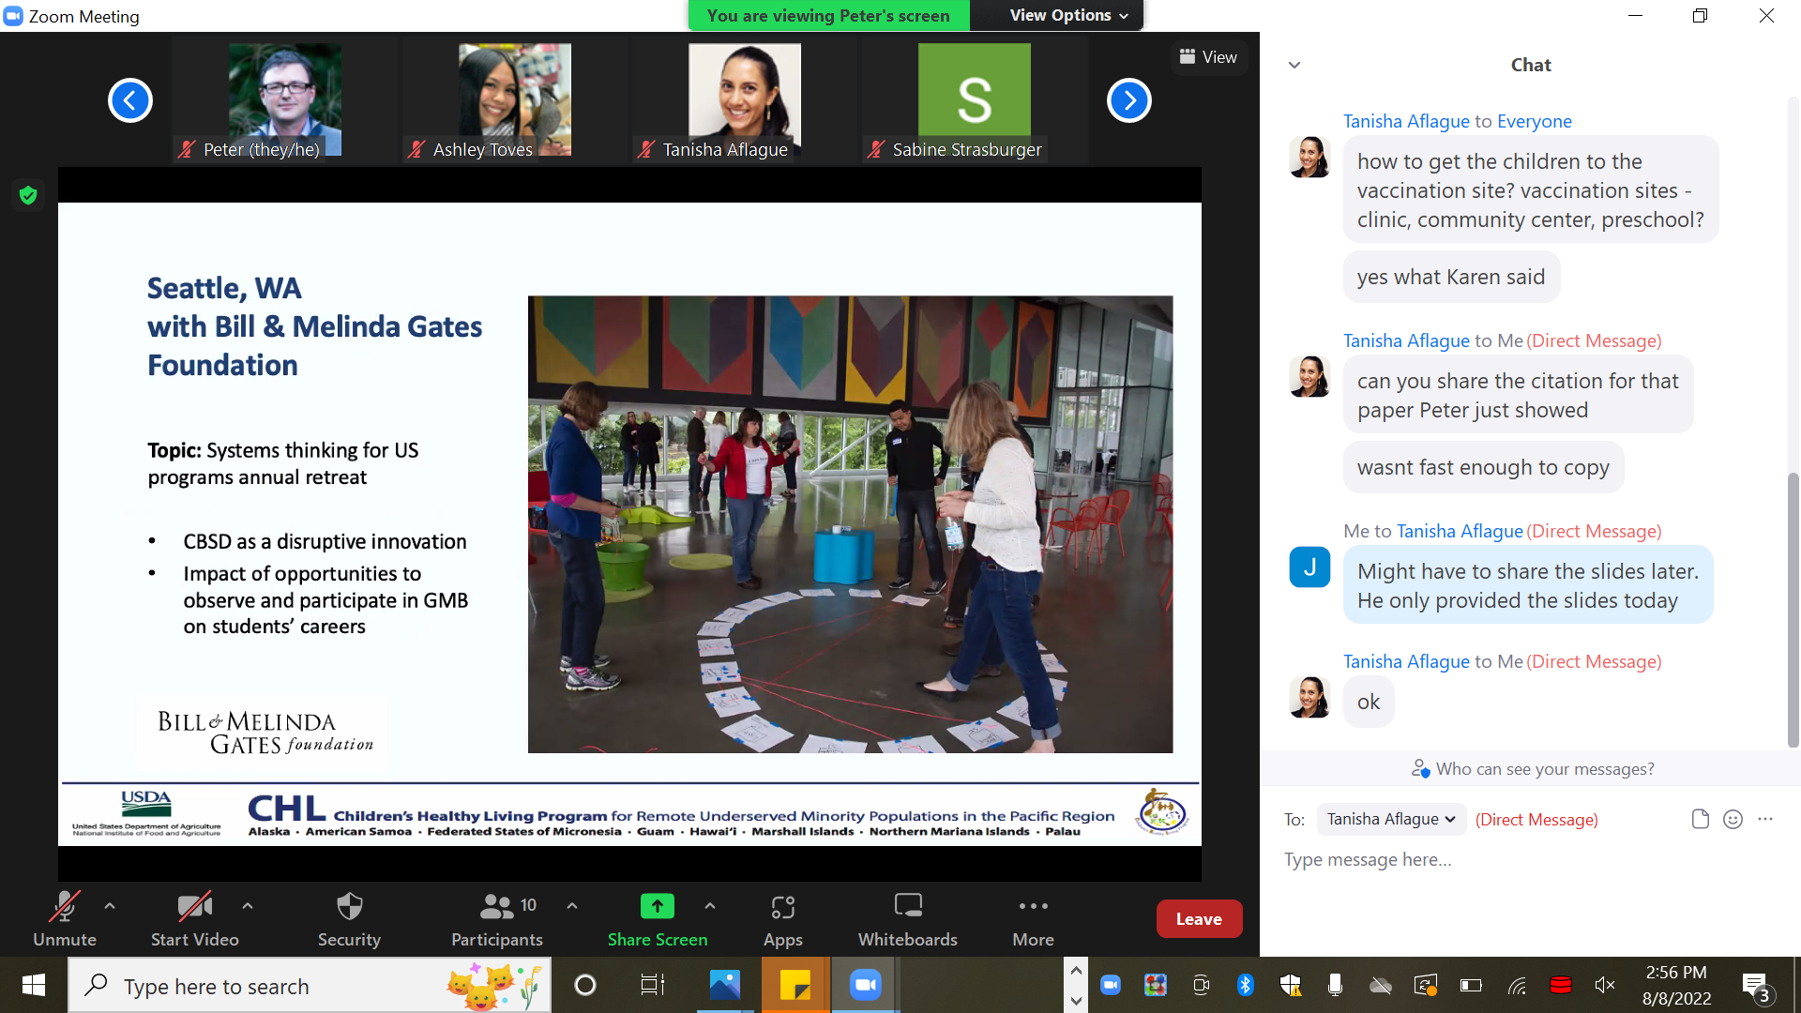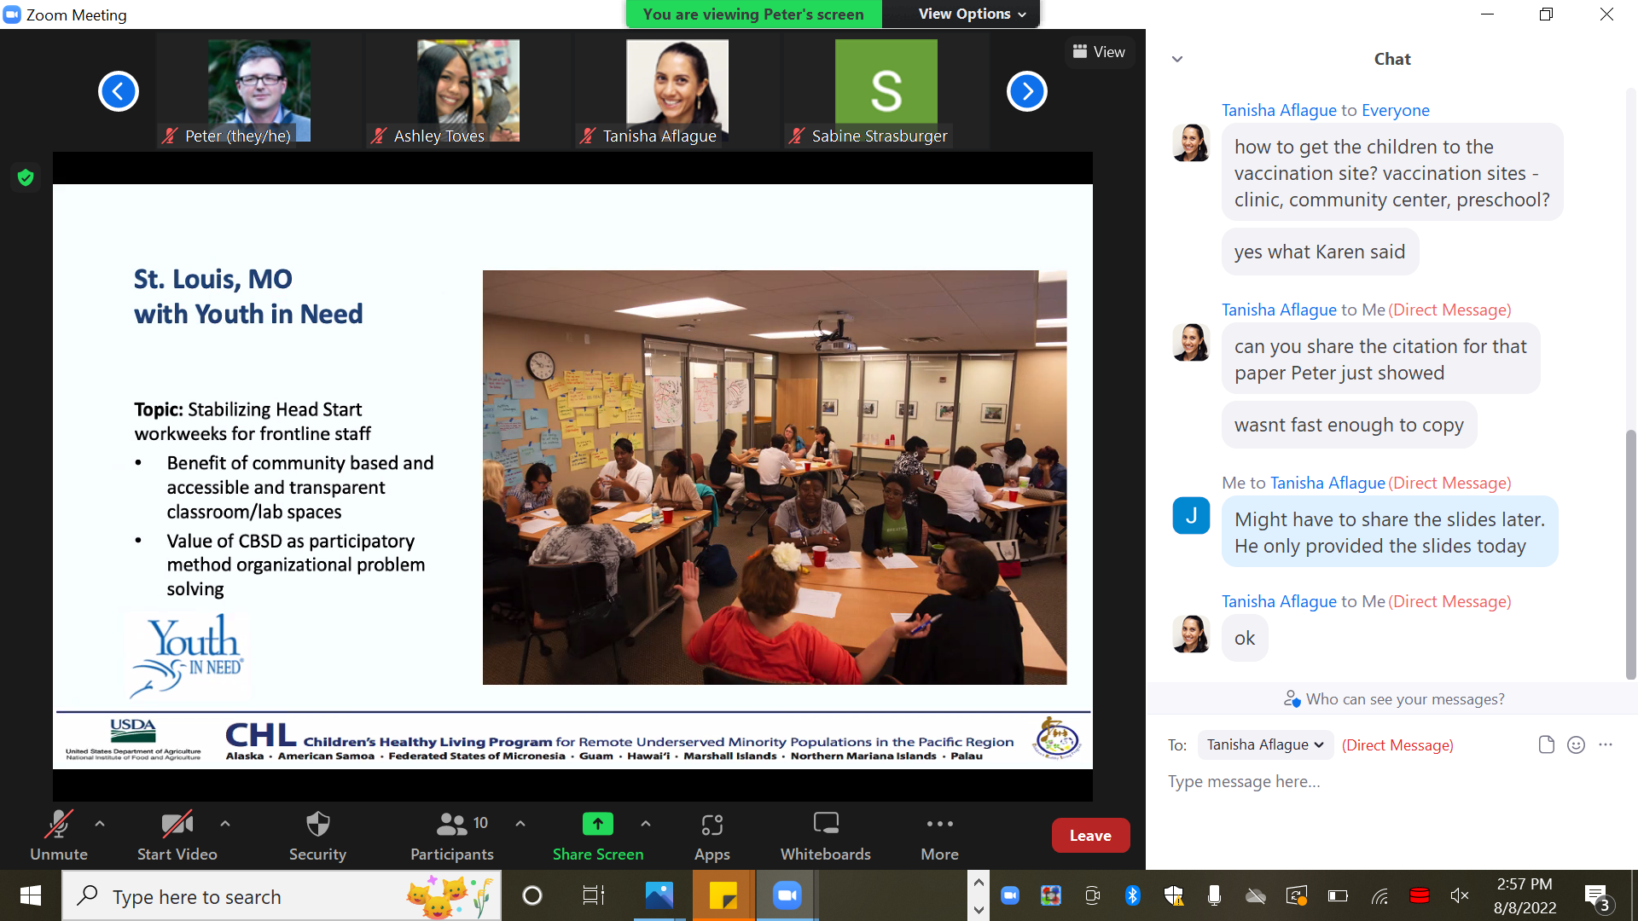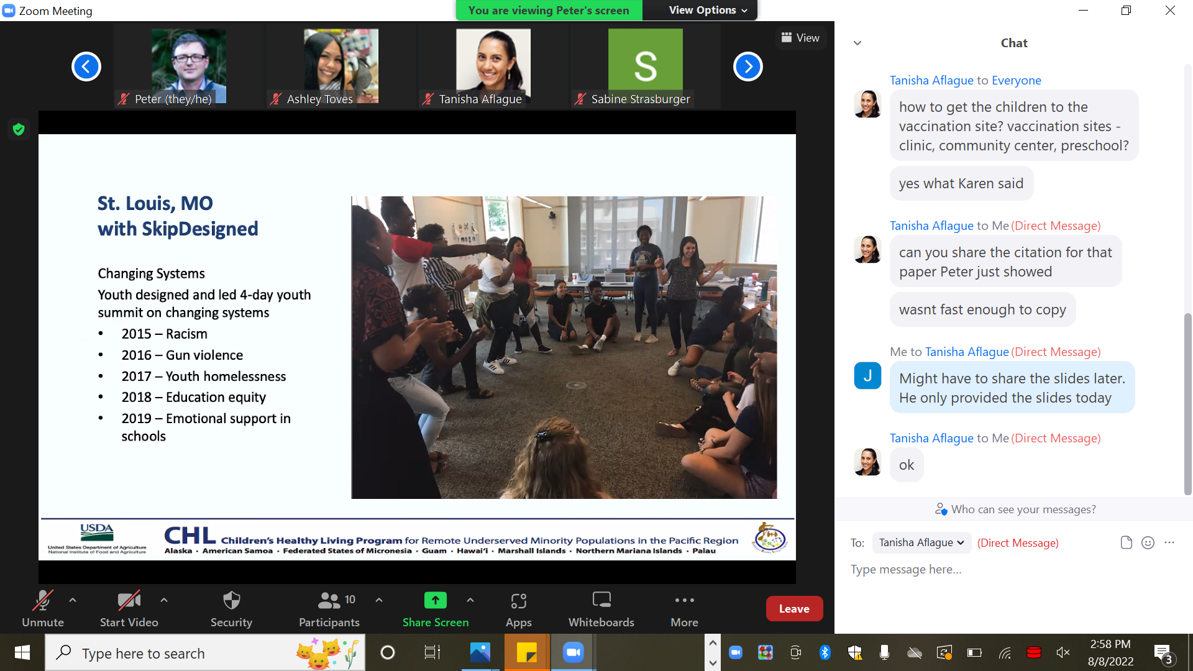 | None

