NC-1177 Day 1 Attendees
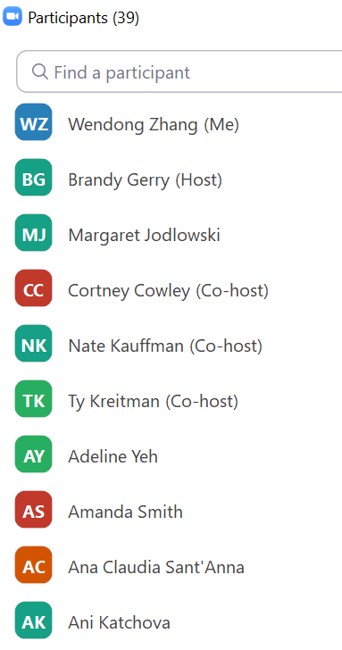
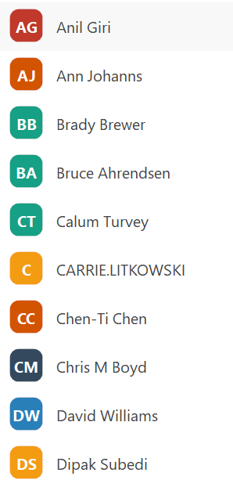
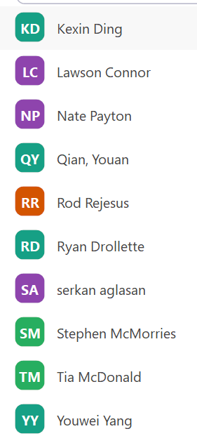

Calum Turvey, Cornell University
Brady Brewer--Purdue University
Ana Claudia Sant'Anna - West Virginia University
Ani Katchova, The Ohio State University
Cortney Cowley, Federal Reserve Bank of Kansas City
Margaret Jodlowski, The Ohio State University
Rod Rejesus, NC State University
Gianna Short, USDA FPAC-BC
Tia McDonald, USDA ERS
Youwei Yang, Cornell University
Carrie Litkowski, USDA-ERS
Eric Belasco, Montana State University
Jenny Ifft, Kansas State University
Serkan Aglasan, NC State University
Valentina Hartarska
Harun Bulut, National Crop Insurance Services NCIS
Ann Johanns, Iowa State University
Kevin Kim, Ohio State University
Nate Kauffman, KC Fed
Dipak Subedi USDA-ERS
Bruce Ahrendsen, University of Arkansas
Anil Giri, ERS USDA
Wendong Zhang, Iowa State University
Ryan Drollette, Iowa State University
Kexin Ding, Ohio State University
Amanda Smith, The University of Georgia
Jeff Hopkins, Economic Research Service USDA - thanks putting this on!
Lawson Connor - Louisiana State University
Chris Boyd - University of Minnesota
Youan Qian, Texas A&M University
Juo-Han Tsay - University of Illinois
Nate Payton - AgriBank
Stephen McMorries - Federal Reserve Bank of St. Louis
Chen-Ti Chen - Iowa State
Xudong Rao, North Dakota State University

Steele West

Dave Harper

Marc Bellemare, University of Minnesota

Joe Janzen, University of Illinois

Iuliia Tetteh, Illinois State University

David Oppedahl, Chicago Fed

