Meeting of the Minor Use Animal Drug Program Coordinating Committee (NECC1702)
September 17 - 18, 2018
Center for Veterinary Medicine, FDA
7529 Standish Place, Room 140
Rockville, MD 20855
Attendees
Name | Representing | email Address
Amy Omer | FDA/CVM | Amy.Omer@fda.hhs.gov
John Babish | MUADP/ | jgb7@cornell.edu
Lucy Lee | FDA/CVM | Lucy.Lee@fda.hhs.gov
Margaret Smith | Administrative Advisor, CUAES | mes25@cornell.edu
Meg Oeller | FDA/CVM | Margaret.Oeller@fda.hhs.gov
Peter Johnson | NIFA | PJOHNSON@nifa.usda.gov
Rodman G. Getchell | Cornell University | rgg4@cornell.edu
Ronald Griffith | Iowa State University | rgriffit@iastate.edu

September 17, 2018 (9 am)

Introductions, Meeting Goals & Housekeeping
Dr. Peter Johnson was welcomed to the group and the agenda was reviewed.

Welcome Remarks from Dr. Steve Solomon, Director, CVM
- Continuing need for high-quality data
- GLP: seeking balance between data quality and how onerous/burdensome the requirements are
- More stakeholder engagement needed
- Congressional staffers were most interested in OMUMS; keep that engagement and how to move program forward
- Real need for education of Congress - vet pharm, animal health industry, producers’ needs, veterinarians’ needs
- Alignment/consistent messages
- Not particularly good about conveying NEEDS… what are the needs of producers??
- Can we think of any other incentives?
- Blank slate—opportunity—strategic partnerships - understand the need of our stakeholders
- How has the program elicited needs from stakeholders before - Animal drug user forms; what other ways can the program do this?
- Kansas State collaboration? There is a large presence of Animal Health in this area and KSU is very engaged in collaborative projects
- 5% OTC that still need to be under a legal home
- Consortium funding? Instead of pharma supportive of a single drug, what if we create a single pot of money from several pharma; but how much do we need? What is the cost of drug development for minor species?

Updates/Plans for current projects:
Stakeholders need to perceive that the organization they are working with is going to be around for a while/stable and reputable
- Fenbendazole for pheasants
  - TAS: complete
  - HFS: complete (except for tox piece);
  - Effectiveness: outstanding—completed in 2000; must re-affirm data with white paper; goal is that by the end of this calendar year to be submitted;
  - Environmental impact: initially wanted to ask for categorical exclusion from the EA, that request rejected; Eric Rosenblum will put together an exposure assessment report, including relevant information on how pheasants are managed, where leftover feed goes, etc.
- Fenbendazole for quail
  - Effectiveness: (a) farmed quail- completed back in 2000, would need to re-affirm; (b) free-ranging quail- recent study completed, submission being prepared
  - TAS: recent study completed, study designed to cover both farmed and free-ranging quail, submission being prepared
  - Environmental impact/free-ranging quail: Planning a categorical exclusion request (regs say that if the drug is already approved in a species that has similar animal management practices, the proposed new use can be excluded from having to provide an EA).
  - Human food safety: method/validation is currently under review; residue depletion study completed, final study report undergoing QA review
  - The indication for the free-ranging quail = Lots of stakeholders! Lots of resources towards combatting the decrease of quail – especially in Texas !
- Erythromycin in salmon
  - New sponsor to work on CMC technical section; will require a new API (active pharmaceutical ingredient)
  - Still working with Chris Moffitt as conduit between manufacturer and end-users;
  - Effectiveness: TS complete in 2000, when asked for re-affirmations in 2012-13 claim for all salmonids came back as chinook only; ONADE recommended we do another study; hope to write justification
  - TAS: TS complete in 2000, when asked for re-affirmations in 2012-13 claim for all salmonids came back as chinook only;
  - Have had conversations with ONADE about going back to all salmonids for both EFF and TAS TSs, but with new API, calling into question EVERYTHING;
  - Environmental impact: EA completed back when previous sponsor was involved; will need to be revised based on removal of proprietary information
- Strontium chloride in salmon
  - TAS: Rod did TAS study (submitted in Jan 2016; incomplete); TAS will be submitted by the end of the year;
  - Effectiveness, environmental, HFS: white paper arguments for the rest of the TS; lots of data from the public domain—i.e. public health organizations
- Ivermectin block in cattle
  - Collaboration between= (Texas cattle fever tick, USDA/ARS/APHIS, state veterinary, Postive Feeds)
  - Project was deemed minor use bc it was geographically contained to a small area to eradicate cattle fever tick; this product is not intended to be used outside the quarantine zone
  - TAS, HFS, environmental, effectiveness: No progress on any of the technical sections
  - Postive Feeds has made no progress on the CMC technical section. Have recommended that they seek advice from a manufacturing consultant.
  - Is there an option for another legal status? Perhaps legal compounding?
  - Dr. Baca, our USDA contact down in Texas, recently retired; Amy needs to contact Dr. Hallie Hassel
  - Need to have an action plan for this project
  - APHIS will likely want to continue this if at all possible; Mexico has seen ivermectin resistance and tick is spreading along the edges of the quarantine zone
- CIDR in goats
  - TAS, HFS, environmental: 3 TS COMPLETE
  - Effectiveness: did complete effectiveness studies but lots of data errors
  - Write up on the data from the farms that we do have; explain why other farms left out
  - Zoetis approved for use in sheep and goats in other countries
  - Not used in dairy goats

Discussions with ONADE Review Staff (Attendees: Anna O’Brien, Susan Storey, Cindy Burnsteel, Emily Smith, Janice Messinheimer, Stacey Pulver, Eric Landis, Jenn Matazcak)
- Issues with effectiveness studies; chlortetracycline study 180,000 per diem cost for dams 3 months
  - Not the same for aquaculture studies at Cornell
- Amy told everyone how IR4’s structure works
- Jenn suggestion more collaboration with other groups to take chunks out of the drug approval process
  - Aquaculture drug approval collaboration
  - Is there a way to identify which drugs are NEEDED
  - If you work on the drug of the most need so people could see the importance
  - AADAP model - they have strengths (strong relationship with fish producers) even though they have their weaknesses
  - Collaborate with USDA ARS and USFWS
- Deer producers - no products; bison producers - no products
- Drug manufacturers - creates liability, board of directors; large pharmaceuticals don’t want any part of smaller projects
  - If a product is used in Canada, it makes the North America usages appear larger
  - Leverage information in the U.S. to other pharma
- On the ONADE side things that are in the pipeline: guidance 61 (provide comments), using real-life data (ADUFA laws - ways in which we use other forms or data for effectiveness, biomarkers, foreign data, literature, education/research); public meeting in June-July 2019
- Recommend succession planning
  - May be different at University setting… graduates and professors come and go
  - Clinicians are the best ones to do the research
- How do we improve communication between MUADP and ONADE?
- University scientist vs. studies for approval process
- Public meeting and studies done at OR
- Tax break??
- Outreach

ONADE Director: Matt Lucia
- Pursuing generic animal drugs
  - Safety and effectiveness addressed via bioequivalence
  - Would need to address residue depletion/chemistry
  - B1 supplement - adding new drug to a supplement
- Public meeting for outreach: come to AHI and GADA (talk to them and explain MUMS) and public meetings (make your case to everyone)
- Get MUMS page on CVM website?? (Ann Norris or Siobahn)
- Any statutory changes… A19 form
- ONADE perspective- get them on their agenda
- Generic animal drug companies are growing and changing…
Report from North Central Coordinator Ron Griffith
Termination Report
Minor Use Animal Drug Program Cooperative Agreement (1697942541CA)
Iowa State University Account Number 412-05-77
Tulathromycin (Draxxin) Tissue Residue in Goats. The ultimate objective of this project is to perform studies in support of FDA/CVM approval of a label claim for Draxxin in goats. In the summer and fall of 2017, Dr. Joe Smith conducted work to determine the pharmacokinetics of Draxxin in infected vs uninfected goats (Abstract of presentation at the ACVIM meeting below). In addition, selected target tissues were harvested from the uninfected goats and frozen for determination of tissue residue levels in preparation for conducting a required Human Food Safety study.
Effect of Oral CTC and Parenteral OTC on Respiratory and GI Microbiome. Principal investigators: Kelly Still Brooks and Paul Plummer. The purpose of this study was to evaluate if medicating feeder lambs with oral CTC decreases the prevalence of clinical and subclinical respiratory disease. This study was conducted as a blinded, randomized clinical trial enrolling 160 weaned feeder lambs with natural exposure to ovine respiratory disease. The efficacy of CTC for control of ovine respiratory disease was evaluated through overall average daily gain, ruminal core body temperature, ante mortem clinical respiratory disease scores, post mortem lung lesion scores, and pulmonary tissue culture. Current project efforts are focused on preparation and laboratory analysis of the banked biologic samples. The ovine plasma CTC concentration determinations have been completed by Scott Wetzlich (UC Davis) and the raw data has been returned to the research team. Dr. Fufa Bari completed DNA library preparation of a subset of the bronchoalveolar lavage samples last fall; viral metagenomic sequencing was run at the ISU VDL and the bioinformatics analysis has been returned to the research team. These samples will be submitted for tetracycline resistance marker shotgun sequencing at the end of the summer (2018) when the 16s samples are ready for assay. DNA prep for the water biofilm samples is nearly complete and DNA prep of the BAL, fecal, cecal, and rumen samples will be performed this summer, with bulk submission of all samples for 16s sequencing slated for this fall. Coordination is in progress to complete the quantitative feed tetracycline analysis through Zoetis this summer.
Ivermectin Molasses/Protein/Mineral Tubs for Eradication of Cattle Fever Ticks. The study report for this project has been compiled and organized. Plans are to return the report to Dr. Dan Baca for submission to the FDA/CVM. However, the manufacturer has not reached an agreement with Merial for the right of reference and the manufacturer has also not been able to complete the Chemistry and Manufacturing Component. The latter was to be performed before or at least early in the work.
Efficacy of CIDRs for synchronization of estrus in goats. No progress to report.
Extended Vaccinal Immunity to Haemonchus contortus in Sheep. Principal Investigators: Matt Brewer and Doug Jones. 24 sheep were divided into 4 experimental groups: adjuvant only (ADJ), soluble vaccine (SOL), implant with dextran adjuvant (DD), or implant with Quil A adjuvant (DQ). Sheep were infected with 4500 larvae 9 months post-vaccination (12 sheep) or 9000 larvae 1 year post-vaccination, and necropsied 50-60 days post infection.
Implanted sheep had lower adult worm counts and all vaccinated sheep had decreased egg counts. Vaccination was also associated with a modest increase in PCV. FAMACHA scoring did not reveal any dramatic differences between control and vaccinated animals. Implanted animals had ELISA endpoint titers that were orders of magnitude greater than control animals 55 weeks post-vaccination. IHC revealed serum antibodies binding to a variety of worm tissues, including the gut and body wall. Statistical analysis, additional IHC, and measurement of cytokines (recall responses) are underway. We have identified a suitable source of refined Haemonchus gut antigen for future experiments. A manuscript describing these results is in preparation.
Pharmacokinetics of Tulathromycin in Goats with Experimentally-Induced Respiratory Disease
Joe S Smith¹, Jonathan P Mochel¹, Benjamin K Schneider¹, David J Borts¹, Ron W Griffith¹
¹Iowa State University, Ames, IA, USA
Tulathromycin is a macrolide antibiotic that is used for the treatment of respiratory disease in multiple species. There are currently labelled formulations of tulathromycin for use in cattle and pigs, but there are no FDA-approved formulations for the treatment of respiratory disease in goats. Although infectious diseases have been shown to alter the disposition kinetics of various drugs in multiple species, there are currently no data available to describe the pharmacokinetics of tulathromycin in goats with respiratory disease.
The primary objective of this study was to determine the pharmacokinetics (PK) of a subcutaneous injection of tulathromycin in goats with respiratory disease, and compare it to the disposition kinetics of tulathromycin in healthy goats. An additional objective was to compare tissue residue levels between the healthy vs. diseased animals.
Twelve commercial female Boer or Boer-cross goats were randomly allocated to 2 groups (control vs. experimental). The experimental group was challenged via intra tracheal and intranasal administration with Pasteurella multocida P1062. All goats were administered a 2.5 mg/kg subcutaneous bolus dose of tulathromycin. Plasma concentrations of tulathromcyin were determined by LC-MS. Initial non-compartmental analysis of control goats yielded a [median (Q1-Q3)] maximum concentration of 2192 (1394, 5244) ug/mL and a half-life lambda z of 85.8 (79.8, 92.9) hr. Experimental (infected) goats yielded a maximum concentration of 1157 (927, 1328) ug/mL and a half-life lambda z of 101.9 (91.5, 121.4) hr.
No long-term adverse effects were noted from drug administration. Clinicians should be aware of the potential for pharmacokinetic variation of tulathromycin in goats with respiratory disease.
Supported by the United States Department of Agriculture Animal and Plant Health Inspection Service (USDA APHIS), Minor Use Minor Species funds, Cooperative Agreement 16-9794-2541-CA
Efficacy of oral chlortetracycline for control of naturally acquired respiratory disease in feeder lambs
Katelyn Ternus¹, Dawson LaBorde², Ron Griffith³, Paul Plummer⁴, Kelly Still Brooks⁵
Iowa State University, Class of 2019¹^{,2}, Department of Veterinary Microbiology & Preventative Medicine³, Department of Veterinary Diagnostic & Production Animal Medicine^{4,5}, College of Veterinary Medicine, Ames, IA
Abstract
Chlortetracycline (CTC) is a broad spectrum tetracycline antibiotic that is FDA approved in cattle for control (350 mg/hd/day) and treatment (10 mg/#bw/day) of Pasteurella bacterial pneumonia. It is frequently used on a minor-species extra-label basis for the same purpose in feeder lambs, despite an incomplete understanding of the efficacy and dose of oral CTC necessary to control ovine respiratory disease. The purpose of this study was to evaluate if medicating feeder lambs with oral CTC decreases the prevalence of clinical and subclinical respiratory disease. This study was conducted as a blinded, randomized clinical trial enrolling 160 weaned feeder lambs with natural exposure to ovine respiratory disease. Sixteen pens of 8-10 weaned feeder lambs were limit-fed either a medicated diet containing approximately 350 mg/hd/day of CTC (CTC350) or the same non-medicated base diet (PLACEBO) for two weeks. The efficacy of CTC for control of ovine respiratory disease was evaluated through overall average daily gain, ruminal core body temperature, ante mortem clinical respiratory disease scores, post mortem lung lesion scores, and pulmonary tissue culture. Lambs with clinical respiratory disease were treated at first presentation with parenteral long-acting oxytetracycline and re-treated after 72 hours if indicated; with no difference in retreatment rate between the treatment groups. Pending analysis of plasma tetracycline concentrations and tetracycline MIC’s from the Mannheimia haemolytica and Pasteurella multocida isolates it can be concluded that a 14 day course of oral chlortetracycline at 350 mg/hd/day does not decrease the incidence or severity of ovine respiratory disease in feeder lambs when naturally challenged.
Research Grant: United States Department of Agriculture Animal and Plant Health Inspection Service (USDA APHIS), Minor Use Minor Species funds, Cooperative Agreement 412-05-77
Student Support: USDA APHIS, Minor Use Minor Species funds, Cooperative Agreement 412-05-77
Quarterly Report 4/1/18 to 6/30/18
Minor Use Animal Drug Program Cooperative Agreement AP17VSSPRS00G002
Iowa State University Account Number 412-05-86

Tulathromycin (Draxxin) Tissue Residue in Goats. Dr. Joe Smith has completed the laboratory testing for the method validation for tissue residue analysis.

Effect of Oral CTC and Parenteral OTC on Respiratory and GI Microbiome. MIC determinations for the isolates of Mannheimia haemolytica and Pasteurella multocida recovered from the lungs of feeder lambs fed chlortetracycline has been completed. All recovered isolates of both organisms were susceptible to tetracycline.
Ivermectin Molasses/Protein/Mineral Tubs for Eradication of Cattle Fever Ticks. No progress to report.
Efficacy of CIDRs for synchronization of estrus in goats. No progress to report.
Extended Vaccinal Immunity to Haemonchus contortus in Sheep. This is a continuation of the study. Originally, 24 lambs were divided into 4 experimental groups: adjuvant only (ADJ), soluble vaccine (SOL), implant with dextran adjuvant (DD), or implant with Quil A adjuvant (DQ). All lambs have been challenged and the results from two challenge experiments combined. Four months of per diem animal expenses was charged to the 2017 grant. Partial salary for a research assistant to continue sample analysis was charged to the 2017 grant.
Meeting Adjourned 5:30 pm

Tuesday, September 18, 2018
8:00 to 10:00 am
Group discussed funding options and organizational structure going into the future. The following schematic was developed to evaluate a more functional organizational structure going into the future and consistent with the developing Tactical Sciences Coordination Network.
Schematic Developed for MUADP Structure During Brainstorming Session

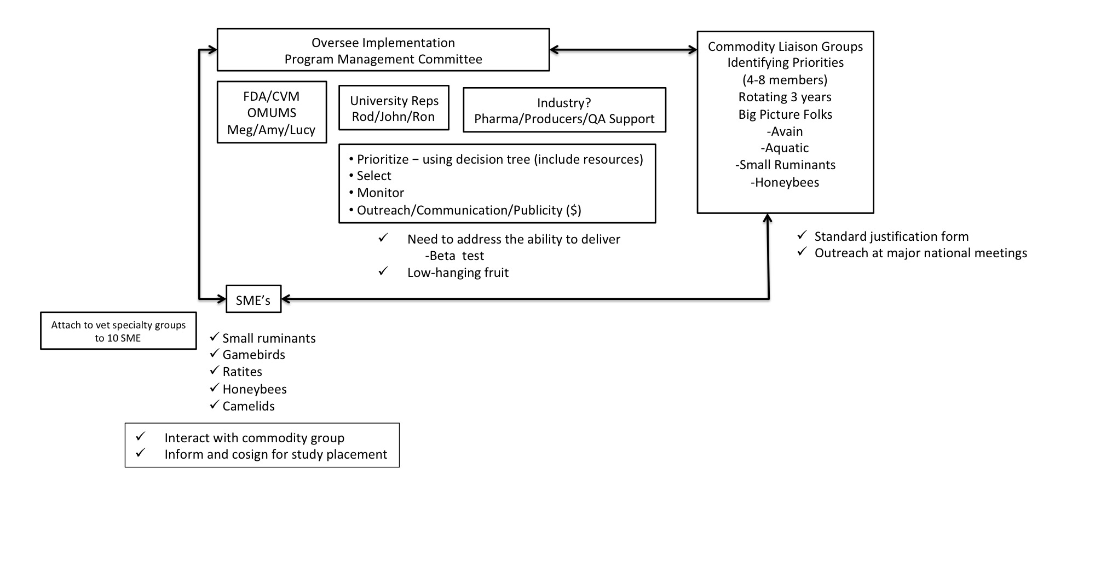

The process of selecting drug candidates was discussed in connection with the previous format of drug prioritization by the Program. It was concluded that more stakeholder involvement is necessary and that stakeholders should be well informed as to the progress and timelines of an FDA/CVM drug approval. Every effort should be made to keep stakeholders involved during the complete process.
Flow Chart Outlining The Process For Selection Of Drugs For Testing In The Minor Use Animal Drug Program

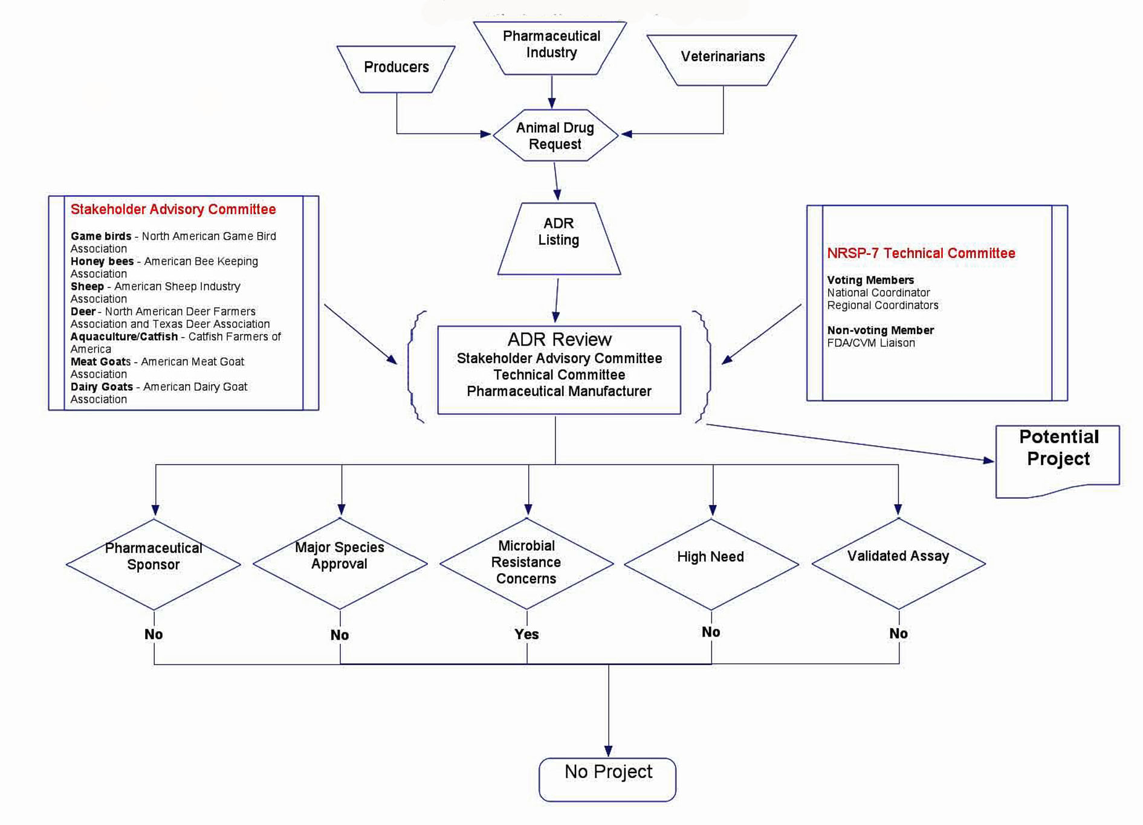
- During the spring annual meeting, the NRSP-7 Technical Committee and representatives of the Stakeholder Advisory Committee (SAC) review the current projects and consider new ADR for funding. Each newly received ADR is then evaluated by the Technical Committee and SAC according to established criteria that include (1) availability of a pharmaceutical manufacturing sponsor, (2) major species approval, (3) microbial resistance concerns, (4) significance to the animal industry, (5) cost of developing the necessary data, and (6) food safety implications. ADR requests that meet these criteria are considered as potential projects.
- Specific regional coordinators are assigned follow-up of all potential projects generally decided by regional expertise. Further concerns regarding the potential project are then addressed including: (1) the identification of researchers and research facilities, (2) development of FDA/CVM approved protocols with reasonable numbers of animals, and (3) scheduling. Monthly conference calls of regional coordinators, administrative advisors, FDA/CVM and USDA/CSREES liaisons provide continued follow-up of potential project progress.
- Regional Coordinators determine: (1) what kind and how much work has been done on the compounds selected for study, (2) the approval requirements, (3) data collection capabilities available at the leader laboratory and at other laboratories in the region, (4) level of funding required, (5) whether a proper field research program is underway that will provide samples for analysis, and (6) initiate negotiations for such financial support as may be needed for performance of necessary work at other universities, federal agencies, or private concerns.
Discussion of next annual meeting was proposed to be done by teleconference, with the next teleconference to be scheduled for mid- to late October.

Meeting adjourned at 10 am

