NCDC231 Multi-state group
April 10, 2017 Meeting

Participants
Archie Clutter, Dean of ARD
Troy Sadler, University of Missouri, Re-STEM Center
- Science ed as academic discipline, SSI’s as context for teaching and learning
- Support teachers to develop their own SSI-oriented curriculum around FEW issues
- EPSCOR projects- education modules to feature the water science that is coming from the science-side of the project
Andrew Kinslow, grad student for Troy Sadler
Hannah Scherer, Virginia Tech
- Similar to Hui Hui
- USDA grant- working with rural Virginia county, tying in food safety through inquiry-based methods, helping school revamp their curriculum
- Systems thinking- geoscience ed, what do teachers mean when they say “systems thinking”
Hui Hui Wang
- Engineering design – pollinator unit?
- STEM integration
Julie Brown- UMN
- Culturally responsive teachers
- Water quality, air quality, citizen science projects to connect students to issues in their area
Gillian Roehning- UMN
- Urban students- connecting to where your food comes from
- Issues-based urban ag projects
Todd Campbell- UConn
- Informal science education, AISL project, adult education
- Former science teacher, interested in modeling as an anchoring practices to do other practices
Jenny Dauer-UNL
- DBER focus, improving undergraduate education, SSI and decision making and systems thinking, media literacy, what decision-making frameworks are appropriate from a classroom
- MS and HS teachers with water issues
Kathleen Hunt- Iowa state, new faculty
- Science communication faculty group, falling back on values rather than content knowledge, argumentation background
Christie Li- University of Missouri
- Environment Issue Forums- classroom resource for MS- HS classroom to hold forums on climate change, energy, water. Goal to make participants feel like they have enough info to do something about challenges. How can we support them taking action?
- Low-income families- support camps for ag education, where does our food come from?
Dave Gosslin
- Decision-making and connection to values, interested in behavior change, how do we connect to their value system to get them to change
- Interested in how people work together on science “teams”
Jamie Loizzo UNL ALEC
- Online field trips, Project Based Learning, having undergrads(?) connect with real scientists
Cory Forbes
- WELS2, USDA grant? Groundwater Foundation project- computer-based simulation
- Water in Society undergrad class- DBER
- New minor in CASNR? On FEW issues

INFEWS (from NSF and USDA NIFA)-
Focus on interdisciplinary teams, focus is on the problem rather than a single discipline

Committee Summary and Objectives
Submit grant proposal next fall.
Goals/objectives for the planning committee
- Advance FEW education and outreach efforts
- Serve as a hub for research on FEW education efforts
- Enhance collaboration aroune FEW education and education research in the state of Nebraska and beyond

Cory would like to see a network of individuals across interdisciplinary boundaries; establish institution-specific working groups

Todd: Making note of using terms “science literacy” or “sustainability” come with baggage—these are loaded terms, may consider carefully how we frame this research proposal
We might consider focusing on building skills or knowledge to support the broader aim of feeding 9 billion people as the focus rather than ensuring that students are “scientifically literate”

Jamie: Do we fit into other grants broader impacts or are we leading the grant process and inviting scientists to our grant?

Dave: Working in an interdisciplinary way—these issues focus on more than just science—they involve social ideas, decision making, etc.—Can we use what students bring to the table with these skills and/or content to frame the issue rather than situating it in a strictly science way?

Committee logistics
- Two-year planning period
- Bring together people, write up a proposal, tie in more people to the process
- A question to think about…Where do we bring in people over the long term?
- Five-year project is the first goal?
- Proposal will go out to Ag Experiment Stations for review

Gillian: Playing the long-game. National and international partnerships would help make this group relevant long term and help with bringing funders to the table.

Gillian has connections in Egypt. Cory mentioned that these connections may not be complete after 2 years—but an ongoing thing.

Dave: Institute in Maryland bringing together teams—group will discuss a way forward on a particular issue

Cory: SENCER would be a similar

Today’s meeting-- Looking for a way forward (Output, Outcomes or Projected Impacts, Timeline) to develop the proposal by October 2017.

Relevance of this planning committee
Kathleen: buy in from other scientists working with USDA or Land Grant colleges? Need to participate in a hatch meeting to justify research salary dollars.

Hannah: Knowing this (from Kathleen) is the reason scientists from ag would be interesting in participating

Troy: being a part of this committee planning with members from NE, IA, MN, MO is better than just saying you have this person who wrote you a reference letter saying they would work with you

Dissemination/Advertising of this Committee
NACTA, Network of STEM education Centers, Earth Educators Rendezvous, NAAEE,

Are there other communities and organizations that we want to reach out to? Venues to showcase this committee? Something international?
Gillian: NARST?
Troy: what is the goal of being visible as a committee? Letting others know that work is being done? Recruiting new members? Or is presentation at difference conference meetings good PR to show USDA (A “CV for the committee”, so to speak)

Cory: Yes, both of these things. Next year, recruiting new members would be important, including international collaborators

Todd: Think of 3-4 commitments/goals/objectives and fit in our connections to these objectives

Meeting/Workshop/Conference
Get funding for a mini-conference, funds to pay for travel for additional participants
Think in terms of next year looking to meet again, but bigger

Todd: think of this smaller group as the steering committee and connecting with a larger group every year

Short-term capacity building
What are the expertise we are looking for? What types of people are we looking for (teaching particular courses? Specific scientific expertise?)

Todd:
Potential early stab at commitments/priorities that might initiate collaborative mingling

Goals

Todd’s initial thoughts
Participant Level
- Reposition the pursuit of food, energy, water education in context of pressing localized problems with global significance (Learning as Participation)
- Prioritize efforts that attend to equitable and accessible participation in food, water, energy planning and problem solving (Equity and Accessibility)
Organizational Level
- Negotiate multidisciplinary/multi-state work that has a coherent trajectory in the pursuit of pressing food, water, and energy education and educational research (Coherent Multidisciplinary-Multi-State Trajectory)

Brainstorm in small groups for these goals

Sharing of group’s goals
Dave, Jamie, Christina:
Three priorities? Components of a broader based project?
The committee’s goal would be to advance science education, this is a discussion of how
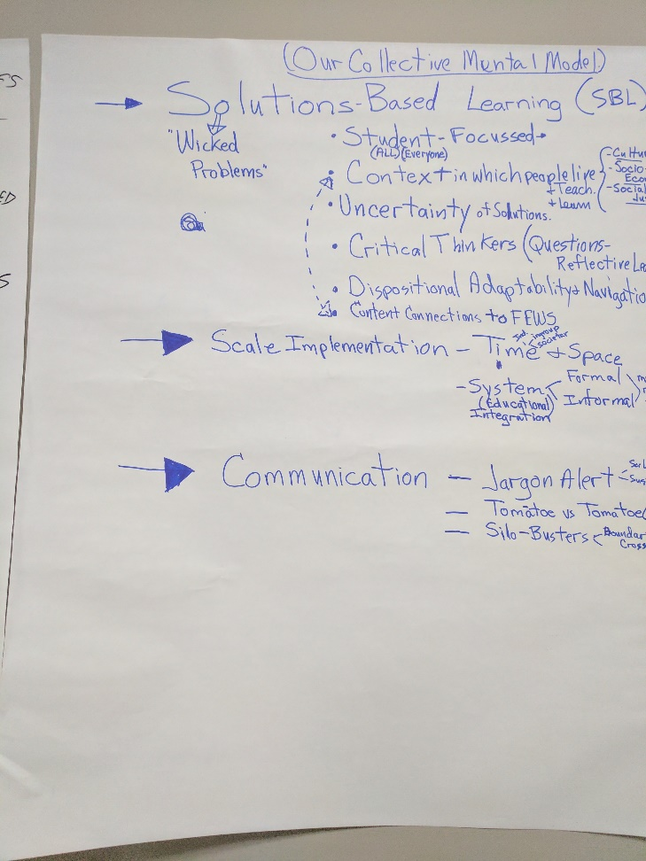
Our goals should be to point out solutions rather than problems
- Solutions-Based Learning
  - Student-focused
    - Context in which people live, teach, learn
  - Critical thinkers
    - Develop questions and reflective in learning
  - Dispositional adaptability and navigation
  - Content connections to FEWS
- Scale implementation
  - Time and Space- How long before our small projects can be scaled up to a larger outcomes? (Is this what is being said?)
  - System (Educational) Integration- Formal or Informal or Other
    - Merging formal and informal education outcomes?
- Communication
  - Jargon alert
  - Tomato vs. Tomato??
  - Train students to be silo-busters (working across interdisciplinary boundaries)

What are the common threads across us?
Commonalities beyond FEW issues?
Synergy that exists?
Outcomes we are interested in? (Ag exposure? Equity?)

Next group: Cory, Erin, Kathleen
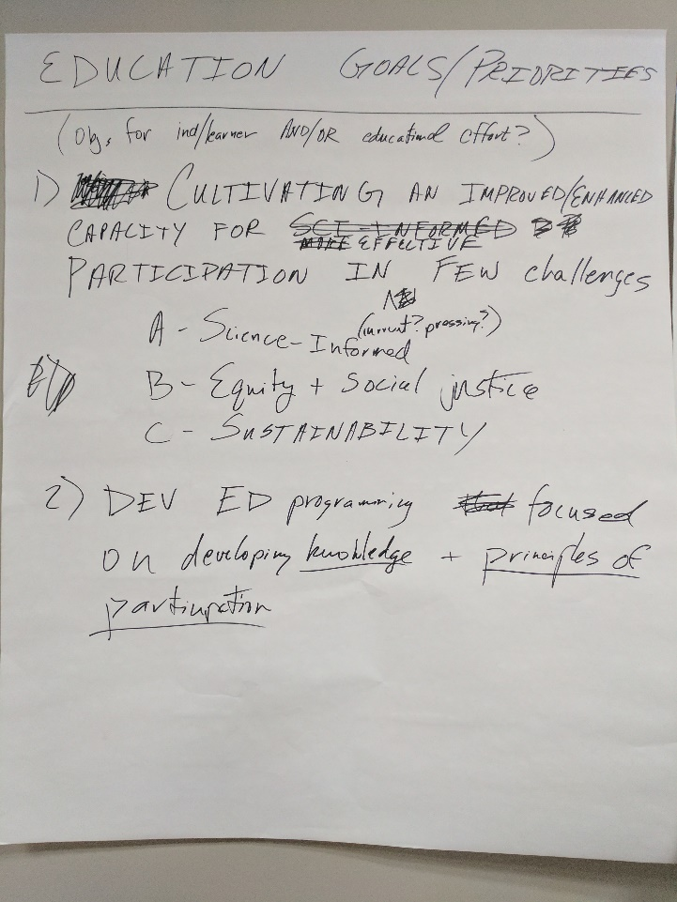

Next group (Gillian, Hannah, Julie, others?): 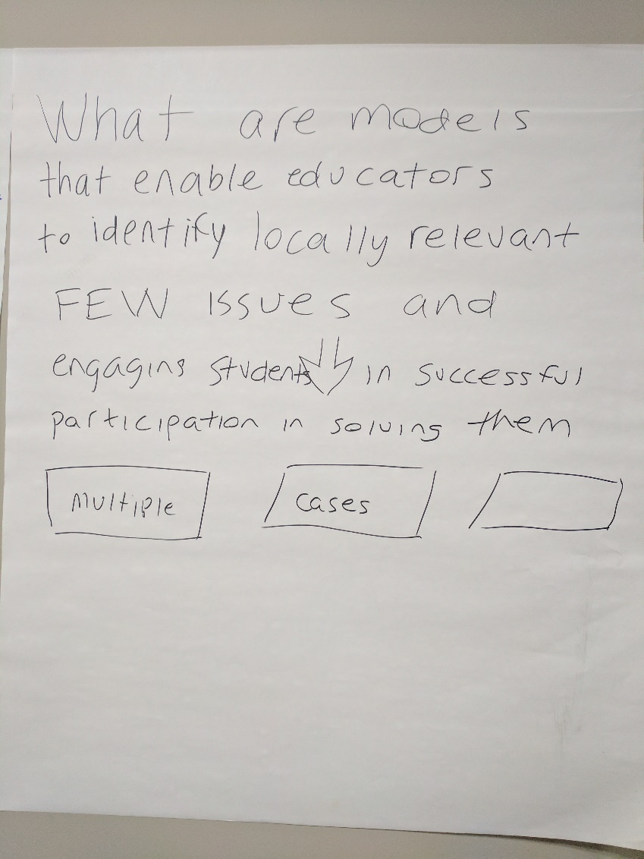
What are models that enable educators to identify locally relevant FEW issues and engaging students in successful participation in solving them?
This can be turned into an empirical question.
We answer this question about models as a group.
Our institutional projects represent multiple cases. Product would be to identify some models that work for teachers to use local situation/issues to engage students in participating in how to solve them?
Identify “levers”

Various models work—what about them is working? At what scale is this working? We want our work to be important in our local areas, but we can also look at what might work at other locations or scales?
Methodologies that are nimble and might be useful in multiple settings?
What are we doing research-wise to contribute to knowledge in the “field”?

If students had certain experiences in FEW education, they would walk away from the experience with a new vision of their world and their place in it?

All our ideas seem to have in common…
All include learners as participants rather than static learners
Ways to think about learning: 1) through participation 2) with equity and accessibility and 3) by building new knowledge

Does teaching things using FEW as a framework—do students learn content, skills, etc. better than using an alternative framework?
FEW provides a context for applying our knowledge and skills. What ideas are useful when solving these problems? What practices are important/necessary to successfully solving _____ problems.

Having a common theoretical framework could be useful? This could also be limiting or scary for researchers.

What does the committee afford us that we can’t do on our own?
Does model X have the outcome of A, B, and C?

What does a model mean?
Model is a loaded term. What are best practices? Might be better
The vocabulary is important here—methods, strategies, “teaching, learning, engagement”
Maybe a next step would be to map out target audiences? Get a sense of language important to everyone?

Dave: FEW Issues—using this as an example of a “Wicked Problem”
Possible strategies to approach FEW issues?
- Citizen science
- Project-Based Learning
- Active Learning

What is a FEW challenge? Does it need to involve food-energy-water? Just one of these?
Engagement with the content as well as with others?
Engagement ladder in public participation literature
Engagement: awareness to behavior change

Our projects are concrete examples of….???
Everyone can send a summary of their program (target audiences, participation

Operationalize term “participation” to decide what qualifies?

Todd: Could we push Equity and Social Justice into the stem of our group’s 1st educational outcome
Not only should our learners consider equity and accessibility when designing solutions but we also need to think about what counts as scientifically-informed methods (farmers experiencing and providing evidence that climate change is happening because they have observed it, change in length of season)

Science within FEW issues—does this mean studying science within a context of being able to be applied to a real-world issue that affects people globally (regardless of whether the content presents food, energy, and water and their connections)???

Next steps,
Follow up – what conferences/venues do we want to be at
Higher education grant proposal—call for participation from group members, due at end of May.
Request some specifics from existing projects

