W1193 Locoweed Regional Project
Locoweed and its fungal endophyte: impact, ecology, and management

Held November 7, 2017, in Las Cruces, NM

Participants/Affiliations:
Daniel Cook – USDA/ARS Poisonous Plant Lab, Logan, UT Daniel.cook@usda.ars.gov.us
Barbara Keith – Dept Land Resources and Environmental Sciences (LRES), Montana State University, bkeith@montana.edu
Christopher Schardl – University of Kentucky, chris.schardl@uky.edu
Tracy Sterling – Dept. LRES, Montana State University, tracy.sterling@montana.edu
Rebecca Creamer – Dept EPPWS, New Mexico State University, creamer@nmsu.edu
Aziza Noor – Molecular Biology, New Mexico State University, anoor@nmsu.edu
Marwa Neyaz – Dept EPPWS, New Mexico State University, marwane@nmsu.edu
Erik Lehnhoff – Dept, EPPWS, New Mexico State University, lehnhoff@nmsu.edu
Yongtao Yu – College of Agriculture, Ningxia University, yongtao@nmsu.edu
Ram Nadathur – Molecular Biology, New Mexico State University, januj88@nmsu.edu

Daniel Cook presented an overview and timeline of research on locoweeds and their associated fungal endophytes, as well as other swainsonine-containing plants and fungi. The swainsonine-containing plants are found in the western USA and China (Astragalus and Oxytropis spp.), Australia (Swainsona), worldwide (Ipomoea- Convulvulaceae), and South America (Sida – Malvaceae). Ipomoea also contain calystegine toxins, which the plant produced. Some Astragalus species in the western USA are toxic due to swainsonine and others due to accumulation of selenium or nitrotoxin. Swainsonine causes disease by inhibiting alpha mannosidase, causing a lysosomal storage disease, and mannosidase II, leading to altered glycoprotein synthesis. He updated the current research efforts with brief reports on publications in 2016 and 2017 including those by Klypina et al (Weed Science), Cook et al. (Chemistry and Biodiversity), (The Rangeland Journal), (Toxicon), (G3), and (Toxicon).

Yongtao Yu, visiting scientist, gave a background of locoweed research in China and presented and update on recent unpublished research. Locoweeds that have caused problems in China include Astragalus variabilis and A. strictus, and Oxytropis ochrocephala, O. kansuensis, O. glabra, and O. glacialis. Data was presented from Guodong Yang and Jianhua Wang showing that when feeding radiolabelled lysine to endophyte, the label goes to pipecolic acid and then to swainsonine. When endophyte was grown on liquid media without nitrogen, mycelia dry weight peaked at least a week before swainsonine levels peaked. Growth of Undifilum oxytropis and swainsonine production was studied in liquid media. A pH of greater than 5.5 was optimal for swainsonine production. Addition of lysine to the media increase swainsonine production, while addition of pipecolic acid inhibited swainsonine production. In recent work, mutants of U. oxytropis were made using various mutagens including UV and EMS. Although the mutants have not been extensively tested, several were very low swainsonine producers.

Aziza Noor, a PhD student working with Rebecca Creamer, discussed her work on the microscopy analysis of the Chaetothyriales fungus associated with Ipomoea carnea. Using confocal and fluorescence microscopy, she showed that the fungus was found on the outside of leaves and stems, but not under the surface of the epidermis. The fungus was visualized in a dense network around trichomes and stomates without penetrating the leaves or stems. The work strongly suggests that the fungus grows solely epiphytic with the plants.

Marwa Neyaz, a MS student working under Rebecca Creamer, presented her molecular characterization of locoweed species and varieties. She used three primer sets to variable regions with the chloroplast and ITS primers to differentiating among species and varieties of Astragalus mollissimus and Astragalus lentiginosus. Nontoxic varieties clustered with other nontoxic varieties or those with low levels of toxicity. Also varieties from the same region clustered together. The toolset developed can be helpful with identification of locoweeds and predictive relationships among the plants.

Tracey Sterling and Barb Keith presented a update of locoweed work at Montana State University. The role of the fungal endophyte on various locoweed (Astragalus mollissimus var. mollissimus and Oxytropis sericea) plant growth parameters was measured in the common garden established in 2011 and located at the Montana Ag Experiment Station’s Post Farm near Bozeman MT. These growth parameters included evaluation of plant survival over winter, gas exchange of carbon assimilation and transpiration, flower and seed numbers to determine fecundity, and seed germination rates of those collected. There is not an endophyte effect for plant survival although there is a species survival difference with fifty percent of O. sericea plants surviving 3-years, regardless of endophyte status and no A. mollissimus plants surviving beyond 2-years. No A. mollissimus plants were alive in the spring of 2017 and no new plants were established. There is not an endophyte effect in plant photosynthesis or stomatal conductance in either of the locoweed species, however, there is a year effect for transpiration with O. sericea E+ plants showing a statistical higher rate of transpiration, but only for one of the 5 years analyzed. For both A. mollissimus and O. sericea, presence of the endophyte does not affect fecundity. Data analysis was averaged across age of plant. We are currently investigating whether is there is an age-related endophyte effect for these parameters.

A legacy study was initiated in the garden by establishing O. sericea seedlings to evaluate the effect of previous endophyte exposure on the physiological responses of plants with and without the endophyte to determine if epigenetics are playing a role in plant response to the endophyte. Seeds were collected from 20, 1-year-old plants in 2014 (10 E+ and 10 E-) (Fig. 1); from these, five seedlings from each were established in Fall 2015. There is no difference in survival rates between E+ and E- plants after two winters. Similarly there was not a detectable difference in gas exchange or fecundity between E+ and E- plants after two winters. Twenty-one percent more E- plants set seeds after the first over-wintering; however this discrepancy was not seen after the second over-wintering with 88% and 86% E- and E+ plants, respectively, setting seed.

To establish a second generation of plants free from the fungal endophyte, seeds from two plants from 5 E- and 5 E+ families were collected, germinated in the greenhouse and transplanted to the garden during spring 2017 (Fig. 1). Again, there is no detectable difference in gas exchange between E+ and E- plants 2 months post transplanting.
The common garden study thus far has shown there is no apparent cost or benefit of the fungal endophyte on plant success for field-grown +/- E plants.

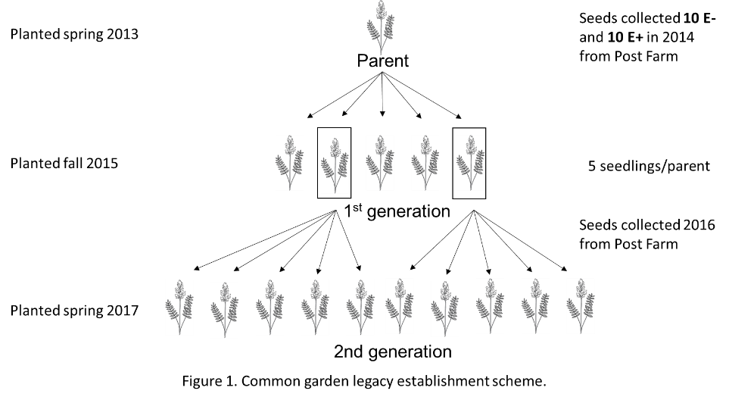

Aziza Noor presented a talk on her research comparing the nucleotide sequence of the ketide synthase important in swainsonine biosynthesis (KS-SWA) among swainsonine-producing fungi. She found that it worked well to separate phylogenetic groups of fungi from a particular host, Alternaria fulva from A. cinerea. It also separated out the endophytes from Swainsona. Interestingly it grouped A. bornmuelleri and A. gansuense together, which are both phytopathogens that produce very low levels of swainsonine. The groupings of fungi were similar to clades produced from ITS primers. The variability within KS-SWA protein sequence was very low, which could be expected from this coding region.

Rebecca Creamer presented a project from a student in the Bridge program on isolation of fungi loosely associated with Oxytropis sericea plants with and without endophyte grown in a common garden in Utah. A minimal surface sterilization of 30 sec was done prior to isolation. The resulting fungi were identified using ITS sequence. Results showed many Alternaria species associated with the leaves of E+ plants, with a predominance of A. alternata, a known phytopathogen, although no disease symptoms were seen. E+ stems yielded both A. oxytropis and A. alternata. These results suggest a possible mutualist role to suppress pathogens for the endophyte via niche colonization.

The group discussed cooperative research projects and resources that could be shared among the group. Daniel Cook and Rebecca Creamer will continue to collaborate on endophytes associated with Swainsona sp and with endophytes associated with the Astragalus pubentissimus/pardilinus group. Chris Schardl and Rebecca Creamer will cooperate on a prospective grant for a large cooperative project with Chinese collaborators further addressing seed-transmitted endophytic fungi.

Suggested topics for research were microscopic analysis of germinating seeds of Astragalus and Ipomoea, identification of an endophyte within Sida, looking at multiple stresses and fire on antagonistic interactions, comparing the microbiome of field-grown plants, and conducting a total mineral analysis of field-grown plants.

Accomplishments and Impacts:

The entire group met, discussed the current status of locoweeds, locoism and fungal endophytes. A subset of the group worked together on cooperative research. Several papers will be written from the collaborative work. The subset set priorities for collaborative research for the coming year.

A collaborative group of Daniel Cook, Chris Schardl, and Rebecca Creamer published a paper identifying PKS as the key enzymes in the swainsonine biosynthetic pathway. Chris Schardl and Rebecca Creamer released the new name of the swainsonine-producing fungus, Slafractonia leguminicola. Rebecca Creamer’s students worked with Daniel Cook on microscopy of in vivo and in vitro growth of Alternaria oxytropis, A. fulva, and A. cinerea. That work is accepted for publication/in press. They also worked on Chaetothyriales-producing fungus from Ipomoea carnea. That work is being written for publication. They also collaborated on work to compare the KS-Swa from different swainsonine-producing fungi. That work is being written for publication. Rebecca Creamer’s student also collaborated with Daniel Cook on a phylogenetic comparison of Astragalus mollissimus and A. lentiginosus varieties. That work is being written for publication.

Publications: No group publications. However, publications on the topic by collaborations and by members during 2017 are listed below.

Alhawatema, M., Sayed, Cook, D., Creamer, R. 2107. RNAi-mediated down regulation of a melanin polyketide synthase (pks 1) gene in the fungus Slafractonia leguminicola. World J. Microbiol. Biotech. 33:179.

Cook, D., Donzelli, B.G.G., Creamer, R., Baucom, D. L., Gardner, D.R., Pan, J., Moore, N., Krasnoff, S.B., Jaromczyk, J.W., Schardl, C.L. 2017. Swainsonine biosynthesis genes in diverse symbiotic and pathogenic fungi. G3:Genes, Genomes,Genetics 7:1791-1797.

Cook, D., Gardner, D.R., Martinez, A., Robles, C.A., Pfister, J.A. 2017. Screening for swainsonine among south American Astragalus species. Toxicon 139: 54

Cook, D., Gardner, D.R., Welch, K.D., Allen, J.G. 2017. A survey of swainsonine content in Swainsona species. The Rangeland Journal 39:213-218.

Lu, H., Quan, H., Zhou, Q., Ren, Zhenhui, Xue, R., Zhao, B., Creamer, R. 2017. Endogenous fungi isolated from three locoweed species from rangeland in western China. Afr. J. Microbiol. Res. 11:155-170.

