WERA-027 Technical Meeting Minutes
January 29th, 2020

Attendance

Name | Organization | Email
Caroline Gray | Colorado State University | caroline.gray@colostate.edu
David Holm | Colorado State University | david.holm@colostate.edu
Tom Drader | Lamb Weston | thomas.drader@lambweston.com
Tom Salaiz | McCain Foods | thomas.salaiz@mccain.com
Brian Charlton | Oregon State University | Brian.A.Charlton@oregonstate.edu
Clint Shock | Oregon State University | clinton.shock@gmail.com
Nichole Baley | Oregon State University | Nichole.Baley@oregonstate.edu
Solomom Yilma | Oregon State University | solomom.yilma@oregonstate.edu
Stan Li | Oregon State University | tianxiao.li@oregonstate.edu
Jeanne Debons | PVMI | jeannedebons@msn.com
Tina Brandt | Simplot | Tina.Brandt@simplot.com
Fahrettin Goktepe | SunRain | fgoktepe@sunrainvarieties.com
Chelsey Lowder | University of Idaho | chelseyl@uidaho.edu
Mark McGuire | University of Idaho | mmcguire@uidaho.edu
Mike Thornton | University of Idaho | Miket@uidaho.edu
Ransey Portenier | University of Idaho | ranseyp@uidaho.edu
Brian Schneider | USDA-ARS | brian.schneider@usda.gov
Jonathan Whitworth | USDA-ARS | jonathan.whitowrth@usda.gov
Rich Novy | USDA-ARS | rich.novy@usda.gov
Roy Navarre | USDA-ARS | roy.navarre@usda.gov
Chandler Dolezal | WSU | chandler.dolezal@lambweston.com
Francisco Gonzalez | WSU | francisco.gonzalez@wsu.edu
Mark Pavek | WSU | mjpavek@wsu.edu
Rick Knowles | WSU | rknowles@wsu.edu
Zach Holden | WSU | zholden@wsu.edu
Alejandro Cruz | Lamb Weston | alejandro.cruz@lambweston.com
Max Feldman | USDA-ARS Prosser, WA | max.feldman@usda.gov
Joe Townsend | WSU | joe.townsend@wsu.edu
Jolyn Rasmussen | Simplot | jolyn.rasmussen@simplot.com
Andre Gagnon | Progest 2001 | andre.gagnon@progest.com
Rhett Spear | University of Idaho | rhetts@uidaho.edu
Moises Aguilar | Oregon State University | moises.aguilar@oregonstate.edu

ANNUAL MEETING MINUTES SUMMARY
Chair Francisco Gonzalez (WSU) called the meeting to order at 12:08 PM.
Remembrance of Dr. Creighton Miller was given by Jeff Koym.
Introductions were given by each person during the Tri-State meeting and the attendance form was passed around.
AGENDA
A motion to approve the agenda was brought up by David Holm (CSU) and seconded by Mark Pavek (WSU); approved by a unanimous vote.
MINUTES
A motion to approve the minutes was brought up by Jeanne Debons (PVMI); second by Mike Thornton (UI) was approved by unanimous vote.
MEETING
State Reports
2020 Tri-State/WERA 27 Technical Committee Meetings – Idaho Report

Summary of accomplishments:
Over 110,000 Aberdeen-generated seedling tubers and approximately 20,000 seedling tubers obtained from other state breeding program were planted on 28 acres for first field generation selection at Aberdeen, as well as an additional 1,800 second-field year (12-hill) selections. Seven agronomic trials of Aberdeen breeding clones and the National Fry Processing Trial were planted at Aberdeen and Kimberly, as well as disease screening trials for early blight, common scab, and PVY/PLRV. In addition, the Tri-State Specialty Trials were conducted at Parma and Aberdeen.

Tri-State and Western Regional Trial Results
In 2019, 15 entries from the Aberdeen program were entered in advanced agronomic and processing trials in the Tri-State and Western Regional to assess their performance relative to industry standards. We had 8 russet clones in the Western Regional Trials, 7 russet clones in the early season Tri-State Variety Trials, and 7 in the late-season Tri-State Variety Trials.
Russet Trial Results: The highest yielding clones in the Aberdeen Early Tri-State Trial were A10595-13sto, AOR10204-3, A11194-1, and COA11013-2, however, A10595-13sto, AOR10204-3, and COA11013-2 were the only clones that produced higher total yields U.S. No. 1 yields than all standard varieties (Table 1). Specific gravities for these clones were comparable to Ranger Russet, Russet Burbank and Russet Norkotah, with the exception of A10007-3, which was relatively low. Merit scores were highest for A09022-4, A10007-3, A11194-1, AOR08540-1, and COA11013-2. Hollow heart incidence was low for all clones with the exception of AOR8540-1 and COA11013-2 with 17.5% and 15% respectively.
In the Late Tri-State Russet Trial, the top-yielding clones were AOR10204-3, AOR08540-1, A10595-13sto, and COA11013-2 all of which produced higher total and US No. 1 yields than the standard cultivars with the exception of AOR08540-1having a lower US No. 1 yield than Russet Burbank and Ranger Russet (Table 2). Specific gravities were comparable to Russet Burbank, Ranger Russet, and Russet Norkotah with A10007-3 and AOR10204-3 having specific gravities similar to Russet Norkotah. Merit scores were highest for A09022-4, A10007-3, A11194-1, AOR08540-1, and COA11013-2. Fry colors after 3 months of storage at 45ºF were generally acceptable (USDA 1 and 2) for all clones except AOR08540-1 and Russet Norkotah. Hollow heart incidence was low for all clones.
Table 1. Yield and quality characteristics of four standard russet potato cultivars and eight breeding lines grown in Early Tri-State Russet Trial at Aberdeen, ID during 2019. ¹
Cultivar/Breeding line | Total Yield | No. 1 Yield | % >10oz | Specific Gravity | Merit | Maturity | Hollow Heart (%)
Ranger Russet | 345 | 285 | 28 | 1.080 | 2.9 | 4.0 | 0.0
Russet Burbank | 360 | 262 | 17 | 1.077 | 2.5 | 3.5 | 0.0
Russet Norkotah | 267 | 210 | 17 | 1.072 | 3.4 | 2.0 | 0.0
Shepody | 272 | 214 | 36 | 1.071 | 2.1 | 4.1 | 0.0
A09022-4 | 332 | 259 | 21 | 1.081 | 3.3 | 4.1 | 0.0
A10007-3 | 306 | 283 | 60 | 1.068 | 3.5 | 4.4 | 0.0
A10595-13sto | 374 | 316 | 47 | 1.080 | 2.8 | 3.6 | 0.0
A11194-1 | 347 | 260 | 14 | 1.077 | 3.3 | 3.6 | 0.0
AOR08540-1 | 338 | 267 | 33 | 1.077 | 3.4 | 4.5 | 17.5
AOR10204-3 | 386 | 327 | 39 | 1.070 | 2.8 | 4.0 | 0.0
AOR11217-3 | 277 | 209 | 27 | 1.077 | 2.9 | 4.5 | 0.0
COA11013-2 | 363 | 299 | 23 | 1.078 | 3.6 | 3.9 | 15.0

¹ Yields are reported in cwt/A. Merit score is based on appearance characteristics and rated on a 1-5 scale, where 5 = exceptionally good. Maturity is rated 1-5, where 5 = very late. Hollow heart (HH) is reported as the percentage of 10 tubers greater than 10 ounces showing the defect. Early harvest is approximately 129 days after planting.

Table 2. Yield and quality characteristics of three standard russet potato cultivars and eight breeding lines grown in Late Tri-State Russet Trial at Aberdeen, ID during 2019. ¹
Cultivar/Breeding line | Total Yield | No. 1 Yield | % >10oz | Specific Gravity | Merit | Maturity | Hollow Heart (%) | Fry Color²
Ranger Russet | 505 | 408 | 47 | 1.084 | 2.5 | 3.1 | 0.0 | 1.2
Russet Burbank | 478 | 386 | 29 | 1.081 | 2.9 | 2.3 | 0.0 | 1.9
Russet Norkotah | 300 | 238 | 22 | 1.073 | 3.6 | 1.0 | 2.5 | 2.7
A09022-4 | 420 | 342 | 38 | 1.084 | 3.4 | 2.8 | 0.0 | 0.4
A10007-3 | 443 | 395 | 69 | 1.073 | 3.5 | 3.0 | 0.0 | 2.1
A10595-13sto | 521 | 438 | 56 | 1.081 | 2.9 | 2.1 | 0.0 | 0.7
A11194-1 | 456 | 338 | 28 | 1.085 | 3.3 | 2.4 | 0.0 | 1.9
AOR08540-1 | 511 | 378 | 54 | 1.085 | 3.8 | 3.0 | 0.0 | 3.2
AOR10204-3 | 561 | 470 | 54 | 1.077 | 2.5 | 3.1 | 0.0 | 2.1
AOR11217-3 | 480 | 398 | 45 | 1.087 | 3.0 | 2.3 | 0.0 | 0.9
COA11013-2 | 529 | 452 | 30 | 1.082 | 4.0 | 2.5 | 0.0 | 0.6
¹ Yields are reported in cwt/A. Merit score is based on appearance characteristics and rated on a 1-5 scale, where 5 = exceptionally good. Maturity is rated 1-5, where 5 = very late. Hollow heart (HH) is reported as the percentage of 10 tubers greater than 10 ounces showing the defect. Late harvest is approximately 148 days after planting.
²Fry samples stored at 45ºF for approximately 2 months. Color determined using USDA color chart 00-4 with lower number lighter fry color.

In the Late Western Regional Trial at Aberdeen, the top-yielding clones were A07061-6, A071012-4BF, AO02183-2, and OR12133-10 (Table 3), all of which met or exceeded the total and U.S. No. 1 yields of the standard cultivars. Additionally, A07769-4 and A08433-4VR met or exceeded U.S. No. 1 yields of the standard cultivars. Specific gravities for all clones were higher than Russet Burbank, with A071012-4BF, A08433-4VR, AOR07781-5, and AO02183-2 higher than Ranger Russet. The incidence of hollow heart for all clones was relatively low. Fry colors following 3 months at 45 ºF were generally acceptable.

A07061-6, A071012-4BF, A07769-4, A08433-4VR, AO02183-2, OR12133-10, and POR12NCK50-1 produced greater total and U.S. No. 1 yields than the standard cultivars in the Late Western Regional Trial at Kimberly. (Table 4). Specific gravities for the highest yielding clones were all higher than Russet Burbank except for A07061-6 which was similar to Russet Norkotah. Merit scores at Kimberly were highest for CO09205-2RU, A07769-4, AO02183-2, POR12NCK50-1, and CO100187-4RU. All clones had acceptably light fry colors after 3 months of storage. No hollow heart was seen with the exception of CO10087-4RU, AO02183-2, and CO09076-3RU with 10%, 7.5%, and 5% respectively.

Table 3. Yield and quality characteristics of three standard russet potato cultivars and thirteen breeding lines grown in Late Western Regional Russet Trial at Aberdeen, ID during 2019. ¹
Cultivar/Breeding line | Total Yield | No. 1 Yield | % >10oz | Specific Gravity | Merit | Maturity | Hollow Heart (%) | Fry Color²
Ranger Russet | 487 | 339 | 41 | 1.090 | 2.4 | 3.1 | 0.0 | 0.7
Russet Burbank | 422 | 298 | 21 | 1.077 | 2.0 | 2.4 | 0.0 | 1.4
Russet Norkotah | 249 | 184 | 15 | 1.068 | 2.8 | 1.0 | 0.0 | 1.6
A07061-6 | 533 | 415 | 28 | 1.083 | 2.8 | 2.5 | 0.0 | 0.6
A071012-4BF | 510 | 387 | 48 | 1.097 | 2.4 | 3.0 | 0.0 | 0.7
A07769-4 | 449 | 391 | 56 | 1.086 | 3.9 | 3.3 | 2.5 | 0.4
A08422-4VRsto | 342 | 316 | 32 | 1.092 | 2.4 | 1.9 | 0.0 | 1.8
A08433-4VR | 446 | 339 | 43 | 1.083 | 2.0 | 3.4 | 0.0 | 0.6
A10021-5TE | 405 | 320 | 36 | 1.089 | 3.1 | 2.6 | 0.0 | 0.6
AO02183-2 | 487 | 411 | 23 | 1.093 | 3.8 | 3.0 | 0.0 | 0.3
AOR07781-5 | 355 | 269 | 28 | 1.091 | 2.1 | 2.3 | 2.5 | 0.4
CO09205-2RU | 383 | 285 | 9 | 1.078 | 3.4 | 2.4 | 0.0 | 0.5
CO10087-4RU | 246 | 160 | 1 | 1.089 | 2.5 | 1.0 | 0.0 | 0.6
COTX05095-2Ru/Y | 361 | 263 | 18 | 1.080 | 2.8 | 1.0 | 0.0 | 0.9
OR12133-10 | 537 | 447 | 28 | 1.088 | 3.4 | 2.8 | 0.0 | 0.6
POR12NCK50-1 | 391 | 317 | 27 | 1.088 | 2.9 | 2.5 | 0.0 | 0.9
¹ Yields are reported in cwt/A. Merit score is based on appearance characteristics and rated on a 1-5 scale, where 5 = exceptionally good. Maturity is rated 1-5, where 5 = very late. Hollow heart (HH) is reported as the percentage of 10 tubers greater than 10 ounces showing the defect.
Late harvest is approximately 146 days after planting.
² Fry samples stored at 45ºF for approximately 2 months. Color determined using USDA color chart 00-4 with lower number lighter fry color.

Table 4. Yield and quality characteristics of three standard russet potato cultivars and fifteen breeding lines grown in Late Western Regional Russet Trial at Kimberly, ID during 2019.
Cultivar/Breeding line | Total Yield | No. 1 Yield | % >10oz | Specific Gravity | Merit | Hollow Heart (%) | Fry Color²
Ranger Russet | 562 | 392 | 45 | 1.092 | 2.4 | 0.0 | 0.6
Russet Burbank | 570 | 345 | 33 | 1.086 | 1.8 | 0.0 | 1.1
Russet Norkotah | 430 | 321 | 27 | 1.073 | 2.8 | 0.0 | 0.8
A07061-6 | 725 | 552 | 46 | 1.078 | 2.8 | 0.0 | 1.2
A071012-4BF | 691 | 545 | 53 | 1.098 | 2.1 | 0.0 | 1.0
A07769-4 | 568 | 470 | 54 | 1.084 | 3.4 | 0.0 | 0.5
A08422-4VRsto | 485 | 402 | 39 | 1.087 | 2.6 | 0.0 | 1.3
A08433-4VR | 656 | 428 | 37 | 1.085 | 2.0 | 0.0 | 1.5
A10021-5TE | 509 | 384 | 35 | 1.095 | 2.8 | 0.0 | 0.6
AO02183-2 | 767 | 615 | 53 | 1.090 | 3.0 | 7.5 | 0.8
AOR07781-5 | 510 | 387 | 44 | 1.095 | 2.4 | 0.0 | 0.5
CO09076-3RU | 402 | 251 | 22 | 1.090 | 2.0 | 5.0 | 1.7
CO09205-2RU | 515 | 395 | 22 | 1.076 | 3.6 | 0.0 | 1.0
CO10087-4RU | 376 | 291 | 13 | 1.100 | 3.0 | 10.0 | 0.8
CO10091-1RU | 298 | 188 | 4 | 1.086 | 2.1 | 0.0 | 0.7
COTX05095-2Ru/Y | 507 | 371 | 20 | 1.082 | 2.3 | 0.0 | 0.7
OR12133-10 | 864 | 658 | 44 | 1.093 | 2.3 | 0.0 | 1.2
POR12NCK50-1 | 583 | 496 | 47 | 1.090 | 3.0 | 0.0 | 0.8
¹ Yields are reported in cwt/A. Merit score is based on appearance characteristics and rated on a 1-5 scale, where 5 = exceptionally good. Hollow heart (HH) is reported as the percentage of 10 tubers greater than 10 ounces showing the defect.
Late harvest is approximately 159 days after planting.
² Fry samples stored at 45ºF for approximately 2 months. Color determined using USDA color chart 00-4 with lower number lighter fry color.

National Fry Processing Trial: A total of seventeen breeding clones and varieties from our program were also entries in the 2019 National Fry Processing Trial (NFPT) which seeks to identify processing varieties having acceptable agronomic characteristics and low acrylamide that could be rapidly adopted by the U.S. potato processing industry. Two of the seventeen entries were entered into the Tier 2 category, one in Tier 3, with the remaining 14 entries entered into Tier 1. Following discussion and final recommendations of the NFPT Steering Committee, those 2019 entries found acceptable for trialing in 2020 will be advanced to Tiers 2 and 3, with additional new entries identified for Tier 1 evaluations in 2020. In addition, the breeding program is progressing in developing germplasm with genetic resistance to PVY, PVX, and PLRV, PMTV, late blight (foliar and tuber), nematodes, corky ringspot, and zebra chip disease—for example, several entries in the NFPT in 2019 exhibited extreme resistance to PVY. New varieties will continue to be released in cooperation with the University of Idaho Nuclear Seed Program, private seed growers in the state, and the processing and fresh pack industries.

Agronomic Research Trials: Additional studies were conducted in 2019 designed to compare nitrogen use efficiency of 6 advanced selections from the breeding program with that of Russet Burbank. The efficiency of N fertilizer use for these new clones is substantially greater than standard varieties, ranging from 10-25% better than Russet Burbank. Reducing fertilizer applications per unit of yield produced would provide a considerable economic benefit to growers and would also contribute significantly to the sustainability of potato production systems. Additional studies were conducted to determine optimal seed management practices, seed piece spacing, and nitrogen management guidelines for new and previously released Tri-State varieties. Phosphorus requirements of most of the new varieties were similar to or lower than those for Russet Burbank and Ranger Russet.

Selecting Specialty Potato Varieties

Accomplishments:
Promising specialty breeding lines from the Pacific Northwest Potato Variety Development Program were evaluated in two locations. These same lines were also evaluated for dormancy length and chemical composition.

Results:
Objective 1- Identify and completely evaluate within Idaho growing areas tri-state potato germplasm with specialty characteristics.

Field Evaluations - Seed of two standard potato cultivars and 4 breeding lines were obtained from Brian Charlton (OSU, Klamath Falls) and Rich Novy (ARS, Aberdeen). There was not enough seed of COA13039-4Y to include at all locations, so it was not planted at Aberdeen. The seed was cut, organized into a randomized, four-replicate trial, and planted at the Aberdeen and Parma R & E Centers in late April to early May.

Growing conditions were cold and wet during the early part of the season, which delayed plant development and reduced yields in comparison to previous trials. Chieftain reached a total yield of 502 cwt/acre at Parma. A081229-RY was the only breeding line above 500 cwt/acre, while A08122-12R was the third-highest yielding entry. (Table 1). These same lines were also among the highest-yielding selections at Aberdeen (Table 2). Chieftain and Yukon Gold had a high proportion of tubers over 10 oz at both locations, indicating that they may reach optimum tuber size earlier than most other entries due to relatively low tuber set. The premium yield category (2-6oz) is an attempt to capture the perceived optimum size of specialty tubers for fresh market. A08122-12R and A081229-RY both tended to produce high premium yields at both locations (Tables 1 and 2).

Specific gravity ranged from 1.071 to 1.086 at Parma, and from 1.072 to 1.086 in Aberdeen (Tables 1 and 2). Yukon Gold had the highest specific gravity at both locations, while COA13039-4Y had the highest specific gravity of the breeding lines. Specific gravity greatly affects cooking quality, and this information should be used with the culinary evaluations reported in the WSU cultivar report to make decisions about appropriate uses for these new potential varieties.

Most of the entries showed very few external and internal defects. The exceptions were growth cracks in NDA8512C-1R and common scab in Yukon Gold at both Parma and Aberdeen (Tables 1 and 2). The growth cracks were not prevalent enough at Parma to detract from overall appearance, but they were a factor in appearance at Aberdeen.

Merit score is a combined evaluation of yield, tuber size distribution, tuber shape uniformity, and appearance. A08122-12R and A081229-RY had the highest merit scores at both locations (Tables 1 and 2).

Table 1. Yield and quality characteristics of two standard specialty potato cultivars and three breeding lines grown in Parma, ID during 2019. ¹
 | Total Yield | No. 1 Yield | Premium Yield  (2-6oz) | Yield  0-2 oz | Yield  >10 oz | Specific Gravity | Skin app | Maturity | Scab | Hollow Heart (%) | Growth Crack | Merit
Cultivar/Breeding Line
Chieftain | 502 | 478 | 175 | 12 | 122 | 1.072 | 2.0 | 3.3 | 4.3 | 0.0 | 4.8 | 2.5
A08122-12R | 491 | 394 | 349 | 92 | 5 | 1.074 | 4.0 | 2.3 | 4.3 | 0.0 | 5.0 | 4.0
NDA8512C-1R | 407 | 377 | 181 | 22 | 43 | 1.071 | 3.0 | 2.8 | 4.5 | 0.0 | 3.8 | 3.0
A081229-RY | 528 | 512 | 386 | 90 | 7 | 1.076 | 2.0 | 4.0 | 4.7 | 0.0 | 5.0 | 3.5
Yukon Gold | 434 | 408 | 164 | 15 | 75 | 1.086 | 3.0 | 2.6 | 3.0 | 0.0 | 5.0 | 3.0
COA13039-4Y | 336 | 261 | 238 | 61 | 6 | 1.083 | 4.0 | 2.4 | 4.5 | 0.0 | 5.0 | 2.0
¹ Yields are reported in cwt/A. Merit score is based on appearance, yield, uniformity, and defects and rated on a 1-5 scale, where 5 = exceptionally good. Maturity is rated 1-5, where 5 = very late. Scab, growth cracks (GC), and second-growth (Knobs) are rated 1-5, where 5 = none. Hollow heart (HH) is reported as the percentage of 10 tubers showing the defect.

Table 2. Yield and quality characteristics of two standard specialty potato cultivars and three breeding lines grown in Aberdeen, ID during 2019. ¹
Cultivar/Breeding line | Total Yield | No. 1 Yield | Premium Yield. (2-6oz) | Yield  0-2 oz | Yield  > 10 oz | Specific Gravity | Skin app | Maturity | Scab | Hollow Heart (%) | Growth Crack | Merit
Chieftain | 398 | 381 | 97 | 15 | 114 | 1.075 | 3.4 | 3.8 | 4.9 | 0.0 | 4.9 | 3.0
A08122-12R | 331 | 240 | 218 | 90 | 0 | 1.072 | 3.7 | 3.3 | 4.8 | 0.0 | 4.8 | 3.8
NDA8512C-1R | 245 | 203 | 107 | 10 | 12 | 1.076 | 4.4 | 2.6 | 4.9 | 0.0 | 3.5 | 1.9
A081229-RY | 325 | 245 | 235 | 79 | 0 | 1.077 | 3.8 | 3.5 | 4.5 | 0.0 | 5.0 | 4.0
Yukon Gold | 266 | 255 | 92 | 7 | 64 | 1.086 | 3.6 | 3.5 | 3.4 | 0.0 | 5.0 | 3.1
¹ Yields are reported in cwt/A. Merit score is based on appearance, yield, uniformity, and defects and rated on a 1-5 scale, where 5 = exceptionally good. Maturity is rated 1-5, where 5 = very late. Scab, growth cracks (GC), and second-growth (Knobs) are rated 1-5, where 5 = none. Hollow heart (HH) is reported as the percentage of 10 tubers showing the defect.

Biochemical Assessments- The cultivars and breeding lines showed a range of biochemical characteristics, such as solids, antioxidant levels, glycoalkaloids, and Vitamin C content (Table 3). None of the glycoalkaloid levels were high enough to cause concern, while NDA8512C-1R was noteworthy for high antioxidant content.

Table 3. Biochemical characteristics of two standard specialty potato cultivars and three breeding lines grown in Aberdeen, ID during 2018.
Cultivar | Solids Oven Dry (%) | Antioxidants  (ug/g FW) ² | Vitamin C (mg/100 g FW) | Glycoalkaloids (mg/100 g FW)
Chieftain | 19.3 | 472 | 28 | 4.8
A08122-12R | 21.2 | 427 | 34 | 1.5
NDA8512C-1R | 19.2 | 519 | 27 | 2.1
A081229-RY | 19.7 | 428 | 29 | 4.7
Yukon Gold | 21.0 | 493 | 30 | 5.6
² Higher numbers for antioxidant capacity indicate potentially greater health benefits.

Storage Evaluations- Skin color and appearance were rated on samples from the Parma trial after approximately 90 days storage at 45ºF. Most entries had moderate skin appearance, with lower ratings being associated with russeting, black scurf and enlarged lenticels (Table 4). Dormancy length varied from 80 to 122 days at 45ºF, with breeding line COA13039-4Y notable for very short dormancy compared to the other entries.

Table 4. Appearance ratings and dormancy length for two standard specialty potato cultivars and four breeding lines grown in Parma, ID during 2019.
Cultivar | Appearance¹ | Dormancy length
Chieftan | 2.0 | 126
A08122-12R | 4.0 | 84
NDA8512C-1R | 3.0 | 126
A081229-RY | 2.0 | 97
Yukon Gold | 3.0 | 119
COA13039-4Y | 2.0 | 19
¹ Rated on a 1 = very poor to 5 = very good scale.
Appearance ratings were taken on 11/13/2019

Objective 2- Cooperate with the Pacific Northwest variety development program to identify specialty breeding lines with potential for release. One of the breeding lines evaluated in 2019 trials has been in the Tri-state specialty trial for two years. Therefore, Table 5 presents a historical summary of performance compared to Chieftain as a check for red-skinned varieties. A08122-12R has shown merit in both years of the trial. We recommend that it be considered for advancement into the Western Regional Trials.

Table 5. Compilation of multiple years of data for breeding lines grown in the specialty potato trial 2018-2019. Values are means of four replications and two locations (Parma and Aberdeen).
Cultivar/Breeding line | 2018 |  |  | 2019 |  |  | Average
 | Total Yield | Premium Yield (2-6oz) | Merit | Total Yield | Premium Yield  (2-6oz) | Merit | Total Yield | Premium Yield  (2-6oz) | Merit
Chieftain | 478 | 80 | 2.5 | 450 | 136 | 2.8 | 464 | 108 | 2.6
A08122-12R | 464 | 189 | 3.3 | 411 | 284 | 3.9 | 438 | 237 | 3.6
¹ Yields are reported in cwt/A. Merit score is based on appearance and agronomic characteristics and rated on a 1-5 scale, where 5 = exceptionally good.

Publications:
Waxman, A., J. Stark, M. Thornton, N. Olsen, J. Guenthner , and R. Novy. 2019. The effects of harvest timing on textural quality of three processing potato varieties: Russet Burbank, Alpine Russet and Clearwater Russet. American Journal of Potato Research 96:33-47.

Presentations & Reports:
Labelle Russet: An early maturing, dual-purpose variety with wide adaptability and long tuber dormancy (poster). Potato Association of America, Winnipeg, Canada, July 30, 2019.

Potato variety development. Simplot Management Trainee Tour, Parma, ID, July 11, 2019.

Growth and development of Clearwater Russet as influenced by in-season nitrogen application. Agronomy and Physiology Section of the European Association for Potato Research. Ljubljana, Slovenia, July 3, 2019.

Oregon
2019 Oregon Potato Breeding and Variety Development Report:
- ~64,500 single hill seedling tubers were planted at a remote site near Klamath Falls: 74.5 % Russets, 8% chips, and 7.5% specialty). In addition, ~5,000 ‘B’ seedling tubers segregating for PVY were planted as single hills at HAREC. We selected 26 clones from Hermiston single hills and Picked 798 clones from Russet crosses, 168 from Chip crosses and 86 clones from specialty crosses
- 831 PYT1 (2nd year in the field) selections were planted as 4-Hills at HAREC (85.5% Russets; 9% Chipper and 5.5% Specialty). All these selections were planted at KF as part of the evaluation and Seed Increase. Selected 89 Russets, 8 Chips, and 13 Specialty clones
- 137 PYT2 (3rd year in the field; 72 % Russets, 20 % Chip and 8 % specialty) selections were planted at three locations (HAREC, MES, KBREC). In addition, an early harvest PYT2 trial was planted at Hermiston and PYT-2 specialty selection was planted at Corvallis. Retained 29 Russets, 5 Chip and 4 Specialty clones.
- Statewide (mid-generation) trials were conducted on 35 russet selections, 13 chip selections, and 13 specialty selections. Retained 6 russets, 5 chip, and 7 specialty clones.
- 19 russet and 4 chipping regional selections were harvested as early harvest trials (4 x 24 Hills) while 12 tristate and 18 regional russet selections were harvested as full season trails (4 x 24 Hills) at HAREC. Short season tristate, regional chip and tristate specialty (4 selections), and early harvest tristate and regional specialty trials (13 selections) were also harvested at KBREC and MES, respectively.
- Harvested around 40,000 seedling tubers for 2020 single hill planting at KBREC
- All the selections from Oregon breeding program, tristate and regional and advanced and newly released selection breeder seed for ID and OR were planted at KBREC for seed increase. ~88,000 lbs of Tristate and regional seed and 18,000lbs of statewide seed were harvest. The seed will be available for distribution to the Tri-state and Industry partners
- More than 600 crosses were made with primary objectives of breeding for resistance to soil-borne pathogens and PVY.
- NCPT and SNAC trials were conducted at HAREC and NFPT trial at MES.
Additional Updates
- Dr. Clint Shock retired from OSU. He will be continuing as Emeritus professor and will be working with Oregon Potato Breeding and Variety Development.
- Dr. Tom Chastain is appointed as interim department head of Crop and Soil Science. A search is underway for the permanent department head.
- Moises Aguilar is hired as a permanent faculty research assistant at Hermiston and will be helping with all the breeding activities at Hermiston location.
- Dr. Sapinder Bali, post-doctoral researcher at Hermiston, took a new post-doc position with Dr. Cynthia Gleason, WSU.
- Hu Shengwei and Femi Omilani are graduate students working with the Potato breeding program. Hu Shengwei is working on developing molecular markers for Corky ringspot resistance from Castle Russet and markers to differentiate race 1 and race 2 of Columbia root-knot nematode. Femi Omilani will be working on mutation breeding and comparative genomics for Solanum bulbocastanum and S. tuberosum..

Washington
Washington State University Tri-State/WERA027 State Report for the 2019 Growing Season

An annual report was compiled for the all WSU-tested Tri-State and Regional WERA027) potato varieties and titled: 2019 Washington “Potato Cultivar Yield and Postharvest Quality Evaluations”. This annual report provides detailed information about promising new potato clones and cultivars grown in Washington conducted by the Washington State University (WSU) Potato Research Group. It is available online at www.potatoes.wsu.edu. Each year, the book includes a multi-year summary of russet-type clones that are graduating from the Regional Variety Trial. This year A07061-6 and A08433-4VR graduate; the multi-year performance is marginal and they appear to have no outstanding qualities relative to yield, economic return, appearance, or post-harvest performance. We suggest discarding both clones.

Mark Pavek has 2 graduate students and at least 1 is currently being paid with PVMI royalties returned to the WSU Potato Group. WSU conducted 7 potato variety trials (Tri-State, Regional, and Acrylamide) and, in conjunction with N.R. Knowles, over 20 agronomy trials on new and existing varieties, including row width, fertility, tuber length, water deficit, and various seed treatment or nutrient additive trials. Seventeen of these trials contained Tri-State clones and/or varieties.

Dr. N. Richard Knowles is retiring Feb 15, 2020, from his role as WSU as our Post-Harvest Potato Physiologist. We wish him well.

To introduce a newer clone (La Belle Russet (A06021-1T) to the fresh market industry, we will provide enough tubers to be used in the potato bar lunch at the 2020 Annual WA OR Potato Conference and Trade Show.

WSU Pavek Potato Group conducted 8 agronomy-type trials with Tri-State varieties and one numbered clone. The research trials included:

- Effects of a growth regulator (Maleic Hydrazide (MH30)) on 7 cultivars. Cultivars include Alturas, Ranger Russet, Russet Norkotah TX278, Umatilla Russet, Clearwater Russet, Payette Russet, and Russet Burbank. Growers use to improve tuber type and reduce undersized tuber production. This trial was designed to assess cultivar specific grower return, tuber yield, grade, size, quality, and number per plant. Also, to see if the disorder internal brown spot could be reduced and tuber dormancy in storage increased.

- In-field tuber greening x cultivar and tillage method. We hypothesize that agronomic and cultural management between potato growers will vary greatly. We also hypothesize that the percentage of field green tubers will vary by grower and directly correlate to management practices. In-field greening also varies by cultivar. We examined Russet Burbank, Umatilla Russet, Alturas, Clearwater Russet, and Ranger Russet in this study. This is the first year of two research years.

- Evaluating deficit irrigation as a management strategy to improve potato marketable yield of popular russet cultivars. Determine the effects of water stress imposed at critical periods of tuber development on productivity, water use efficiency, crop value, and tuber quality (Alturas, Clearwater Russet, Ranger Russet, Russet Burbank, Umatilla Russet).

- Phosphorus rate x cultivar: Produced detailed growth, development and storability profiles for newly released cultivars (NWVDP) under six levels of in-season P (ranging from deficit to excess), took petiole and soil samples through the growing season at key stages and determined subsequent effects of the P levels on retention of nutritional and process qualities during storage. (Clearwater Russet, Ranger Russet, Russet Burbank, Umatilla Russet, Mountain Gem Russet, and Castle Russet). When soil values are around 20 ppm, growers should apply around 250 lbs P/A.

- National Fry Processing Trial: Tested 40 clones from eight states for their processing qualities specifically looking at acrylamide levels.

- Seed size trial with Clearwater Russet using measured seed sizes between 0.5 oz to 3.5 oz. looking at any in-season issues and tuber quality and economic return differences. Yield and seed-cost adjusted grower return peaked using 3.5 oz seed pieces.

- Simulated hail damage trial at 0, 50, and 100% defoliation rates to four cultivars at various key stages of development including tuber initiation, early and late bulking to see what the resulting effects were to tuber quality and grower return. Repeated defoliation was done to simulate multiple hail storms during the season.

- Optimum Potassium Fertilizer Rates, Timing, and Sources for Five Russet Potato Cultivars. Research Question: What is the optimum potassium fertilizer rate and source to achieve maximum yield, quality, and economic return for various potato cultivars? Justification: Fertilizer recommendations do not exist for varieties other than Russet Burbank. Five varieties were used: R. Burbank, Ranger R., Clearwater R., Umatilla R., Norkotah R and five rates of pre-plant potassium: 0, 200, 400, 600, 800 lb K2O/ac were applied. This was the first of three research years.

Colorado
Colorado Potato Breeding and Selection Program - 2019 Report

- Breeding and Selection Program

The Colorado Potato Breeding and Selection Program intercrossed 91 parental clones in 2019 in two separate crossing blocks. The emphasis of the first crossing block was russet (fresh and processing) and chip cultivar development. The second crossing block emphasized russet and red cultivar development and PVY resistance. Seed from 229 combinations was obtained.

The second crossing block also included three dihaploid inducers (IVP35, IVP48, and IVP101). A Seeds were obtained from six crosses with tetraploid russets, reds, and yellows. These seeds have been screened initially for diploids based on the embryo spot marker. A total of 101 seeds were planted in the greenhouse. Those emerging will be further screened to verify ploidy status in the spring of 2020.

A subset of crosses from 2017 and 2018 was planted in the greenhouse in 2019 to produce seedling tubers. A total of 13,764 first-size seedling tubers representing 50 families were produced in the first crop. Another 160 families in a second crop are currently being harvested. These seedlings will undergo initial field selection in 2020. These families represent crosses segregating primarily for russets, yellows, and specialties (fingerlings) and disease resistance (PVY, PCN, corky ringspot, common scab, late blight, Fusarium, and Verticillium wilt). Primarily second- through third-size seedling tubers will be distributed to Idaho (USDA-ARS), North Dakota, Maine, Oregon, Texas, Minnesota, and Alberta, Canada (Agriculture Canada).

Colorado grew 89,034 first-year seedlings in the field representing 417 families in 2019, with 639 selected for subsequent planting, evaluation, and increase in future years. A portion of these seedlings was obtained from the USDA-ARS (Aberdeen, Idaho), Texas A&M University, North Dakota State University, Oregon State University, and the University of Maine.

Another 727 clones were in 12-hill, preliminary, and intermediate stages of selection. At harvest, 216 were saved for further increase and evaluation in 2020. Seventy-nine advanced selections were saved and will be increased in 2020 pending further evaluation. Another 239 selections and cultivars were maintained for germplasm development, breeding, and other experimental purposes including seed increases/maintenance.

Field trials conducted in 2019 included: Preliminary Trial, Intermediate Yield Trial, Intermediate Yield Chip Trial, Intermediate Specialty Yield Trial, Advanced Yield Trial, Advanced Fingerling Yield Trial, Southwestern Regional Russet Trial, Southwest Regional Chip Trial, Southwest Regional Specialty Trial, Western Regional Russet Trial, Western Regional Red Trial, Western Regional Specialty Trial, Western Regional Chipping Trial, and the San Luis Valley Chipping Trial. All trials are grown under “low input” conditions, primarily for reduced nitrogen and fungicide.

A total of 167 samples are in the process of being evaluated for two or more of the following postharvest characteristics: blackspot susceptibility, storage weight loss, dormancy, enzymatic browning, specific gravity, french fry color, french fry texture, chip color, and red color retention. Several advanced selections were evaluated in the Southwest Regional Trials, Western Regional Trials, or by potato growers in 2019 representing russets, yellows, specialties, and chipping selections. Advanced Colorado selections evaluated in the Southwest Regional Trials and Western Regional Trials were six russets (CO09076-3RU, CO09205-2RU, CO10085-1RU, CO10087-4RU, CO10091-1RU, CO11009-3RU), seven yellows (CO09128-5W/Y, CO09218-4W/Y, CO10064-1W/Y, CO10097-2W/Y, CO10098-5W/Y, CO11250-1W/Y, CO11266-1W/Y), and five chippers (CO10073-7W, CO10076-4W, CO11023-2W, CO11023-9W, CO11037-5W). The status of these selections will be determined at upcoming meetings with regional collaborators and growers.

An application for Plant Variety Protection (PVP Number 201800158) was submitted for ‘Winterset' (CO02321-4W) in 2018. We recently were notified that the PVP Office has determined that a certificate of plant variety protection may be issued. Plant Breeders’ Rights have also been applied for in Australia. This cultivar was developed for processing into potato chips.

Plant Breeders’ Rights for three selections has recently been applied for in Canada. They are CO00277-2R (Canada Rose), CO97087-2RU (Maritime Russet), and CO98067-7RU (Nonpareil Russet). PVP applications are in preparation for the US.

Names for another three selections have recently been determined and PVP applications are in preparation. They are AC05175-3P/Y (Columbine Gold), CO05068-1RU (Rocky Mountain Russet), and CO05037-3W/Y (Vista Gold).

- Publications

Bough, R. A., Holm, D. G., Jayanty. S. S. 2019. Evaluation of cooked flavor for fifteen potato genotypes and the correlation of sensory analysis to instrumental methods. Am. J. Potato Res. https://doi.org/10.1007/s12230-019-09757-0.

Essah, S. Y. and Holm, D. G. 2019. Response of russet potato to compost application rate with optimum or reduced nitrogen fertilizer application. Am. J. Potato Res. 96:332. (Abstract).

Holm, D. G., Gray, C., and Gaudreau, K. 2019. 2018 Potato Breeding and Selection Research Report to the Colorado Potato Administrative Committees (Area II and Area III). 131pp.

Holm, D. G., Gray, C., Gaudreau, K. 2019. 2019 Open House and Advanced Selection Evaluation Meeting: Colorado advanced potato selections data summary. 37pp. (Unpub).

Sharma, C., Swaney-Stueve, M., Jayanty, S., Sathuvalli, V., Holm. D., Chambers IV, E., and Talvera, M. 2019. Consumer and sensory analysis of a wide variety of potato cultivars to identify drivers of liking. Pagborn Sensory Science Symposium 2019. DOI: 10.13140/RG.2.2.13261.38886. (Poster).

Sharma, C., Chambers IV, E., Jayanty, S., Sathuvalli, V., Holm. D., and Talvera, M. 2019. Development of a lexicon to describe the sensory characteristics of a wide variety of potatoes grown in the U.S.A. Institute of Food Technologists 2019, DOI: 10.13140/RG.2.2.23485.00482. (Poster).

Texas
2019 TEXAS POTATO BREEDING PROGRAM PROGRESS REPORT
(potato.tamu.edu)

- 70,066 first-year seedlings, resulting from 389 different full-sib families, were grown for selection on the Barrett Farm (33,794) near Springlake and on the CSS Farm (36,272) near Dalhart. Some 588 original selections were made (0.8% selection rate). Out of 560 second-year clones, 59 were selected (11%).
- We received seedling tubers from Idaho (11,886), Colorado (19,931), and North Dakota (7,441) breeding programs.
- We grew 80,575 tuberlings in the greenhouses at College Station and Lubbock from true seed. 30,803 were planted in Texas and we sent second and third-size tuberlings to Idaho (6,913), Colorado (22,379), North Dakota (15,469) and Minnesota (5,011).
- In the 2018-19 crossing block, we included 72 parents with a 39% success rate which produced 202 families. Approximately 22,402 true seed were produced.
- Trials were conducted at Springlake (summer crop– planted March 21-26 and May 17 harvested July 10, 14, and August 13) and Dalhart (fall crop– planted May 13-15 and harvested September 8, 15 and 18) - 929 advanced selections/new cultivars were evaluated in 21 separate trials. This involved planting/harvesting over a six-month period.
- Southwestern and Western Regional Trials were conducted at both Springlake (Red/Specialty) and Dalhart (Chip, Russet and Red/Specialty).
- The Texas program entered three selections (ATX06264s-4R/Y, ATTX05175s-1R/Y, and COTX04193s-2R/Y) in the Western Regional Red/ Specialty Trial, and one selection in the Western Regional Russet Trial (COTX05095-2Ru/Y). The program also entered three selections in the Southwest Regional Chip Trial (ATTX07042-3W, TX09403-15W, and TX09403-21W) and one entry in the Southwestern Regional Russet Trial (COTX08322-10Ru).
- The Texas Program had three entries (NDTX12135-1W, NDTX14362AB-1W, and NDTX1246-5W/Y) in the Potatoes USA Fast-Track National Chip Processing Trial and six entries in the EGSS of the National Chip Processing Trial (AORTX09033-11W, ATX13134-3W/Y, NDTX13280CB-3W, ATTX07042-3W, TX09403-15W, and TX09403-21W).
- The Texas Potato Field Day was held on July 18, 2019, on the Barrett Farm near Springlake, and included some 50 attendees, representing growers, industry, researchers, and students.
- New Zebra Chip tolerant clones (diploids and tetraploids) were entered in tissue culture, cleaned (disease-free) and micropropagated. Some of the ZC tolerant clones were used as parents in the crossing block. A trial including eight advanced chipping clones was conducted in Weslaco to test ZC tolerance under natural (no insecticide used) field conditions.
- Emphasis on virus testing and clean-up continued.
- Dr. Miller passed on November 3, 2019. His presence in the Program will be greatly missed.
- We have two Ph.D. Students (Jeewan Pandey and Sanjeev Gautam) and four undergraduate students.
- Angel Chappell left the program and we hired a new Research Associate, Mythreyi Jamadagni.
- The Texas Russet Norkotah strains continue to be the prevalent varieties planted in Texas. Potato yields in Texas remain among the highest in the nation (440-465 cwt/a) in the summer crop-producing states.
- The Texas Russet Norkotah selections (TXNS112, TXNS278, and TXNS296) collectively ranked third (in acreage) among the varieties accepted for seed certification in 2018. Russet Burbank and the Frito-Lay varieties ranked above these three selections. Certified seed acreage of the Texas Russet Norkotah strain selections continued to increase in 2019.
- Reveille Russet, released in 2015, is gaining rapid acceptance (16 licensees in 7 States), with demand far exceeding seed supply. The release was published in The American Journal of Potato Research in 2018. The protection application for Reveille Russet was accepted for filing by the Canadian Plant Breeders Rights office in 2019. Research areas related to this variety include the use of treatments to improve skin set and management strategies to handle dormancy in order to maximize seed germination.
- Vanguard Russet was submitted for PVP (201800428) in 2018. In 2019, we received notification that this variety will be granted a certificate in 2020. This variety was promoted in 2019 to enhance adoption. The protection application for Vanguard Russet was accepted for filing by the Canadian Plant Breeders Rights office in 2019.
Publications

Peer review articles:
Vigue, S.J., D.C. Scheuring, J.W. Koym, C.M. Rush, F. Workneh, C. Tamborindeguy, J.C. Miller Jr., D.S. Douches, R.G. Novy, M.I. Vales. Identification of tetraploid potato clones with good processing quality among genotypes with reduced Zebra Chip symptomatology. Amer. J. Potato Res. (accepted)

Posters:
Fang, C., J. Zou, X. Qian and M.I. Vales. Non –invasive acoustic evaluation of root mass of tuber crops. President’s Excellence Fund Symposium. T3 poster sessions. April 4, 2010. Water and Leonore Annenberg Presidential Conference Center, College Station, TX.
Gautam, S., D.C. Scheuring, J.W. Kyom and M.I. Vales. 2019. Heat stress in Texas potato production: Effect of planting date in tuber yield and quality. Horticultural Sciences Poster Symposium. College Station, TX. December 5, 2019. (awarded third prize)
Pandey, J. D.C. Scheuring, J.W. Koym, A. Chappell, J.C. Miller Jr., J. Coombs, D.S. Douches and M.I. Vales. 2019. Genetic structure and molecular diversity among clones representing the Texas A&M Potato Breeding Program. Horticultural Sciences Poster Symposium. College Station, TX. December 5, 2019. (awarded second prize)
Pandey, J, D.C. Scheuring, J.W. Koym, A. Chappell, J.C. Miller Jr., J. Coombs, D.S. Douches and M.I. Vales. 2019. Evaluation of genetic diversity among experimental clones and varieties maintained in vitro by the Texas A&M Potato Breeding and Variety Development Program. The Potato Association of America. 2019 Annual Conference. Winnipeg, Manitoba, Canada, July 28 - August 1, 2019.
Pandey, J., D.C. Scheuring, J.W. Koym, A. Chappell, J.C. Miller Jr., J. Coombs, D.S. Douches and M.I. Vales. 2019. Single Nucleotide Polymorphisms (SNPs) based fingerprinting of the Texas A&M potato breeding collection. 2019 ASHS Annual Conference. Las Vegas, NV, July 21-25, 2019.
Toinga, S., M. Janga, M.I. Vales, and K.S. Rathore. 2019. Evaluation of the CRISPR-Cas9 system for targeted gene knockout in potato (Solanum tuberosum L.). ASA, CSSA, SSSA 2019 Annual Meetings, San Antonio, TX, November 10-13, 2019.

Reports:
Koym, J.W., D.C. Scheuring J.C. Miller, Jr., and M.I. Vales. 2019. Southwest Regional Potato Variety Trial Report 2018. Texas A&M AgriLife Research, College Station and Lubbock, TX. 21p. http://potato.tamu.edu/reports.html
Koym, J.W., D.C. Scheuring J.C. Miller, Jr., and M.I. Vales 2019. Western Regional Red/Specialty Variety Trial Report 2018. Texas A&M AgriLife Research, College Station and Lubbock, TX. 24p. http://potato.tamu.edu/reports.html
Vales, M.I., J.C. Miller Jr., J.W. Koym, and D.C. Scheuring. 2019. 2019 Field Day Handbook. July 18, 2019. Texas Potato Variety Development Program. Texas A&M AgriLife Research, College Station and Lubbock, TX. 33p. http://potato.tamu.edu/reports.html
Vales, M.I., J. C. Miller, J.W. Koym, and D.C. Scheuring. 2019. Texas Potato Breeding Report, 2018. Texas A&M AgriLife Research, College Station and Lubbock, TX. 295p. http://potato.tamu.edu/reports.html

Oral presentations
Invited talk: Vales, M.I., S.J. Vigue, D.C. Scheuring, J.W. Koym, C.M. Rush, C. Tamborindeguy, D.S. Douches, R.G. Novy, and J.C. Miller Jr. 2019. Breeding for Potato Zebra Chip Resistance in Texas: Update and Prospects. Texas A&M AgriLife Research and Extension Center at Weslaco, TX. March 8th, 2019.
Invited talk: Vales, M.I. Tribute to Creighton Miller. NCCC215 Breeding and Genetics Technical Committee Meeting. SCRI Diploid potato discussion. December 9-10, 2019. Chicago, IL.
Volunteered talk: Vales, M.I. True potato seed cleaning methods: Effect on seed germination. NCCC215 Breeding and Genetics Technical Committee Meeting. SCRI Diploid potato discussion. December 9-10, 2019. Chicago, IL.

Impact statement
The Texas A&M Potato Program developed 17 Potato varieties since its inception. Potato varieties developed by the Texas A&M Program benefit Texas growers, processors, and consumers but also have an impact nationwide. Certified seed of TAMU released potato varieties was planted in 7,968 acres in the USA in 2018, representing 7.9% of the national seed production. There are 59 licensees of TAMU Potato varieties in the US and Canada.

California
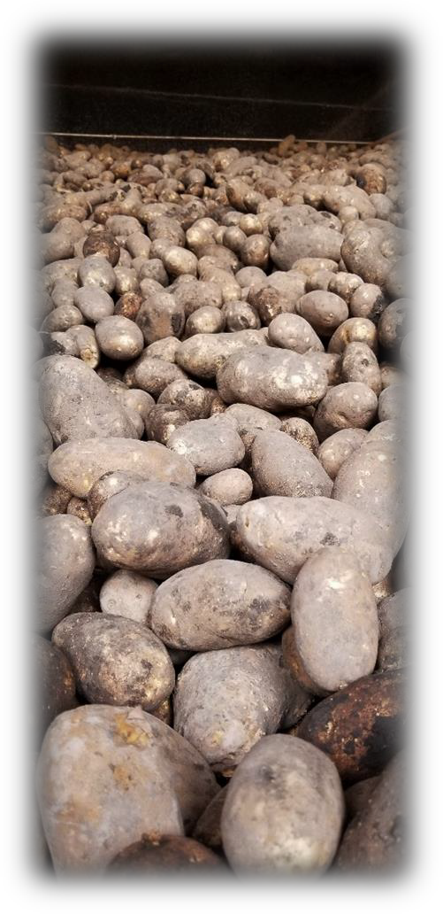
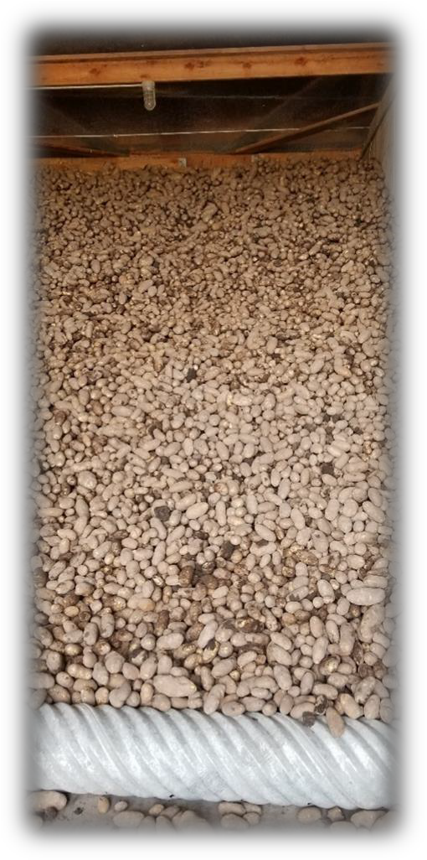

Three variety trials were grown at the Intermountain Research and Extension Center during 2019.

Trials were categorized by their market type and included russet, specialty and chip.

Trial results are summarized in this
report.
P a g e | 0
2019
Potato Variety Development In Tulelake, CA

Table of Contents
Acknowledgements 2
Introduction 2
Late Russet Variety Trial
Cultural Information 3
Tables 4-7
Tulelake Variety Photos and Comments 8-10
Red/Specialty Variety Trial
Cultural Information 11
Tables 12-16
Tulelake Variety Photos and Comments 17-18
Chipping Potato Variety Trial
Cultural Information 19

Tables 20-23
Tulelake Variety Photos and Comments 24-25

RESEARCH REPORT
Number 195, 2019

Intermountain Research & Extension Center

2019 Annual Progress Report Potato Variety Development in Tulelake

Rob Wilson: Center Director/Farm Advisor Email: rgwilson@ucanr.edu Phone: (530) 667-5117
Fax: (530) 667-5265

Darrin Culp: Superintendent of Agriculture Email: daculp@ucanr.edu Phone: (530) 667-5117

Kevin Nicholson: Staff Research Associate II
Email: kwnicholson@ucanr.edu Prepared Report

Three potato variety trials were conducted at the Intermountain Research and Extension Center (IREC) in Tulelake, CA. Trials were categorized by market type and included a Russet trial with 21 entries, a Specialty trial with 15 entries, and a Chipping trial with 10 entries. Entries included selections from the Western Regional (WR) variety development program, Southwest Regional (SWR) variety development program, and varieties of local interest.

Weather data can be found at: http://www.cimis.water.ca.gov Station # 91.

Late Russet Variety Trial
The Late Russet Variety Trial is a combination of eighteen entries from the Western Regional Variety Trial (WR) and three entries from the Southwest Regional Trial (SWR). Merit scoring and culls were evaluated considering fresh market standards, given most Russets grown in Tulelake, CA are sold for fresh market. Important characteristics for the local area include total yield, percent US No. 1 yield, fresh merit score, tuber shape uniformity, low internal and external defects, and resistance to early- dying. See Tables 1-4 for Russet results and Figure 1 for entry pictures and comments.

Trial Information

Location: Intermountain Research and Extension Center, Tulelake, CA
Soil Type: Tulebasin mucky silty clay loam
Planting Date: May 17th 2019
Vine Kill Date: September 10th 2019

Days to Vine Kill: 116
Harvest Date: September 27th 2019

Irrigation: Solid-set sprinklers; applied water + precipitation = 23.65 inches
Plot Length: 18.3 Feet
In-Row Spacing: 10 Inches
Row Spacing: 36 Inches

Number of Reps: 4
# of Fertilizer/Acre: 210-0-150

Seed Treatment: Maxim 4FS and Fir Bark Dust

Weed Control: Prowl H2O and Eptam 7E (pre-emergence)

Matrix SG (early post-emergence)
Insecticides: Admire Pro (In-furrow)
Fungicides: Quadris (In-furrow)
Vine Kill Method: Rolling and Reglone at labeled rates

Table 1. Tuber Yield and Size of Russet Potato Entries.

Tuber Yield (cwt/A)¹
U.S. No. 1's
Trial %1's U.S. 1's Total >14oz 10-14oz 6-10oz 4-6oz <4oz Culls + 2's
Ranger Russet | WR | 74 | bcd | 304.6 | bcd | 409.8 | bcdef | 30.2 | abc | 71.3 | ab | 148.2 | cdefgh | 85.1 | efghi | 49.9 | gh | 25.0 | bcd
Russet Burbank | WR | 65 | cdef | 248.0 | def | 378.3 | cdefg | 4.7 | def | 29.6 | cde | 122.9 | cdefghi | 95.5 | cdefg | 81.4 | cde | 44.3 | ab
Russet Norkotah | WR | 72 | bcd | 240.1 | defg | 332.0 | ghi | 17.5 | abcdef | 63.4 | abc | 111.3 | fghij | 65.4 | ghi | 52.9 | fgh | 21.5 | bcd
A07061-6 | WR | 75 | bc | 358.0 | ab | 478.8 | ab | 5.0 | def | 38.6 | bcde | 169.5 | abc | 149.9 | a | 101.1 | abc | 14.7 | cd
A071012-4BF | WR | 77 | ab | 349.9 | ab | 452.8 | abc | 25.4 | abcde | 81.4 | a | 162.9 | abcde | 105.5 | cde | 58.4 | efgh | 19.1 | bcd
A07769-4 | WR | 78 | ab | 328.7 | bc | 419.5 | bcde | 34.9 | a | 88.8 | a | 172.5 | abc | 67.4 | ghi | 38.0 | h | 17.9 | bcd
A08422-4VRsto | WR | 85 | a | 345.9 | ab | 405.1 | bcdefg | 6.5 | cdef | 41.8 | bcde | 201.3 | ab | 102.8 | cdef | 48.8 | gh | 3.9 | d
A08433-4VR | WR | 79 | ab | 311.1 | bcd | 393.9 | cdefg | 7.3 | cdef | 38.5 | bcde | 156.4 | bcdef | 116.3 | bcd | 62.3 | defgh | 13.2 | d
A10021-5TE | WR | 65 | def | 251.1 | def | 385.5 | cdefg | 4.3 | def | 13.4 | e | 100.4 | hij | 137.3 | ab | 122.5 | a | 7.5 | d
AO02183-2 | WR | 76 | ab | 333.7 | bc | 438.5 | abc | 37.6 | a | 82.7 | a | 165.4 | abcd | 85.5 | efghi | 49.3 | gh | 17.9 | bcd
AOR07781-5 | WR | 66 | cdef | 220.9 | efgh | 338.5 | fghi | 20.3 | abcdef | 59.1 | abcd | 105.1 | ghij | 56.7 | i | 44.9 | gh | 52.5 | a
CO09076-3RU | WR | 55 | g | 186.3 | fgh | 341.1 | fghi | 32.9 | ab | 42.4 | bcde | 81.3 | ij | 62.6 | hij | 68.5 | defg | 53.4 | a
CO09205-2RU | WR | 76 | ab | 269.9 | cde | 355.4 | defgh | 5.5 | def | 41.9 | bcde | 133.6 | cdefgh | 94.4 | cdefg | 61.8 | defgh | 18.2 | bcd
CO10087-4RU | WR | 70 | bcde | 174.1 | gh | 246.9 | j | 2.5 | ef | 20.9 | de | 79.6 | ij | 73.6 | fghi | 60.9 | defgh | 9.5 | d
CO10091-1RU | WR | 59 | fg | 160.3 | h | 269.9 | ij | 0.0 | f | 8.0 | e | 70.1 | j | 82.3 | efghi | 106.9 | ab | 2.7 | d
COTX05095-2Ru/Y | WR | 62 | efg | 264.9 | cde | 424.6 | bcd | 7.3 | cdef | 25.9 | cde | 114.3 | efghij | 124.6 | abc | 111.5 | a | 40.9 | abc
OR12133-10 | WR | 80 | ab | 406.3 | a | 510.3 | a | 10.0 | bcdef | 54.7 | abcd | 207.6 | a | 144.0 | ab | 85.3 | bcd | 8.6 | d
POR12NCK50-1 | WR | 76 | ab | 308.7 | bcd | 405.5 | bcdefg | 26.4 | abcd | 71.8 | ab | 153.9 | bcdefg | 83.0 | efghi | 55.6 | fgh | 14.7 | cd
COTX08322-10RU | SWR | 72 | bcd | 252.4 | def | 348.6 | efgh | 1.1 | f | 37.4 | bcde | 128.3 | cdefghi | 86.7 | defghi | 74.8 | def | 20.3 | bcd
CO10085-1RU | SWR | 71 | bcde | 202.2 | efgh | 285.5 | hij | 3.1 | def | 34.3 | bcde | 100.2 | hij | 67.6 | ghi | 67.4 | defg | 12.8 | d
CO11009-3RU | SWR | 75 | bc | 247.5 | def | 331.1 | ghi | 5.4 | def | 41.6 | bcde | 117.2 | defghij | 88.7 | defgh | 60.6 | efgh | 17.6 | bcd
Mean |  | 72 |  | 274.5 |  | 378.6 |  | 13.7 |  | 47 |  | 133.4 |  | 94.1 |  | 69.7 |  | 20.8
¹Mean comparisons were performed using Tukey's-Kramer HSD; means with the same letter within columns are not significantly different

Table 2. External Tuber Characteristics of Russet Potato Entries.

 | Trial | Merit Score¹ |  | Russeting² |  | Eye Depth³ |  | Shape  Uniformity⁴ |  | Length/Depth  Ratio⁵ |  | Length/Width  Ratio⁵
Ranger Russet | WR | 3.5 | ab | 3.0 | de | 3.9 | abcd | 4.0 | ab | 2.43 | abcde | 2.03 | ab
Russet Burbank | WR | 3.4 | ab | 3.3 | bcd | 3.8 | abcd | 3.8 | ab | 2.22 | bcdef | 1.86 | bcdef
Russet Norkotah | WR | 3.9 | a | 4.1 | ab | 3.8 | abcd | 3.8 | ab | 2.05 | defg | 1.79 | defg
A07061-6 | WR | 2.3 | c | 2.0 | f | 3.9 | abcd | 3.5 | b | 1.97 | bcdef | 1.67 | fghi
A071012-4BF | WR | 3.4 | ab | 3.4 | abcd | 3.3 | cd | 4.0 | ab | 1.96 | defg | 1.70 | fgh
A07769-4 | WR | 3.4 | ab | 3.3 | bcd | 3.3 | cd | 3.5 | b | 1.94 | fg | 1.72 | efgh
A08422-4VRsto | WR | 2.9 | bc | 2.9 | def | 3.9 | abcd | 3.6 | ab | 1.94 | abc | 1.64 | ghi
A08433-4VR | WR | 3.4 | ab | 3.4 | abcd | 3.8 | abcd | 3.6 | ab | 2.00 | a | 1.56 | hi
A10021-5TE | WR | 3.4 | ab | 3.1 | cde | 3.8 | abcd | 4.0 | ab | 1.96 | cdefg | 1.83 | cdefg
AO02183-2 | WR | 3.4 | ab | 3.4 | abcd | 4.0 | abcd | 3.9 | ab | 2.12 | g | 2.15 | a
AOR07781-5 | WR | 3.1 | abc | 4.3 | a | 3.3 | cd | 3.6 | ab | 2.38 | bcdef | 1.83 | bcdefg
CO09076-3RU | WR | 3.1 | abc | 3.5 | abcd | 3.6 | abcd | 3.5 | b | 2.15 | efg | 1.98 | abcd
CO09205-2RU | WR | 3.5 | ab | 3.4 | abcd | 4.1 | abc | 4.4 | a | 2.24 | bcdef | 2.12 | a
CO10087-4RU | WR | 3.8 | ab | 3.4 | abcd | 4.4 | a | 4.0 | ab | 2.49 | ab | 1.99 | abcd
CO10091-1RU | WR | 3.1 | abc | 4.0 | abc | 4.3 | ab | 3.9 | ab | 2.43 | ab | 1.49 | i
COTX05095-2Ru/Y | WR | 3.4 | ab | 3.0 | de | 4.5 | a | 4.0 | ab | 1.85 | fg | 1.67 | fghi
OR12133-10 | WR | 3.1 | abc | 2.3 | ef | 3.1 | d | 4.0 | ab | 1.88 | defg | 1.77 | efg
POR12NCK50-1 | WR | 3.8 | ab | 3.8 | abcd | 3.4 | bcd | 3.9 | ab | 2.04 | bcdef | 2.02 | abc
COTX08322-10RU | SWR | 3.0 | abc | 3.3 | bcd | 3.6 | abcd | 3.5 | b | 2.39 | bcdef | 1.66 | fghi
CO10085-1RU | SWR | 3.1 | abc | 3.6 | abcd | 3.6 | abcd | 3.5 | b | 2.29 | abcd | 1.90 | bcde
CO11009-3RU | SWR | 3.8 | ab | 3.8 | abcd | 3.6 | abcd | 3.8 | ab | 1.98 | efg | 1.75 | efgh
Mean |  | 3.3 |  | 3.3 |  | 3.7 |  | 3.8 |  | 2.13 |  | 1.82
1 1=Worst, 5=Best - Fresh Market Russet Merit Score takes into account multiple factors including tuber shape, eye depth, russeting, and shape uniformity
2 1=Light,5=Heavy
3 1=Deep, 5=Shallow
4 1= Non Uniform, 5=Very Uniform
5 Ratio of 10 tubers measured from each plot, 8-14 oz in size.

Table 3. Tuber Defects of Russet Potato Entries.
 | Trial | Hollow Heart¹ |  | Stem-end Necrosis¹ |  | Vascular Discoloration¹ |  | Black Spot Bruise¹ |  | Knobs² |  | Growth Crack² |  | Irregular Shaped² |  | Greening²
 |  | % |  | % |  | % |  | % |  | % |  | % |  | % |  | %
Ranger Russet | WR | 0 | c | 0 | a | 25 | abcd | 3 | a | 0.1 | a | 1.8 | bc | 2.1 | ab | 0.5 | ab
Russet Burbank | WR | 3 | c | 8 | a | 13 | cd | 5 | a | 2.4 | a | 4.5 | ab | 0.6 | ab | 0.1 | b
Russet Norkotah | WR | 0 | c | 3 | a | 10 | cd | 0 | a | 2.2 | a | 0.4 | c | 0.9 | ab | 0.1 | b
A07061-6 | WR | 0 | c | 0 | a | 20 | bcd | 0 | a | 1.7 | a | 0.6 | c | 0.4 | b | 2.0 | a
A071012-4BF | WR | 0 | c | 0 | a | 30 | abcd | 13 | a | 1.3 | a | 0.7 | c | 0.7 | ab | 0.1 | b
A07769-4 | WR | 3 | c | 5 | a | 10 | cd | 8 | a | 0.5 | a | 0.8 | c | 0.6 | ab | 0.9 | ab
A08422-4VRsto | WR | 3 | c | 0 | a | 13 | cd | 0 | a | 0.0 | a | 0.3 | c | 0.3 | b | 0.0 | b
A08433-4VR | WR | 0 | c | 0 | a | 13 | cd | 0 | a | 1.7 | a | 0.5 | c | 0.7 | ab | 0.5 | ab
A10021-5TE | WR | 0 | c | 0 | a | 18 | bcd | 8 | a | 1.0 | a | 0.3 | c | 0.3 | b | 0.2 | ab
AO02183-2 | WR | 0 | c | 0 | a | 33 | abcd | 0 | a | 1.1 | a | 0.9 | c | 0.9 | ab | 0.5 | ab
AOR07781-5 | WR | 3 | c | 0 | a | 58 | a | 3 | a | 2.7 | a | 4.4 | ab | 1.8 | ab | 0.9 | ab
CO09076-3RU | WR | 5 | bc | 3 | a | 10 | cd | 3 | a | 3.0 | a | 6.1 | a | 2.2 | ab | 0.7 | ab
CO09205-2RU | WR | 0 | c | 0 | a | 20 | bcd | 0 | a | 1.2 | a | 0.4 | c | 2.0 | ab | 1.3 | ab
CO10087-4RU | WR | 40 | a | 8 | a | 48 | ab | 0 | a | 0.7 | a | 1.1 | c | 0.7 | ab | 0.0 | b
CO10091-1RU | WR | 8 | bc | 5 | a | 0 | d | 0 | a | 0.1 | a | 0.3 | c | 0.5 | b | 0.0 | b
COTX05095-2Ru/Y | WR | 0 | c | 0 | a | 15 | bcd | 0 | a | 1.2 | a | 6.4 | a | 0.6 | ab | 0.5 | ab
OR12133-10 | WR | 0 | c | 0 | a | 38 | abc | 10 | a | 0.6 | a | 0.6 | c | 0.2 | b | 0.8 | ab
POR12NCK50-1 | WR | 0 | c | 3 | a | 48 | ab | 3 | a | 1.2 | a | 0.0 | c | 1.6 | ab | 0.1 | b
COTX08322-10RU | SWR | 0 | c | 10 | a | 38 | abc | 3 | a | 1.3 | a | 0.0 | c | 2.7 | a | 0.5 | ab
CO10085-1RU | SWR | 0 | c | 5 | a | 28 | abcd | 0 | a | 0.6 | a | 0.7 | c | 2.0 | ab | 0.0 | b
CO11009-3RU | SWR | 18 | b | 0 | a | 8 | cd | 3 | a | 0.8 | a | 1.1 | c | 1.0 | ab | 0.5 | ab
Mean |  | 4 |  | 2 |  | 23 |  | 3 |  | 1.2 |  | 1.5 |  | 1.1 |  | 0.5
1 Ten, 8 to 14 oz. tubers were evaluated from each plot.
2 Percent of total tubers.

Table 4. Disease Susceptibility, Stand, Tuber Set, Average Tuber Size and Specific Gravity of Russet Potato Entries.

Trial
Vert Wilt Rating¹
Early Dying²
(A.U.D.P.C.) % Stand
Tubers per Plant
Average Tuber Size
Specific Gravity

Ranger Russet | WR | 5.3 | defgh | 229.5 | fgh | 99 | a | 6.6 | defgh | 6.2 | abcd | 1.092 | cdef
Russet Burbank | WR | 7.0 | abcde | 583.9 | defg | 99 | a | 7.4 | def | 5.2 | efgh | 1.088 | defg
Russet Norkotah | WR | 9.0 | a | 1951.3 | a | 98 | a | 5.8 | gh | 5.9 | abcdef | 1.078 | h
A07061-6 | WR | 5.0 | efgh | 167.3 | gh | 100 | a | 9.9 | a | 4.9 | fghi | 1.084 | fgh
A071012-4BF | WR | 5.3 | defgh | 232.2 | fgh | 100 | a | 7.7 | cde | 5.9 | abcde | 1.088 | defg
A07769-4 | WR | 6.3 | cdefg | 387.1 | fgh | 99 | a | 6.3 | efgh | 6.8 | a | 1.108 | a
A08422-4VRsto | WR | 7.5 | abc | 941.9 | cde | 98 | a | 7.2 | defg | 5.7 | bcdef | 1.096 | bcd
A08433-4VR | WR | 4.5 | gh | 117.6 | gh | 98 | a | 7.9 | bcd | 5.1 | efgh | 1.091 | cdefg
A10021-5TE | WR | 6.8 | bcdef | 525.9 | efgh | 98 | a | 9.0 | abc | 4.4 | hi | 1.096 | bcde
AO02183-2 | WR | 3.8 | h | 92.1 | h | 100 | a | 6.8 | defgh | 6.4 | ab | 1.097 | bcd
AOR07781-5 | WR | 7.0 | abcde | 485.3 | efgh | 99 | a | 5.4 | h | 6.4 | abc | 1.105 | ab
CO09076-3RU | WR | 7.8 | abc | 1032.6 | bcd | 95 | abc | 6.6 | defgh | 5.4 | bcdefg | 1.100 | abc
CO09205-2RU | WR | 6.5 | cdefg | 405.9 | fgh | 99 | a | 6.8 | defgh | 5.3 | defgh | 1.088 | defg
CO10087-4RU | WR | 9.0 | a | 1482.6 | ab | 89 | c | 6.1 | fgh | 4.6 | ghi | 1.082 | gh
CO10091-1RU | WR | 7.3 | abcd | 713.5 | cdef | 96 | ab | 7.1 | defg | 4.0 | i | 1.096 | bcde
COTX05095-2Ru/Y | WR | 8.8 | ab | 1682.5 | a | 98 | a | 9.3 | ab | 4.7 | ghi | 1.092 | cdef
OR12133-10 | WR | 6.0 | cdefg | 399.4 | fgh | 100 | a | 9.4 | ab | 5.5 | bcdefg | 1.087 | efgh
POR12NCK50-1 | WR | 6.5 | cdefg | 592.8 | defg | 95 | abc | 7.2 | defg | 5.9 | abcde | 1.099 | bc
COTX08322-10RU | SWR | 7.8 | abc | 1153.8 | bc | 99 | a | 7.0 | defg | 5.1 | efgh | 1.097 | bcd
CO10085-1RU | SWR | 4.8 | fgh | 178.8 | gh | 98 | a | 5.9 | fgh | 5.0 | efgh | 1.099 | bc
CO11009-3RU | SWR | 3.5 | h | 48.2 | h | 90 | bc | 6.9 | defgh | 5.4 | cdefgh | 1.102 | ab
Mean |  | 6.4 |  | 638.3 |  | 97 |  | 7.3 |  | 5.4 |  | 1.093
1Verticillium wilt ratings based on a 0-9 scale (0=None 9=Dead) for August 29st 104 days after planting.
2 Area Under Disease Progress Curve based on foliar early-dying ratings taken 80, 91, 96 and 104 days after planting. Higher value is more susceptible

4

Figure 1. 2019 Late Russet Trial Entries.
Ranger Russet | Russet Burbank | Russet Norkotah
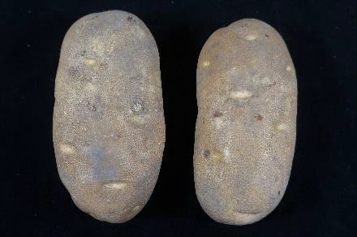  - Check | 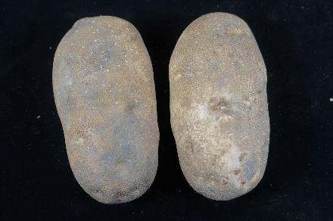  - Check | 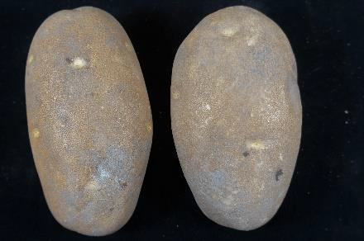  - Check
COTX08322-10RU | A07061-6 | A071012-4BF
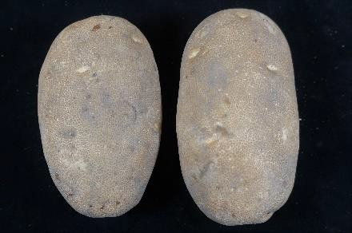  - Susceptible to early dying  - Irregular shape | 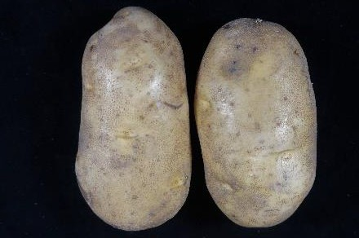  - High tubers per plant  - Little russeting  - Resistant to early dying | 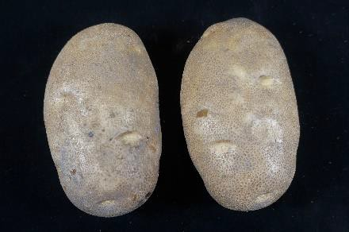  - Blocky  - Pink Eyes
A07769-4 | A08422-4VRsto | A08433-4VR
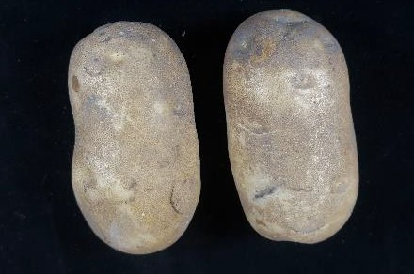  - High incidence of shatter bruise | 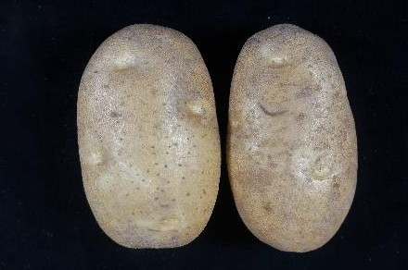  - High %1s | 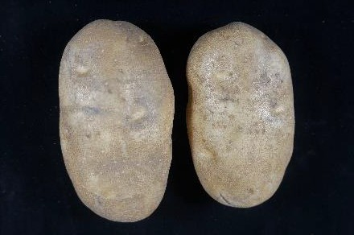  - Lumpy  - Resistant to early dying

A10021-5TE | AO02183-2 | AOR07781-5
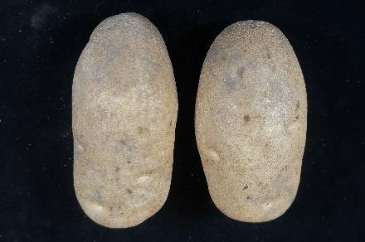  - More <4oz tuber size than most | 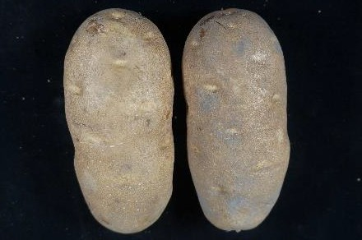  - Resistant to early dying | 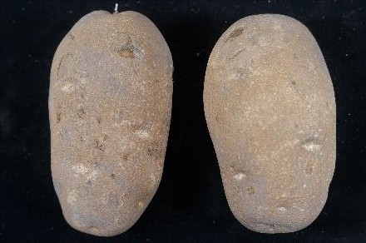  - Lumpy shape
CO09076-3RU | CO09205-2RU | CO10087-4RU
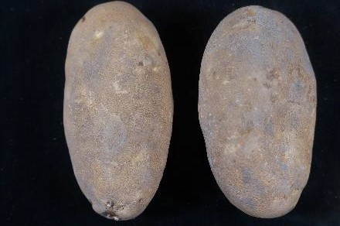  - Low % 1s  - High % cull | 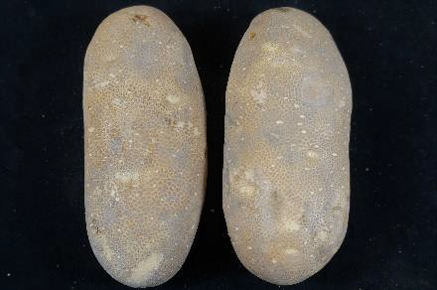  - Long and narrow | 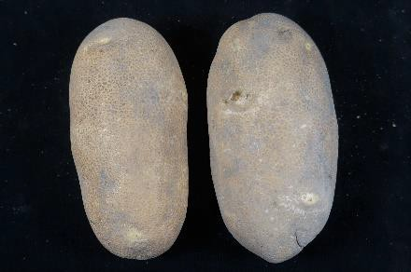  - Lowest total yield in trial
CO10091-1RU | COTX05095-2Ru/Y | OR12133-10
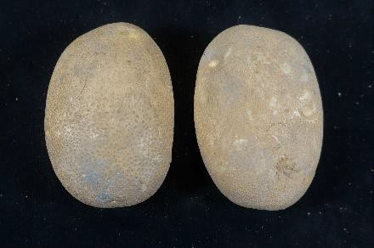  - Round  - Small average tuber size | 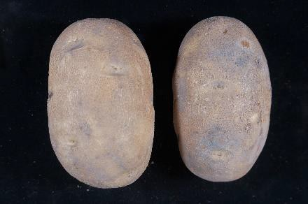  - Blocky shape  - Resistant to early dying | 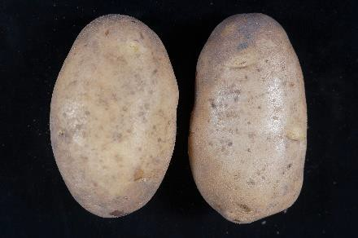  - Very light russet

POR13NCK50-1 | CO10085-1RU | CO11009-3RU
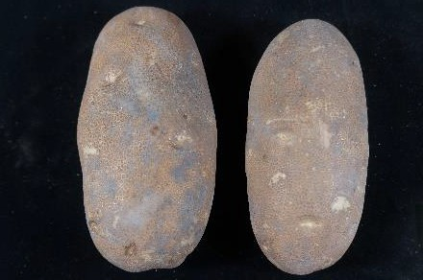  - Long  - Looks similar to Norkotah | 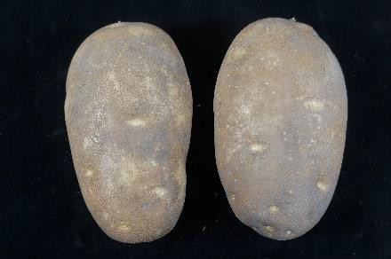  - More ruptured lenticels than most  - Resistant to early dying | 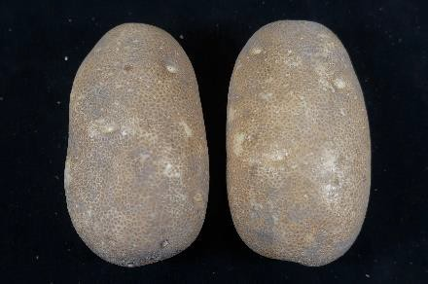  - Resistant to early dying

Red/Specialty Variety Trial

The Red/Specialty Trial included 13 entries from the Western Regional Variety Trial (WR) and two entries from the Southwest Regional Trial (SWR). Important vine and tuber characteristics for fresh market red/specialty types include: skin and flesh color, fresh merit score, tuber shape, tuber uniformity, tubers per plant, and average tuber size. See Tables 5-9 for Red/Specialty trial results and Figure 2 for entry pictures and comments.

Trial Information

Location: Intermountain Research and Extension Center, Tulelake, CA
Soil Type: Tulebasin mucky silty clay loam
Planting Date: May 17th 2019
Vine Kill Date: September 10th 2019
Days to Vine Kill: 116
Harvest Date: October 1st 2019

Irrigation: Solid-set sprinklers; applied water + precipitation = 23.65 inches
Plot Length: 18.3 Feet
In-Row Spacing: 10 Inches
Row Spacing: 36 Inches

Number of Reps: 4
# of Fertilizer/Acre: 210-0-150

Seed Treatment: Maxim 4FS and Fir Bark Dust

Weed Control: Prowl H2O and Eptam 7E (pre emergence)

Matrix SG (early post emergence)
Insecticides: Admire Pro (In-furrow)
Fungicides: Quadris (In-furrow)
Vine Kill Method: Rolling and Reglone at labeled rates

Table 5. Skin and Flesh Characteristics of Specialty Potato Entries.

Clone / Variety | Trial | Skin Color1 | Skin Color  Rating | Flesh color | Flesh Color  Rating
Chieftain | WR | Red | 2.1 | White | 1.8
Red LaSoda | WR | Red | 2.0 | White | 1.9
A08112-7R | WR | Red | 2.9 | White | 1.8
ATTX05175S-1R/Y | WR | Red | 2.9 | Yellow | 3.1
ATX06264s-4R/Y | WR | Red | 3.6 | Yellow | 3.3
COTX04193S-2R/Y | WR | Red | 3.9 | Yellow | 3.5
Yukon Gold | WR | Yellow | 1.1 | Yellow | 2.9
CO09128-5W/Y | WR | Yellow | 1.0 | Yellow | 4.3
CO09218-4W/Y | WR | Yellow | 1.0 | Yellow | 3.9
CO10064-1W/Y | WR | Yellow | 1.0 | Yellow | 3.8
CO10097-2W/Y | WR | Yellow | 1.1 | Yellow | 3.9
CO10098-5W/Y | WR | Yellow | 1.6 | Yellow | 5.0
POR14PG22-3 | WR | Yellow | 1.0 | Yellow | 3.4
CO11250-1W/Y | SWR | Yellow | 1.4 | Yellow | 3.1
CO11266-1W/Y | SWR | Yellow | 1.5 | Yellow | 4.0
 |  |  | 1.9 |  | 3.3
Mean
11=Light, 5=Dark; Reds and purples were rated using red/purple color scale. Yellows were rated using a white/yellow color scale. All varieties were rated using the same internal flesh darkness scale.

Table 6. Tuber Yield and Size of Specialty Potato Entries.

Tuber Yield (cwt/A)¹

Clone / Variety Trial Total Yield 10-14 oz 6-10 oz 4-6 oz < 4oz > 14 oz Culls
Chieftain | WR | 617.8 | a* | 89.4 | b | 260.7 | a | 131.7 | ab | 102.5 | gh | 20.8 | c | 12.9 | bc
Red LaSoda | WR | 626.5 | a | 129.4 | a | 163.4 | b | 56.3 | d | 48.6 | i | 122.0 | a | 106.7 | a
A08112-7R | WR | 437.7 | cd | 5.8 | cde | 68.4 | def | 115.4 | abc | 231.9 | c | 0.8 | c | 15.3 | bc
ATTX05175S-1R/Y | WR | 488.8 | bc | 3.4 | de | 46.8 | ef | 121.1 | ab | 298.7 | bc | 0.0 | c | 18.9 | bc
ATX06264s-4R/Y | WR | 506.9 | bc | 29.8 | c | 131.2 | bc | 134.0 | ab | 191.9 | cd | 3.6 | c | 16.4 | bc
COTX04193S-2R/Y | WR | 434.5 | cd | 4.5 | cde | 62.3 | def | 132.8 | ab | 227.5 | c | 0.0 | c | 7.5 | bc
Yukon Gold | WR | 441.3 | cd | 84.0 | b | 144.7 | bc | 68.8 | d | 53.2 | i | 67.5 | b | 23.0 | bc
CO09128-5W/Y | WR | 383.8 | de | 0.0 | e | 10.6 | f | 56.4 | d | 313.8 | bc | 0.0 | c | 3.0 | c
CO09218-4W/Y | WR | 288.8 | f | 16.7 | cde | 83.9 | cde | 74.1 | d | 90.7 | hi | 6.1 | c | 17.3 | bc
CO10064-1W/Y | WR | 431.0 | cd | 25.6 | cde | 123.8 | bcd | 119.5 | ab | 130.0 | fgh | 6.0 | c | 26.1 | b
CO10097-2W/Y | WR | 431.0 | cd | 16.2 | cde | 135.5 | bc | 131.5 | ab | 139.8 | efg | 1.8 | c | 6.1 | bc
CO10098-5W/Y | WR | 314.5 | ef | 3.1 | de | 64.8 | def | 84.7 | cd | 139.8 | efg | 1.1 | c | 21.0 | bc
POR14PG22-3 | WR | 559.8 | ab | 2.5 | de | 36.0 | ef | 110.5 | bc | 405.2 | a | 0.0 | c | 5.6 | bc
CO11250-1W/Y | SWR | 505.9 | bc | 27.9 | cd | 138.2 | bc | 142.9 | ab | 179.7 | de | 2.6 | c | 14.7 | bc
CO11266-1W/Y | SWR | 464.4 | cd | 14.4 | cde | 117.7 | bcd | 144.6 | a | 168.6 | def | 3.7 | c | 15.4 | bc
Mean |  | 462.2 |  | 30.2 |  | 105.9 |  | 104.4 |  | 181.5 |  | 15.7 |  | 20.7
¹Mean comparisons were performed using Tukey's-Kramer HSD; means with the same letter within columns are not significantly different

Table 7. External Tuber Characteristics of Specialty Potato Entries.

Clone / Variety | Trial | Merit¹ |  | Eye Depth² |  | Tuber  Shape³ |  | Shape  Uniformity⁴ |  | Length/Depth  Ratio⁵ |  | Length/Width  Ratio⁵
Chieftain | WR | 3.5 | a | 3.6 | a | 2.6 | ab | 3.5 | a | 1.59 | bc | 1.27 | bcd
Red LaSoda | WR | 2.6 | bcde | 2.6 | b | 2.0 | bcde | 3.0 | a | 1.40 | def | 1.11 | fgh
A08112-7R | WR | 3.6 | a | 4.0 | a | 1.8 | cdef | 3.4 | a | 1.41 | def | 1.17 | def
ATTX05175S-1R/Y | WR | 3.6 | a | 3.9 | a | 1.5 | def | 3.4 | a | 1.29 | efg | 0.97 | i
ATX06264s-4R/Y | WR | 3.1 | abc | 3.9 | a | 1.6 | def | 3.4 | a | 1.44 | cde | 1.11 | fgh
COTX04193S-2R/Y | WR | 3.6 | a | 3.9 | a | 1.4 | ef | 3.5 | a | 1.41 | def | 1.03 | hi
Yukon Gold | WR | 3.4 | ab | 4.0 | a | 2.6 | ab | 3.5 | a | 1.55 | cd | 1.26 | cde
CO09128-5W/Y | WR | 3.6 | a | 4.1 | a | 1.1 | f | 3.8 | a | 1.23 | g | 1.05 | ghi
CO09218-4W/Y | WR | 3.1 | abc | 4.1 | a | 2.3 | abcd | 3.6 | a | 1.57 | c | 1.19 | def
CO10064-1W/Y | WR | 3.4 | ab | 3.9 | a | 2.3 | abcd | 3.8 | a | 1.49 | cd | 1.15 | efg
CO10097-2W/Y | WR | 2.9 | abcd | 4.0 | a | 1.6 | def | 4.0 | a | 1.26 | fg | 1.13 | fgh
CO10098-5W/Y | WR | 2.4 | cde | 3.8 | a | 3.0 | a | 3.3 | a | 1.81 | a | 1.43 | a
POR14PG22-3 | WR | 2.5 | cde | 3.6 | a | 2.5 | abc | 2.9 | a | 1.47 | cd | 1.22 | cdef
CO11250-1W/Y | SWR | 2.3 | de | 3.9 | a | 2.9 | a | 2.9 | a | 1.74 | ab | 1.38 | ab
CO11266-1W/Y | SWR | 2.0 | e | 3.8 | a | 2.8 | ab | 3.1 | a | 1.54 | cd | 1.33 | abc
Mean |  | 3.0 |  | 3.8 |  | 2.1 |  | 3.4 |  | 1.48 |  | 1.19
1 1=Worst, 5=Best - Specialty Merit Score takes into account important appearance factors of the Specialty market including tuber shape, eye depth, and shape uniformity
2 1=Deep, 5=Shallow
3 1=Round, 5=Oblong
4 1= Poor uniformity, 5=Very Uniform
5 Ratio of 10 tubers measured from each plot

Table 8. Tuber Defects of Specialty Potato Entries.

Clone / Variety | Trial | Hollow  Heart¹ |  | Stem End  Necrosis |  | Vascular  Dicoloration¹ |  | Knobs² |  | Growth  Crack² |  | Greening²
 |  | % |  | % |  | % |  |  | % | % |  |  | %
Chieftain | WR | 5 | ab | 3 | a | 23 | ab | 0.9 | b | 0.4 | b | 0.0 | c
Red LaSoda | WR | 0 | b | 0 | a | 13 | ab | 1.2 | b | 4.2 | a | 0.6 | bc
A08112-7R | WR | 0 | b | 3 | a | 20 | ab | 1.3 | ab | 0.0 | b | 1.5 | bc
ATTX05175S-1R/Y | WR | 0 | b | 0 | a | 25 | ab | 1.3 | ab | 0.1 | b | 1.3 | bc
ATX06264s-4R/Y | WR | 0 | b | 0 | a | 15 | ab | 1.4 | ab | 0.2 | b | 0.5 | bc
COTX04193S-2R/Y | WR | 5 | ab | 0 | a | 48 | a | 0.5 | b | 0.3 | b | 0.5 | bc
Yukon Gold | WR | 13 | ab | 8 | a | 15 | ab | 1.2 | ab | 0.3 | b | 0.2 | c
CO09128-5W/Y | WR | 0 | b | 0 | a | 20 | ab | 0.4 | b | 0.0 | b | 0.4 | bc
CO09218-4W/Y | WR | 20 | a | 5 | a | 10 | b | 1.1 | b | 0.1 | b | 1.8 | ab
CO10064-1W/Y | WR | 0 | b | 3 | a | 8 | b | 0.2 | b | 0.1 | b | 3.2 | a
CO10097-2W/Y | WR | 0 | b | 5 | a | 18 | ab | 0.7 | b | 0.0 | b | 0.1 | c
CO10098-5W/Y | WR | 0 | b | 0 | a | 33 | ab | 2.4 | a | 0.0 | b | 0.9 | bc
POR14PG22-3 | WR | 0 | b | 0 | a | 23 | ab | 0.5 | b | 0.0 | b | 0.9 | bc
CO11250-1W/Y | SWR | 0 | b | 0 | a | 15 | ab | 1.0 | b | 0.2 | b | 0.7 | bc
CO11266-1W/Y | SWR | 3 | b | 0 | a | 25 | ab | 0.9 | b | 0.0 | b | 1.1 | bc
Mean |  | 3 |  | 2 |  | 21 |  | 1.0 |  | 0.4 |  | 0.9
1 Ten, 6-10oz. tubers were evaluated from each plot.
2 Percent of total tubers.

Table 9. Disease Susceptibility, Stand, Tuber Set, Average Tuber Size and Specific Gravity of Specialty Potato Entries.

 |  | Vert Wilt | Early-Dying² |  |  | Average
Clone / Variety | Trial | Rating¹ | (A.U.D.P.C.) | % Stand | Tubers/Plant | Size (oz) | Specific Gravity

Chieftain WR 6.8 bc 528.1 cde 90 ab 11.3 de 5.6 c 1.081 gh
Red LaSoda WR 6.0 bcd 439.2 cdef 97 a 7.6 f 7.9 a 1.087 defg
A08112-7R WR 5.8 cd 271.5 efg 96 a 13.7 cd 3.1 ghi 1.091 cde
ATTX05175S-1R/Y WR 6.5 bc 353.8 defg 99 a 17.0 b 2.7 hij 1.093 bcd
ATX06264s-4R/Y WR 6.5 bc 402.3 defg 96 a 13.4 cd 3.6 defg 1.084 fg
COTX04193S-2R/Y WR 8.8 a 1460.6 a 91 ab 13.8 cd 3.2 fgh 1.076 h
Yukon Gold WR 7.0 abc 678.1 cd 91 a 7.0 f 6.4 b 1.087 defg
CO09128-5W/Y WR 8.8 a 1177.5 ab 97 a 16.4 bc 2.2 j 1.085 efg
CO09218-4W/Y WR 3.5 e 48.3 g 61 c 11.4 de 4.0 de 1.067 i
CO10064-1W/Y WR 4.5 de 102.2 fg 88 ab 11.0 de 4.1 d 1.099 ab
CO10097-2W/Y WR 6.0 bcd 272.7 efg 93 a 10.1 ef 4.2 d 1.085 efg
CO10098-5W/Y WR 7.8 ab 826.9 bc 75 bc 11.5 de 3.4 efg 1.106 a
POR14PG22-3 WR 6.0 bcd 275.6 efg 98 a 21.7 a 2.4 ij 1.089 def
CO11250-1W/Y SWR 5.3 cde 199.2 efg 97 a 12.2 de 3.9 de 1.097 bc
CO11266-1W/Y SWR 4.5 de 81.1 fg 90 ab 12.3 de 3.8 def 1.091 cdef

Mean 6.2 474.5 91 12.7 4.0 1.088
1Verticillium wilt ratings based on a 0-9 scale (0=None 9=Dead) for August 29st 104 days after planting.
2 Area Under Disease Progress Curve based on foliar early-dying ratings taken 80, 91, 96 and 104 days after planting. Higher value is more susceptible.

Figure 2. 2019 Red/Specialty Entries.
Cheiftain | Red LaSoda | A08112-7R
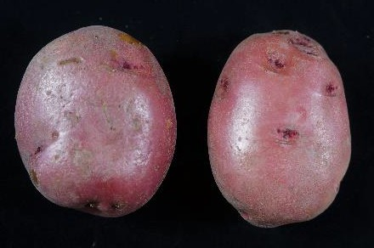  - Check | 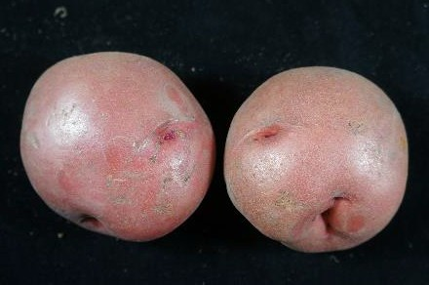  - Check | 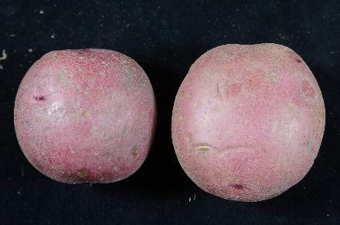  - Uniform shape
ATTX05175S-1R/Y | ATTX06264s-4R/Y | COTX04193S-2R/Y
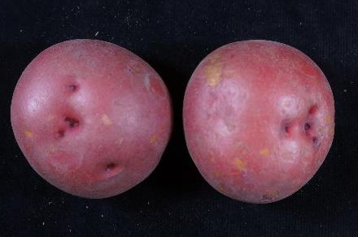  - Pancake shaped  - Low average tuber size | 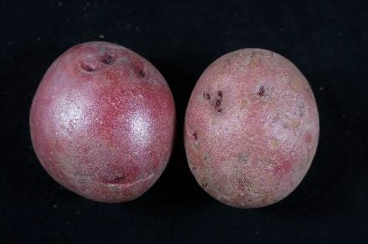  - High percentage of <4oz  - Deep red to purple skin color | 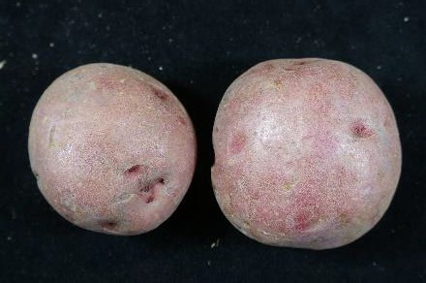  - Flattened shape  - Susceptible to black dot
Yukon Gold | CO09128-5W/Y | CO09218-4W/Y
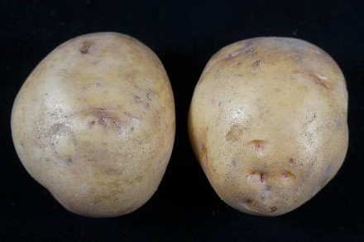  - Check | 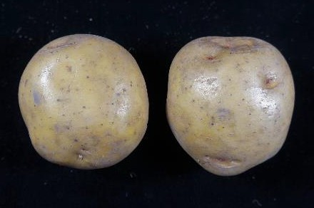  - Pink eyes | 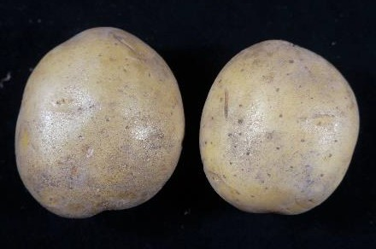  - Flat shape  - Ruptured lenticels  - 20% hollow heart  - 60% stand

CO10064-1W/Y | CO10097-2W/Y | CO10098-5W/Y
- Pink eyes | 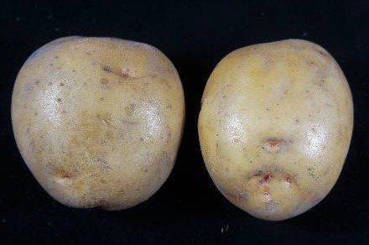  - Has some russeting | 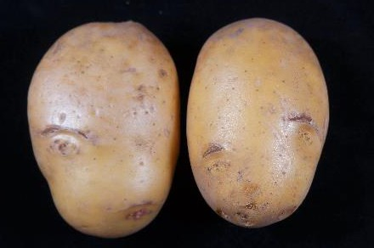  - Susceptible to black dot
POR14PG22-3 | CO11250-1W/Y | CO11266-1W/Y
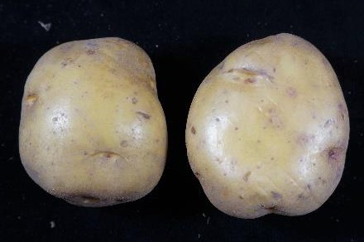  - High tubers per plant  - High <4oz tuber yield | 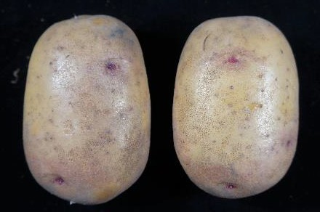  - Pink eyes and pink splotches on skin | 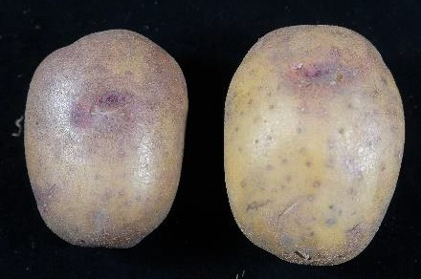  - Pink eyes and pink splotches on skin

Chipping Potato Variety Trial

The 2019 Chipping Trial included four entries from the Western Regional Variety Trial (WR) and seven entries from the Southwest Region (SWR). Important characteristics for processing chippers include: total yield, tubers per plant, tuber shape, tuber uniformity, average tuber size, and specific gravity. See Tables 10-13 for Chipping Trial results and Figure 3 for entry pictures and comments.

Trial Information
Location: Intermountain Research and Extension Center, Tulelake, CA
Soil Type: Tulebasin mucky silty clay loam
Planting Date: May 17th 2019
Vine Kill Date: September 10th and 17th 2019
Days to Vine Kill: 116
Harvest Date: September 27th 2019

Irrigation: Solid-set sprinklers; applied water + precipitation = 23.65 inches
Plot Length: 18.3 Feet
In-Row Spacing: 10 Inches
Row Spacing: 36 Inches

Number of Reps: 4
# of Fertilizer/Acre: 210-0-150

Seed Treatment: Maxim 4FS and Fir Bark Dust

Weed Control: Prowl H2O and Eptam 7E (pre emergence)

Matrix SG (early post emergence)
Insecticides: Admire Pro (In-furrow)
Fungicides: Quadris (In-furrow)
Vine Kill Method: Rolling and Reglone at labeled rates

Table 10. Tuber Yield and Size of Chipping Potato Entries.

Tuber Yield (cwt/A)¹
Clone / Variety | Trial | Total |  | >14 oz |  | 10-14 oz |  | 6-10oz |  | 4-6 oz |  | <4 oz |  | Culls
Atlantic | Check | 521.8 | a | 26.5 | a | 93.6 | a | 236.5 | a | 99.2 | c | 55.5 | d | 10.6 | b
Snowden | WR | 483.5 | ab | 3.8 | b | 38.0 | b | 162.5 | ab | 157.3 | a | 115.3 | abc | 6.7 | b
CO10073-7W | WR | 430.6 | ab | 4.6 | b | 14.5 | b | 119.6 | b | 122.6 | abc | 144.7 | a | 24.7 | b
CO10076-4W | WR | 468.4 | ab | 2.7 | b | 25.2 | b | 150.1 | b | 143.0 | ab | 133.7 | ab | 13.7 | b
CO11023-2W | SWR | 401.3 | b | 5.0 | b | 28.5 | b | 143.1 | b | 111.2 | bc | 99.4 | bc | 14.2 | b
CO11023-9W | SWR | 425.0 | ab | 6.7 | b | 45.6 | b | 162.4 | ab | 114.0 | bc | 84.3 | cd | 12.1 | b
CO11037-5W | SWR | 440.9 | ab | 5.6 | b | 29.3 | b | 154.7 | b | 129.6 | abc | 101.3 | bc | 20.4 | b
TX09403-15W | SWR | 447.2 | ab | 8.7 | b | 42.7 | b | 173.2 | ab | 109.4 | bc | 94.6 | c | 18.6 | b
TX09403-21W | SWR | 457.0 | ab | 4.3 | b | 44.8 | b | 180.7 | ab | 119.6 | abc | 90.4 | cd | 17.3 | b
ATTX07042-3W | SWR | 483.7 | ab | 2.8 | b | 19.6 | b | 117.3 | b | 133.3 | abc | 147.8 | a | 62.9 | a
Mean |  | 455.9 |  | 7.1 |  | 38.2 |  | 160.0 |  | 123.9 |  | 106.7 |  | 20.1
¹Mean comparisons were performed using Tukey's-Kramer HSD; means with the same letter within columns are not significantly different

Table 11. Merit Score and Tuber Characteristics of Chipping Potato Entries

Clone / Variety | Trial | Merit¹ |  | Eye depth² |  | Tuber  Shape³ |  | Shape  Uniformity⁴ |  | Length/Depth  Ratio⁵ |  | Length/Width  Ratio⁵
Atlantic | Check | 3.4 | a | 3.3 | a | 2.4 | a | 3.6 | a | 1.36 | a | 1.12 | ab
Snowden | WR | 3.6 | a | 3.1 | a | 1.5 | ab | 3.8 | a | 1.30 | abc | 1.02 | def
CO10073-7W | WR | 3.1 | a | 3.9 | a | 1.9 | ab | 3.6 | a | 1.39 | a | 1.11 | abc
CO10076-4W | WR | 3.0 | a | 3.5 | a | 1.5 | ab | 3.9 | a | 1.22 | bcd | 0.97 | f
CO11023-2W | SWR | 3.1 | a | 3.4 | a | 1.6 | ab | 3.8 | a | 1.26 | abcd | 1.02 | def
CO11023-9W | SWR | 3.5 | a | 3.9 | a | 1.1 | b | 4.1 | a | 1.16 | d | 1.00 | ef
CO11037-5W | SWR | 3.5 | a | 3.5 | a | 1.5 | ab | 3.8 | a | 1.19 | cd | 0.99 | ef
TX09403-15W | SWR | 3.5 | a | 3.4 | a | 1.9 | ab | 3.6 | a | 1.31 | abc | 1.08 | bcd
TX09403-21W | SWR | 3.4 | a | 3.4 | a | 1.9 | ab | 3.5 | a | 1.28 | abcd | 1.05 | cde
ATTX07042-3W | SWR | 3.1 | a | 3.9 | a | 2.3 | a | 3.9 | a | 1.34 | ab | 1.17 | a
Mean |  | 3.3 |  | 3.5 |  | 1.8 |  | 3.8 |  | 1.28 |  | 1.05
1 1=Worst, 5=Best - Chipper Merit Score takes into account multiple factors including tuber shape, eye depth, and shape uniformity
2 1=Deep, 5=Shallow
3 1=Round, 5=Oblong
4 1= No Uniformity, 5=Very Uniform
5 Ratio of 10 tubers measured from each plot

Table 12. Tuber Defects of Chipping Potato Entries.

Clone / Variety | Trial | Hollow  Heart¹ |  | Vascular  Discoloration¹ |  | Stem End  Necrosis¹ |  | Knobs² |  | Growth  Crack² |  | Greening²
 |  | % |  | % |  | % |  | % |  | % |  | %
Atlantic | Check | 0 | a | 5 | a | 0 | a | 0.5 | a | 0.0 | b | 1.9 | bc
Snowden | WR | 0 | a | 23 | a | 0 | a | 0.2 | a | 0.1 | b | 1.6 | c
CO10073-7W | WR | 8 | a | 13 | a | 0 | a | 0.3 | a | 1.9 | b | 4.3 | a
CO10076-4W | WR | 0 | a | 10 | a | 0 | a | 0.8 | a | 0.5 | b | 1.7 | c
CO11023-2W | SWR | 10 | a | 15 | a | 3 | a | 0.4 | a | 0.8 | b | 1.4 | c
CO11023-9W | SWR | 0 | a | 33 | a | 0 | a | 0.7 | a | 0.0 | b | 1.9 | bc
CO11037-5W | SWR | 0 | a | 25 | a | 3 | a | 0.8 | a | 0.5 | b | 3.7 | ab
TX09403-15W | SWR | 3 | a | 30 | a | 3 | a | 0.2 | a | 2.1 | b | 1.5 | c
TX09403-21W | SWR | 3 | a | 25 | a | 3 | a | 0.5 | a | 1.5 | b | 1.7 | c
ATTX07042-3W | SWR | 0 | a | 15 | a | 0 | a | 0.6 | a | 9.7 | a | 2.3 | bc
Mean |  | 2 |  | 19 |  | 1 |  | 0.5 |  | 1.7 |  | 2.2
1 Ten, 6-10oz tubers were evaluated from each plot.
2 Percent of total tubers.

Table 13. Disease Susceptibility, Stand, Tuber Set, Average Tuber Size and Specific Gravity of Chipping Potato Entries.
Specific
Gravity
Average Tuber
Size (oz)
Tubers per
Plant
% Stand
Early-Dying²
(A.U.D.P.C.)
Vert Wilt
Rating¹
Trial
Clone / Variety

Atlantic | Check | 6.3 | ab | 462.0 | b | 95 | a | 7.8 | d | 6.4 | a | 1.100 | a
Snowden | WR | 6.5 | a | 597.0 | ab | 94 | a | 10.1 | abc | 4.7 | bc | 1.100 | a
CO10073-7W | WR | 5.0 | bc | 222.4 | c | 95 | a | 10.1 | abc | 4.1 | c | 1.090 | bc
CO10076-4W | WR | 4.5 | cd | 139.6 | c | 94 | a | 10.3 | ab | 4.4 | bc | 1.088 | cd
CO11023-2W | SWR | 4.0 | cd | 84.0 | c | 91 | a | 8.6 | bcd | 4.7 | bc | 1.100 | a
CO11023-9W | SWR | 3.5 | d | 52.9 | c | 93 | a | 8.3 | cd | 5.1 | b | 1.080 | d
CO11037-5W | SWR | 5.0 | bc | 124.0 | c | 94 | a | 9.1 | bcd | 4.7 | bc | 1.098 | ab
TX09403-15W | SWR | 7.3 | a | 688.8 | a | 92 | a | 8.9 | bcd | 5.0 | b | 1.085 | cd
TX09403-21W | SWR | 7.0 | a | 608.9 | ab | 93 | a | 9.1 | bcd | 5.0 | b | 1.085 | cd
ATTX07042-3W | SWR | 5.0 | bc | 160.2 | c | 94 | a | 11.5 | a | 4.1 | c | 1.090 | bc

Mean 5.4 314 94 9.4 4.8 1.092
1Verticillium wilt ratings based on a 0-9 scale (0=None 9=Dead) for August 29st 104 days after planting
2 Area Under Disease Progress Curve based on foliar early-dying ratings taken 80, 91, 96 and 104 days after planting. Higher value is more susceptible to early dying.

Figure 3. 2019 Chipping Trial Entries.
Atlantic | Snowden | CO10073-7W
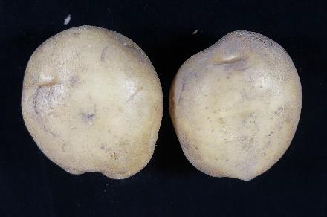  - Check | 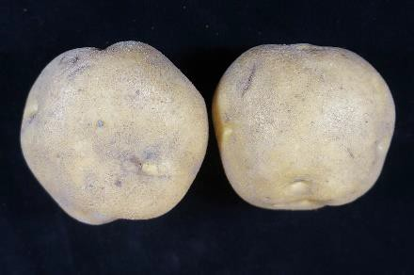  - Check | 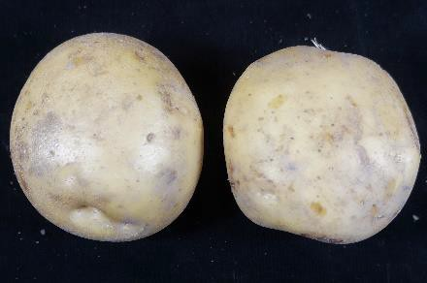  - Small average tuber size
CO10076-4W | CO11023-2W | CO11023-9W
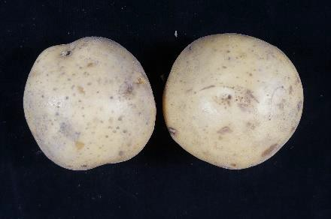 | 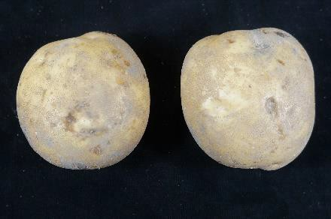  - 10 % hollow heart  - High specific gravity | 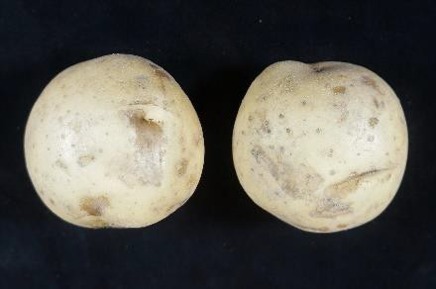  - Resistant to early dying  - Low specific gravity
CO11037-5W | TX09403-15W | TX09403-21W
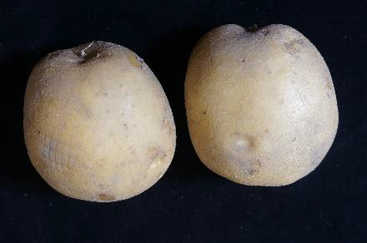 | 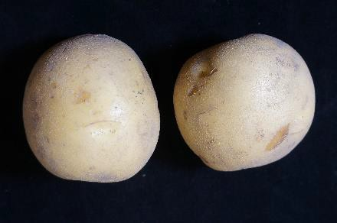  - Low specific gravity | 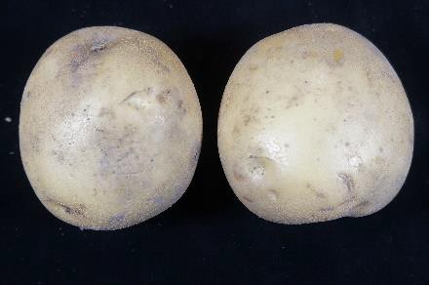  - Low specific gravity

ATTX07042-3W
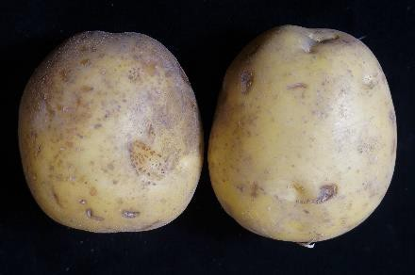
- 10% growth cracks
- High cull yield

The University of California prohibits discrimination or harassment of any person on the basis of race, color, national origin, religion, sex, gender identity, pregnancy (including childbirth, and medical conditions related to pregnancy or childbirth), physical or mental disability, medical condition (cancer-related or genetic characteristics), ancestry, marital status, age, sexual orientation, citizenship, or service in the uniformed services (as defined by the Uniformed Services Employment and Reemployment Rights Act of 1994: service in the uniformed services includes membership, application for membership, performance of service, application for service, or obligation for service in the uniformed services) in any of its programs or activities. University policy also prohibits reprisal or retaliation against any person in any of its programs or activities for making a complaint of discrimination or sexual harassment or for using or participating in the investigation or resolution process of any such complaint. University policy is intended to be consistent with the provisions of applicable State and Federal laws. Inquiries regarding the University's nondiscrimination policies may be directed to the Affirmation Action/Equal Opportunity Director, University of California, Agriculture and Natural Resources, 1111 Franklin Street, 6th Floor, Oakland, CA 94607, (510) 987-0096.

Administrative Report
Mark McGuire announced that the deadline to submit WERA Renewal is in 60 days. Jeane Debons, Jeff Koym Rhett Spear volunteered to be on the committee to submit the WERA Renewal.
Administrative Roles and Responsibilities
Administrative Advisor: Liaison with western university directors of the Agricultural Experiment Stations
Chair: Coordinates annual meetings
Secretary: Records annual meeting minutes
Subcommittee chair, Russet Trial: Coordinates and reports on russet variety trials
Subcommittee chair, Red Trial: Coordinates and reports on red-skinned
Variety trials
Subcommittee chair, Chipper Trial: Coordinates and reports on chipping variety Trials
Regional Early/Late Russet Results
Field Results discussed by Rich Novy
Clones to graduate:
A07061-6
A08433-4VR
AOR07781-5
Clones to return:
A071012-4BF
A07769-4
A10021-5TE
CO10087-4RU
CO10091-1RU
OR12133-10
POR12NCK50-1
Clones to drop:
A08422-4VRsto
AO02183-2
CO09076-3RU
CO09205-2RU
COTX05095-2Ru/Y
New Entry Clones:
AOR08540-1
AOR10204-3
CO10085-1RU
CO11009-3RU
Post-Harvest discussed by Rick Knowles (WSU)
David Holm mentioned that there was potential herbicide damage to the WR seed from Colorado. That could account for the low stand and yields. Rich noted the high levels of PVY infection in Hermiston, saying the if a clone had 0%, it probably has extreme resistance to PVY. Jeff Koym explained the antioxidant analysis and rating scale. Tom Salaiz suggested that samples for disease testing should come from a stressful growing environment. Roy Navarre agreed. Fahrettin Goktepe asked about the ideal tuber size needed for testing and Roy said it depends on the market type.
Rick Knowles mentioned the overall low specific gravities in the trial this year. He also mentioned that there was cold sweetening discoloration in the middle of some of the fry samples.
It was decided to add Clearwater Russet as a check for the russet trial. Individual locations are responsible for sourcing their own seed this year. Jeanne offered to help provide seed as well.
Regional Specialty Results
Field discussed by; Jeff Koym (Texas A&M)
Clones to Graduate:
ATTX05175S-1R/Y
COTX04193S-2R/Y
CO09128-5W/Y
CO09218-4W/Y
Clones to Return:
A08112-7R
ATX06264s-4R/Y
CO10064-1W/Y
CO10098-5W/Y
Clones to Drop:
CO10097-2W/Y
New Entry Clones:
CO11250-1W/Y
CO11266-1W/Y
PORTX03PG25-2R/R
Post-harvest not conducted by Rick Knowles
Jeff mentioned that yellows are moving toward smaller or B sizes. The number of tubers per plant was discussed for the specialty market. Jonathan Whitworth asked Fahrettin what is the ideal number of tubers per plant. Fahrettin said more than twenty is good, but 25 is ideal. Mike Thornton will provide extra data from Othello to be included in the WR Red and Specialty trials. La Ratte will be added as a fingerling check.
Regional Chipping Trial
Field Discussed by Caroline Gray
Clones to Graduate:
AOR09034-3
NDA081453CAB-2C
Clones to Return:
CO10073-7W
CO10076-4W
New Entry Clones:
AOR12197-4
CO11023-2W
CO11023-9W
CO11037-5W
TX09403-15W
Jonathan asked the cooperators if we could remove “Percent net Necrosis” from the Vascular Discoloration column. It was agreed unanimously.

2021 Meeting Date/Location
- To be determined via email among the official state representatives
Discussion of 2021 officers
Election of Chair
- Vice-chair Alejandro Cruz (WSU) move up to chair for the year 2021.
Election of Vice-Chair
- Isabel Vales (Texas A&M) moves from secretary to Vice Chair
Election of Secretary
- Zach Holden (WSU) selected to secretary position by Francisco, seconded by Mark Pavek (WSU); the vote was unanimous
Seed Suppliers and Shipping Lists – Brian Charlton
- Brian Charlton reviewed the shipping lists and OSU responsibilities for shipping to trial sites
  - Seed request should be submitted by February 14, 2020

Jeff Koym moved to adjourn the meeting and David Holm seconded at 2:24 pm. Vote was unanimous.
Minutes were compiled by Jeff Koym and Caroline Gray.

