WERA-027 Technical Meeting Minutes
January 23rd, 2018
Name | Organization | Email
Chelsey Lowder | University of Idaho | chelseyl@uidaho.edu
Mike Thornton | University of Idaho | Miket@uidaho.edu
Mark McGuire | University of Idaho | mmcguire@uidaho.edu
Jenny Durrin | University of Idaho | jsdurrin@uidaho.edu
Matthew Roth | University of Idaho | mroth@uidaho.edu
Justin Hatch | University of Idaho | jlhatch@uidaho.edu
Sagar Sathuvalli | Oregon State University | vidyasas@hort.oregonstate.edu
Brian Charlton | Oregon State University | Brian.A.Charlton@oregonstate.edu
Stan Li | Oregon State University | tianxiao.li@oregonstate.edu
Clint Shock | Oregon State University | clinton.shock@oregonstate.edu
Dan Hane | Retired – Oregon State U | d_hane@msn.com
Jeanne Debons | PVMI | jeannedebons@msn.com
Jeff Koym | Texas A&M | j.koym@tmau.edu
Doug Scheuring | Texas A&M | d.scheuring@tamu.com
Mark Pavek | WSU | mjpavek@wsu.edu
Rick Knowles | WSU | rknowles@wsu.edu
Chandler Dolezal | WSU | cdolezal@wsu.edu
Francisco Gonzalez | WSU | francisco.gonzalez@wsu.edu
Roy Navarre | USDA-ARS | roy.navarre@ars.usda.gov
Richard Donaldson | McCain Foods | richard.donaldson@mccain.com
Bret Nedrow | Simplot | bret.nedrow@simplot.com
Tom Drader | Lamb Weston | thomas.drader@conagrafoods.com
Fahrettin Goktepe | SunRain | fgoktepe@sunrainvarieties.com
Caroline Gray | CSU | Caroline.gray@colostate
David Holm | CSU | David.holm@colostate
Skyler Peterson | CA-IREC | skypeterson@ucanr.edu
Nichole Baley | OSU | Nichole.baley@oregonstate.edu
Emily Lopez | OSU | Emily.lopez@oregonstate.edu
Ali Fulmer | UofI | Fulmer1661@valdals.uidaho.edu
Ruijun Qin | OSU-Hermiston | Ruijun.quin@oregonstate.edu
Moises Aguilar | OSU -Hermiston | Moises.aguilar@oregonstate.edu
Rhett Spear | McCain | Ralon.spear@mccain.com
Tina Brandt | JR Simplot | Tina.brandt@simplot.com
Bill Buhsig | JR Simplot | William.buhsig@simplot.com
Colton Thurgood | WSU | Colton.thurgood@wsu.edu
Alejandro Cruz | WSU | Alejandro.cruz@wsu.edu
Zachary Holden | WSU | Zholden@wsu.edu
Launa Hamlin | WSU-IAREC | Launa.hamlin@ars.usda.gov
Rich Quick | USDA-ARS | Rick.quick@ars.usda.gov
Angel Chappell | TAMU | Alchappell2008@tamu.edu
ATTENDANCE

ANNUAL MEETING MINUTES SUMMARY
Chair Jeff Koym (Texas A&M) called the meeting to order at 11:00 AM.
Introductions were given by each person and the attendance form was pass around.
AGENDA
A motion to approve the agenda was brought up by Jeff Koym (Texas A&M); approved by unanimous vote.
MINUTES
A motion to approve the minutes was brought up by Jeanne Debons (PVMI); first by Jeff Koym (Texas A&M) and second by Chelsey Lowder (UofI); approved by unanimous vote.
Sagar Sathuvalli (OSU) requested chip color index measurements to remain consistent, using a scale of 1 – 5, instead of the 1 – 6 scale that was used on table 9 of the chip report.
Sagar Sathuvalli (OSU) proposed sequencing potato variety Atlantic at the University Wisconsin. The cost of sequencing will cost $120,000 and asked for the industry and other universities to help fund this project. He offered to help with $20,000 to fund this project.
Jeanne Debons (PVMI) announced a new feature offered within the PVMI website called “exclusive opportunities” for those who would like to “champion” varieties that have not been release but are available for commercial marketing.
Jeff Koym (Texas A&M) proposed developing a “verbal” classification to characterized the length-to-width ratio of potatoes.
MEETING
State Reports
State reports in entirety may be found near the end of this document
California – Rob Wilson
- They have been working on organic amendments on specialty varieties.

Colorado – Dave

Idaho –
In 2017, potato breeding clones, including 118, 111 single hills (1st field generation clones), were planted, maintained, and harvested at three seed sites, with advanced breeding clones evaluated in 32 replicated field trials in six locations across southern Idaho for their potential as new potato varieties.
We had 5 russet clones in the Western Regional Trials.
In the Late Western Regional Trial at Aberdeen, the top yielding clones were A08433-4VR, A07061-6, and AOR06070-1KF all of which exceeded the standard cultivar yields.
Specific gravities for each of the top yielding clones were higher than Russet Burbank. The incidence of hollow heart for AOR06070-1KF (43%) is a potential concern since it averaged 40% hollow heart in 2015. C008065-2RU and C00823 l-1RU also had high percentages of hollow heart. All of the clones had relatively light fry colors after 3 months of storage at 45°F except for TX08352-5Ru. TX08352-5Ru, A08009-2TE, and A06030-23 had the highest merit scores.
There also were some very high yielding clones in the Late Western Regional Trial at Kimberly, including A07061-6, COTX09022-3RuRE/Y, A08433-4VR, and A03141-6 (Table 4). A07061- 6, A03141 -6 produced the highest US No. 1 yields, which were substantially higher than the standard cultivars. Specific gravities for the four highest yielding experimental clones were all higher than the standard varieties. Merit scores were highest for TX08352-5Ru, C00823 l-1RU, A006191-1, AOR06070-1KF, A06030-23, and C008065-2RU. All clones had acceptably light fry colors after 3 months of storage, except for A08009-2TE and TX08352-5Ru.
Oregon –
No written report submitted
Washington – Mark Pavek & Rick Knowles
No written report submitted
See pages 56 – 93 of the 2017 Potato Cultivar Yield and Postharvest Quality Evaluations
http://potatoes.wsu.edu/wp-content/uploads/2018/01/2017-WSU-Potato-Cultivar-Annual-Report-Researchers-Edition.pdf

Texas – Dr. Creighton Miller
- Dr. Isabel Vales assumed leadership of the Texas Potato Breeding and Variety Development Program in January 2017. Isabel’s first year focused mainly on the conventional aspect of the breeding program in order to identify production constraints and define priorities and research direction for the Texas Program. Dr. Miller remains involved during the transition period.
- 56,014 first year seedlings, resulting from 369 different full-sib families, were grown for selection on the Barrett Farm (3,936) near Springlake and on the CSS Farm (52,078) near Dalhart. Around 360 original selections were made (0.6% selection intensity)
- We received seedlings tubers from the Idaho (7,097), Colorado (20,019), and North Dakota (8,563) breeding programs.
- We grew 15,966 tuberlings in the greenhouse at College Station from true seed and sent tuberlings to Idaho (1,154), Colorado (9,710), and North Dakota (5,810). We sent 2,000 true potato seed to Minnesota.
- Our crossing block 2016-17 was very successful. We had 62 parents with a 34% success rate which produced 183 families. Approximately 169,275 true seed was produced. We are very happy with the new greenhouse installations at HortTrec.
- Trials were conducted at Spring lake (summer crop– planted March 21-27 and harvested July 2, 4, 24, and 28 ) and Dalhart (fall crop– planted May 15-19 and harvested September 3,11 and 22) - 987 advanced selections/new cultivars were evaluated in 42 separate trials. This involved planting/harvesting over a six-month period.
- Southwestern and Western Regional Trials were conducted at both Springlake (Chip, Russet and Red/Specialty) and Dalhart (Chip, Russet and Red/Specialty).
- The Texas program entered three selections (COTX00104-6R, NDTX059759-3RY/Y Pinto, and PORTX03PG25-2R/R) in the Western Regional Red/ Specialty Trial, two selections in the Western Regional Russet Trial (COTX09022-3RuRE/Y and TX08352-5Ru) and one selection in the Western Regional Chip Trial (NDTX081648CB-13W). The program also entered two selections in the Southwest Regional Russet Trial (AOTX05043-1RU and COTX05095-2RU).
- The Texas Program had 16 entries (AORTX09032-3W, AORTX09033-4W, AORTX09037-1W, AORTX09037-4W/Y, AORTX10247-1W/Y, NDTX113030C-3W, AORTX09033-11W, AORTX09037-5W/Y, AORTX09144-2W, COTX12235-2W, COTX12428-1W, NDTX113467CB-1W, NDTX12203AB-1W, NDTX1244-3W/Y, NDTX1246-3W/Y, and TX13563-1W) in the Potatoes USA Fast-Track National Chip Processing Trial.
- One Texas entry (NDTX081648CB-13W) was included in the National Snack Food Trial.
- The Texas Potato Field Day was held on July 13, 2017 on the Barrett Farm near Springlake, and included some 70 attendees, ranging from Canada to Mexico. Dr. Vales was introduced to the industry.
- Zebra Chip evaluations were conducted based on artificial infestation under field and greenhouse conditions. Results showed promising tolerance in diploids, advanced clones with crop wild introgressions, and wild relatives.
- Emphasis on virus testing and clean-up continued. We purchased a new ELISA plate reader.
- Our lab is equipped for basic molecular biology work. We have purchased the necessary equipment and supplies.
- We have a master student (Sam Vigue), a PhD Student (Jeewan Pandey) and three undergraduate students.

- The Texas Russet Norkotah strains continue to be the prevalent varieties planted in Texas. Potato yields in Texas remain amongst the highest in the nation (440-465 cwt/a) among the summer crop producing states.
- The Texas Russet Norkotah selections (TXNS112, TXNS278, and TXNS296) collectively ranked third (in acreage) among the varieties accepted for seed certification in 2016. Russet Burbank and Frito varieties ranked above these three selections.
- Reveille Russet, released in 2015, is gaining rapid acceptance (17 licensees in 8 States), with demand far exceeding seed supply.

2018 Meeting Date/Location
- University of Idaho is responsible for selecting a location for the 2018 Meeting
Discussion of 2018 officers

Election of Chair
- Vice chair move up to chair for the 2018 year.
Election of Vice Chair
- Francisco Gonzalez (WSU) moves from secretary to Vise Chair
Election of Secretary
- Alex Cruz (WSU) elected to secretary position by Francisco Gonzalez (WSU), seconded by Mark Pavek (WSU); the vote was unanimous
Seed Supplies and Shipping Lists – Brian Charlton
- Brian Charlton reviewed the shipping lists and OSU responsibilities for shipping to trial sites
________________________ moved to adjourn the meeting and ______________________ seconded at 12:00 pm. Vote was unanimous.
ACCOMPLISHMENTS

No content

IMPACT STATEMENTS
- The fresh market industry, French fry processors, and chippers have incorporated many Tri-State varieties into their production operations. Ranger Russet, Umatilla Russet, Bannock Russet, Alturas and Clearwater Russet were the 3rd, 4th, 5th, 6th, and 7th most widely grown varieties in Idaho in 2016, respectively (NASS, Crop Production, December, 2016), and accounted for 20% of the planted acreage in Idaho. Umatilla Russet, Ranger Russet, Alturas, Clearwater Russet, and Defender were the 2nd, 4th, 6th, 8th, and 11th most widely grown varieties in OR in 2016, respectively, accounting for 42% of total potato acreage. In WA, Ranger Russet, Umatilla Russet, Alturas, and Clearwater Russet ranked 2nd, 4th, 5th, and 7th, respectively in acreage and accounted for 36% of total potato acreage. Tri-State varieties represented 24% of the U.S. fall potato production and 17% of U.S. seed potato production in 2016.

- Tri-State varieties continue to perform well in various production regions throughout the USA and abroad. Breeding efforts at OSU complement and enhance those of the USDA/ARS programs in Aberdeen, ID and Prosser, WA by incorporating disease and pest resistance using multi-trait genotypic recurrent selection.

- Varieties released by the NWPVD Program are now produced on 140,000 acres in the Pacific Northwest with value to growers estimated at approximately $620 million. On a national basis, Tri-State varieties were produced on 255,000 acres. With the recent acceptance of Clearwater Russet and Blazer Russet for processing by McDonald’s on a regional basis, we expect the acreage of these varieties to increase significantly.

- The effect of the Tri-State Potato Variety Development Program on the Northwest potato industry has been substantial. Ranger Russet, Umatilla Russet, Alturas, Bannock Russet, and Clearwater Russet, are examples of russet cultivars released from the Tri-State program that have greatly benefited the United States and Northwest potato industry, being the 3nd, 4th, 7th, 9th, and 10th most widely grown cultivars in the United States in 2016, respectively, with Tri-State varieties representing 33.5%, or 309,000 acres, of the fall crop nationally. (NASS, Crop Production, December 2016).

- Ranger Russet, Umatilla Russet, and Alturas were the 3rd, 4th, and 5th most widely grown cultivars in the PNW (ID, OR, WA) in 2016, respectively, and accounted for 27% of the PNW planted acreage. Varieties recently released by the Tri-State program are now produced on more than 143,000 acres in the Pacific Northwest with value to growers estimated at approximately $600 million. In the past 10 years, the US farm-gate value of Tri-State varieties has increased by approximately $190 million.

- On average, the WSU potato project engages three to six graduate students, three postdoctoral, five technical, and numerous undergraduate students in the project annually.

- Colorado cultivars and clonal selections accounted for 40% of the 10,938 acres of Colorado certified seed accepted for certification in 2016. Advanced Colorado selections accounted for another 1% of the seed acreage.

- Colorado State University releases accounted for 32% of the estimated 50,900 acres planted to fall potatoes in Colorado in 2016. Primary Colorado cultivars planted were Canela Russet (12%), Russet Norkotah-S3 (9%), Russet Norkotah-S8 (4%), Rio Grande Russet (4%), and Centennial Russet (3%).

- Five of the top 20 russet cultivars grown for seed in the U.S. [Canela Russet (#6), Silverton Russet (#8), Centennial Russet (#11), Rio Grande Russet (#14), Mesa Russet (#16)] in 2016 were developed by the Colorado program. Twenty-two percent of the Russet Norkotah acreage (including line selections) was attributed to Colorado Russet Norkotah Selections 3 and 8. For reds, Sangre and Colorado Rose ranked #6 and #8 respectively. For chippers, Chipeta ranked #8. For colored-fleshed specialties, Purple Majesty and Mountain Rose both ranked #1for red- and purple-fleshed cultivars respectively.

- Since 1976, there have been 44 potato cultivars (22 russets, 10 reds, 8 specialties, and 4 chippers) (including clonal selections) released by Colorado or in cooperation with other agencies.

STATE REPORTS
2016 University of California WERA 27 State Report
No written report submitted

2016 Colorado State University WERA 27 State Report
No written report submitted

2016 University of Idaho Tri-State/WERA 27 State Report
In 2017, potato breeding clones, including 118, 111 single hills (1st field generation clones), were planted, maintained, and harvested at three seed sites, with advanced breeding clones evaluated in 32 replicated field trials in six locations across southern Idaho for their potential as new potato varieties. Tri-State and Western Regional Trial Results
In 2017, 22 entries from the Aberdeen program were entered in advanced agronomic and processing trials in the Tri-State and Western Regional to assess their performance relative to industry standards. We had 5 russet clones in the Western Regional Trials, 9 russet clones in the early season Tri-State Variety Trials, 7 in the late season Tri-State Variety Trials and 3 clones in the Tri-State Specialty trial.
Russet Trial Results: The highest yielding clones in the Aberdeen Early Tri-State Trial were A07705-4, AOR06576-1, A07098-4, A07769-4 and A071012-4BF, with both total and US No. 1 yields greatly exceeding those of the standard cultivars (Table 1). Two additional clones, A08510-lLB and Al 0021-5TE, also yielded well in the early season trial. Specific gravities for these clones were relatively high, with the exception of A07705-4 and AOR06576-1, which were similar to those for Russet Burbank and Russet Norkotah. Merit scores were highest for A08422-2VRsto, A07769-4 and A07098-4.

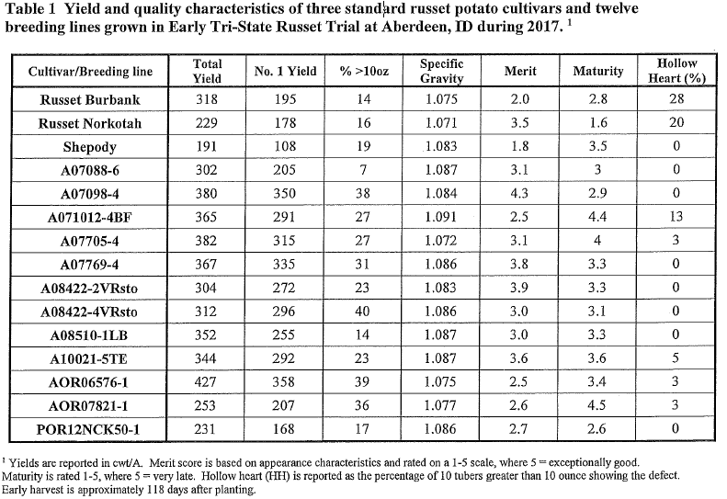
In the Late Tri-State Russet Trial, the top yielding clones were A07769-4, A071012-4BF, Al0021-5TE, and AOR06576-1, all of which produced significantly higher total and US No. 1 yields than the standard cultivars (Table 2). A07705-4 and A07098-4 also perf01med well. Specific gravities for A07769-4, A071012-4BF, and A10021-5TE were considerably higher than Ranger Russet, while those for A07705-4 and AOR06576-l were lower than Russet Burbank but higher than Russet Norkotah. Merit scores were highest for A07769-4, A10021-5TE A08422-
2VRsto and A07098-4. Fry colors after 3 months of storage at 45°F were generally light for all clones except for AOR06576-l and A07098-4.

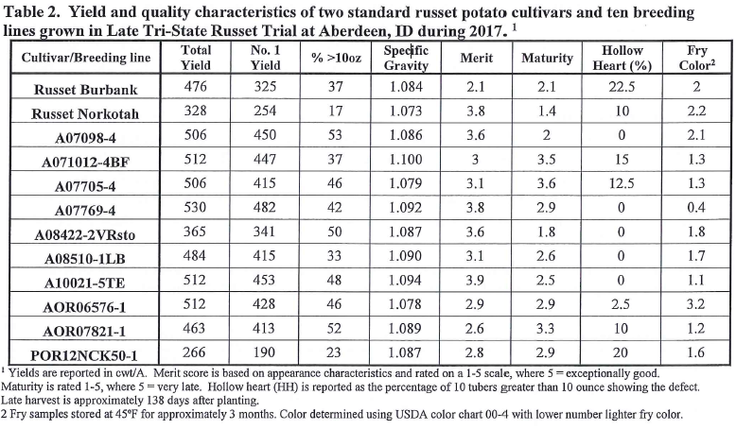
In the Late Western Regional Trial at Aberdeen, the top yielding clones were A08433-4VR, A07061-6, and AOR06070-1KF (Table 3), all of which exceeded the standard cultivar yields. Specific gravities for each of the top yielding clones were higher than Russet Burbank. The incidence of hollow heart for AOR06070-1KF (43%) is a potential concern since it averaged 40% hollow heart in 2015. C008065-2RU and C00823 l-1RU also had high percentages of hollow heart. All of the clones had relatively light fry colors after 3 months of storage at 45°F
except for TX08352-5Ru. TX08352-5Ru, A08009-2TE and A06030-23 had the highest merit scores.
There also were some very high yielding clones in the Late Western Regional Trial at Kimberly, including A07061-6, COTX09022-3RuRE/Y, A08433-4VR, and A03141-6 (Table 4). A07061-6, A03141 -6 produced the highest US No. 1 yields, which were substantially higher than the standard cultivars. Specific gravities for the four highest yielding experimental clones were all higher than the standard varieties. Merit scores were highest for TX08352-5Ru, C00823 l-1RU, A006191-1, AOR06070-1KF, A06030-23, and C008065-2RU. All clones had acceptably light
fry colors after 3 months of storage, except for A08009-2TE and TX08352-5Ru.
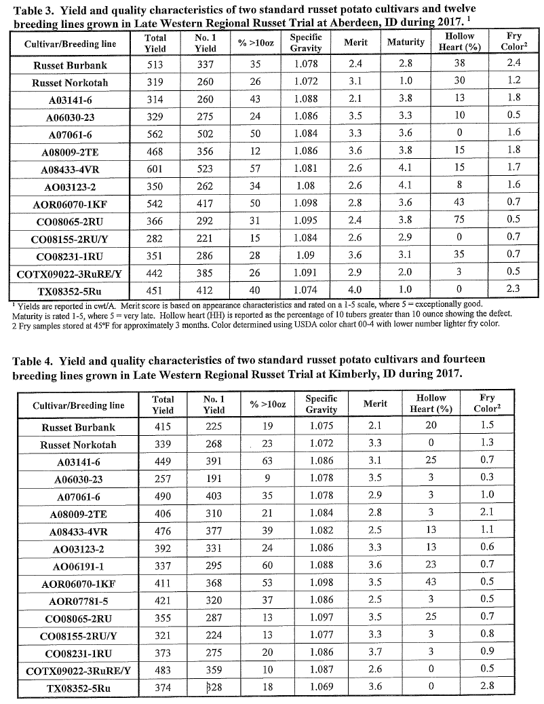
National Fry Processing Trial: A total of twelve breeding clones and varieties from our program were also entries in the 2017 National Fry Processing Trial (NFPT) which seeks to identify processing varieties having low acrylamide that could be rapidly adopted by the U.S. potato processing industry. Five of twelve entries were entered into the Tier 2 category, with the remaining seven entries entered into Tier 1. Following discussion and final recommendations of the NFPT Steering Committee, those 2017 entries found acceptable for trialing in 2018 will be advanced to Tiers 2 and 3, with an additional six new entries identified for Tier 1 evaluations in 2018. In addition, the breeding program is progressing in developing germplasm with genetic resistance to PVY, PVX, and PLRV, PMTV, late blight (foliar and tuber), nematodes, corky ringspot and zebra chip disease- for example several entries in the NFPT in 2017 exhibited extreme resistance to PVY. New varieties will continue to be released in cooperation with the University ofldaho Nuclear Seed Program, private seed growers in the state, and the processing and fresh pack industries.
Agronomic Research Trials: Additional studies were conducted in 2017 designed to compare nitrogen use efficiency of 5 advanced selections from the breeding program with that of Russet Burbank. The efficiency ofN fertilizer use for these new clones is substantially greater than standard varieties, ranging from 10-25% better than Russet Burbank. Reducing fertilizer applications per unit of yield produced would provide a considerable economic benefit to growers and would also contribute significantly to the sustainability of potato production systems. Additional studies were conducted to determine optimal phosphorus rates, seed management practices, seed piece spacing, and N management guidelines for new and previously released Tri-State varieties. The phosphorus requirements of most of the new varieties were similar to or lower than those for Russet Burbank and Ranger Russet.
Specialty Trial Results: Field Evaluations - Seed of two standard potato cultivars and 4 breeding lines were obtained from Brian Charlton (OSU, Klamath Falls). This seed was used in replicated trials at both the Paima and Aberdeen R&E Centers. The seed was cut, organized into a randomized, four-replicate trial, and planted at the Aberdeen and Parma R & E Centers. Chieftain produced the highest total tuber yields at both Paima and Aberdeen (Tables 5 and 6). Among the yellow-fleshed selections, both A06336-2Y and A06336-5Y performed sirnilai· to Yukon Gold in terms of total yield, but had higher yields in the premium 2-6 oz size category.
Among fingerling types, POR11PG62-3 had higher total and premium yields compared to LaRatte at Parma, but performed similarly to LaRatte at Aberdeen. Tubers above 10 oz are not generally desirable for the specialty market. Both Chieftain and
Yukon Gold produced a high proportion of greater than 10 oz tubers at Parma and Aberdeen
(Tables 5 and 6). A06336-2Y, A06336-5Y, LaRatte and POR11PG62-3 all produced few to no greater than 10 oz tubers. Specific gravity ranged from 1.059 to 1.0779 at Paima, and from 1.070 to 1.084 in Aberdeen
(Tables 5 and 6). Specific gravity greatly effects cooking quality, and this information should be used with the culinai-y evaluations reported in the WSU cultivar report to make decisions about appropriate uses for these new potential varieties.
Most of the entries showed very few external and internal defects. The exceptions were growth cracks in Chieftain and POR11PG62-3 at Parma, and common scab in Yukon Gold at Aberdeen, and hollow heart in Yukon Gold at both locations (Tables 5 and 6).
Merit score is a combined evaluation of yield, tuber size distribution, tuber shape uniformity, and appearance. A06336-2Y was the only entry that had high merit scores at both Parma and Aberdeen, while A06336-5Y had the highest merit score at Aberdeen.

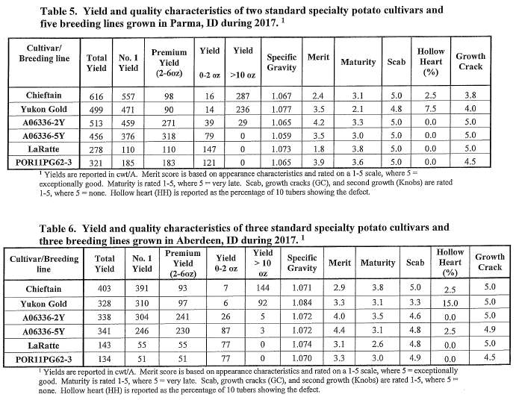
Biochemical Assessments- The cultivars and breeding lines showed a range of biochemical characteristics, such as solids, antioxidant levels, glycoalkaloids, and Vitamin C content (Table 7). None of the glycoalkaloid levels were high enough to cause concern, while POR11PG62-3 was noteworthy for high antioxidant and Vitamin C content.

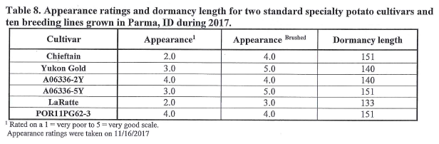

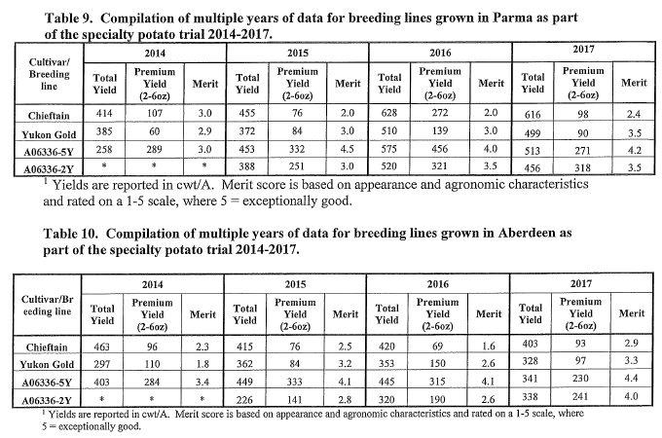

PUBLICATIONS:
Bali, S., V. Sathuvalli, C. Brown, R. Novy, L. Ewing, J. Debons, D. Douches, J. Coombs, D.
Navarre, J. Whitworth, B. Charlton, S. Yilma, C. Shock, J. Stark, M. Pavek, and R. Knowles.
2017. Genetic fingerprinting of potato varieties from the Northwest Potato Variety Development
Program. American Journal of Potato Research 94:54-63.
Novy, R.G., J.L. Whitworth, J.C. Stark, B.L. Schneider, N.R. Knowles, M.J. Pavek, L.O.
Knowles, B.A. Charlton, V. Sathuvalli, S. Yilma, C.R. Brown, M. Thornton, T.L. Brandt, N.
Olsen. 2017. Payette Russet: A Dual-Purpose Potato Cultivar with Cold-Sweetening Resistance,
Low Acrylamide Formation, and Resistance to Late Blight and Potato Virus Y. American Potato
Journal 94:38-53.
Endelman, J.B., C.A. Schmitz Carley, D.S. Douches J.J. Coombs, B. Bizimungu, W.S. De Jong,
K.G. Haynes, D.G. Holm, J.C. Miller Jr., R.G. Novy, J.P. Palta, D.L. Parish, G.A. Porter, V.R.
Sathuvalli, A.L. Thompson, and G.C. Yencho. 2017. Pedigree reconstruction with genome-wide
markers in potato. American Journal of Potato Research 94:184-190.
Mondal, S., Lin, Y., Carroll, J.E., Wenninger, E.J., Bosque-Perez, N.A., Whitworth, J.L.,
Hutchinson, P., Eigenbrode, S., and S.M. Gray. 2017. Potato virus YTransmission Efficiency
from Potato Infected with Single or Multiple Vims Strains. Phytopathology 107:491-498.
Mondal, S., Wenninger, E.J., Hutchinson, P.J.S., Whitworth, J.L., USDA-ARS, Shrestha, D.,
Eigenbrode, S.D., Bosque-Perez, N.A., and W.E. Snyder. 2017. Responses of Aphid Vectors of
Potato leaf roll vims to Potato Varieties. Plant Disease 101 :1812-1818.
Rashidi, M., R.G. Novy, C.M. Wallis, and A. Rashed. 2017. Characterization of host plant
resistance to zebra chip disease from species-derived potato gentoypes and the identification of
new sources of zebra chip resistance. PLoS ONE 12(8): e0183283.
https://doi.org/10.1371/journal.pone.O 183283
Schmitz Carley, C.A., J.J. Coombs, D.S. Douches, P.C. Bethke, J.P. Palta, R.G. Novy, and J.B.
Endelman. Automated tetraploid genotype calling by hierarchical clustering. 2017. Theoretical
and Applied Genetics 130:717-726.
Stark, J.C., R.G. Novy, J. L.Whitworth, N.R. Knowles, M.J. Pavek, M. Thornton, C.R. Brown,
B.A. Charlton, V. Sathuvalli, T.L. Brandt, N. Olsen and S.Yilma. 2017. Pomerelle Russet: An
Early Maturing Potato Variety with High Yields of U.S. No. 1 Tubers Suitable for Fresh Market
and Mid-Storage Processing and Tolerance to Potato Mop-Top virus. American Journal of Potato
Research, DOI: 10.1007/s12230-017-9593-l; In Press.
Wang, Y., L.B. Snodgrass, P.C. Bethke, A.J. Bussan, D.G. Holm, R.G. Novy, M.J. Pavek, G.A.
Porter, C.J. Rosen, V. Sathuvalli, A. Thompson, M.K. Thornton, and J.B. Endelman. 2017.
Reliability of measurement of genotype x environment interaction for potato specific gravity.
Crop Science 57:1966-1972
Yilma, S., B. A. Charlton, C. C. Shock, D. C. Hane, S. R. James, A. R. Mosley, K. A. Rykbost,
E. B. G. Feibert, N. R. Knowles, M. J. Pavek, J. C. Stark, R. G. Novy, J. L. Whitwmih, J. J.
Pavek, D. L. Corsini, T. L. Brandt, N. Olsen, C.R. Brown, M. I. Vales, and Vidyasagar
Sathuvalli. 2017. Sage Russet: a New High Yielding Russet Potato Variety with ColdSweetening
Resistance, High Vitamin C and Protein Contents and Excellent Fresh Pack and
Processing Potential. American Journal of Potato Research 94:379-389.

