Accomplishments:

This section of the report is presented by objective, and primarily highlights data and publications that have been completed to date.

Objectives

- Estimate genetic variation associated with animal health using classical animal breeding and genomic techniques to facilitate sustainable beef cattle production systems.

Objective 1.1 External Parasites

University of the Virgin Islands. This study was conducted to evaluate the tick load of Senepol cows and their calves under tropical conditions. Data was collected on 140 spring calving cow calf pairs in 2011 through 2015. Cows and calves were evaluated for tick burden at weaning and calves were evaluated again as yearlings. Tick load was evaluated using a visual score (1 = clean, 2 = light, 3 = moderate or 4 = heavy) prior to acaricide treatment. The change in calf tick core between weaning and yearling was calculated as (yearling score – weaning score). Correlations among cow and calf traits were evaluated using PROC CORR. Ticks scores at weaning and yearling, and changes in scores over time (weaning to yearling) were analyzed using GLM with sire, sire line and sex in the model.
Cow tick score and calf tick score at weaning were not correlated (r = -.03, P > 0.10). In calves tick score at weaning had a low, negative correlation with yearling tick score (r = -0.18, P = 0.04). Cow tick score at weaning was correlated with calf yearling tick score (r = 0.23, P < 0.009).
Tick scores was not different between bulls and heifers at weaning (1.4 ± 0.1 vs. 1.5 ± 0.1 respectively; P > 0.10) or at yearling (2.5 ± 0.1 vs 2.3 ± 0.1, respectively: P < 0.10). Tick score increased from weaning to yearling in bulls and heifers (P < 0.0001). The magnitude of change in calf tick score from weaning to yearling was not different between bulls and heifers (1.3 ± 0.2 vs. 1.1 ± 0.2, respectively; P > 0.10). The tick scores at weaning and yearling were different among sires (Figures 1 and 2) and sire lines (Figures 3 and 4). The change in calf tick score from weaning to yearling was different among sires (Figure 3) and lines (Figure 4).

Figure 1. Weaning tick score of Senepol calves by sire. Numbers inside bars indicate the number of calves out of the sire.

Figure 2. Yearling tick score of Senepol calves by sire. Numbers inside bars indicate the number of calves out of the sire.

Figure 3. Weaning tick score of Senepol calves by sire line. Numbers inside bars indicate the number of calves out in that sire line

Figure 4. Yearling tick score of Senepol calves by sire line. Numbers inside bars indicate the number of calves out in that sire line

Figure 5. Change in tick score (Yearling score – Weaning score) in Senepol calves by sire. Numbers inside bars indicate the number of calves out of the sire.

Figure 6. Change in tick score (Yearling score – Weaning score) in Senepol calves by sire line. Numbers inside bars indicate the number of calves out of the sires in that line.

The relationship between cow and calf tick scores at weaning, and as yearlings, was low. There were differences in tick scores at weaning and yearling, and changes in tick scores over time, among sires and sire lines.
The tick load scoring system has been incorporated into data collection as part of the routine management of the herd. The low correlation of tick load between cows and calves, and even within calves, and the frequent dipping schedule may limit the amount of progress that can be made when selecting for the trait of tick resistance.

Objective 1.2 Eye and facial pigmentation associated with animal health
Texas A&M:
- Tables 1, 2, 3 show current numbers. DNA not collected on all so misleadingly high.
- Lesions reported in tables have not been confirmed by veterinarian.
- Added North Dakota State University, several Hereford herds in South Africa
- Bulls don’t give us much info because there are generally few and many have been selected for eye pigmentation
- Across year photo sequence appears to confirm scleral pigmentation occurrence in response to insult.

Table 1. Eye pigmentation record totals
 | Hereford | Bos indicus | Bos taurus
2012 Davis et al. | 120 | 492 | 471
2013 calves | 24 | 59 | 119
2013 cows | 23 | 56 | 9
2013 yearlings |  |  | 25
2014 calves | 17 | 114 | 26
2014 cows | 0 | 14 | 37
2014 yearlings |  |  | 2
2015 calves | 0 | 60 | 18
2015 yearlings | 0 | 6
2016 calves | 0 | 216 | 79
2016 cows | 218 | 97 | 184
2016 yearlings | 15 | 15 | 107
Lesions | 77 | 34 | 29
Total | 417 | 1,129 | 1,077

Table 2. Repeated images for monitoring scleral pigmentation changes
 | Hereford | Bos indicus | Bos taurus
2013 | 28 | 74 | 60
2014 | 18 | 181 | 48
2015 |  | 75 | 35
2016 |  | 103 | 57
Lesions | 17 | 20 | 8
Total | 46 | 433 | 200

Table 3. Lesions observed
 | Animals | Both eyes | Sclera | Lower lid | Upper lid | Inner lid | Caruncle | Whole eye | Pigmented
Hereford | 77 | 22 | 39 | 11 | 2 | 3 | 4 | 17 | 43
Bos indicus | 34 | 6 | 10 | 4 | 1 | 13 | 4 | 5 | 11
Bos taurus | 29 | 6 | 12 | 1 | 1 | 3 | 2 | 10 | 13

Objective 1.3 Udder conformation
Texas A&M:
Same cows as resource herds in Objective 1.2: Whiteface (Table 4) and Brahman (Table 5)
Two scores to record:
Teat size scores and udder support scores 1 to 9 per BIF (2010) guidelines

- Birth when calves are weighed and tagged.
- Mid-lactation (3-4 mo calf age)
- One week post-weaning

Observations at birth will be on different days according to calving. The other observations should be done as much as possible in a single day, and as much as possible by the same person.

Noting abnormalities of the udder may permit us to create analyzable traits.

Include sire and dam of cow in file.

Table 4. Descriptive statistics for udder scores of white face cows at College Station (76 cows) and Menard (45 cows)
 |  |  |  | Correlation coefficients
 | N | Mean | SD | 2 | 3 | 4 | 5 | 6
Spring udder 1 | 182 | 6.73 | 1.82 | 0.66 | 0.54 | 0.48 | 0.53 | 0.48
Spring teat 2 | 182 | 6.88 | 1.66 |  | 0.45 | 0.55 | 0.62 | 0.55
Mid udder 3 | 145 | 6.32 | 1.90 |  |  | 0.67 | 0.53 | 0.50
Mid teat 4 | 145 | 6.61 | 1.82 |  |  |  | 0.49 | 0.54
Wean udder 5 | 184 | 6.71 | 1.85 |  |  |  |  | 0.66
Wean teat 6 | 184 | 6.99 | 1.81
¹Udder and teat scores per Beef Improvement Federation Guidelines: 1 = very pendulous udder; very large, balloon-shaped teats; 5 = intermediate, moderate size udders or teats; 9 = very tight udder; very small teats.

Table 5. Brahman udder scores (2016 only)
 |  | Udder score |  |  | Teat score
 | Birth | Mid | Wean | Birth | Mid | Wean
Mean | 3.59 | 2.95 | 3.86 | 3.63 | 4.73 | 5.77
SD | 1.19 | 1.29 | 1.61 | 1.90 | 1.28 | 1.93
Min | 1 | 1 | 1 | 1 | 3 | 2
Max | 5 | 6 | 8 | 6 | 7 | 9

University Of Arkansas:
Assess genetic control of udder characteristics across lactation and parity.
Cattle will be evaluated for Udder conformation traits and scored according to BIF guidelines (2010) for Udder Suspension and Teat size. Scores for each trait range from 1 to 9 with 9 indicating tight suspension and small teat size and will be evaluated at calving, mid-lactation and weaning. In addition, any udder abnormalities such as evidence of mastitis, dead quarters, tumors, injuries or other diseases will be recorded. Cow traits related to reproductive performance and calf traits to include sire/sire breed of calf, birth weight and date, weaning weight and date and post weaning performance will be recorded.
Cattle will be evaluated at weaning for foot conformation according to the foot score guidelines from the American Angus Association. Scores for each trait range from 1 to 9 with 9 indicating extremely shallow heel, long toe and extremely weak pasterns for foot angle and extreme scissor claw and/or screw claw. Pronounced curling of one or both claws and crossing of claws for claw set. A score of 5 is considered Ideal. Cow traits related to reproductive performance and calf traits to include sire/sire breed of calf, birth weight and date, weaning weight and date and post weaning performance will be recorded.

The objective of this study was to determine if any relationships exist between udder conformation, Foot conformation and production traits in cows housed at the University of Arkansas beef research unit near Fayetteville. An Angus-based fall calving cow herd (n=316) was observed and udder scores were recorded at birth, mid-lactation and at weaning. Cows were evaluated on a scale from 1 to 9 for udder suspension and teat size according to BIF guidelines. A score of 1 indicated a very pendulous suspension and large, balloon shaped teats and a score of 9 represented a tight suspension and refined teat size. Foot scores were also evaluated at weaning according the to the American Angus Association foot scoring guidelines.

Table 1: Udder Suspension and Teat Score means.
 | Calving |  | Mid-Lactation |  | Weaning
 | Udder | Teat Size | Udder | Teat Size | Udder | Teat Size
Overall Mean | 6.57 | 6.4 | 6.08 | 6.35 | 6.0 | 6.18
Age
2 | 7.2 | 6.7 | 6.2 | 6.0 | 6.8 | 6.8
3 | 7.1 | 6.7 | 6.4 | 6.5 | 6.1 | 6.3
4 | 6.9 | 6.2 | 6.1 | 6.3 | 6.0 | 6.0
5-9 | 6.3 | 6.3 | 6.2 | 6.5 | 5.8 | 6.1
10 | 6.0 | 6.0 | 5.9 | 6.5 | 5.9 | 6.1
11+ | 5.9 | 6.5 | 5.7 | 6.3 | 5.4 | 5.8

Table 2: Mean Weaning Weight across Udder Scores.
 | Udder Suspension | Teat Size
4 | 552.36 | 502.14
5 | 530.25 | 507.28
6 | 513.02 | 520.78
7 | 469.22 | 486.94
8 | 434.09 | 479.41

Table 3: Claw set means
Claw Set  Score | Cow BW | BCS | Calf wean wt.
4 | 1064.0 | 4.75 | 482.5
5 | 1127.1 | 4.85 | 532.5
6 | 1138.1 | 4.6 | 502.1
7 | 1142.6 | 4.5 | 475.4
8 | 1095.4 | 4.3 | 471.9
Table 4: Foot Angle means
Foot Angle Score | Cow BW | BCS | Calf wean wt.
5 | 1197.4 | 4.6 | 500.2
6 | 1100.8 | 4.3 | 475.8
7 | 1142.6 | 4.8 | 511.9
8 | 1212 | 5 | 523.65

These data indicate that udder suspension and teat size score does vary not only with age but also over the course of post-partum production. Udder suspension and Teat score was noted to have a relationship with weaning weight but could be related to maturity of the cow. There does seem to be evidence that the closer to the Ideal score of 5 the greater the calf weaning wt.

Foot conformation as it relates to soundness, udder suspension and teat quality are among the most important functional traits of beef females. Foot problems along with unsound udders and teats are associated with reduced productive life and inferior calf performance, and is a major reason why cows are culled from the breeding herd. Understanding the implications of theses scores could improve the culling process and improve production efficiency and productive life.

Mississippi State University (Starkville):
Udder and teat scores were collected on Angus (n=163 cows with 354 records), Charolais (n=54 cows with 100 records) and Hereford (n=23 cows and 57 records) fall calving cows from 2011 to 2015 with a dam age ranging from 2 to 13 yr. Udder and teat scores were taken at calving using Beef Improvement Federation guidelines. Udder scores ranged from 1 (very pendulous) to 9 (very tight). Teat scores ranged from 1 (very large, balloon-shaped teats) to 9 (very small teats). Calf performance data included BW and WW. Udder data were analyzed using the MIXED procedure of SAS with udder or teat scores as response variables with year, breed, and dam age as fixed effects with dam as a random effect. Calf performance data were analyzed within breed with WW as the response variable with fixed effects of sex and udder score with dam age and age at weaning as covariates and sire as the random variable.
Birth weight was negatively correlated with udder (-0.20) and teat (-0.20) scores (P<0.001). Breed significantly affected udder scores with Angus dams having the higher scores (6.76 ± 0.14) when compared to Charolais (6.14 ± 0.20) and Hereford (5.99 ± 0.25) which were similar (P<0.05). Teat scores followed the same pattern as Angus dams had significantly higher scores than Charolais and Hereford which were not different (P<0.05). Dams 11 yr or older had the lowest udder scores while 4 yr olds and 5 to 10 yr olds were intermediate with 2 and 3 yr olds having the highest (P<0.005). Results were similar for teat scores with 11+ yr old cows having the lowest teat scores while 5 to 10 yr olds were higher but lower than 2, 3, and 4 yr olds which were similar (P<0.05). There were no differences in WW due to udder scores for the three breeds. For teat scores, WW was significantly different in Angus with calves weaning the lightest from dams with a score of 1 and heaviest from dams with a score of 2, 3, and 5 (P<0.05). Breed and age differences existed for udder and teat scores. A relationship existed between Angus teat scores and calf weaning weights.

Results were similar to other findings on udder conformation in beef cattle. Udder and teat scores should be taken at calving and at weaning in order to identify problem cows and to prevent smaller weaning weights at weaning.
- Meta-analyses of economically important traits of cow productivity and fertility to assess breed and production system combinations.
University of Florida:
Activities:
- Collection of health, survival, fertility, growth, ultrasound, carcass, and meat palatability data from animals from the multibreed Angus-Brahman (MAB) and Brahman herds from the University of Florida (UF). Utilization of embryo transfer to increase the size of the Brahman herd.
- Updating and maintenance of the MAB and Brahman herd databases containing health, survival, fertility, preweaning growth, postweaning growth, carcass and meat palatability data (n = 7,523).
- Collection of blood samples from calves (n = 314), and semen or blood from new sires (n = 14) used in the MAB and Brahman herds (stored at UF).
- Genomic-polygenic and polygenic predictions for nine ultrasound and carcass traits in Angus-Brahman multibreed cattle using three sets of genotypes.
- FORTRAN software updates for editing of phenotypes, genotypes, and pedigree data and construction of input data files for imputation from lower to higher-density genotyping chips followed by genomic-polygenic evaluation using single-step methodology.
- SAS programs updates for editing, statistical description, and mixed model analysis of feed intake, growth, ultrasound, carcass, and meat palatability traits in the MAB and Brahman populations.
- Development of a statewide Brahman and Brahman-Angus database that includes pedigree and phenotypic information for fertility, growth, ultrasound, carcass, and meat palatability traits from private Brahman and UF herds.
- Development of a statewide Brahman and Brahman-Angus tissue sample repository with blood, ear-notches, and semen samples from private Brahman and UF herds.
- Association of SNPs and haplotypes in µ-calpain and calpastatin genes with Warner-Bratzler Shear Force in a multibreed Brahman-Angus population (R. Mateescu).
- Influence of Brahman genetics on muscle fiber properties, protein degradation, and tenderness in the Angus-Brahman multibreed herd (T. Scheffler).
- Colonization dynamics of Cefotaxime resistant bacteria in beef cattle raised without Cephalosporin antibiotics (K. C. Jeong).
- Influence and regulation of vitamin D on the immune system, health, and growth of beef calves (C. D. Nelson).

  - Genomic-polygenic and polygenic predictions for nine ultrasound and carcass traits in Angus-Brahman multibreed cattle using three sets of genotypes. The objectives of this study were to estimate variance components, genetic parameters, EBV, accuracies, and rankings for nine ultrasound and carcass traits in a multibreed Angus-Brahman population using three genomic-polygenic models and one polygenic model (PM). The genomic-polygenic models used the complete GeneSeek GPF250k SNP set (GPM), top 5% SNP (GPMR1), and 5% SNP evenly spread across the genome (GPMR2). Yearling ultrasound traits were weight (UW), ribeye area (UREA), backfat (UFAT), and percent intramuscular fat (UPIMF). Carcass traits were slaughter age (SLA), hot carcass weight (HCW), ribeye area (REA), backfat thickness (FAT), and marbling score (MAR). The 9-trait GPM, GPMR1, GPMR2, and PM contained fixed contemporary group, age of calf (ultrasound traits only), sex of calf, and direct heterosis effects, and random animal and residual effects. Variance components and genetic parameters were computed using AIREMLF90. Comparable heritabilities were obtained with GPM and PM for UW (GPM: 0.54 ± 0.05; PM: 0.51 ± 0.05), UREA (GPM: 0.36 ± 0.03; PM: 0.34 ± 0.03), UFAT (GPM: 0.12 ± 0.02; PM: 0.11 ± 0.02), UMPIMF (GPM: 0.34 ± 0.03; PM: 0.30 ± 0.03), SLA (GPM: 0.59 ± 0.07, PM: 0.61 ± 0.06), HCW (GPM: 0.58 ± 0.06, PM: 0.52 ± 0.07), REA (GPM: 0.48 ± 0.04, PM: 0.45 ± 0.05), FAT (GPM: 0.41 ± 0.05, PM: 0.30 ± 0.05), and MAR (GPM: 0.56 ± 0.07, PM: 0.51 ± 0.08). Additive genetic correlations between pairs of ultrasound and carcass traits were all between -0.31 and 0.81. The highest positive additive genetic correlations were between UW and UREA, UW and HCW, UW and REA, UREA and HCW, UREA and REA, UFAT and FAT, and between HCW and REA. The largest negative additive genetic correlations were between UREA and UPIMF, UFAT and SLA, UFAT and HCW, UPIMF and REA, and between REA and MAR. High similarity among genomic-polygenic EBV and accuracies from GPM, GPMR1, and GPMR2 as well as high-rank correlations for sires, dams, and progenies indicated that the two reduced genotype sets were appropriate alternatives to the complete GPF250k SNP set for animal evaluation and selection in this multibreed Angus-Brahman population. High EBV variability among animals of all Angus and Brahman percentages indicated that optimization of genetic progress through selection in multibreed Angus-Brahman populations should be based solely on genetic merit regardless of breed composition. As an example, Figure 1 below shows genomic-polygenic EBV (GEBV) for two ultrasound traits (ribeye area and intramuscular fat) and their corresponding carcass traits (ribeye area and marbling).

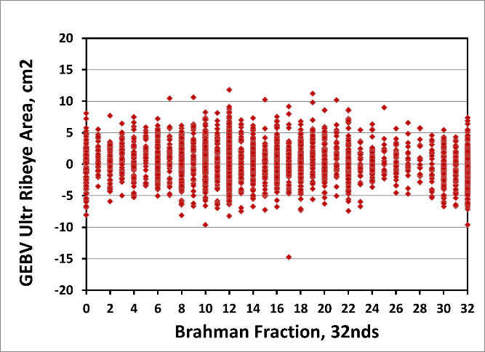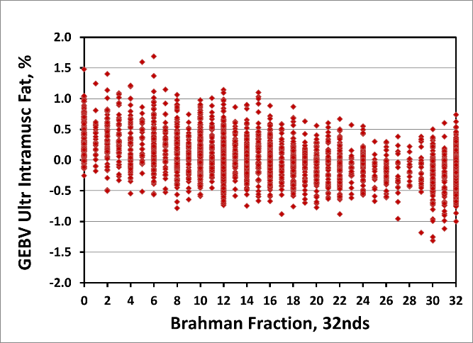
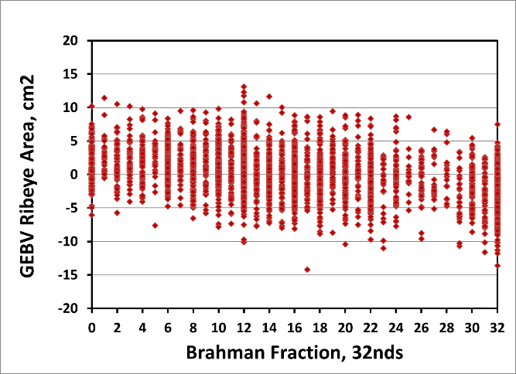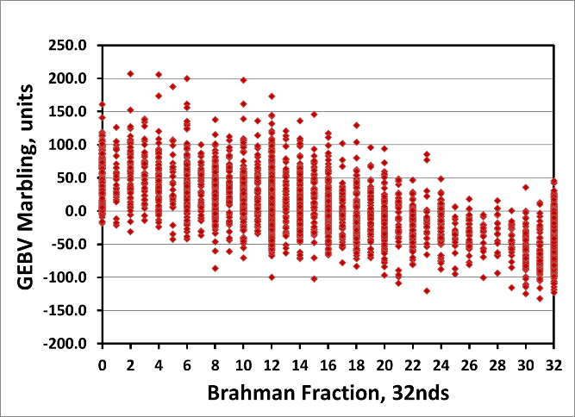
Figure 1. Genomic-polygenic EBV (GEBV) for two ultrasound traits (ribeye area and intramuscular fat) and their corresponding carcass traits (ribeye area and marbling)

  - The Florida Brahman genomics project. This two-year project was initiated in January 2017. Its aim is to develop a statewide selection and mating program for Florida Brahman cattle focused on genomic selection and assortative mating to improve three target traits of high economic importance: meat tenderness, marbling, and reproductive tract score, a trait closely associated with fertility and age at first calving. Currently there are seven Brahman breeders contributing to the project with pedigree and phenotypic data as well as tissue samples (blood, ear notches, semen) for genotyping with GeneSeek GGP250k or GGP50k. The American Brahman Breeders Association supplied pedigree (n = 15,844) and growth data (n = 7,358) files containing accumulated information from 1976 to 2016. The UF multibreed Angus-Brahman and the Brahman herds will contribute with pedigree (n = 8,302), phenotypes for reproduction, growth, ultrasound, carcass, and meat palatability traits (n = 6,755), and existing genotypes (Illumina 3k, GeneSeek GGP 150k, GeneSeek GGP 250k). Current work includes acquisition of 2016 and 2017 pedigree and phenotypic data from Florida Brahman breeders, semen and ear notch samples for genotyping, and integration of the ABBA, UF, and Florida Brahman breeder pedigree and phenotypic datasets. This will be followed by the testing of multiple-trait genomic-polygenic analyses for several sets of traits (e.g., reproductive tract score, age at first calving, and first calving interval; weaning weight, ultrasound weight, ultrasound ribeye area, ultrasound marbling; ultrasound weight, ultrasound ribeye area, ultrasound marbling, slaughter age, hot carcass weight, ribeye area, marbling, tenderness). Subsequently, the use of these genomic-polygenic predictions will be explained to Florida Brahman and discussed in the context of their individual herds as well as the complete Florida Brahman population. Table 1 below shows the number of pedigree and phenotype records, tissue samples, and GeneSeek GGP250 genotypes as of April 2017.
Table 1. Records, Tissue Samples, and Genotypes (April 2017)
Dataset | Pedigree file | Phenotype file | Tissue Samples | GeneSeek GGP250k
Florida Brahman breeders | 198 | 115 | 1,400 | 0
ABBA (All years; Unedited files) | 15,844 | 7,358 | 0 | 0
UF Brahman herd | 673 | 446 | 475 | 47
UF Brahman-Angus Multibreed herd | 8,302 | 6,755 | 2,801 | 738

  - Brahman genetics influence on muscle fiber properties, protein degradation, and tenderness in the Angus-Brahman multibreed herd. The objective of this study was to determine influence of Brahman genetics on muscle contractile and metabolic phenotype and postmortem proteolysis. Cattle used in this study represent a continuous spectrum of Angus-Brahman genetic variation and were divided into six breed groups for analysis. Steers (n = 6 per breed group) were harvested and samples from Longissimus were collected at 1.5 h, 24 h, and 14 d postmortem. Western blotting and SDS-vertical agarose gel electrophoresis were used to assess proteolysis during the 14 d aging period, and immunohistochemistry and enzyme activity were used to evaluate muscle fiber characteristics. Tenderness at 14 d was determined by Warner-Bratzler shear force (WBSF) and a trained sensory panel. As Brahman influence increased, WBSF increased (P = 0.0009) and sensory tenderness decreased (P < 0.0001). Calpain-1 autolysis decreased as Brahman percentage increased (P=0.0025), and corresponded with reduced degradation of troponin-T, desmin, and titin. Increasing Brahman percentage was associated with greater citrate synthase activity and greater cross-sectional area of type IIx fibers. Brahman and Brahman-Angus crossbred cattle produced tougher steaks and exhibited decreased protein degradation. Brahman genetics influenced not only the calpain-calpastatin system, but also muscle fiber size and metabolic properties.

  - Association of SNPs and haplotypes in µ-calpain and calpastatin genes with Warner-Bratzler Shear Force (WBSF) in a multibreed Brahman-Angus population. Tenderness has been established as the most important quality trait in meat, especially in beef, and it essentially depends on the amount of connective tissue, myofibrillar protein degradation and intramuscular fat content. Myofibrillar protein degradation is a result of various autogenous proteolytic enzymes. The calpain family and their inhibitor calpastatin are the main effectors in this process of myofibrillar protein degradation.
The objectives of this study were to construct a linkage disequilibrium (LD) block analysis in µ-calpain and calpastatin genes and perform association tests per SNP and LD-Block with WBSF. Sixteen SNP in µ-calpain and 26 SNP in calpastatin were genotyped and the informative SNP were used in a LD-Block prediction test and association assay. The measurements cook loss (Pcookloss) and WBSF were recorded in steaks from 673 steers. WBSF measures the amount of force required to shear a core of cooked meat of 1.27 cm in diameter. High values of WBSF are indicative of tougher samples. The µ-calpain gene had one LD-Block (Figure 2), and UA-IFASA-1370 and 29-44097612 were their tagged SNP. Both SNPs are located in an intron region of µ-calpain. This LD-Block has an extension of 11 kb and includes seven exons. The last two exons are part of the 3’UTR. Calpastatin had three LD-Blocks. LD-Block 1 is located between ARS-BFGL-NGS-43901 (intron) and 7-98535683 (exon); this block has an extension of 37 kb distributed in the third intron of calpastatin and the next six exons. LD-Block 2 has 7-98542988 (intron), BovineHD0700028773 (exon) and 7-98560787 (exon) as tagged SNP; this LD-Block extends on 17 kb and covers various exons in the last third section of calpastatin. The tagged SNP of LD-Block 3 are ARS-USMARC-116 (intron) and 7-98581038 (3’UTR); this block is located in the final section of calpastatin with an extension of 14 kb and includes the 3’UTR (Figure 1). 3) The SNP marker ARSUSMARC116 was associated with WBSF. Animals with genotype CC had the highest WBSF value (4.73 ± 0.10 kg). Genotype CC yielded higher WBSF than genotypes TT (4.14 ± 0.17 kg) and CT (4.28 ± 0.11 kg). LD-Block 3 of calpastatin (ARSUSMARC116 is one of its tagged SNPs) was also associated with WBSF. LD-Block 3 diplotype CG-CG (4.75 ± 0.18 kg) had higher WBSF values than diplotype TA-CG (4.32 ± 0.12 kg), and both of them yielded hither WBSF values than diplotypes TA-TA (4.13 ± 0.11 kg) and TG-CG (3.77 ± 0.24 kg; Figure 3).

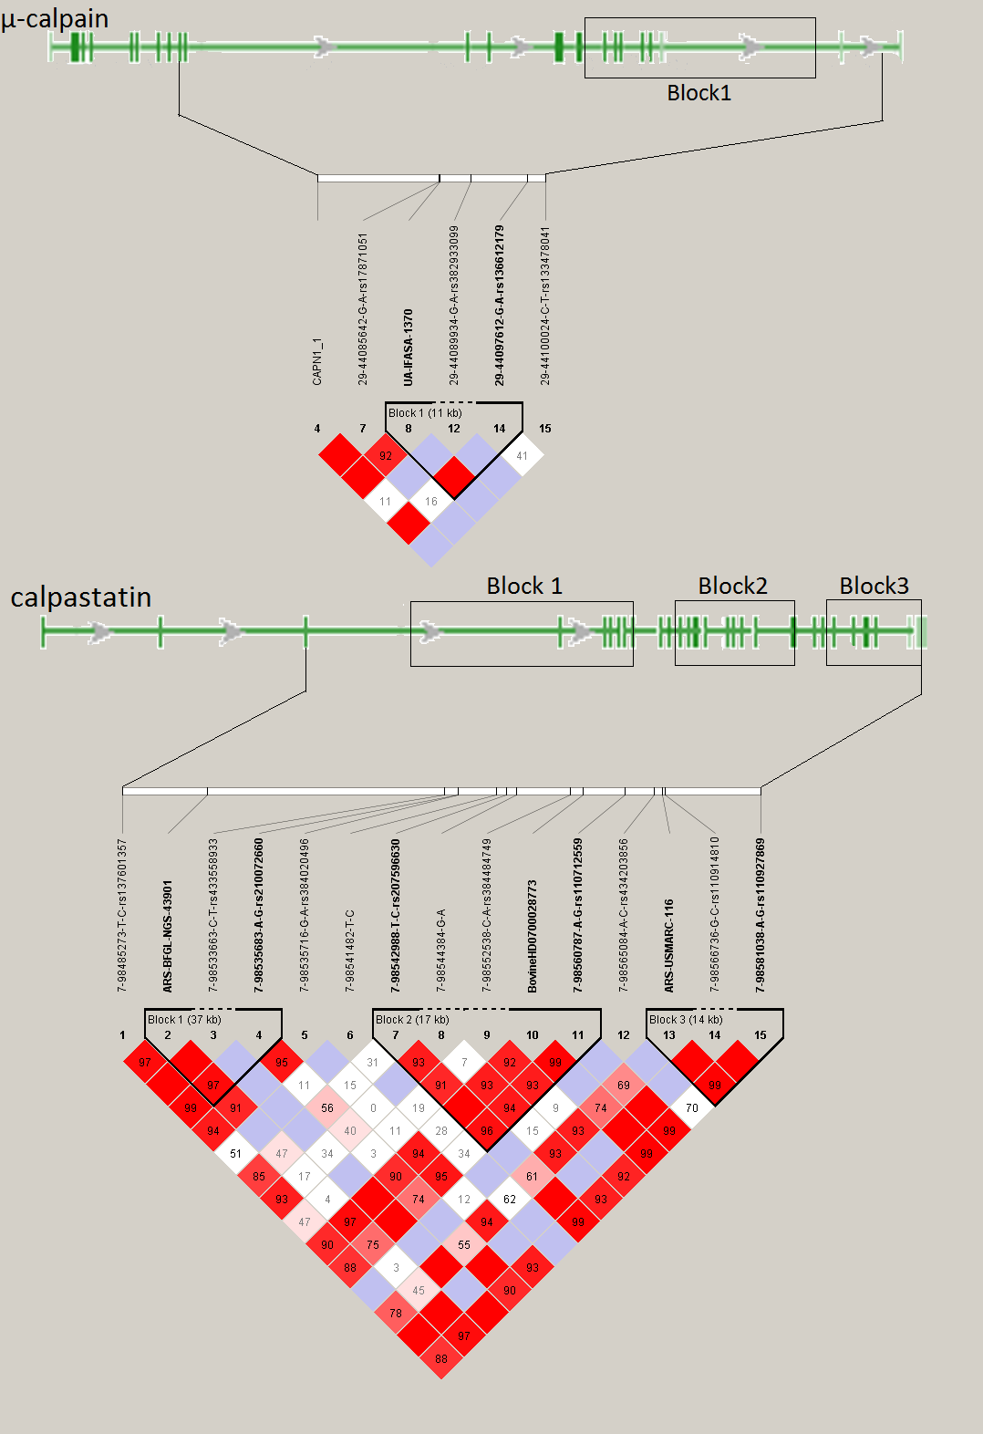

Figure 2. Linkage Disequilibrium blocks in 196 families. A. µ-calpain B. calpastatin.
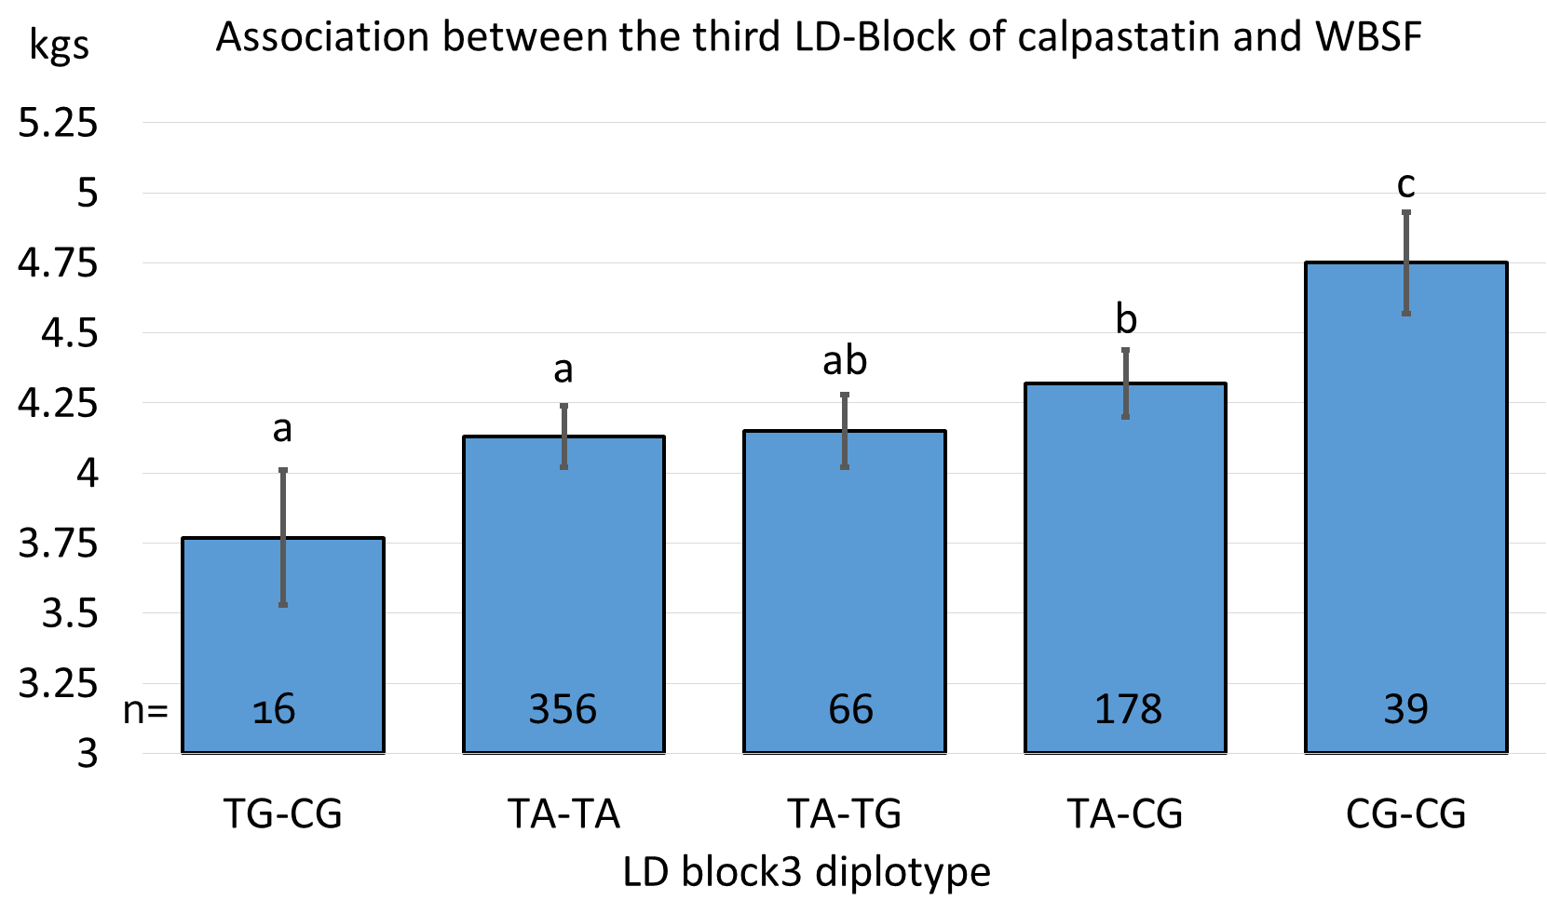

Figure 3. Association between the LD-Block 3 of calpastatin and the measurement WBSF. ARSUSMARC116 and 7-98581038 are the tagged SNPs in this LD-Block.

  - Colonization dynamics of Cefotaxime resistant bacteria in beef cattle raised without Cephalosporin antibiotics. The emergence of infections caused by antimicrobial resistant microorganisms (ARMs) is currently one of the most important challenges to public health and medicine. Though speculated to originate from the overuse of antibiotics during food animal production, we hypothesized that cattle are exposed to naturally occurring ARMs in the environment. In this cohort study, a herd of beef calves with no previous exposure to antibiotics was followed during the first year of life in order to investigate the rate of colonization by bacteria resistance to the third-generation cephalosporin cefotaxime. Fecal samples were collected from the recto-anal junction of cattle at approximately 3, 6, 9 and 12 months of age and tested for cefotaxime resistant bacteria (CRB) and the presence of extended spectrum β-lactamases (ESBLs). The colonization dynamics of CRB in calves (n = 188) was evaluated with samples collected from four periods using longitudinal statistical analyses. Colonization by CRB was a dynamic process with over 92% of the calves testing positive for CRB at least once during the first year of life. All isolates subjected to antimicrobial susceptibility test were resistant to at least five different antibiotics and carried multiple variants of the blaCTX-M genes. Metagenomic analysis revealed significant differences in microflora of the calves with and without CRB colonization at different ages. This study provided evidence that colonization of beef calves by ARMs is a natural, dynamic process that can occur in the absence of veterinary or agricultural use of antibiotics.

- Documentation of genetic components pertaining to heat tolerance adaptive traits in sustainable beef cattle production systems
Texas A&M:
Tables 6 and 7. Age of cow appears to be influential only in transition times.

Table 6. Descriptive statistics: monthly coat scores of Angus cows
Month | N | Mean | SD | Min | Max
April | 53 | 2.64 | 1.27 | 1 | 5
May | 53 | 2.64 | 1.27 | 1 | 5
June | 45 | 1.33 | 0.74 | 1 | 4
July | 50 | 1.12 | 0.44 | 1 | 3
Sep | 34 | 1.44 | 0.50 | 1 | 2
Oct | 53 | 1.70 | 0.75 | 1 | 3
Dec | 42 | 4.55 | 0.77 | 3 | 5
Jan | 57 | 4.84 | 0.49 | 3 | 5
Feb | 62 | 4.79 | 0.55 | 3 | 5
March | 61 | 4.95 | 0.28 | 3 | 5
April | 58 | 3.79 | 1.10 | 1 | 5

Table 7. Age category means for Angus cow coat score
 | April | May | October | April
2 | 4.14 ± 0.42ª | 4.22 ± 0.35ª | 2.31 ± 0.19ª | 4.61 ± 0.23ª
3 | 2.50 ± 0.36^{b} | 2.50 ± 0.33^{b} | 1.50 ± 0.21^{b} | 3.60 ± 0.31^{b}
4 | 2.40 ± 0.50^{b} | 2.40 ± 0.47^{b} | 1.80 ± 0.30^{ab} | 3.50 ± 0.49^{b}
5 | 2.11 ± 0.26^{b} | 2.05 ± 0.23^{b} | 1.50 ± 0.16^{b} | 3.38 ± 0.35^{b}
6 | 2.67 ± 0.46^{b} | 2.75 ± 0.37^{b} | 1.29 ± 0.26^{b} | 3.33 ± 0.23^{b}
¹P < 0.01
June and February 0.08 < P < 0.12
July, September, December, January P > 0.29.
Age categories: 2, 3, 4 correspond to years of age; 5 indicates cows from age 5 to 10; 6 indicates cows older than 10 yr.

University of Arkansas:
The objective of this study was to measure variation in hair coat shedding and determine if any relationships existed between coat shedding and production traits in cows housed at the University of Arkansas beef research unit near Fayetteville. An Angus-based commercial beef cattle herd (n = 160) was observed during 2016. Once monthly from March until July, at approximately 28-day intervals, mature cows and replacement heifers were evaluated for shedding on a scale from 1 to 5. A score of 5 indicated the cow/heifer had a full winter coat and a score of 1 represents a slick, short summer coat. For each cow, the first month a score of 3 (approximately 50% shed) or less was reached was considered the month of first shedding (MFS), and 3 levels were recognized reflecting MFS in May, June, July or After July (if cow had not shed by July). Phenotypic data for cow age, calf weaning weight, BCS of cow at weaning, BW of cow at weaning, BCS of cow pre-breeding, BW of cow pre-breeding, pregnancy rate, birth weight of calf and age of the cow were collected and analyzed in PROC MIXED of SAS. Frequency of MFS occurred with the following order: June>July>May>After July. Cow age was significantly different (P<0.01) with MFS group means for May and June being older than cows that exhibited MFS in July or After July with respective ages being 8, 7.9, 5.3 and 3.9. Cow BW prebreeding and cow BW at weaning was significantly greater (P<0.01) for cows that exhibited MFS in May and June compared to cows that exhibited MFS in July or After July. Adjusted calf birth weight was highest (P < 0.01) for cows exhibiting MFS in May and June (72 & 68 lb) compared to calf birth weight cows exhibiting MFS in July and After July (62 & 55 lb). Adjusted calf weaning weight was similar for all groups exhibiting calf weaning weights of 478, 466, 446, and 384 lb, respectively. In these data, MFS score did not effect (X² = 0.88) overall pregnancy rates with cows exhibiting MFS in May having overall pregnancy rate (100%), cows with MFS in June (96%) and July (95%) and with MFS After July (100%). Artificial insemination pregnancy rate was similar (X² = 0.49) for cows exhibiting MFS in May, June, July or After July.
In these data, MFS score impacted cow BW prebreeding, cow BW at weaning, and adjusted calf birth.

Hair shedding scores, although subjective, are well within the reach of both commercial and seedstock breeders. By using these scores and understanding their implications in cattle production will aid them in the match of genetic resource to production resources. This could easily increase current production by 10%.

Kansas State University:
A total of seven groups of 120 cross-bred steers, at least 240 days of age, with an approximate initial body weight of 284 kg are being used in a 91 day (21d adaptation and 70d test) feed and WI trial to establish baseline measurements, followed by a 35 day water restriction (this restriction will be preceded by a 35 day step-down in WI for a total study length of 161 days for each group of cattle). Only steer calves will be used to facilitate generation of truckload lots and eliminate sex effects. Within groups, all animals are blocked into two groups by weight and randomly allocated in a completely randomized block design to one of four pens (12.2 x 30.5 m) with 30 animals per pen. Each pen provides 186.5 m² of shade and is equipped with an Insentec feed and WI system comprised of six feed bunks and one water trough. Due to the capacity of the facility, each replication consists of 120 calves, for a total of seven replications in a ~3.5 year period (n=840). In addition to the cattle involved in the intake trial, at least 20 additional animals per replication will be maintained as a control group, receiving normal management in the feedyard. For the control group, we collect daily pen WI using water meters and carcass data upon harvest. For the cattle in the WI barn, each replication begins with a 21 day acclimation period following arrival at the Willard Sparks Beef Research Center (WSBRC) at Oklahoma State University in Stillwater, OK, in which cattle adjust to the growing ration, experimental facility, Insentec feed system, pen mates, and recover after transport. After the acclimation period, a 70 day feed and WI trial is conducted to assess relationships between WI and genetics, and the health, performance, and behavior of low vs. high WI animals. To be in compliance with feed intake guidelines outlined by the Beef Improvement Federation (BIF, 2012), weights are taken at least every 14 days (Figure 1). At the conclusion of this 70 day intake trial, each individual animal will have a baseline WI established. Animals in groups 1-3 were managed on a slick bunk protocol (SLICK) and animals in groups 4-5 were provided ad libitum access to feed. All animals had ad libitum access to water during the baseline period.
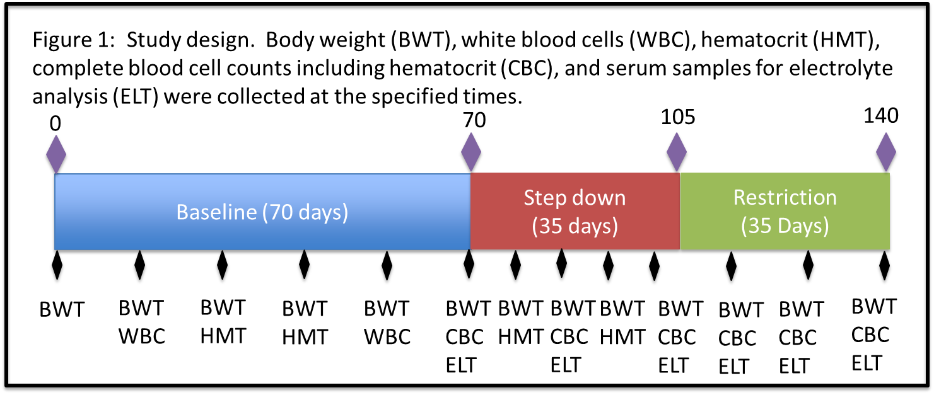
The Insentec system allows us to reduce WI each week for four weeks until a reduction of 50% of each individual steer’s baseline WI is achieved. Steers are allowed to acclimate to the 50% restriction for one week before being sustained at this level of WI for the final restriction phase (35 days). This restriction phase serves several purposes, including simulation of reduced WI that results from increased water adulterants and decreased water quality. It will also serve to evaluate the possibility of using mild water restriction as a management tool during extreme drought (provided that a relatively easy method for slight water restriction could be implemented on-farm and animal well-being is not significantly impacted). We will monitor the animal’s performance during this time as compared to the control group performance and behavior (social activity and quantitative heat stress measures) as well as their own data from the baseline period related to behavior, performance, health (blood cell counts, hematocrit levels, electrolyte balance), and feed intake. Those animals which exhibit the most consistent performance, show minimal thermal stress during this period, maintain immunity and health status (blood cell counts within a normal range and lack of visible disease), and display the lowest decline in hydration levels (including hematocrit and electrolyte balance), will be deemed those most adaptable. Microbial populations are sampled during both phases of the study and will be evaluated to determine how these populations change during restriction as well as to identify any fixed differences between those animals most efficient and adaptable versus those least adaptable. The water restriction level we chose is moderate compared to some literature estimates (Thornton and Yates 1968), and our procedure was tested on a small group of beef cattle prior to initiating this study to ensure that the level of restriction is appropriate and does not severely impact animal welfare. All animal procedures have been approved by the Oklahoma State University Animal Care and Use Committee.
Throughout the study, ambient and pen environmental conditions are monitored using a Davis Vantage Pro 2 weather station and Onset HOBO data loggers which continuously record temperature, humidity, solar radiation, black globe temperatures, and wind speed. Animal behavior is monitored using both live observations and the Noldus© Information Technology camera and software system. At the conclusion of the water restriction phase, animals continue to the finishing phase under normal management, and carcass quality attributes (hot carcass weight, kidney/pelvic/heart fat percentage, 12th rib backfat, ribeye area, marbling score, USDA quality grade, and USDA yield grade) are collected at harvest using camera grading systems. Although tissue samples are not a funded component of this grant, we have collected tissue samples wherever possible to maximize the value and usefulness of this discovery population. We plan to use these tissues to evaluate differences in gene expression between low and high water intake cattle and we also hope to use them to evaluate whether any prolonged epigenetic changes are induced by water restriction.
We have almost completed data collection for the fifth group of calves to be fed within the Insentec facility. We have been successfully building a large phenotypic database and sample database that tracks samples across project years to facilitate data analysis and maintenance of biological samples.
We have successfully instituted a water restriction on all animals in the study so far, although our procedures have improved since the beginning of the study. We have made additional refinements to our procedures and protocol, which have enabled us to achieve a more uniform restriction on all animals. Given the Insentec system’s inability to force animals from the system when they have consumed their allotted intake for the day, restriction levels are not exact on a daily or aggregate basis. However, we have endeavored to reduce this variation wherever possible and will account for the restriction level in all analyses that utilize this data to ensure animals are compared as fairly as possible. Our goal is to restrict animals to ±5% of their goal restriction amount.
We have collected rumen and fecal samples both before and at the end of the restriction phase for each animal in all groups. To ensure the greatest consistency possible throughout the trial, we will keep the ration fed as uniform as possible across all groups of animals in the study (the core ration is identical, with minor modifications to account for any variance in forage quality). Percentage dry matter averages approximately 75%.
Blood samples were analyzed for complete blood cell counts (total cell counts of red blood cells, platelets, hemoglobin, hematocrit, and white blood cell differentials). For weeks when CBCs were not conducted (due to budget restrictions), blood samples were still collected and evaluated for hematocrit levels to consistently monitor any harmful signs of dehydration and health. Blood samples were also stored for future analysis of electrolyte balance, which will be conducted following completion of the final group in the trial to minimize cost of reagents. To ensure the greatest consistency of cattle handling throughout the trial, human-cattle interactions and movement through our handling facilities was evaluated with a scoring system to ensure that consistent handling interactions and low-stress techniques were practiced.
All cattle are individually and uniquely identified with colored strips in order to differentiate between animals on continuous video recordings of animal social behaviors. The video footage has been stored on multiple 16 TB RAID 0 data backup systems for behavioral analysis. Cattle in groups 2-4 were also equipped with accelerometers (IceQubes, IceRobotics Ltd, UK) that automatically log data on the number of steps taken, as well as standing and lying behaviors. Group 1 cattle were equipped with similar activity loggers (HOBO Pendant G data loggers, Onset, Bourne, MA), however the loggers used were not compatible in the pen conditions. Therefore, new and more rugged loggers were acquired and successfully incorporated into group 2 cattle, and will be used for all future cattle groups. Cattle temperament and exit velocity was also measured for all cattle every time animals were processed or handled in a squeeze chute. Each day during the water restriction period, respiration rates were collected on all animals twice daily to monitor signs of thermal stress.
We have also collected tissue samples at harvest (primarily muscle, kidney, and liver) whenever possible and we have flash-frozen them for future analysis. Several students have been working on processing these samples through the last year and RNA will be extracted on a portion of them for gene expression analysis. We plan to utilize a small subset of divergent samples for RNA-Seq analyses later in the summer and fall.

In 2017, the National Cattle Comfort Advisor was launched with the collaboration of the Oklahoma Mesonet. Maps on weather variables and the Cattle Comfort Index are available at http://cattlecomfort.mesonet.us/. A sample map is included in Figure 2 below.

Figure 2: National Cattle Comfort Index map for June 12, 2017 at 100% solar radiation.
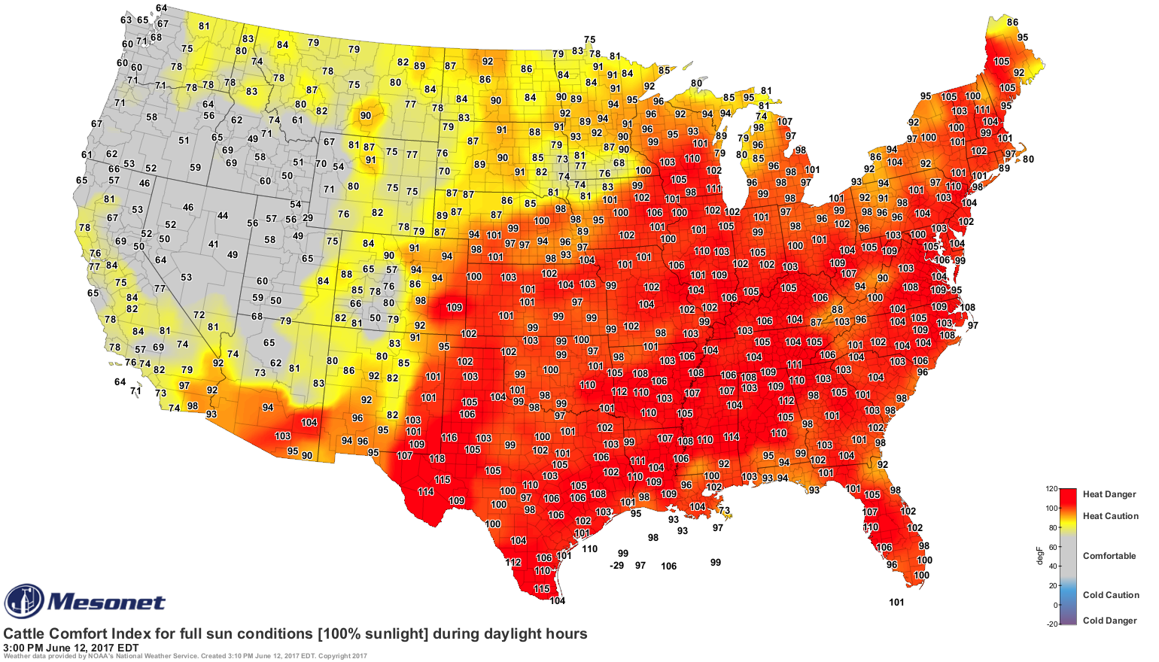

Students currently working on the project are analyzing data related to behavior (Kelsey Bruno, Oklahoma State), characterization of test length (Cashley Ahlberg, Kansas State), characterization of water intake (Ahlberg), effect of environmental parameters on water intake and predicting water intake (Ahlberg), preliminary genome-wide association analyses and prediction of breed composition and breed effects (Ahlberg), preliminary gene expression analyses (Chris Gaffney, Oklahoma State), adaptability to environmental stressors (Ahlberg), and preliminary analyses of residual water intake (Ahlberg, Levi McPhillip, Oklahoma State).

Table 1. Feed and water intake summary.
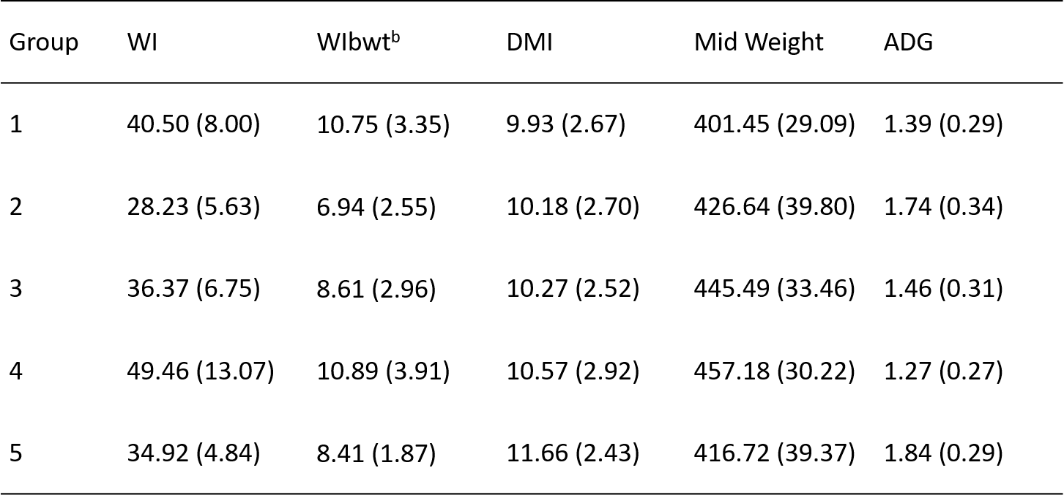
ªWI, DMI, Mid Weight, and ADG are measured in kilograms
^{b}WIbwt Water intake as a percent of body weight
Table 2. Length of test analysis summary. Analyses labeled forward utilized increasing numbers of days starting at day 0 and moving forward in time in 7 days increments. Analyses labeled backward utilized increasing numbers of days starting at day 70 and moving backward in time using 7 day increments.
 | 7 | 14 | 21 | 28 | 35 | 42 | 49 | 56 | 63 | 70
Forwardª
Pearson | 0.830 | 0.892 | 0.921 | 0.941 | 0.966 | 0.977 | 0.988 | 0.992 | 0.997 | 1.0
Spearman | 0.793 | 0.858 | 0.876 | 0.903 | 0.947 | 0.966 | 0.983 | 0.989 | 0.997 | 1.0
Backward^{b}
Pearson | 0.712 | 0.822 | 0.920 | 0.933 | 0.950 | 0.970 | 0.985 | 0.994 | 0.999 | 1.0
Spearman | 0.639 | 0.792 | 0.899 | 0.923 | 0.943 | 0.963 | 0.982 | 0.993 | 0.998 | 1.0
ªWindows were formed starting at the beginning of the 70-day trial period
^{b}Windows were formed starting at the end of the 70-day trial period

Table 3. Summary of water intake (water intake as a percentage of body weight WIbwt) and efficiencies (residual water intake, RWI; water to gain ratio, W/G) for animals with the lowest 1/3, middle 1/3, and top 1/3 of intakes (low, medium, and high, respectively) for each group of animals.
Group | Trait^{b} | Low | Medium | High
1 | WIbwt | 8.39ª | 9.90^{b} | 11.96^{c}
 | RWI | -5.06ª | -0.68^{b} | 5.74^{c}
 | W/G | 27.46ª | 29.25ª | 32.77^{b}
2 | WIbwt | 5.66ª | 6.50^{b} | 7.65^{c}
 | RWI | -2.48ª | -0.56^{b} | 3.06^{c}
 | W/G | 16.03ª | 16.29ª | 18.29ª
3 | WIbwt | 6.85ª | 8.16^{b} | 9.39^{c}
 | RWI | -4.15ª | -0.64^{b} | 4.54^{c}
 | W/G | 23.32ª | 26.16^{b} | 27.77^{b}
4 | WIbwt | 8.50ª | 10.06^{b} | 13.94^{c}
 | RWI | -7.88ª | -2.36^{b} | 10.24^{c}
 | W/G | 32.32ª | 40.53^{b} | 49.69^{c}
5 | WIbwt | 7.66ª | 8.56^{b} | 8.98^{c}
 | RWI | -1.51ª | 0.05^{b} | 1.53^{c}
 | W/G | 18.11ª | 19.83^{b} | 20.05^{b}

4: Investigation of early cow-life performance (first four parities) affecting lifetime production in Brahman and Brahman-Angus cows

