**Accomplishments**:

This section of the report is presented by objective, and primarily highlights data and publications that have been completed to date.

**Objectives**

1. **Estimate genetic variation associated with animal health using classical animal breeding and genomic techniques to facilitate sustainable beef cattle production systems.**

**Objective 1.1 External Parasites**

**University of the Virgin Islands**. This study was conducted to evaluate the relationship of tick load of Senepol cows and their calves under tropical conditions. Data were collected at weaning on multiparous (n = 44) and primiparous (n = 5) Senepol cows and calves (n = 31) born in spring 2015. At weaning cow tick load was evaluated using a visual score (1 = clean, 2 = light, 3 = moderate or 4 = heavy) prior to the monthly acaricide treatment. Cow BW, hip height and condition score (1 = thin, 9 = fat) were also measured. Calf BW, hip height and tick load were measured at weaning. Average daily gain (ADG) was calculated for calves for the period from birth to weaning. Data were analyzed using GLM procedures with cow locational and pregnancy status as the main effect for cow traits and sex as the main effect for calf traits. Correlations among cow and calf traits was also evaluated using PROC CORR.

There was no difference (P > 0.10) in 205-d adjusted weaning weight, ADG, hip height or tick score between bulls and heifers (Table 1). The majority of claves had tick scores of clean or light with only 1 calf having a score of moderate, and no calves had a high tick score (Table 1). There was no difference (P > 0.10) in 205-d adjusted weaning weight, ADG, hip height or tick score between tick scores of calves (Table 1).

Dry cows had greater BW (P < 0.0001) and BCS (P< 0.002) than lactating cows at weaning, but there was no difference (P > 0.10) in hip height or tick score (Table 2). There was no difference (P > 0.10) in any trait between open and pregnant cows. Cows with heavy tick burdens had lower BCS than other cows, but there were only 2 cows in the heavy tick score group. There were no differences in either BW or HHT among tick scores.

Cow tick score and calf tick score at weaning were not correlated (r = -.02, P > 0.10). Cow tick score had a moderate negative correlation with BCS (r = -0.53, P < 0.002). Calf tick score was not correlated with any calf traits (P > 0.10).

|  |  |  |  |  |
| --- | --- | --- | --- | --- |
| Table 1. Calf traits at weaning by sex and tick score | | | | |
| Sex | 205 d adj  weaning weight, kg | ADG birth – wean, kg/d | Hip height, cm | Tick score |
| Heifer | 180 ± 5 | 299 ± 7 | 104 ± 0.9 | 1.5 ± 0.2 |
| Bull | 191 ± 5 | 295 ± 5 | 105 ± 0.8 | 1.6 ± 0.1 |
| Tick score |  |  |  |  |
| Clean (n = 14) | 190 ± 5 | 0.68 ± 0.02 | 105 ± 0.9 | ------ |
| Light (n = 16) | 111 ± 5 | 0.65 ± 0.02 | 104 ± 0.9 | ------ |
| Moderate (n = 1) | 213 ± 19 | 0.76 ± 0.09 | 104 ± 3.4 | ------ |

|  |  |  |  |  |
| --- | --- | --- | --- | --- |
| Table 2. Cow traits at weaning by pregnancy, lactation status and tick score | | | | |
| Lactation | BW, kg | BCS | HHT, cm | Tick Score |
| Dry (n = 18) | 563 ± 16a | 6.5 ± 0.2c | 134 ± 1.0 | 1.9 ± 0.2 |
| Lactating (n = 31) | 459 ± 13b | 5.6 ± 0.2d | 132 ± 0.8 | 1.9 ± 0.1 |
| Pregnancy |  |  |  |  |
| Open (n = 34) | 491 ± 15 | 5.9 ± 0.2 | 134 ± 0.8 | 1.9 ± 0.1 |
| Pregnant (n = 15) | 512 ± 22 | 5.8 ± 0.3 | 132 ± 1.1 | 1.8 ± 0.2 |
| Tick Score |  |  |  |  |
| Clean (n = 13) | 492 ± 24 | 6.2 ± 0.3c | 131 ± 1.2 | ------ |
| Light (n = 30) | 505 ± 16 | 6.0 ± 0.2c | 134 ± 0.8 | ------ |
| Moderate (n = 4) | 511 ± 43 | 5.3 ± 0.5c | 137 ± 2.1 | ------ |
| Heavy (n = 2) | 397 ± 61 | 4.0 ± 0.6d | 131 ± 2.9 | ------ |
| a,b P < 0.0001; c,d P < 0.002; | | | | |

**Oklahoma State University:**

Animal records included the breeds Angus, Hereford, Limousin, Simmental, and Brangus; however, the majority of records were Angus and Hereford, so records from those two breeds were used for quality filtering (n=42 Angus and 19 Herefords in year 1 and n=50 Angus and 21 Herefords in year two). To be included in analyses, animals were required to possess at least three weeks of fly count data and associated breed association production data. There were 52 animals that met these criteria in year 1 and 66 in year 2, which created a total dataset of 82 individuals (some animals had records in both years).

To better describe changes in sensitivity to fly counts over time, reaction norms were formed utilizing multiple regression procedures (regressing the fly load on THI) in SAS 9.3 (Cary, NC). Large positive slopes indicated extreme responsiveness of the animal’s fly count to the environment, and a flatter slope indicates less responsiveness to the environment and a stable fly count over time.

Direct fly counts for year 1 and year 2 were not normally distributed, but the slopes of the reaction norms were normally distributed. A mixed model analysis was conducted with the fixed effect of breed and the random effect of animal. Solutions for random effects were not generated due to low accuracy, which is a result of limited observations within a breed group and no pedigree data. Average adjusted weaning weight (AAWW) was used as the dependent variable to test whether breed or slope had a significant effect on animal performance. Slope was not significant, but breed was found to have a significant impact on weaning weights. Pearson and Spearman correlations were also generated.

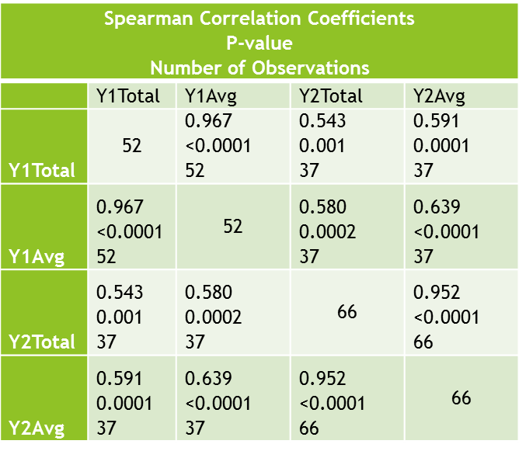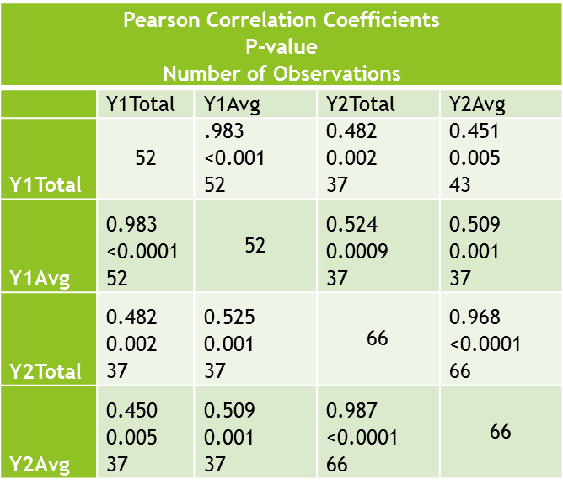

There were a few limitations of our analysis. Breed was confounded with coat color, which is known to have an impact on fly counts. Breeds also have significant differences in weaning weights, so the significant differences we found likely have no relationship to fly counts. During analysis we subsequently found that cattle had been treated with pesticides to reduce fly counts and these treatments were not recorded or shared with our team previously. Additionally, animals were rotated to different pastures during the course of data collection. Pasture conditions are known to have an impact on fly counts, and all of these reasons cumulatively are likely why we did not find any significant impacts in our study.

In the future, we hope to identify cooperator herds which will provide more transparency so we can more accurately describe differences between animals in fly counts. DNA samples were scheduled for collect during late spring 2016, but were not collected due to relatively low quality of phenotypic records given the limitations discussed previously. We (Rolf and Talley) are also exploring ideas to shorten the data collection period so that the need to not treat animals for an entire summer is mitigated and to also make data collection easier for both university personnel and cattlepersons themselves.

**Objective 1.2 Eye and facial pigmentation associated with animal health**

**Texas A&M:**

Table 1. Occurrence and proportion (519 records) of various characters in animals with repeated images

|  |  |  |  |  |  |
| --- | --- | --- | --- | --- | --- |
|  |  |  |  | Scleral pigmentation |  |
|  | Lesions | Freckle | Red1 | Left | Right |
| Hereford | 17 | 4 |  | 12 | 19 |
| *Bos indicus* | 11 | 49 | 51 | 200 | 204 |
| *Bos taurus* | 6 | 1 | 7 | 108 | 112 |
| Grand total | 34 | 54 | 58 | 320 | 335 |
| Mature | 30 | 43 | 49 | 274 | 286 |
| Yearlings | 4 | 11 | 9 | 46 | 49 |
| Hereford | 0.37 | 0.087 |  | 0.261 | 0.413 |
| *Bos indicus* | 0.033 | 0.148 | 0.155 | 0.606 | 0.618 |
| *Bos taurus* | 0.042 | 0.007 | 0.049 | 0.755 | 0.783 |
| Grand total | 0.066 | 0.104 | 0.112 | 0.617 | 0.645 |
| Mature | 0.071 | 0.101 | 0.116 | 0.646 | 0.675 |
| Yearlings | 0.042 | 0.116 | 0.095 | 0.484 | 0.516 |

1Red in *Bos indicus* and *Bos taurus* categories only.

Based on 37 Hereford, 188 *Bos indicus* cross cows, and 108 *Bos taurus* cross cows.

Table 2. Occurrence and proportion of various characters in new images

|  |  |  |  |  |  |  |
| --- | --- | --- | --- | --- | --- | --- |
|  |  |  |  | Scleral pigmentation |  |  |
|  | Lesions | Freckle | Red | Left | Right | Total |
| Hereford | 24 | 2 |  | 7 | 11 | 64 |
| *Bos indicus* | 23 | 13 | 84 | 190 | 202 | 308 |
| *Bos taurus* | 5 | 0 | 21 | 165 | 160 | 236 |
|  |  |  |  |  |  |  |
| Calves | 24 | 0 | 97 | 249 | 254 | 436 |
| Mature | 27 | 15 | 9 | 98 | 103 | 145 |
| Yearlings | 1 | 0 | 0 | 15 | 17 | 27 |
| Grand Total | 53 | 15 | 106 | 362 | 374 | 608 |
| Hereford | 0.375 | 0.031 |  | 0.109 | 0.172 |  |
| *Bos indicus* | 0.075 | 0.042 | 0.273 | 0.617 | 0.656 |  |
| *Bos taurus* | 0.021 |  | 0.089 | 0.699 | 0.678 |  |
|  |  |  |  |  |  |  |
| Calves | 0.055 |  | 0.222 | 0.571 | 0.583 |  |
| Mature | 0.186 | 0.103 | 0.062 | 0.676 | 0.710 |  |
| Yearlings | 0.037 |  |  | 0.556 | 0.630 |  |
| Total | 0.086 | 0.025 | 0.174 | 0.595 | 0.615 |  |

1Red in *Bos indicus* and *Bos taurus* categories only.

Table 3. Eyelid pigmentation proportions in animals with repeated images

|  |  |  |  |  |  |  |  |  |  |  |
| --- | --- | --- | --- | --- | --- | --- | --- | --- | --- | --- |
|  | Complete pigmentation | | No pigmentation | | Intermediate | | | |  | |
|  | Left | Right | Left | Right | Left | | Right | | Total | |
| Hereford | 10 | 11 | 9 | 6 | 18 | | 19 | | 46 | |
| *Bos indicus* | 285 | 283 | 0 | 3 | 45 | | 44 | | 330 | |
| *Bos taurus* | 110 | 1100 | 2 | 0 | 30 | | 33 | | 143 | |
| Hereford | 0.217 | 0.239 | 0.196 | 0.130 | | 0.587 | | 0.630 | |
| *Bos indicus* | 0.864 | 0.858 |  | 0.009 | | 0.136 | | 0.133 | |
| *Bos taurus* | 0.769 | 0.769 | 0.014 |  | | 0.217 | | 0.231 | |

Table 4. Eyelid pigmentation proportions in new images

|  |  |  |  |  |  |  |  |
| --- | --- | --- | --- | --- | --- | --- | --- |
|  | Complete pigmentation | | No pigmentation | | Intermediate | |  |
|  | Left | Right | Left | Right | Left | Right | Total |
| Hereford | 14 | 19 | 10 | 8 | 40 | 37 | 64 |
| *Bos indicus* | 266 | 266 | 3 | 3 | 39 | 39 | 308 |
| *Bos taurus* | 191 | 198 | 3 | 1 | 42 | 37 | 236 |
| Hereford | 0.219 | 0.297 | 0.156 | 0.125 | 0.625 | 0.578 |  |
| *Bos indicus* | 0.864 | 0.864 | 0.010 | 0.010 | 0.127 | 0.127 |  |
| *Bos taurus* | 0.809 | 0.839 | 0.013 | 0.004 | 0.178 | 0.157 |  |

Table 5. Udder pigmentation

|  |  |  |  |
| --- | --- | --- | --- |
| Location | *Bos indicus* | *Bos taurus* | N |
| Menard | 2.36 (1.43) | 1.2 (0.89 | 24 |
| Overton | 1.66 (1.77) | -- | 106 |
| N | 120 | 10 |  |

Udder pigmentation amount scored subjectively from 0.5 (minimal pigmentation) to 5 (complete pigmentation).

**Objective 1.3 Udder conformation**

**Texas A&M:**

Table 6. Udder and teat score means in whiteface cows at College Station (n = 71 cows with 94 records) and Menard (n = 44 cows with 80 records): 2015 and 20161

|  |  |  |  |  |  |  |
| --- | --- | --- | --- | --- | --- | --- |
|  | Calving | | Mid-lactation | | Weaning | |
| Age | Udder | Teat | Udder | Teat | Udder | Teat |
| 2 | 7.66 ± 0.36a | 7.89 ± 0.34a | 8.37 ± 0.34a | 8.37 ± 0.34a | 7.94 ± 0.24a | 7.78 ± 0.27a |
| 3 | 6.84 ± 0.19b | 7.11 ± 0.17b | 6.72 ± 0.29b | 7.20 ± 0.30b | 6.77 ± 0.19a | 6.79 ± 0.22ab |
| 4 | 6.32 ± 0.31c | 6.58 ± 0.29c | 6.25 ± 0.73cd | 6.50 ± 0.74c | 6.50 ± 0.94ab | 7.50 ± 1.08b |
| 5 to 10 | 5.19 ± 0.56cd | 5.77 ± 0.51cd | 5.50 ± 0.60de | 5.50 ± 0.60d | 5.67 ± 0.54b | 5.83 ± 0.62bc |
| 11 and older | 4.92 ± 0.62d | 5.24 ± 0.57d | 4.75 ± 0.52e | 5.38 ± 0.52d | 3.89 ± 0.52c | 4.67 ± 0.51c |

a-d Means in a column not sharing superscripts differ (*P* < 0.05).

1Udder and teat scores per Beef Improvement Federation Guidelines: 1 = very pendulous udder; very large, balloon-shaped teats; 5 = intermediate, moderate size udders or teats; 9 = very tight udder; very small teats.

Table 7. Pearson correlation coefficients for udder and teat scores in whiteface cows (College Station and Menard) with birth and weaning weight

|  |  |  |  |  |  |  |  |  |
| --- | --- | --- | --- | --- | --- | --- | --- | --- |
|  |  |  | Calving | | Mid-lactation | | Weaning | |
|  | Birth wt | Wean wt | Udder | Teat | Udder | Teat | Udder | Teat |
| Birth wt |  | **0.46** | 0.0002 | 0.016 | 0.021 | 0.101 | 0.183 | –0.033 |
| N |  | 92 | 165 | 165 | 49 | 49 | 89 | 89 |
| Wean wt |  |  | **–0.354** | **–.0332** | **–.0335** | **–0.305** | **–0.297** | **–0.322** |
| N |  |  | 81 | 81 | 46 | 46 | 87 | 87 |

$\left|r\right|>0.2$ differ from $0$ and presented in boldface font.

1Udder and teat scores per Beef Improvement Federation Guidelines: 1 = very pendulous udder; very large, balloon-shaped teats; 5 = intermediate, moderate size udders or teats; 9 = very tight udder; very small teats.

Table 8. Udder and teat score means in Brahman cows at Overton 2015

|  |  |  |  |
| --- | --- | --- | --- |
|  |  | Calving | |
| Age | N | Udder | Teat |
| 2 | 27 | 6.92 ± 0.30a | 8.26 ± 0.33a |
| 3 | 17 | 7.35 ± 0.38a | 7.00 ± 0.42b |
| 4 | 8 | 6.25 ± 0.55a | 6.38 ± 0.61c |
| 5 to 10 | 50 | 5.44 ± 0.22b | 5.60 ± 0.24c |
| 11 and older | 2 | 4.50 ± 1.10ab | 4.00 ± 1.22c |

a-c Means in a column not sharing superscripts differ (*P* < 0.05).

1Udder and teat scores per Beef Improvement Federation Guidelines: 1 = very pendulous udder; very large, balloon-shaped teats; 5 = intermediate, moderate size udders or teats; 9 = very tight udder; very small teats.

Table 9. Eye pigmentation record totals through the present

|  |  |  |  |
| --- | --- | --- | --- |
|  | Hereford | *Bos indicus* | *Bos taurus* |
| 2012 Davis et al. | 120 | 492 | 471 |
| 2013 calves | 24 | 59 | 119 |
| 2013 cows | 23 | 46 | 34 |
| 2014 calves | 0 | 113 | 9 |
| 2014 cows | 0 | 5 | 36 |
| 2015 calves | 0 | 60 | 18 |
| 2016 cows | 19 | 0 | 0 |
| 2016 yearlings | 4 | 0 | 20 |
|  | 190 | 775 | 707 |
| **Target** | **2,000** | **2,000** | **2,000** |

Table 10. Repeated images for monitoring scleral pigmentation changes

|  |  |  |  |
| --- | --- | --- | --- |
|  | Hereford | *Bos indicus* | *Bos taurus* |
| 2013 | 28 | 52 | 60 |
| 2014 |  | 139 | 10 |
| 2014 yearlings |  | 17 | 26 |
| 2015 |  | 76 | 33 |
| **Total** | **28** | **284** | **129** |

**University of Arkansas:**

Cattle were evaluated for Udder conformation traits and scored according to BIF guidelines (2010) for Udder Suspension and Teat size. Scores for each trait range from 1 to 9 with 9 indicating tight suspension and small teat size and will be evaluated at calving, mid-lactation and weaning. In addition, any udder abnormalities such as evidence of mastitis, dead quarters, tumors, injuries or other diseases will be recorded. Cow traits related to reproductive performance and calf traits to include sire/sire breed of calf, birth weight and date, weaning weight and date and post weaning performance will be recorded.

The objective of this study was to determine if any relationships existed between udder conformation and production traits in cows housed at the University of Arkansas beef research unit near Fayetteville. An Angus-based fall calving cow herd (n=216) was observed and udder scores were recorded at birth, mid-lactation and at weaning. Cows were evaluated on a scale from 1 to 9 for udder suspension and teat size according to BIF guidelines. A score of 1 indicated a very pendulous suspension and large, balloon shaped teats and a score of 9 represented a tight suspension and refined teat size.

Table 1: Udder Suspension and Teat Score means.

|  |  |  |  |  |  |  |
| --- | --- | --- | --- | --- | --- | --- |
|  | Calving | | Mid-Lactation | | Weaning | |
| Udder | Teat Size | Udder | Teat Size | Udder | Teat Size |
| **Overall Mean** | 5.97 | 5.95 | 6.27 | 6.64 | 5.82 | 6.10 |
|  | | | | | | |
| **Age** |  |  |  |  |  |  |
| ≤ 3 | 7.33 | 7.15 | 6.57 | 6.53 | 6.00 | 6.04 |
| 4 - 6 | 6.28 | 5.78 | 6.54 | 6.87 | 5.97 | 6.36 |
| 7 - 10 | 5.14 | 5.58 | 6.17 | 6.60 | 5.65 | 6.17 |
| 11 + | 5.13 | 5.30 | 5.78 | 6.57 | 5.68 | 5.81 |

Table 2: Mean Weaning Weight across two Udder Score groups.

|  |  |  |  |  |
| --- | --- | --- | --- | --- |
|  | Udder Suspension | | Teat Size | |
| ≤ 5 | > 5 | ≤ 5 | > 5 |
| Weaning Wt. (lbs) | 538.04 | 474.51 | 508.44 | 508.57 |
|  |  |  |  |  |

1. **Meta-analyses of economically important traits of cow productivity and fertility to assess breed and production system combinations.**

**University of Virgin Islands:** This study was conducted to evaluate growth of Senepol bull and heifer calves from birth to a year of age.

There was no effect (P > 0.10) of sex on birth weight or 205-d adjusted weaning weight (Table 3). Bulls had a greater 365-d adjusted yearling weight (P < 0.04) than heifers. Bulls had a greater ADG from birth to weaning than heifers (P < 0.001) but there was no difference in ADG from weaning to yearling (P > 0.10). Weaning HHT was greater (P < 0.04) in bulls than in heifers but there was no difference (P > 0.10) in yearling hip height (Table 4). Yearling SC of bulls and PA of heifers is also shown.

|  |  |  |  |  |  |
| --- | --- | --- | --- | --- | --- |
| Table 3. Calf weights and ADG by gender | | | | | |
| Sex | Birth weight  kg | 205 d adj  weaning weight kg | 365 d adj yearling weight kg | ADG  birth – wean  kg/d | ADG  wean – year  kg/d |
| Heifer | 41 ± 1.1 | 203 ± 7 | 247 ± 6a | 0.74 ± 0.03c | 0.29 ± 0.03 |
| Bull | 42 ± 1.2 | 221 ± 8 | 267 ± 7b | 0.83 ± 0.03d | 0.27 ± 0.04 |
| a,b P < 0.04; c,d P < 0.03 | | | | | |

|  |  |  |  |  |
| --- | --- | --- | --- | --- |
| Table 4. Calf hip height and yearling pelvic area or scrotal circumference | | | | |
| Sex | Weaning hip height, cm | Yearling hip height, cm | Yearling pelvic area, cm2 | Yearling scrotal circumference, cm |
| Heifer | 105 ± 1.0a | 113 ± 0.9 | 129 ± 4.5 | ------ |
| Bull | 108 ± 1.1b | 114 ± 1.0 | ------ | 23.2 ± 0.8 |
| a,b P < 0.04 | | | | |

**University of Florida:**

* 1. Multibreed genomic-polygenic and polygenic evaluation of Bos taurus-Bos indicus cattle for growth traits in an Angus-Brahman multibreed population under subtropical conditions. Dataset included 5,300 calves, 293 sires, 1,725 dams. Similar estimates of variance components and genetic parameters with both models. Higher percent Brahman tended to yield higher EBV values for direct birth and weaning weight traits, but lower EBV for postweaning gain direct and birth and weaning weight maternal. Animals with high and low EBV for all traits existed across the Angus-Brahman expected composition spectrum. Genomic-polygenic values of animals ranging from 0 to 100% Brahman are shown in the Figure below for weaning weight direct and weaning weight maternal.

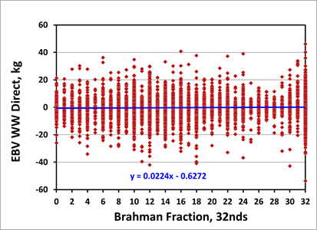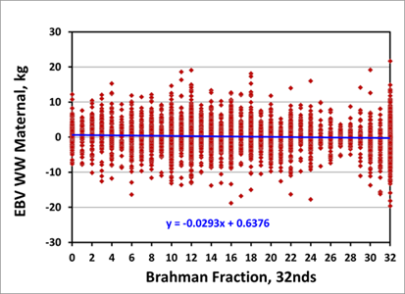

* 1. Genomic-polygenic evaluation of multibreed Angus-Brahman cattle for postweaning ultrasound and weight traits with actual and imputed Illumina50k SNP genotypes. Additive genomic to total genetic variance fractions for postweaning ultrasound traits explained by 46,909 actual and imputed Illumina50k SNP genotypes were 0.17 for ultrasound ribeye area, 0.32 for ultrasound fat thickness, 0.25 for ultrasound percent intramuscular fat, and 0.19 for postweaning weight. Rank correlations between genomic-polygenic and polygenic EBV were higher (0.93 to 0.96) than between genomic-polygenic and genomic EBV (0.81 to 0.94), and between genomic and polygenic EBV (0.66 to 0.81).
  2. Growth and reproduction genomic-polygenic and polygenic parameters and prediction trends as Brahman fraction increases in an Angus-Brahman multibreed population. Traits were 365-d yearling weight (YW), yearling reproductive tract score (RTS), age at first calving (AFC), and first calving interval (FCI). Numbers of phenotypic records were 1,758 for YW, 381 for RTS, 1,385 for AFC, and 985 for FCI. Heritabilities were somewhat higher for GPM than PM (0.47 vs. 0.45 for YW, 0.31 vs. 0.30 for RTS, 0.14 vs. 0.12 for AFC, and 0.31 vs. 0.29 for FCI). Genetic correlations were positive between YW and RTS (GPM: 0.55; PM: 0.60), negative between RTS and AFC (GPM: -0.22; PM: -0.55) and between AFC and FCI (GPM: -0.68; PM: -0.67), and near zero for all other trait pairs. Heifers with higher Brahman percentages tended to be lighter and less mature as yearlings, older at first calving, and have shorter FCI than heifers with higher Angus percentages under the subtropical environmental conditions of the MAB population. Animals with high, medium, and low EBV existed across all Brahman percentages, thus selection of replacement animals of all Brahman percentages could use a common set of objectives. Genomic-polygenic values of animals ranging from 0 to 100% Brahman are shown in the Figure below for reproductive tract score and age at first calving.

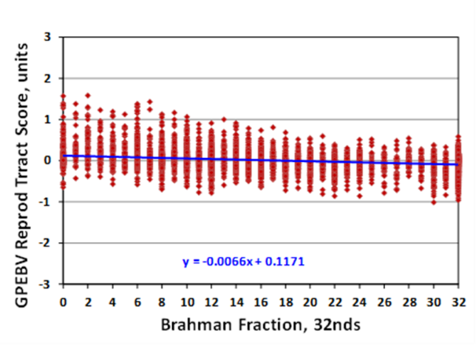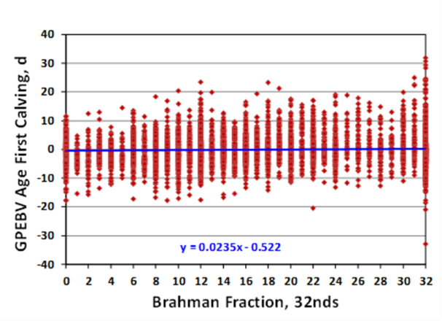

* 1. Ultrasound and carcass genomic-polygenic and polygenic parameters and prediction trends as Brahman fraction increases from 0 to 100% in an Angus-Brahman multibreed population. Ultrasound traits were weight at ultrasound measurements (UYW), ribeye area (UREA), fat over the ribeye (UFAT), and marbling (UMAR). Carcass traits were slaughter weight (SLW), hot carcass weight (HCW), ribeye area (REA), fat over the ribeye (FAT), and marbling (MAR). Numbers of phenotypic records were 1,758 for UYW, 1,748 for UREA, 1,754 for UFAT, 1,752 for UMAR, 761 for SLW, 744 for HCW, REA, and FAT, and 743 for MAR. Heritabilities were mostly higher for GPM than for PM (0.23 vs. 0.20 for UYW, 0.35 vs. 0.28 for UREA, 0.04 vs. 0.02 for UFAT, 0.08 vs. 0.05 for UMAR, 0.44 vs. 0.41 for SLW, 0.55 vs. 0.50 for HCW, 0.55 vs. 0.58 for REA, 0.18 vs. 0.20 for FAT, and 0.31 vs. 0.17 for UMAR). Genetic correlations were mostly positive among all traits with values ranging from low to high. As with reproduction and preweaning growth traits previously evaluated in this population, animals with low, medium, and high EBV existed across the spectrum of Brahman percentages indicating that a common set of selection criteria would be feasible in this multibreed population and likely in similar populations in subtropical and tropical regions. Genomic-polygenic values of animals ranging from 0 to 100% Brahman are shown in the Figure below for ultrasound ribeye area and ultrasound marbling and their corresponding carcass traits, i.e., ribeye area and marbling.

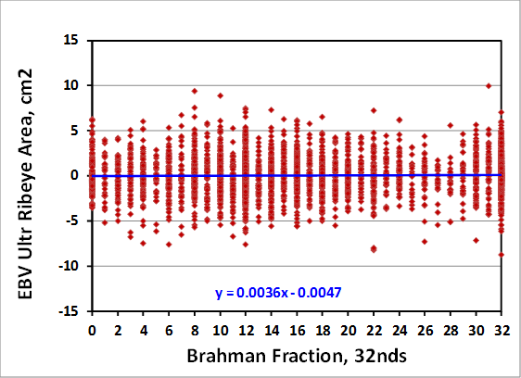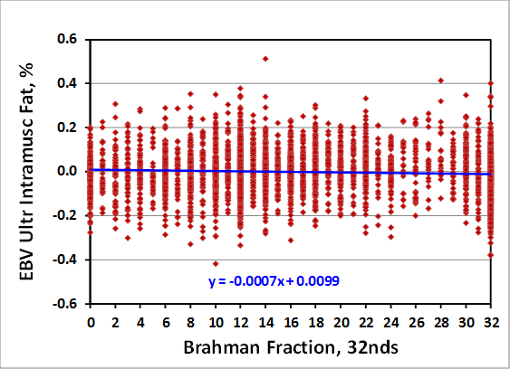

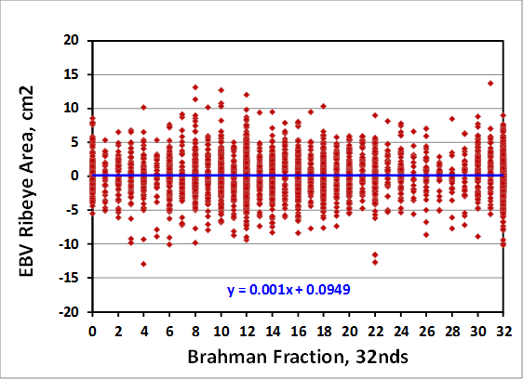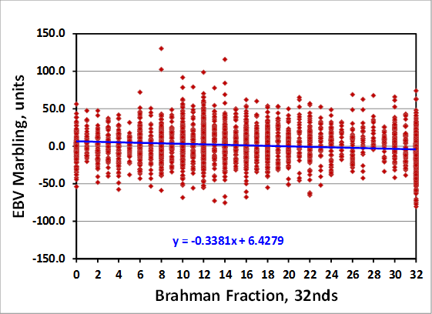

* 1. Genomic tools to improve meat quality traits in Angus-Brahman cattle. Several genomic regions were associated with tenderness of beef in a multibreed Angus-Brahman population. Investigation of several regions revealed strong candidate genes with possible direct relations to meat tenderization process. The predictive analysis revealed that opportunity existed for development and implementation of a system to communicate tenderness attributes to consumers and improve the probability that consumers’ eating expectations are met. The Figure below shows the genome-wide association results with 150K genotypes for Warner-Bratzler Shear Force on 418 animals ranging from 0 to 100% Brahman.

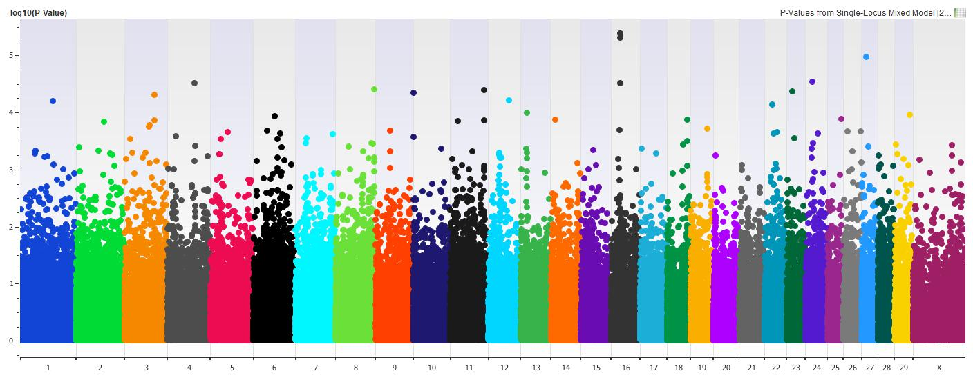

* 1. Relating muscle fiber morphometrics and protein degradation to meat quality in a multibreed herd. Warner-Bratzler Shear Force (WBSF) increased as the percentage of Brahman increased. The degree of μ-calpain autolysis at 24 h decreased as WBSF values increased, and autolysis decreased as the percentage of Brahman increased. Citrate synthase activity increased with greater percentage of Brahman indicating that Brahman genetics tended to influence oxidative capacity. Postmortem proteolysis and muscle fiber type will be utilized to establish predictors for the optimum breed group that provides desirable meat quality and palatability traits, while having enough Brahman influence to thrive in sub-tropical climates.
  2. Effect of Brahman genetics on myofibrillar protein degradation, collagen crosslinking, and meat tenderness. This research showed that loin eye (*longissimus lumborum*) steaks from steers of greater percentage Brahman had reduced tenderness when measured objectively and subjectively. Additionally, trained sensory panelists detected an increase in connective tissue content as percentage Brahman increased. Decreases in tenderness from Brahman steaks were most likely due to the reduction in degradation of desmin and troponin-T proteins and not increases in hydroxylysylpyridinoline crosslinks.
  3. Colonization of beef cattle by Shiga toxin-producing Escherichia coli during the first year of life: a cohort study. This study identified that beef calves were more likely to shed STEC during the first 6 months and that STEC shedding decreased as the animal matured. Animal breed group, sex of the calf, and average weight gain were not significantly associated with STEC colonization. The Figure below shows the prevalence of STEC and mean body weight of calves ranging from 0 for 100% Brahman during their first year of life.



1. **Documentation of genetic components pertaining to heat tolerance adaptive traits in sustainable beef cattle production systems**

**University of Arkansas:**

The objective of this study was to measure variation in hair coat shedding and determine if any relationships existed between coat shedding and production traits in cows housed at the University of Arkansas beef research unit near Fayetteville. An Angus-based commercial beef cattle herd (n = 251) was observed during 2015. Once monthly from March until July, at approximately 28-day intervals, mature cows and replacement heifers were evaluated for shedding on a scale from 1 to 5. A score of 5 indicated the cow/heifer had a full winter coat and a score of 1 represents a slick, short summer coat. For each cow, the first month a score of 3 (approximately 50% shed) or less was reached was considered the month of first shedding (MFS), and 3 levels were recognized reflecting MFS in May, June, July or After July (if cow had not shed by July). Phenotypic data for cow age, calf weaning weight, BCS of cow at weaning, BW of cow at weaning, BCS of cow pre-breeding, BW of cow pre-breeding, pregnancy rate, birth weight of calf and age of the cow were collected and analyzed in PROC MIXED of SAS. Frequency of MFS occurred with the following order: June>July>After July>May. Cow age was significantly different (P<0.01) with MFS group means for May and June being older than cows that exhibited MFS in July or After July with respective ages being 6.1, 6.0, 3.4 and 3.2. Cow BW prebreeding and cow BW at weaning was significantly greater (P<0.01) for cows that exhibited MFS in May and June compared to cows that exhibited MFS in July or After July. Calf birth weight was highest (*P* < 0.01) for cows exhibiting MFS in May and June (74 & 71 lb) compared to calf birth weight cows exhibiting MFS in July and After July (64 & 60 lb). Calf weaning weight was greatest (*P* < 0.01) for cow with MFS in May and June compared to cows for July and After July with cows exhibiting calf weaning weights of 559, 524, 500, and 463 lb, respectively. In these data, MFS score effected (*X2* < 0.009) overall pregnancy rates with cows exhibiting MFS in May having the greatest overall pregnancy rate (100%), intermediate in cows with MFS in June (94%) and July (86%) and lowest in cows with MFS After July (71%%). Artificial insemination pregnancy rate was similar (*X2 = 0.31*) for cows exhibiting MFS in May, June, July or After July.

**Oklahoma State University:**

We have almost completed data collection for the fourth group of calves to be fed within the Insentec facility. We have not encountered any significant challenges with phenotyping or collection of environmental data, and we have been successfully building a large phenotypic database and sample database that tracks samples across project years to facilitate data analysis and maintenance of biological samples.

We have successfully instituted a water restriction on all animals in the study so far, and we have made additional refinements to our procedures and protocol, which have enabled us to achieve a more uniform restriction on all animals. Given the Insentec system’s inability to force animals from the system when they have consumed their allotted intake for the day, restriction levels are not exact on a daily or aggregate basis. However, we have endeavored to reduce this variation wherever possible and will account for the restriction level in all analyses that utilize this data to ensure animals are compared as fairly as possible.

We have noticed wide ranges of variability in feed and water intakes on a daily basis, which have not been extensively noted within the literature. This is likely because data from other intake systems, such as GrowSafe systems, is reported in aggregate after it has been processed by the company. We have undergone extensive verification procedures to ensure the quality and reliability of this data, including periodic scale validation, daily and weekly system maintenance and monitoring, and visual and quantitative validations of the data being collected. We recently developed a more automated methodology for the aggregation of data for both daily intake and cumulative baseline determinations, and this data pipeline will assist in processing the large amount of feed and WI data being collected, and help ensure that all data is handled uniformly across the groups of steers in the project.

We have collected rumen and fecal samples both before and at the end of the restriction phase for each animal in groups 1 and 2. To ensure the greatest consistency possible throughout the trial, we will keep the ration fed as uniform as possible across all groups of animals in the study (the core ration is identical, with minor modifications to account for any variance in forage quality).

Blood samples were analyzed for complete blood cell counts (total cell counts of red blood cells, platelets, hemoglobin, hematocrit, and white blood cell differentials). For weeks when CBCs were not conducted (due to budget restrictions), blood samples were still collected and evaluated for hematocrit levels to consistently monitor any harmful signs of dehydration and health. Blood samples were also stored for future analysis of electrolyte balance, which will be conducted following completion of the final group in the trial to minimize cost of reagents. To ensure the greatest consistency of cattle handling throughout the trial, human-cattle interactions and movement through our handling facilities was evaluated with a scoring system to ensure that consistent handling interactions and low-stress techniques were practiced.

All cattle are individually and uniquely identified with colored strips in order to differentiate between animals on continuous video recordings of animal social behaviors. The video footage has been stored on multiple 16 TB RAID 0 data backup systems for behavioral analysis. Cattle in groups 2-4 were also equipped with accelerometers (IceQubes, IceRobotics Ltd, UK) that automatically log data on the number of steps taken, as well as standing and lying behaviors. Group 1 cattle were equipped with similar activity loggers (HOBO Pendant G data loggers, Onset, Bourne, MA), however the loggers used were not compatible in the pen conditions. Therefore, new and more rugged loggers were acquired and successfully incorporated into group 2 cattle, and will be used for all future cattle groups. Cattle temperament and exit velocity was also measured for all cattle every time animals were processed or handled in a squeeze chute. Each day during the water restriction period, respiration rates and eye recession scores were collected on all animals twice daily to monitor signs of thermal stress and hydration status.

We have also collected tissue samples at harvest (primarily muscle, kidney, and liver) whenever possible and we have flash-frozen them for future analysis. Several students have been working on processing these samples through the last year and RNA will be extracted on a portion of them for gene expression analysis. Additionally, we hope to use these tissues to look at some targeted epigenetic modifications or epigenomics work in the future.

**Table 1.** Feed and water intake summary.

|  |  |  |  |  |  |  |  |
| --- | --- | --- | --- | --- | --- | --- | --- |
| Season | n | Water Intake | Feed Intake | Water Intake (% BW) | Feed Intake (%BW) | Mid-Test Weight | Avg. Daily Gain |
| Summer | 235 | 38.36 kg | 13.85 kg | 9.7% | 2.7% | 395.9 kg | 1.38 kg/d |
| Winter | 117 | 25.65 kg | 13.92 kg | 6.5% | 2.8% | 393.6 kg | 1.72 kg/d |

**Figure 1**. Baseline Water vs. Feed Intake in Groups 1 (blue, R2=0.36), 2 (red, R2=0.33), and 3 (green, R2=0.34).

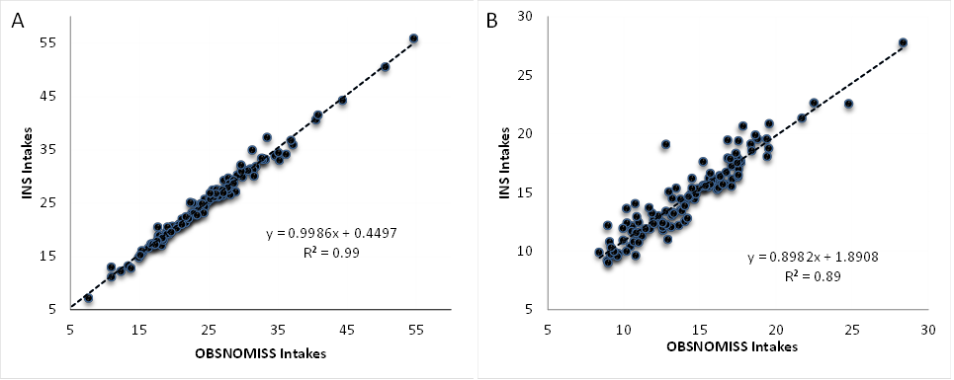**Figure 2.** Comparison of total daily water intake values during the baseline (A) and restriction (B). Because validation was done by visual observation, records where a missing starting or ending weight was missing were assumed to be consistent with the Insentec record.

**Mississippi State University (Starkville):**

The objective of this study as to evaluate the effect of hair shedding on reproductive performance in purebred Angus females (n=204). Hair coat shedding data were collected every 30 d from March to July from 2013 to 2014. Dams were observed by two technicians for hair shedding and given a visual score of 1 to 5 with a score of 1 indicating completely shed, 2 = 25% shed, 3 = 50% shed, 4 = 75% shed and 5 = no shedding. The month of first shedding (MFS) was determined when a female reached an average shedding score of ≤3.5 for a given month. Cows were grouped as early shedding (ES) dams if their MFS was in March, April and May, and late shedding dams (LS) if in June and July for further analysis. Heifers and cows were managed to breed in the fall of each year. Heifers and cows were inseminated via AI and then exposed to a bull (NS) for the remainder of the breeding season. Breeding season ranged from 55 to 56 d for cows and from 67 to 91 d in heifers. Data collected included pregnancy rate, calving date, type of breeding (AI or NS), and body condition score. Chi-square analysis was performed on the categorical data using the FREQ procedure of SAS. Shedding data were analyzed using the GLM procedure of SAS with calving date as the response variable with fixed effects of year, cow age, and MFS. There was no association found between pregnancy rates and MFS and ES and LS groups. For type of breeding, more LS (64.18%) females conceived via AI than ES (48.08%) females (P<0.05). Month of first shedding and ES and LS group effects were not significant for calving date.

1. **Investigation of early cow-life performance (first four parities) affecting lifetime production in Brahman and Brahman-Angus cows**

**Research Impact Statements**:

**Objective 1: Estimate genetic variation associated with animal health using classical animal breeding and genomic techniques to facilitate sustainable beef cattle production systems.**

**University of the Virgin Islands:** Because of the low correlation of tick load between cows and calves, and within calves, it may be difficult to select for the trait of tick resistance. One hypothesis is that the frequent dipping schedule (4-6 wk intervals) is suppressing any innate tick resistance of the cattle. The tick load scoring system has been incorporated into data collection as part of the routine management of the herd. The low correlation of tick load between cows and calves, and even within calves, and the frequent dipping schedule may limit the amount of progress that can be made when selecting for the trait of tick resistance.

**Texas A&M:**

1. Hereford cattle have substantially less eye pigmentation, and less scleral pigmentation than Hereford-*Bos taurus* or Hereford-*Bos indicus* (including Braford) crosses.
2. Hereford and Hereford-*Bos indicus* crossbred cows had higher lesion occurrence than Hereford-*Bos taurus* crossbred cows.
3. Preliminary mean and variability of udder pigmentation, measured as a subjective 0 (no pigmentation) to 5 (complete pigmentation) was established withHereford-*Bos indicus* and Hereford-*Bos taurus* cows: mean = 1.7 to 2.4 with SD = 1.4 to 1.8.
4. Approximately the same distribution of Udder Support Score and Teat Score (both defined by Beef Improvement Federation Guidelines) means for cow age categories were observed in Hereford-*Bos indicus* and Hereford-*Bos taurus* cows at the time of calving, mid-lactation, and one week after weaning of calves (7 mo age). Those scores for Brahman cows at the time of calving were similar with a similar age distribution.
5. Udder and Teat scores at calving and weaning were moderately correlated with weaning weight (–0.35 to -0.3), indicating that smaller udders and teats and less pendulous udders were associated with higher weaning weights.

**University of Arkansas:**

Udder and teat quality are among the most important functional traits of beef females. Unsound udders and teats are associated with reduced productive life and inferior calf performance, and poor udder and teat conformation is a major reason why cows are culled from the breeding herd. Understanding the implications of theses scores could improve the culling process and improve production efficiency.

**Oklahoma State University:**

Determining resistance and/or resilience to Horn flies would be helpful in both organic production systems and unconventional production systems that desire to reduce pesticide use or that have issues with pesticide resistance. Additional cooperator herds willing to forego chemical treatment of their herds will be identified.

**Objective 2: Meta-analyses of economically important traits of cow productivity and fertility to assess breed and production system combinations.**

University of Virgin Islands: Knowledge of the effect of gender on growth traits of calves raised on a forage based system in the tropics can be used to assist producers when managing and selecting animals. Calves raised on forage in the tropics will have different growth traits that can be influenced by gender.

**University of Florida:**

1. The similarity between genomic-polygenic and genomic predictions for reproductive, pre and postweaning growth direct, preweaning growth maternal, postweaning ultrasound, and carcass traits indicated that genomic information added little information to genetic predictions for these traits.
2. The large variability among genomic-polygenic and genomic EBV among animals of each 32nds Brahman fraction indicated that selecting animals in this multibreed Angus-Brahman herd could be accomplished using a common set of objectives across all Angus-Brahman breed compositions.
3. Genome-wide association analysis with the GGPHD150k chip from GeneSeek indicated several genomic regions associated with tenderness and the predictive analysis suggested the possibility of developing a more precise system to assess tenderness and improve consumer expectations.

**Objective 3: Documentation of genetic components pertaining to heat tolerance adaptive traits in sustainable beef cattle production systems**

**University of Arkansas:**

Hair shedding scores, although subjective, are well within the reach of both commercial and seedstock breeders. By using these scores and understanding their implications in cattle production will aid them in the match of genetic resource to production resources. This could easily increase current production by 10%.

**Oklahoma State University:**

Water intake research can help producers better manage water resource during drought and may enable selection for increased water efficiency to conserve on-farm water resources. Large amounts of variation exist within water intake in beef steers. The first genotypes will be available in summer 2016, which will allow the first analysis of the heritability of water intake in beef cattle.

**Mississippi State University (Starkville):**

Previous work has suggested a relationship between early shedding of the winter hair coat by the dam and an increase in weight of the weaned calf. Selection of cows that are more adaptive to their environment can be profitable. Hair shedding could be an important trait to consider in selection and its potential relationship to other economic important traits.

**Objective 4: Investigation of early cow-life performance (first four parities) affecting lifetime production in Brahman and Brahman-Angus cows**