NE1438 Multistate Research Committee Meeting – Tampa, FL
9:00 am to 4:00 pm, October 22, 2017
Marriott Tampa Waterside (3rd Level Room 8)

1. Welcome and introductions
Committee members in attendance included Mickey Spokas, Marty Rabenhorst, Bruce Vasilas, Karen Vaughan, John Galbraith and Patrick Drohan.

2. Greetings from NIFA and AES advisors
Jon Wraith had planned to attend and had reserved a flight and accommodations, but he contacted Marty late in the week to inform him that he would not be able to attend because he had to attend a funeral.
We now have a new NIFA representative, as Ray Knighton retired. The new rep is Karelyn Cruz. Karelyn emailed to indicate that by the time she had learned about the details of the meeting, she had already booked her flight to Tampa for the SSSA meeting and her arrival would be too late for her to attend the NE1438 meeting on Sunday.

3. Review and approval of the agenda
Mickey moved to approve the proposed agenda, which was seconded by Bruce and was approved with no objections.

4. Report and discussion of our poster "Comparing Performance of Mn-Coated and Fe-Coated IRIS Devices"
A discussion of the poster that is authored by members of the committee and was to be presented Wednesday afternoon at the Wetland Soils Poster Session was presented to the group by Marty.
The poster was projected on screen and Marty walked the group through the poster. There were a few issues associated with data collection. Due to problems with possible corruption of the PA temperature data, and apparent loss of the backup recorder, the PA data modelled using soil temperature from the MA, MD, and WV site and also the 2 wk average air temperature. This was used to estimate PA 25-30 cm ST data.
Discussion of WY data – The influence of solar radiation on zone 1 was discussed (which was an open meadow/fen) in comparison with zones 2/3 (which was forested and shaded).
We also had an extensive discussion regarding cumulative degree days (avg air temp above 5C during the study period) and how this related to soil temperature.
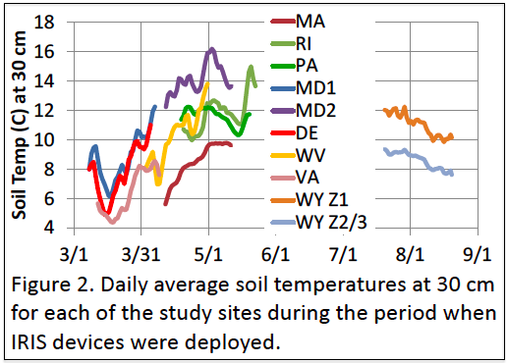

The design and structure of the composite data spreadsheet was explained and the way that the IRIS data were analyzed was reviewed. Careful scrutiny identified an error with the WY water table data as reported on the poster. The correct data were identified and were incorporated into the composite data spreadsheet. We will need to edit figures and redo analyses.

Questions were raised regarding the quality of the IRIS tube construction/painting. The tubes made at UMD were uniform while those originating from some other sources were not so much. It was suggested that if this were to be repeated, that extra time and effort should be made to try to make them more uniform. Also it was suggested that we consider using IRIS films rather than tubes.
There was some conversation about damage to wells and temperature recorders from bears and raccoons.
In cases where recording wells were not available, it was agreed that we need at least weekly readings for the duration of IRIS intensive study in order to more properly develop hydrographs.
We then proceeded to review the way that the Fe IRIS and Mn tube data were analyzed. It was observed that the RI tubes seem to show the opposite trend observed in most of the sites, that is that Fe paint showed faster rates of removal than did the Mn paint and that rates of paint removal (%/day saturated) were greater in B than in organic rich (O/A) horizons.
Results were then reviewed of the rates of paint removal and it was observed that the Mn removal is > than that of Fe.
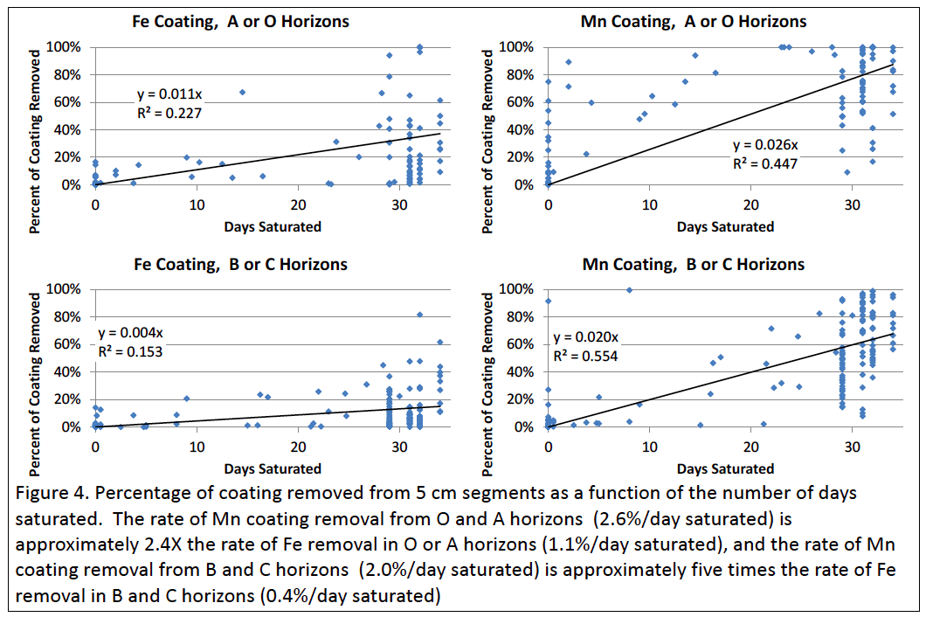

Processes relating the reduction of Mn oxides was discussed and it was mentioned that Mn oxides can be reduced by 1) microorganisms and 2) ferrous iron, which can chemically reduce the Mn oxides.
In a few instances it was noticed that Mn coatings were removed after no apparent cumulative saturation and it was suggested that some of this could be related to the capillary fringe. This will need to be addressed at some point.

5. Updates from each collaborator (Progress, issues, questions)

MA, Mickey – discussed issues related to transforming the transducer data issue; also, she noted that raccoons may be digging up the 10 cm temperature probes.
RI, Mark via email stated “As far as 1438: We are still monitoring the water table levels and soil temperature. We plan on pulling our sticks next month after 1 year. We also placed sticks at the surface for a comparison. We will put sticks back in when we pull the others out.”
DE, Bruce stated that he was continuing the monitoring of water tables, soil temperature, removing sticks after 1 year and maybe replacing for a second year. He is also collecting some water chemistry data through another onsite project.
MD, Marty noted also that they were still monitoring (WT and temperature), and that he was planning to change batteries on wells in November. This was followed by a general discussion on soil temperature sensors.
WY, Karen described that a particular site actually was the middle site in an elevational gradient (another site 1000 ft higher and lower). She also stated that decomposition sticks were deployed last August 1 – and will be removed after 1 year.
We then had some discussion on the definition of a vernal pool– Karen wondered about whether her site was in fact a vernal pool. As Karen described it, it was stated that the site was ponded but was also ephemeral, such that reproduction of amphibians was permitted but not fish. It was generally agreed that the site meets the general definition for a vernal pool.
PA, Patrick described that he had installed hobo pressure transducers, and that he also installed a second round of sticks (since there were issues with the first round – they were tough to remove), Shauna Kay (sp?) will be wrapping up her thesis sometime next May (2018). They also have experienced vandalism, including removal of a well from the site. There was also some conversation regarding bulk density data via vibracoring.
VA, John shared a brief presentation. He is in the process of obtaining some of the data from a former student. He indicated that he almost lost a set of stakes due to burial by sediment. His pools are dry as of 10/17. He also showed a photo of problematic red parent material within the site. There was discussion regarding the possibility of bentonite (used in well casings) being attractive to animals, possibly leading to damage (bears?) He believes that raccoons removed a logger from a well. He also mentioned the availability of slotted steel well casing sold at Home Depot which may be more resistant to bear damage.
6. Overall progress and plans

Review and update of milestone chart - revise NE 1438 timeline
During the coming year, we need to complete the sampling for C stocks; the recommended protocol is to use a single 60 cm aluminum core (3” or 2” irrigation pipe) inserted 50 cm into each plot. After excavation, the cores can be frozen and then cut with sheet metal shears. Any compression is adjusted automatically by having a change in the horizon thickness (Bulk density, C, and horizon thickness are determined from this core). One core is needed at each point along the transect (n=9 cores). A bucket auger should be used to collect samples from 50-100 cm and BD estimated. You can use a block of wood/trex when driving in the cores. A bucket auger can be used to help get the core out (auger next to the core and wiggle core to loosen.
We also need to complete sampling for nitrate/ammonium analysis. Immediately after sampling the soil should be air dried and then sent to Bruce for analysis. Discussion followed about when to sample based on growing degree days (corn metric). Bruce felt it best to “sample when microbes are really active”. It was tentatively decided to sample at 500 GDDs. These data will be used in addressing the question - Is nitrate limiting decomposition? Target date for nitrate sampling is 500 degree days (41F threshold)! It was also decided that in each plot 5 replicate (1”) cores (push probe) would be collected 0-30 cm, composited and then air-dried.

We discussed the possibility of using IRIS films deployed using polycarbonate tubes rather than using standard IRIS tubes in the Spring 2018 deployment. There will be some estimated cost for deployment equipment and Marty will send details. Overall the group was positive about shifting to the films over the tubes.

Karen did a quick demonstration of the Office Lens app used for making photos of whiteboard. She showed an example of Marty’s IRIS film.

Marty conducted a very brief demonstration/tutorial of the Image J (freeware) image analysis software.

Bruce provided a brief update about lab construction at UDel that could slightly complicate the nitrate/ammonium analysis at UDel.

Summary – Status of tasks and objectives

Tasks to be addressed in coming year
1) create spreadsheet for decomposition study: dry weight, 2nd dry weight (Marty). Everyone needs one year of data.
2) create spreadsheet for morphology (Karen), horizon, depth, texture, CoF, structure, redox, bulk density.
3) sample using core for organic (total) C and N (together with CN analyzer) and also Db.
4) sample for nitrate at 500 GGD (Bruce will send around protocol beforehand).
5) aim for 300 GDD to launch another set of IRIS with potential for deployment of films rather than tubes (if tubes, they need to all be painted carefully).

7. Plans for publication
Translating the poster into an article – Marty will outline a Mn/Fe manuscript based on the poster

Other publication plans

Karen will outline a 2nd manuscript that addresses the influence of environmental variables in a more detailed way (C, temperature, saturation frequency).

8. Next meeting
There was discussion regarding where the next meeting should be held. One possibility was in January 2019 in association with the SSSA meeting in San Diego (Jan 6-9, 2019). It was also noted that the NE1438 project extends through the calendar year 2018, so we will likely need to address this with an extension or a new/replacement project. Patrick suggested possibly meeting at EGU (Austria?) in February 2018, and noted that the abstract submission is still open and that when he went last year, the conference was cheaper than attending SSSA. This remained an unresolved issue. We probably will need a conference call in early 2018 to resolve this.

It was moved, seconded and adopted that we adjourn at 4:20 pm.

Submitted by Karen Vaughan

NE-1438 Accomplishments
The 2016-2017 year of the project was the third year of the project. Sites are established, protocols worked out, and experiments and monitoring in progress.
Publications:
Rabenhorst, M.C., P.J. Drohan, J.M. Galbraith, B.A. Needelman, L. Spokas, M.H. Stolt, J.A. Thompson, B.L. Vasilas, K.L. Vaughan. 2017. Comparing Performance of Mn-Coated and Fe-Coated IRIS Devices. Soil Sci. Soc. Am. Annual Meeting, Oct. 22-25, 2017. Tampa, FL. (Oral and Poster 1110). (347-8)
Park, C.E. and M.C. Rabenhorst. 2017. Assessing New Developments in IRIS Technology. Soil Sci. Soc. Am. Annual Meeting, Oct. 22-25, 2017. Tampa, FL. (Poster 1112).
Rabenhorst, M.C. 2017. Oxide-Coated Films - an Improved IRIS Technology. Soil Sci. Soc. Am. Annual Meeting, Oct. 22-25, 2017. Tampa, FL. (347-3).
Rabenhorst, M.C. and J. Post. 2017. Manganese Oxides for Environmental Assessment. Soil Sci. Soc. Am. J. in press.
Drohan, P.J., Plowden, Y., Zimmerman, E., Kraft, J., and D. Kingsbury. 2017. Northern Appalachian wetland ecological sites and their states of disturbance for select benchmark soils. ASA, CSSA, SSSA annual meeting, Tampa, FL. Oct. 22-25, 2017. Abstract #95-1
Ross, B.N. 2017. Assessing hydrology, carbon flux, and soil spatial variability within vernal pool wetlands. M.S. thesis, University of Rhode island, Kingston, RI.

Outreach:
Activities of this project were discussed at the Mid-Atlantic Hydric Soils Committee meetings in January in Raleigh NC and in June in Newton NJ. These meetings are attended by 20-30 people from NRCS, USACE, EPA, consulting companies, faculty and students at University of Maryland, University of Delaware, Penn State, Virginia Tech, and North Carolina State.
The Delaware site was part of the Northeast Regional Pedology Field Tour. Co-hosted by Bruce Vasilas and Joe Valentine. The tour had about 70 participants from ten universities and colleges.
The Delaware site was used for a field trip for the University of Delaware ‘Wetlands’ course.
The project was discussed and hydric soil issues raised at the bi-annual New England Hydric Soils Technical Committee meeting, March 22, 2017, Concord, NH.

