**NC-1178: 2019 Annual Meeting Minutes**

Meeting Dates: July 25-26, 2019

Meeting Location: Loftsgard Hall, North Dakota State University, Fargo, ND

*Chair:* Larry Cihacek, North Dakota State University

*Secretary:* DeAnn Presley, Kansas State University

*Chair Elect:* DeAnn Presley, Kansas State University

*Secretary Elect:* Mohammed Golabi, University of Guam

|  |  |
| --- | --- |
| *Members Present*  Mahdi Al-Kaisi (IA)  Larry Cihacek (ND)  Mohammad Golabi (Guam)  Rattan Lal (OH)  DeAnn Presley (KS)  Humberto Blanco (NE)  Gary Pierzynski (Advisor) | *Members Absent*  Sandeep Kumar (SD) report complete  Lisa Tiemann (MI) report complete  Jose Guzman (SD)  Francisco Arriaga (WI) report complete |
| *Guests*  Sabrina Ruis (NE)  Jasdeep Singh (SD)  Navdeep Singh (SD) |  |

Summary of Minutes of Annual Meeting:

Recorded by DeAnn Presley

*Thursday, July 25, 2019*

Larry Cihacek (ND) opened the meeting at 8:00 AM in Loftsgard Hall at North Dakota State University campus. Department head Frank Casey gave a welcome address and an overview of the department. Gary Pierzynski gave the advisor’s report and made comments.

The business meeting began at 10:00 am with the approval of the 2018 minutes. It was concluded that Mohammed Golabi would host the next meeting in June 2020 in Guam, and Mohammed was elected incoming secretary. We had a discussion of methods and also of publishing a manuscript together, led by Humberto Blanco. We adjourned for lunch.

After lunch Marisol Berti, professor of forages and oilseed crops at North Dakota State University, gave a presentation of ongoing cover crops research happening in North Dakota.

Presentation of research reports followed.

The meeting was adjourned until Friday morning at 8:00 AM. Following adjournment the committee members went to dinner as a group.

*Friday, July 26, 2019*

The committee participants went on a tour. The first stop was by Burton Johnson, director of new and emerging crop research, followed by a tour of Marisol Berti’s cover crop experiments, and concluded with a tour of the NDSU greenhouse complex. The meeting adjourned following the tour at approximately 11:30 AM.

**NC1178 Project Annual Reports for 2019**

**(Station report)**

**Guam**

Mohammad H. Golabi1, PhD

**University of Guam**

**Mangilao, Guam-USA**

**\*\*For impacts and accomplishments, try to emphasize collaborative, multistate efforts whenever available.**

1. **Impact Nugget:  A concise statement of advancements, accomplishments and impacts.  (Limit to 1-2 sentences)**

Guam is composed primarily of limestone rock to the north and red volcanic clay soils in the south. The red volcanic soils in the south are severely eroded and locally are referred to as badlands. These barren sites are exposed to overland flow, wind and rain causing severe soil erosion and producing massive amount of sedimentation in the downstream rivers and shorelines of southern Guam. This massive siltation not only damage the marine environment downstream and effect fisheries in the south but also effect fresh flow of rivers which are the main sources of fresh water for residential consumption in southern Guam.

In addition, transfer and redistribution of soil organic carbon (SOC) caused by sever soil erosion may also have an impact on the overall global C budget (Lal, 2003). Furthermore, the extent of soil erosion, and its impact on soil carbon dynamics, and the potential of erosion management (conservation) to sequester the ‘C’ by mitigating the accelerated sedimentation (Lal, 2003) are among the challenges of soil and environmental scientists not only in Guam but around the world.

In this study which is supported by the NC 1178 multi-state project, we are implementing conservation tillage practices such as reduced till as well as the application of carbonized material (Glaser, B., et.al.,2001 and, Krishnapillai, Murukesan V. 2013) such as ‘biochar’ on these degraded lands of southern Guam. Preliminary results from the aforementioned management practices so far have shown that there has been an increased in soil carbon content, as well as soil quality improvement which are expected to enhance soil health for agricultural sustainability and environmental integrity in Guam and similar islands in Micronesia. The implementation of such management strategies on the wider scope will have a positive impact on water quality, thus the healthy status of the coral reef, which are one of the pillars of economic well-being in Guam and the other islands in Micronesia.

1. **New Facilities and Equipment. Include production areas, sensors, instruments, and control systems purchased/installed.**

The experiment for this study is being conducted at the University of Guam’s experiment station located in the district of Ija village in Southern Guam. The station is supplied with water and equipped with adequate set of farming machinery that are operated and maintained by the university personnel working at the station. However, the equipment at the station does not include No-till planters and similar machinery for conservation farming systems. Therefore, No-till planting is conducted manually using hand held planter. Due to unpredictable weather patterns in the area, irrigation lines were installed for regular watering as well as for fertigation procedures. Also, in order to measure the carbon dioxide emission from the soil, a set of homemade monitoring devices were developed in which sodium hydroxide solution were placed in an enclosure which were placed randomly within each plot. By capturing the carbon dioxide emitted from the soil within the enclosures, the amount of CO2 emission into the atmosphere thus was monitored and estimated from each treatment plot. In addition, soil sampling was conducted (Figure 1, 2) to obtain samples from three increments in depth (15cm, 30cm and 45cm) in order to measure the carbon content of each study plots as they were affected by different treatment. Soil samples were brought to the University of Guam‘s Soil Labs’ for carbon content evaluation as well as other soil parameter measurements.

The application of ‘biochar’ was initially evaluated and compared only between and among the conventionally tilled treatments. However, as part of this year’s (2019) modification, and in order to comply with the recommendation made by the Multi-State group members, we split every individual plot into two sections where, one section continued with the original treatment without ‘biochar’ and the second section was treated with the application of ‘biochar’ while continuing with the same conservation tillage treatment. This procedure thus, was conducted in order to evaluate and compare each treatment plot with a companion plot which received ‘biochar’ application of 15tons per acre.

1. **Unique Project Related Findings.  List anything noteworthy and unique learned this year.**

Due to the weather irregularities (typhoon ‘***wutip’*** in February and drought condition during May, June, July), the crop in the field were damaged severely to the point that we were not able to obtain valuable data for this year’s (2019) project activities. However, data obtained from the previous year had shown that the percent carbon content of the soil was highest under the no-tillage (NT) treatment (Figure 3). This was pertinent to no disturbances on the soil surface during the study period. On the reduced till (RT) treatment plots, the percent carbon content also remained high next to the NT plots mainly due to the minimum disturbances as compared to conventionally tilled (CT) treatment. As it is shown in Figure 3, the percent carbon content in the conventional tilled plots (CT), where the crop residue was removed were the lowest for all sampling events. On the other hand, when ‘biochar’ were applied the carbon content of the soil remained relatively high. It was believed that the ‘biochar’ application to the conventionally tilled plots (CT/BC), not only would serve as soil amendment for soil quality improvement but also, it increased the carbon content of the soil as compared to CT treatment mainly due to the carbon effect of the ‘biochar’ that was added to the soil before planting.

Although not conclusive the accumulated data for this study has shown that No-tillage (NT) farming systems had a distinctive effect on the soil carbon storage capacity and possibly soil carbon sequestration. This indicates that with No-tillage practices we can potentially reduce the amount of carbon dioxide emission (Fig. 4) into the atmosphere from the soil quite considerably. In addition to No-till farming practices, we are also evaluating a method of storing the soil carbon by using ‘Biochar’ as soil amendment. Based on the studies, biochar is capable of absorbing and storing (‘sequestering’) considerable amount of soil carbon hence, reducing the amount of carbon dioxide formation through the oxidation process following each tilling.

1. **Accomplishment Summaries.  Draft one to three short paragraphs (2 to 5 sentences each) that summarize research or outreach accomplishments that relate to the project objectives.  Please use language that the general public can readily comprehend.**

Soil quality and soil and water conservation strategies are the building blocks of agricultural sustainability in Guam and the other islands of the American territories in the western Pacific. In order to improve the soil quality for agricultural sustainability, methods and management practices proposed on this project are demonstrated and/or disseminated among the users (farmers, ranchers, etc.). Methods applied in this project are also being thought in my soil classes as lectures that were given to my students. Methods used are; reduced and minimum tillage practices, crop rotation, crop residue management, use of green manure (legume) and the application of ‘biochar’ as soil amendment for increased soil carbon storage capacity and improved soil quality.

Our parallel research works have shown (Golabi, et. al., 2014) that relatively long growing season and adequate rainfall in Guam enables growth of legumes which can be used as rotating crop to supply nitrogen to subsequent crops, hence maintaining crop productivity and agricultural sustainability in the islands of Micronesia. on the other hand, excessive tillage attributes to soil erosion by water, hence deteriorating the environmental quality in Guam and other island of Micronesia where water quality and coral health are affected by sedimentation and runoff from unprotected farms, ranches and general landscape.

All these concepts described here as being part of our project activities are disseminated among the aforementioned stakeholders and students. In addition, the information was also disseminated via conference presentations (poster and oral), technical reports and journal articles. Furthermore, and in order to disseminate the findings of this project among the public, occasional field days, and other educational events and publication materials (Brochures, Newspaper articles, etc.) have been organized during the project life for agricultural professionals as well as farmers and ranchers and the general public at the University of Guam research station located in Ija (southern Guam).

1. **Impact Statements.  Please draft 2 or 3 impact statement summaries related to the project objectives.  Statements should be quantitative when possible and be oriented towards the general public.  This is perhaps the most difficult yet most important part of the report.**

The results of this on-going research work has shown that the tillage treatment as well as application of amendments (e.g., biochar) affects the quality of soil and its productivity. Also, as shown (Fig. 3), the carbon content of the soil was considerably higher in the upper depths (0- 4 inches) regardless of the tillage treatment. However; the overall carbon content of the soil under conventional tillage (CT) treatment is generally lower due to continuous disturbances of the soil surface and within the tillage depth. This could be due to the fact that the carbon sequestration potential of these soils under conventional tillage practices is inadequate as compared to the No-tillage systems.

Findings from this on-going experiment therefore will contribute to the overall scientific efforts in understanding the role of different agriculture practices in carbon dynamics of the soils, and the ways in which this may reduce atmospheric carbon dioxide (Fig. 4). It also provides information pertaining to the local conditions of the island’s tropical climate as relates to carbon sequestration and/or carbon loss in the form of carbon dioxide emission into the atmosphere following the removal of crop residue as well as disturbances that occur during the tilling process.

As indicated in the earlier sections, the implementation of such practices not only will have a major impact on agricultural sustainability but also will have an impact on water quality and the coral reef, which are very important for economic wellbeing of Guam and the other islands in Micronesia.

1. **Published Written Works.  Include scientific publications, trade magazine articles, books, posters, websites developed, and any other relevant printed works produced.  Please use the formatting in the examples below.**

BOOK CHAPTER:

1. Jose Guzman, and **Mohammad H. Golabi**. (2017). Agroecosystem Net Primary Productivity and carbon Footing. *In the:* ‘Soil Health and Intensification of Agroecosystems’, edited by; Mahdi Al-Kaisi (Iowa State University), and Birl Lowery (University of Wisconsin-Madison). Academic Press (AP), An imprint of Elsevier. London, San Diego, Cambridge, MA, Oxford, England. ***Published***

NEWSPAPER ARTICLES:

1. **Golabi Mohammad H.** You can be the solution to soil pollution issues. Pacific Daily News. January 3, 2019. Vol. 50 No. 336
2. **Golabi Mohammad H.** Vetiver hedgerows help prevent erosion. (Soil erosion a threat to a sustainable water supply in Guam). Pacific Daily News. March 7, 2019. Vol. 51 No. 34
3. **Golabi Mohammad H.** (2019). Prevent soil erosion to protect our water. May 18, 2019. Vol. 51 No 106
4. **Scientific and Outreach Oral Presentations. Include workshops, colloquia, conferences, symposia, and industry meetings in which you presented and/or organized. See below for formatting.**

CONFERENCE/MEETING PRESENTATIONS

1. **Golabi Mohammad H.** (2019). What do we know about the soils of Guam? their formation, properties and functions - How can we take care of these soil? Presented at the Pacific Soil Partnership as part of the activities for ‘Soil Regional Implementation Plan’ to be submitted to the ‘Global Soil Partnership Pillar of Action” which was presented at the ‘Global Soil Partnership Annual Plenary in Rome Italy, during June 5-7, 2019.
2. Chieriel Desamito1, **Mohammad H. Golabi**. 2019. The Impact of Land Application of Biochar on Carbon Sequestration and Agricultural Sustainability- Follow up Research. Conference of Island Sustainability, which was held in Hyatt Regency Guam, during April 8-12, 2019.
3. **Mohammad H. Golabi**, Chieriel Desamito, Clancy Iyekar. (2019). Evaluating the effect of land application of ‘biochar’ on limestone soils for carbon sequestration to reduce climate change effects. Submitted to the: European Society of Soil Conservation, 9th International Congress that was held in Tirana (Albania), during September 6-9, 2019.
4. **Mohammad H. Golabi**[1], S.A. El-Swaify[2]. (2019). Using ‘No-tillage’ farming technique as an assessment tool in soil erosion control study on highly acidic soils formed from the volcanic origin, common in Micronesia. Extended Abstract Submitted to the: Global Symposium on Soil Erosion that was held in FAO HQ, Rome, Italy, during May 15-17, 2019.
5. **Golabi, Mohammad H**., S.A. El-Swaify. (2019). ‘Soil management strategy for enhancing soil quality in Resilient Agriculture’. Abstract submitted to: The Joint International Conference: 4Th WASWAC world conference, 20th ISCO International conference, 4th SCSI international Conference: New Delhi, India. November 5th – 9th, 2019
6. **Mohammad H. Golabi**, and Chieriel S. Desamito, and, Clancy Iyekar. (2019).

Integrating the application of ’biochar’ into Agricultural Conservation Practices for Sequestering Soil Carbon in the cultivated lands of southern Guam. Abstract Submitted to the: Soil Science Society of America’s annual meetings that was held in San Diego, California, during January 6-9, 2019.

1. **Golabi, Mohammad H**., and Clancy Iyekar. (2017). ***Evaluating the role of Soil and Water Conservation on ‘Carbon Sequestration’ for reducing the carbon dioxide (CO2) emission into the Atmosphere – a Case study from southern Guam***. S*ubmitted to the:*1st World Conference on Soil and Water Conservation under Global Change (CONSOWA-2017) for: Sustainable Life on Erath through Soil and Water Conservation. Lleida, ***Spain*** June 12 - 16, 2017. ***Invited Paper***
2. **Golabi, Mohammad H**., and Clancy Iyekar. (2017). ***Would the land application of ‘Biochar’ help ‘Sequester’ soil carbon hence reduces the CO2 emission into the Atmosphere? – an environmental case study in southern Guam.*** *Submitted to:*The 8th Regional Conference on Island Sustainability. April 17-21, 2017 at the Hyatt Regency hotel in the island of ***Guam***.
3. **Golabi, Mohammad H.**, and Clancy Iyekar. (2017). ***Evaluating the benefits of ‘Biochar’ on soil quality while determining its effect on ‘Soil Carbon Sequestration – A pathway to Sustainability.*** *Abstract Submitted to the:* 72nd International Annual Conference of the Soil and Water Conservation Society. ***Madison, Wisconsin,*** July 30th to August 2nd, 2017.
4. **Fund leveraging, specifically, collaborative grants between stations and members**.

COLLABORATIVE EFFORTS

**Potential collaborative research project(s) in the pipe:**

1. Pursuing collaborative efforts with an Agronomy Researcher and Extension Specialist at the Cooperative Research and Extension, Agricultural Experiment Station, College of Micronesia, in the island of Pohnpei, the Federated States of Micronesia (FSM). COM-FSM CRE Division, Kolonia, P.O. Box 1866, Kolonia, Pohnpei FM 96941.
2. On behalf of CSIRO and Pacific Regional Partnership I participated in the Regional Implementation Plan Workshop (2019), which was held in Brisbane Australia, during May 21-23, 2019. Following this workshop, the collaboration with the Pacific Soil Partnership (PSP) with Australian, New Zealand’s and islands of the pacific will continue in order to develop a ‘comprehensive Global Soil Partnership Pillar of Action ‘for managing the soils in the pacific island countries.
3. **Other relevant accomplishments and activities.**
4. In addition to the dissemination of the results from this research via publications and conference presentations indicated above this project has also been used as a teaching tool/opportunity throughout each academic year for educational purposes. Graduate and undergraduate students from the Soil as well as Geography classes at UOG had been taken to the project site where the purpose and the objectives of the project were described to the students as part of outside classroom learning opportunities. The effect of each tillage treatments and crop residue removal as well as the application of ‘biochar’ as a carbonized material from the incomplete combustion of organic waste have been demonstrated to students at the project site where they were able to write report and/or provide answers to the related exam questions.

**REFERENCES:**

Golabi, M. H., S.A. El-Swaify, and Clancy Iyekar (2014). Experiment of “no-tillage” farming system on the volcanic soils of Tropical Island of Micronesia. *International Soil and Water Conservation Research Journa*l. Vol. 2, No. 2, June 2014.

Golabi, M.H., S.E. Radcliffe, W.L. Hargrove, and E.W. Tollner. 1995. Macropore effects in conventional tillage and no-tillage soils. Jour. Soil and Water Cons. 50(2) 205-210.

Lal, R. 2003. Soil erosion and the global carbon budget. Environment International 29 (2003) 437–450. Available at: www.sciencedirect.com

Glaser, B., Balashov, E., Haumaier, L., Guggenberger, G. and Zech, W. 2000. Black carbon in density fractions of anthropogenic soils of the Brazilian Amazon region. *Org Geochem*., 31: 669-678.

Glaser, B., Haumaier, L., Guggenberger, G. and Zech, W. 2001. The 'Terra Preta' phenomenon: a model for sustainable agriculture in the humid tropics. *Naturwissenschaften*, 37-41.

Krishnapillai, Murukesan V. (2013). Role of biochar in improving the fertility of degraded volcanic red soils in Yap. Proposal by: Murukesan V. Krishnapillai, Agricultural Experiment Station, Cooperative Research and Extension, College of Micronesia-FSM, Yap Campus, Colonia, Yap, FSM

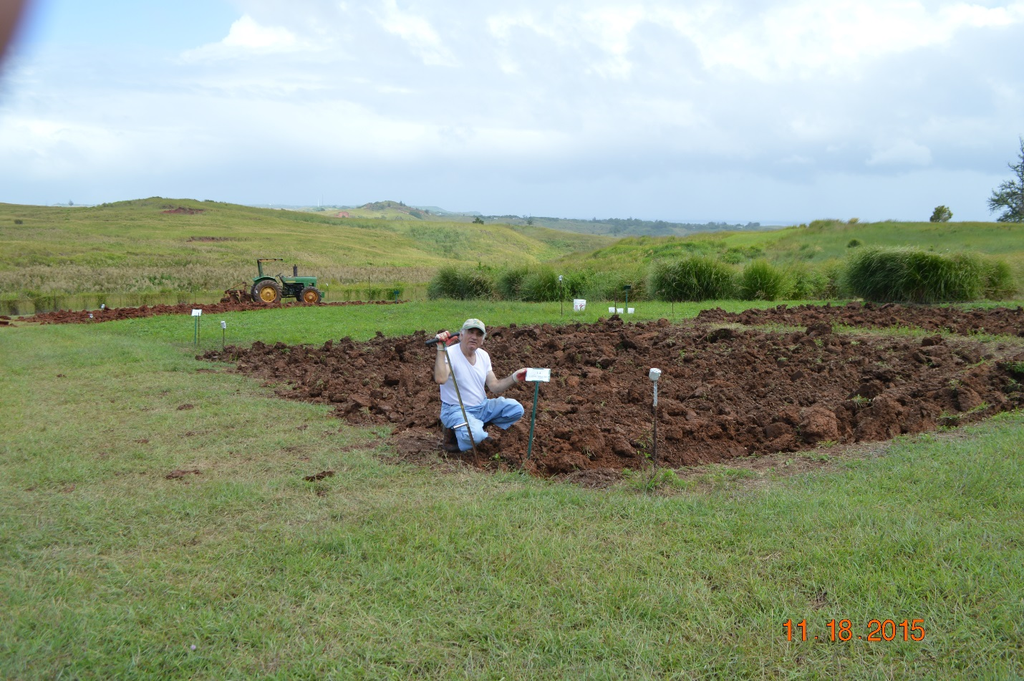

**Figure 1:** Showing Conventionally tilled (CT) plots adjacent to No-tilled (NT) plots during the long-term studies evaluating the carbon dynamics of soils under different treatments. (Nov 2015).

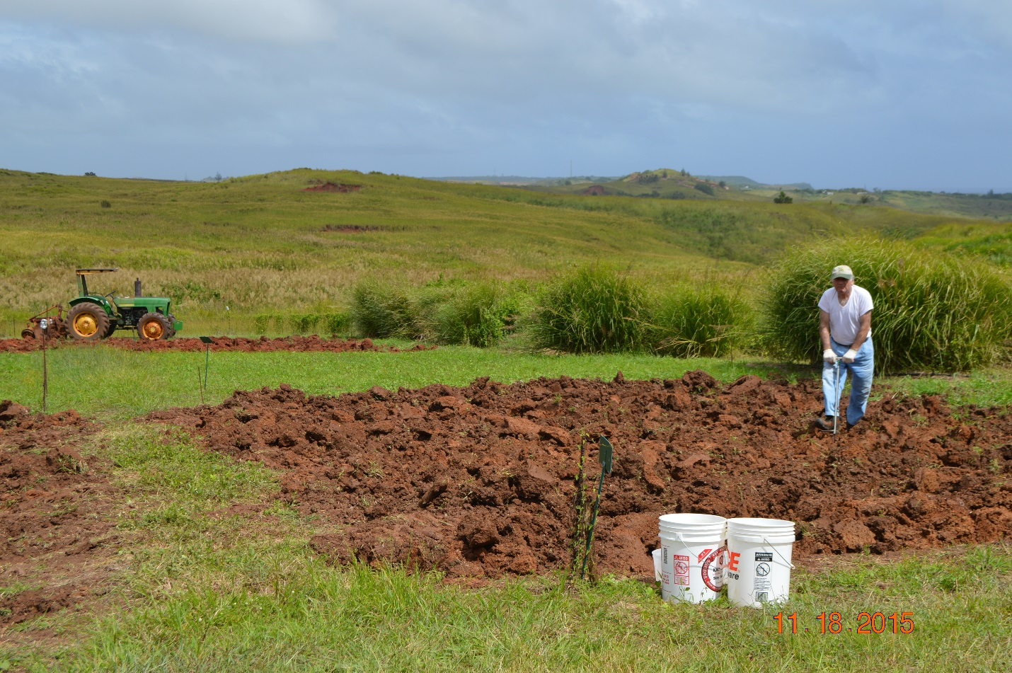

**Figure 2:** Showing soil sampling event during the long-term studies evaluating the carbon dynamics of soils under different treatments in the research station of the University of Guam. (Nov 2015).

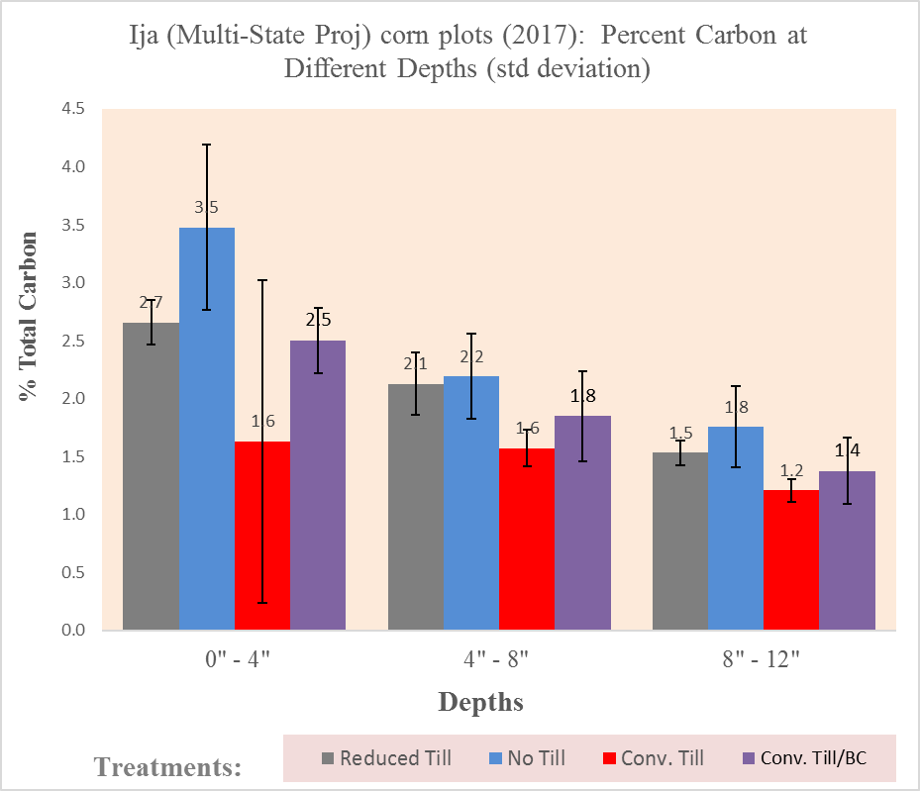

**Figure 3.:** Showing percent carbon content of the soil at different depth under different treatments: Reduced till (RT), No-Till (NT), Conventional till (CT), and Conventional till with ‘Biochar application’ (CT/BC).

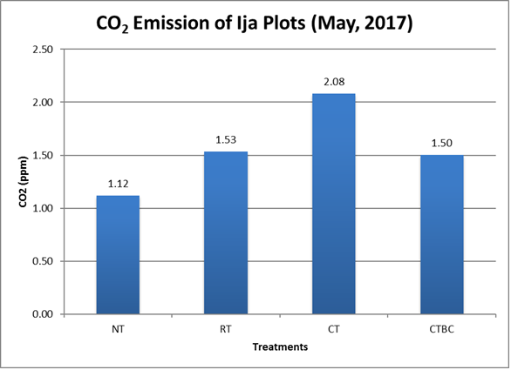

**Figure 4.:** Showing carbon dioxide (CO2) emission from the soils under different treatments: No-till (NT), Reduced till (RT), Conventional till (CT), and Conventional till with ‘biochar’ application’ (CT/BC).

# NC-1178 Annual State Report

|  |
| --- |
| Year: July 25-26, 2019, Fargo, ND |
| **Institution: Iowa State University** |
| **Committee Representative: Mahdi Al-Kaisi, Professor, Agronomy Department** |

1. **Impact Nugget:**

Iowa State University research demonstrated a reduction in input cost of producing corn and soybean with No-till and Strip-till by $15-25/ha compared to conventional tillage and improvement in SOC with NT and ST by 0.3 to 0.5 Mg/ha/yr while conventional tillage systems lost 0.4-0.5 Mg/ha/yr in a 14-yr study.

1. **New Facilities and Equipment:**

None

1. **Unique Project Related Findings:**

* Conservation tillage systems that include NT and ST showed an increase in SOC in the range of 0.30-0.50 Mg/ha/yr, while convectional tillage systems (chisel-plow, deep-rip, and moldboard-plow) caused decline in SOC stocks by 0.4-0.5 Mg/ha after 14 years in Iowa.
* The use of NT and ST reduced farming input cost by $15-25/ha compared to conventional tillage systems.
* Our research showed that continuous corn system led decline in corn yield across all tillage systems by 11-28% compared to corn after soybean. There was no effect on soybean yield across all tillage systems.

1. **Accomplishment Summaries:**

Iowa State University conducted long-term tillage and crop rotation study that include five tillage systems include: no-till (NT), strip-till (ST), chisel plow (CP), deep rip (DR), and moldboard plow (MP) and the three crop rotations include two with soybean: Corn-soybean (C-S), Corn-corn-soybean (C-C-S) and a continuous corn (C-C) system. Corn and soybean yields were determined from the center 4 and 6 rows of each plot, respectively. These experiments implemented at seven Iowa State University Research and Demonstration Farms representing different soil types and climate conditions. Analysis of 14 years of data showed greater yield response with C-S rotation compared to C-C by 11-28% across all tillage systems and greater input cost with Conventional tillage systems compared to NT and ST by 7.5% and %.7%, respectively. Preliminary analysis of soil carbon over the past 14 years showed an improvement in soil carbon with NT and ST by 0.50 and 0.30 Mg/ha/yr, respectively as compared to conventional tillage systems with soil carbon loss of approximately 0.60 Mg/ha/yr.

1. **Impact Statements:**

* Preliminary analysis of soil carbon over the past 14 years showed an improvement in soil carbon with NT and ST by 0.50 and 0.40 Mg/ha/yr, respectively as compared to conventional tillage systems with soil carbon loss of approximately 0.60 Mg/ha/yr.
* The analysis of 14 years of data on the effect of long-term tillage and crop rotation on corn and soybean yield and economic returns showed an interesting trend across the state of Iowa. Corn yield and economic return showed significant variability across the state as affected by soil type and climate conditions.
* Economic return showed a significant advantage for NT and ST over conventional tillage systems where input cost was $15-25/ha less with NT and ST compared to conventional tillage systems. Also the results reveal a significant decline in corn yield with continuous corn compared to corn following soybean rotation.
* The soybean yield in the same study shows no significant differences in yield regardless of tillage or crop rotation. However, economic return for soybean across all tillage systems and locations was 5% greater with C-C-S compared to C-S rotation.

1. **Published Written Works:**

Chaoqun Lu , Zhen Yu, Hanqin Tian, David A Hennessy, Hongli Feng, Al-Kaisi, M.M., Yuyu Zhou, Tom Sauer and Raymond Arritt. 2018. Increasing carbon footprint of grain crop production in the US Western Corn Belt. Environmental Research Letters. 13 124007

1. **Scientific and Outreach Oral Presentations.**

* During the growing season of 2018, several presentations of the preliminary findings of these studies were presented to local farmers and agronomists in the state. These workshops were organized by Extension as part of the annual Extension and education program.
* Yield data collected from these studies analyzed for yield response and economic returns to different tillage and crop rotations. Also, analysis of soil carbon data for the past 14 years conducted to be published in a refereed journal article.
* Training sessions, PowerPoint presentations, and educational materials were presented during different events in the state. In addition to field days, initial findings of this research were shared with other colleagues and agricultural professionals through newsletter articles, and annual meetings.
* Presentation at the regional committee meeting and presentation to extension educators and other agricultural professionals during various events such as the Integrated Crop Management (ICM) conference in Iowa in 2018. The ICM conference is organized annually and approximately 1,000 agricultural professionals attended the conference.

1. **Funding Leveraging: None**
2. **Other Relevant Accomplishments and Activities:**

Soil Health conference is organized since 2016 at Iowa State University. In 2019, two days conference was organized by inviting scientists from land grant universities and ARS-USDA to share their research and present posters. Over 300 farmers, agronomists and students attend the conference in Ames Iowa.

**NC1178 2019 Report**

DeAnn Presley

Department of Agronomy

Kansas State University

Manhattan, KS 66506

1. **Impact Nugget**:

Over a 10-year average, crop residue removal had no significant effect on corn yield at two locations in Kansas. At both sites all treatments appear to have declined in soil organic C content (0-10 cm depth, in Mg ha-1) since initiation in 2009, with no differences among treatments at either site.

1. **New Facilities**: None
2. **Unique Project Related Findings**:

The tradeoff between increasing crop yields and increasing soil organic C sequestration is an illustration of the need for balancing two ecosystem services provided by cropland soils, i.e., provisioning and regulating.

1. **Accomplishment Summary**:

A corn residue removal research project began in 2009 at three sites. One site was discontinued after 2011, but the other two locations are still active research sites. Residue removal studies continue on two sets of plots with 0, 25, 50, 75, and 100% stover removal levels. One plot is in eastern Kansas, and the other is an irrigated site in western Kansas. Crop grain yield is measured annually and soil organic C and bulk density are measured every other year in odd years. Soil organic C has been measured multiple times during the experiment. For the ten-year average, crop yield has not been affected by residue treatment at either site (Table 1, p < 0.05). Relative to the 2009 baseline levels of soil organic C in the upper 10 cm of the soil profile is slightly lower, however, the values are not significantly different between treatments.

Figure 1. Corn yields at 15.5% moisture, averaged by treatment 2009-2018. There are no statistical differences between yields when averaged across years.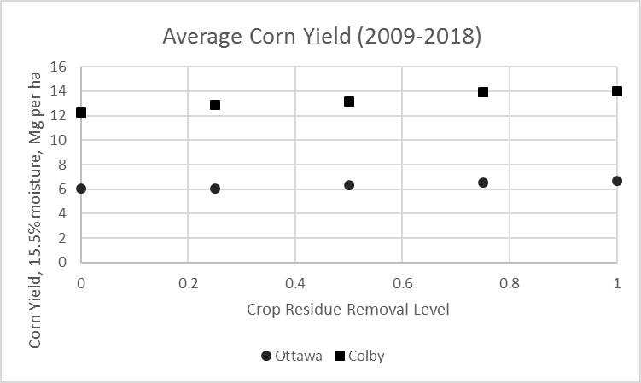

Figure 2. All treatments have less SOC (Mg ha-1) relative to 2009 values, at both sites, with no statistical differences between treatments.

1. **Impact Statements**:

* On average, crop residue removal has had no statistically significant effects on continuous no-till corn yields in this ten-year, two site location study.
* For the upper 10 cm of the soil profile, soil organic C values do not differ among treatments, but the 2017 values are less than the 2009 values.

1. **Published Written Works**

Farney, J.K., G.F. Sassenrath, C. Davis, and D. Presley. 2018. Composition, forage production, and costs are variable in three-way cover crop mixes as fall forage. Crop, Forage, and Turfgrass Management. doi:10.2134/cftm2018.03.0020

1. **Scientific and Outreach Oral Presentations:**

CONFERENCE/MEETING PRESENTATIONS

* 1. Presley, D.R., J. Tatarko, and Y. He. 2018. Removing crop residue in continuous no-tillage systems: Soil and Productivity Effects are Site-Specific. In abstracts of the 21st International Soil Tillage Research Organization Conference, Paris, France. Poster.
  2. L. Starr, P.J. Tomlinson, N.O. Nelson, D.R. Presley, G.J. Kluitenberg, and K.R. Roozeboom. 2018. Soil microbial biomass and enzyme response to cover crop and P fertilization management in a no-till, corn-soybean rotation. In abstracts of the American Society of Agronomy Annual Conference, Baltimore, MD.
  3. Presley, D.R., R.A. Cloyd, C.L. Rivard, K. Oxley, C. Day, and M.M. Kennelly. 2018. Flipping the classroom in extension: Vegetable Crop IPM and soil health webinars and workshops. In abstracts of the American Society of Agronomy Annual Conference, Baltimore, MD.
  4. Presley, D.R. and Y. He. 2018. Soil health and yields on non-sodic soils amended with flue gas desulfurization gypsum. In abstracts of the American Society of Agronomy Annual Conference, Baltimore, MD.
  5. Wills, S., M.P. Robotham, J. Nemeck, D. Osmond, J.L. Heitman, D.R. Presley, P.J. Tomlinson, H. Tao, P.B. DeLaune, K.L. Lewis, G.C. Liles, F.J. Arriaga, and L. Adams. 2019. Putting soil health indicators in context: A project using dynamic soil properties and soil survey to provide reference potentials. In. abstracts of the Soil Science Society of America Annual Conference, San Diego, CA.
  6. Presley, D.R. 2019. Benefits and limitations of physical measures of soil health. In. abstracts of the Soil Science Society of America Annual Conference, San Diego, CA.

EXTENSION PRESENTATIONS

1. March 8, 2018, gave extension presentation on utilizing cover crops for forage and soil health at the Riley County Soil Health Meeting. Manhattan, KS, attended by 100 producers, agency staff, and crop consultants.
2. March 13-14, 2018, attended the Midwest Cover Crops Council annual conference held in Fargo, ND and spoke on the subject of grazing cover crops and soil health in discussion groups. Approximately 60 producers and crop consultants attended.
3. March 27, 2018, spoke at the Food and Ag Advocacy workshop in Manhattan, Kansas, about this research project and its goals. Attended by approximately 40 producers, members of the public, and advocacy group members.
4. April 11, 2018, spoke to about 100 3rd and 4th graders about soil and water erosion at the Wabaunsee County, KS water festival in Alma, KS. (With Peter Tomlinson).
5. April 18, 2018, spoke to about 30 producers and agricultural advisors on the subject of grazing cover crops and soil health in Harper County, Kansas.(With Peter Tomlinson).
6. April 19, 2018, spoke to about 80 5th and 6th graders about soil and water erosion at the Wabaunsee County, KS water festival in Alma, KS.
7. April 28, 2018, spoke to 9 Boy Scouts and 9 adult leaders at the KSU Merit Badge Conference on the subject of soil and water conservation.
8. May 1-2, 2018. Onsite wastewater school. Kansas Small Flows Association. Pratt, Kansas. 30 attended.
9. May 9-10, 2018. Compost operators training. Hays, KS. 12 attended.
10. May 15-16, 2018. Compost operators training. Winfield, KS. 12 attended.
11. June 20-21, 2018. Leavenworth County wastewater treatment system installers meeting. Leavenworth, KS. 14 attended.
12. July 10-13, 2018. Manure and mortality composting on-farm. KARA summer field school. 131 attendees.
13. August 14, 2018. Soil health and cover crops. Hugoton, KS. 40 attended.
14. September 16, 2018. Polygenetic soils of the Flint Hills. Regional Collegiate Soils Contest. 75 attended.
15. October 4-5, 2018. Onsite wastewater school: Basic soil properties. Leavenworth, KS.
16. December 4, 2018. Composting basics. Kansas Turfgrass and Nursery Landscape Conference. Topeka, KS. 50 attended.
17. December 10, 2018. Kansas cover crops research update. Syngenta Agronomists. Manhattan, KS. 10 attended.
18. January 16, 2019. Protecting soil and water quality. Saline County Water Festival. 120 attended.
19. February 13, 2019. Soil and water conservation review for Certified Crop Advisors Exam Preparation. Manhattan, KS. 20 attended.
20. February 20, 2019. Kansas cover crop update. Midwest Cover Crops Council meeting, Springfield, IL. 200 attended.
21. March 18, 2019. Soils and geology of southeast Kansas. Dirt Day in Neodesha. 30 attended.
22. April 27, 2019. Soil and water conservation merit badge. Boy Scouts of America. 12 attended.
23. May 8-9, 2019. Onsite wastewater school: Basic soil properties. El Dorado, KS. 24 attended.
24. July 9-12, 2019. Soil compaction. Kansas Ag Retailers Association Summer Field School. Manhattan, KS. 100 attended.
25. **Fund leveraging:** 
    1. Grant: United States Department of Energy: Enabling Sustainable Landscape Design for Continual Improvement of Operating Bioenergy Supply Systems. Total award $9 million, sub-award to Kansas State University $125,000.
26. **Other Activities:**

Graduate Students:

* 1. Savanna Crossman. M.S. May 2018-present.

**NC1178 2019 Report**

Humberto Blanco, Professor

Department of Agronomy and Horticulture, University of Nebraska-Lincoln

**Cover Crop Root Biomass Production**

1. **Impact Nugget**:

Late-terminated rye cover crop (CC) can increase root biomass production and thereby increase soil C if given sufficient time to grow in spring (termination in early May instead of late Apr). Cover crop roots are generally confined to the surface depth (0 to 5 cm). Cover crop effects on root biomass production may vary from year-to-year and by cropping system.

1. **New Facilities**:
2. **Unique Project Related Findings**:

Late-terminated rye CCs may increase CC biomass production if CCs are given sufficient time in the spring to grow. Late-planted rye CC may increase root biomass production in irrigated environments due to moisture availability.

1. **Accomplishment Summary**:

In spring 2018 and 2019, winter rye cover crop (CC) root biomass samples were collected using a Giddings hydraulic truck-mounted probe to depths of 0 to 5, 5 to 10, and 10 to 20 cm from four sites in Nebraska at the time of CC termination. Two of the sites (one rainfed and one irrigated) were in years 5 and 6 of no CC, early-terminated CC (2 to 3 weeks prior to corn planting), and late-terminated CC (at corn planting) treatments in no-till continuous corn. The other two sites (one rainfed and one irrigated) were in years 4 and 5 of early-planted (21 d prior to harvest) and late-planted (after harvest) CC treatments in no-till continuous corn and corn-soybean.

At the rainfed site, termination date did not affect root biomass production for the 0 to 5 and 5 to 10 cm depths compared to the no CC control in either year (Fig. 1). However, at the irrigated site, late-terminated CCs increased root biomass production in the 0 to 5 cm depth in both years compared to early-terminated and control plots. Root biomass production was unaffected by CC termination date in the 5 to 10 cm depth. The difference in termination date response between these two sites is potentially because of management. The CCs are planted about the same time at both sites, but CCs are terminated about two weeks later at the irrigated site (about May 10), which allows for greater biomass production. The results suggest that CC roots are primarily confined to the surface 5 cm of the soil and that delaying termination can increase CC root biomass production. The increased biomass production can therefore lead to enhanced soil C concentration.

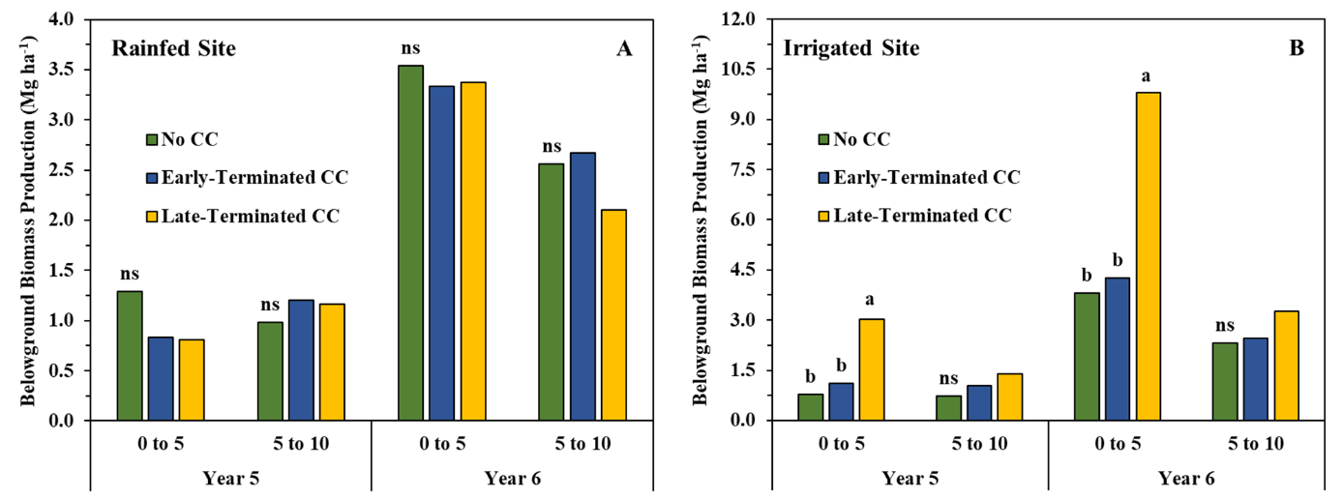**Fig. 1.** Cover crop termination date impact on root biomass production by soil depth at a rainfed (A) and irrigated (B) site in Nebraska after five and six years of CCs. Bars with the same lowercase letter within a site, year, and depth denote statistical differences at *p* < 0.05. ns denotes non-significant.

Rye CC and early planting did not impact root biomass under continuous corn at the rainfed site in year 4 (data not shown). However, rye CC increased root biomass production (from about 0.75 to 3.25 Mg ha-1) in the 0 to 5 cm depth under corn-soybean, but early planting had no effect (data not shown). This rainfed site was not sampled in year 5 due to flooding. The data suggest that rye impacts to root biomass production may be small in rainfed systems despite early planting. The lack of early planting effects could be due to relatively early termination (late Apr to early May).

Rye CC increased root biomass production in year 5 under continuous corn and year 4 under corn-soybean in the 0 to 5 cm depth at the irrigated site (Fig. 2 A-B). Rye CC did not generally impact root biomass production in the 5 to 10 cm depth.

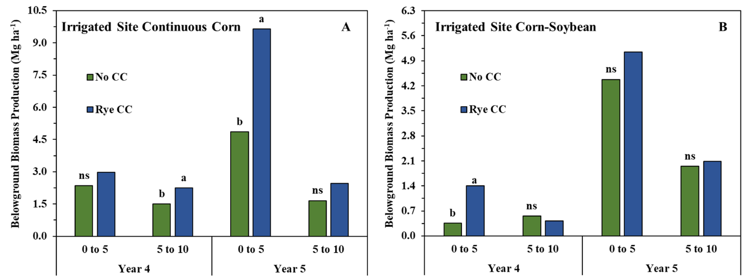

**Fig. 2.** Winter rye CC effect on root biomass production by soil depth under continuous corn (A) and corn-soybean (B) at an irrigated site in Nebraska after four and five years of CCs. Bars with the same lowercase letter within a rotation, year, and depth denote statistical differences at *p* < 0.05. ns denotes non-significant.

Late-planted CCs increased root biomass production at the 0 to 5 and 5 to 10 cm depths in year 4 under continuous corn at the irrigated site (Fig. 4A). At the same site, under corn-soybean, early-planted CCs only increased root biomass production in the 5 to 10 cm depth (Fig. 4B). These data suggest that late CC planting may improve root biomass production due to planting coinciding with fall rains in relatively drier locations where irrigation is used.

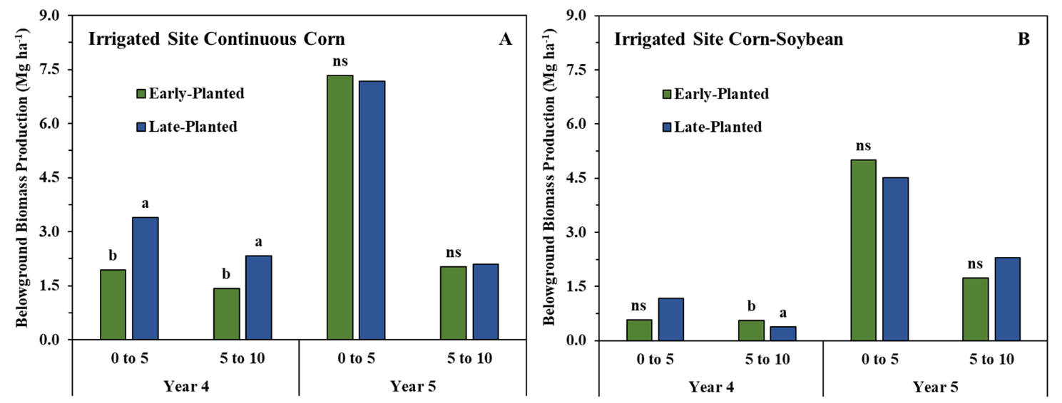

1. **Impact Statements**:

* Late-terminated CCs, particularly when terminated in later in spring can improve root biomass production.
* Cover crop roots are generally confined to the surface depth (0 to 5 cm).
* Early-planted CCs may not always increase root biomass production in rainfed sites, but in irrigated sites, late-planted CCs can increase root biomass in some years.
* The improvement in root biomass production with late-terminated CCs and in some years and locations, changes to planting date, may lead to increased soil C.
* At relatively dry sites, late-planted CCs may increase root biomass production compared to early-planted due to moisture availability.

1. **Published Written Works**

Ruis, S., H. Blanco-Canqui, C. Creech, K. Koehler-Cole, R. Elmore and C. Francis. 2019. Cover crop biomass production in temperate agroecozones. Agron. J. 111:1-17.

Ruis, S., Blanco-Canqui, H., E.T. Paparozzi, and R. Zeeck. 2019. Using processed corn stover as an alternative to peat. HortSci 54:385-394.

Ruis, S., H. Blanco-Canqui, P. Jasa, R. Ferguson, and G. Slater. 2018. Early and late terminated cover crop induced changes to soil gas fluxes and related soil properties. J. Environ. Qual. 47: 1426-1435.

Barker J.; D. Heeren; K. Koehler-Cole; C. Shapiro; H. Blanco-Canqui; R. Elmore; C. Proctor; S. Irmak; C. Francis; T. Shaver, and A. Mohammad. 2018. Cover crops negligible on soil water storage in Nebraska maize – soybean rotation. Agron. J. 110:1718-1730.

Blanco-Canqui, H. 2018. Cover crops and water quality. Agron. J. 110:1633-1647.

Acharya, B.S., H. Blanco-Canqui, R.B. Mitchell, R.M. Cruse, and D.A. Laird. 2018. Dedicated bioenergy crops and water erosion. J. Environ. Qual. 48:485-492.

Shaver, M. T., A.L.Stalker, H. Blanco-Canqui, and S.J. van Donk. 2018. Effects of 5 years of corn residue grazing and baling on nitrogen cycling, soil compaction, and wind erosion potential. J. Plant Nutrition 41: 2425-2437.

Acharya, B.S. and H. Blanco-Canqui. 2018. Lignocellulosic-based bioenergy and water quality parameters: A review. Global Change Biology Bioenergy 10:504-533.

Blanco-Canqui, H. and S.J. Ruis. 2018. No-tillage and soil physical environment. Geoderma 326:164-200.

Werle, R., C. Burr, and H. Blanco-Canqui. 2018. Cereal rye cover crop suppresses winter annual weeds. Canadian J. Plant Sci. 98:498-500.

1. **Scientific and Outreach Oral Presentations:**

July 2018. Cover crop root biomass and soil health. University of Nebraska’s South Central Agricultural Laboratory.

Ruis, S., H. Blanco, C. Proctor, L. Thompson, and A.J. McMechan. January 2019. Oral Presentation: How does cover crop planting date affect properties of sandy and sloping soils? Soil Sci. Soc. Am. International Soils Meeting San Diego, CA.

Ruis, S., H. Blanco, C. Creech, P. Jasa, R. Elmore, K. Koehler-Cole, and C. Francis. January 2019. Poster Presentation: Harvestable amount of cover crop biomass across a precipitation gradient in Nebraska. Soil Sci. Soc. Am. International Soils Meeting San Diego, CA.

Richmond-Boudewyns, E., H. Blanco, S. Ruis, and J. McDowell. January 2019. Poster Presentation: How does cover crop planting date affect soil erodibility in corn rotations? Soil Sci. Soc. Am. International Soils Meeting San Diego, CA.

McDowell, J. H. Blanco, S. Ruis, and E. Richmond-Boudewyns. January 2019. Poster Presentation: Impact of cover crop management on carbon sequestration. Soil Sci. Soc. Am. International Soils Meeting San Diego, CA.

1. **Fund leveraging: None**
2. **Other Activities: None**

# 2019 NC-1178 North Dakota State Report

|  |
| --- |
| Year: 2019 |
| **Institution:** North Dakota State University |
| **Committee Representative:** Larry Cihacek |

1. Impact Nugget:

* Studies of N mineralization from crop residues originating in long-term no-till cropping systems studies show net N immobilization over five (5) simulated growing seasons for high C:N (C:N >40) ratio residue materials.
* Only low C:N (C:N <20) ratio materials showed consistent N mineralization across the five (5) simulated growing seasons.
* Studies relating short term soil incubations of 61 random farmer soil samples with varying soil organic matter (SOM) indicate a net N mineralization of 13 kg/% SOM for a 7-da7 anaerobic incubation.

1. New Facilities and Equipment:

None.

1. Unique Project Related Findings:
2. *N mineralization from long-term no-till crop residues.* A sequence of 5 (5) 12-14 week incubations (Stanford and Smith method) to simulate N mineralization for the 5 “cropping seasons” were conducted with residues applied to the soil surface rather than incorporated. Residues included corn, soybean, spring wheat, winter wheat, winter pea, and forage radish. After each incubation cycle, the soils were frozen for three weeks to simulate a winter season. At the beginning of the next incubation cycle, crop residue was added to the incubation tubes and the incubation was repeated. During the first three cycles, N mineralization mirrored previous studies where crop residues of high C:N ratio residues (>40) showed N immobilization and low C:N ratio residues (<20) showed net mineralization. During the fourth and fifth incubation cycles, untreated soil (control soil) N mineralization increased indicating that changes occurred within the soil microbiological community that increased decomposition of inherent organic matter in the absence for added residue. However, even though base-line N mineralization increased, the N mineralization or immobilization relationships of the residue materials did not change. (See attached Figures 1 through 5).
3. *N mineralization from farmer soil samples.* Sixty one (61) farmer samples from across the state of North Dakota with a range of organic matter values obtained by the NDSU Soil Testing Laboratory were subject to 7-day anaerobic incubations to determine potentially mineralizable N (PMN). Regression analysis of the data indicated that about 7.4 ug N/g soil was mineralized per percent of SOM. This indicated that as soil health potentially improves by using management practices enhancing soil health, soil test based N fertilizer recommendations may need to be adjusted for PMN availability as soil organic matter increases. (See attached figure)
4. Accomplishment Summaries:
5. *N mineralization from long-term no-till crop residues.* Several iterations of N mineralizaton have been conducted including characterization of N mineralization rates from selected drop residues, N mineralization characterization from mixed residues and effects of repeated residue applications over simulated growing seasons. Current studies include incubating residues of corn soybean and wheat in simulated common crop rotations over three simulated “growing seasons” with or without cover crop residues in the wheat or soybean phases of the crop rotations.
6. *N mineralization from farmer soil samples.* PMN evaluations have been completed and the soil samples are being characterized for textural analysis to attempt to relate soil physical property effects on PMN of north Dakota soils.
7. *N mineralization in integrated crop-grazing systems.* No data is being reported for this reporting cycle. However, data continues to be collected for the ninth and tenth (2019) cropping seasons.
8. Impact Statements:
9. In long-term no-till production systems of the northern Great Plains, high accumulations of residues may be contributing to N immobilization in cropping systems, thus requiring higher fertilizer applications to maintain yields.
10. As cropping practices designed to improve soils health (reduced tillage, residue management, cover crops, etc.) potentially increase SOM, and improve soil quality and soil health, contributions of the increased SOM need to be considered in making N fertilizer recommendations.
11. Published Written Works:

Kuar, J., **L. Cihacek,** and A. Chatterjee. 2018. Estimation of Nitrogen (N) and sulfur (S) mineralization in soils amended with crop residues contributing to N and S nutrition of corn in the north Central U.S. Commun. Soil Sci. Plant Anal. 49(18):2256-2266.

Kaur, J., A. Chatterjee, D Franzen, and **L. J. Cihacek**. 2019. Corn Response to Sulfur Fertilizer in the Red River Valley. Agron. J. doi:10.2134/agronj2018.05.0313.

1. Scientific and Outreach Oral Presentations:

**Cihacek L. J.** 2019. Impacts of Erosion. 2019 Cavalier Count Soils Workshop “It’s All about Soils”. April 4, 2019. Langdon, ND

Senturklu, S., D. Landblom, G. Abagandura, S. Kumar, and **L. Cihacek**. 2019. Regenerative drop rotation and livestock grazing reduce nitrogen input and greenhouse gas fluxes. Abstr. No. EGU2019-11674. 2019 EGU General Assembly, April 7-12, 2019. Vienna, Austria

**Cihacek, L. J.**, S. Senturklu, and D. Landblom. 2019. Mineral N cycling in and integrated crop-grazing system. Poster No. 1037. SSSA International Soils Meeting, Jan 6-9, 2019, San Diego, CA.

Alghamdi, R., and **L. J. Cihacek**. 2019. Crop residue contribution to soil N mineralization. Abstract no. 58-4. SSSA International Soils Meeting, Jan 6-9, 2019, San Diego, CA.

**Cihacek, L.,** S. Senturklu, and D. Landblom. 2018. Enhancing Soil Sustainability and Soil Health in an Integrated Crop-Grazing System. p. 43. Abstracts of the 73rd SWCS International Annual Conference. July 29-August 1, 2018. Albuquerque, NM.

Alghamdi, R., and **L. Cihacek**. 2018. Nitrogen Mineralization from Selected No-Till Crop Residues. p. 137. Abstracts of the 73rd SWCS International Annual Conference. July 29-August 1, 2018. Albuquerque, NM.

**Cihacek, L**. 2018. Impacts of erosion. 2018 ND Chapter Soil and Water Conservation Society Annual Workshop and Meeting. ND Chapter Soil and Water Conservation Society. October 16, 2018. Devils Lake, ND.

**Cihacek, L.** 2018. Assessing soil compaction and soil structure. Soil, Crop & Livestock Workshop. NDSU Dickinson Research Extension Center. September 12, 2018. Manning ND.

1. Funding Leveraging:

* Funding for this research has been obtained from the North Dakota State Board of Agricultural Research and Extension (SBARE) corn, soybean and wheat commodity committees as well as the ND Corn Council, ND Soybean Council, and ND wheat Commission.

1. Other Relevant Accomplishments and Activities:

None.

Report figures for Item 3a above:

Figure 1. Relative N mineralization from six surface applied crop residues over a 10 week incubation period for the first incubation period (“growing season”). The N mineralization of each residue material is compared to untreated soil for that incubation interval (horizontal line).

Figure 2. Relative N mineralization from six surface applied crop residues over a 12 week incubation period for the second incubation period (“growing season”). The N mineralization of each residue material is compared to untreated soil for that incubation interval (horizontal line).

Figure 3. Relative N mineralization from six surface applied crop residues over a 14 week incubation period for the third incubation period (“growing season”). The N mineralization of each residue material is compared to untreated soil for that incubation interval (horizontal line).

Figure 4. Relative N mineralization from six surface applied crop residues over a 14 week incubation period for the fourth incubation period (“growing season”). The N mineralization of each residue material is compared to untreated soil for that incubation interval (horizontal line).

Figure 5. Relative N mineralization from six surface applied crop residues over a 14 week incubation period for the fifth incubation period (“growing season”). The N mineralization of each residue material is compared to untreated soil for that incubation interval (horizontal line).

Figure 6. Cumulative N mineralized during each from the untreated control soil during each incubation period.

Report figures for Item 3b above:

Figure 6. Relationship between potentially mineralizable N (PMN) and soil organic matter for 61 farmer soil samples in North Dakota.

1. Funding Leveraging:

**Cihacek, L.** 2016. Plant Available Nitrogen Mineralization from Mixed-species Crop Residues in Long-term No-till Corn Production Systems. North Dakota State Board of Agricultural Research and Education (SBARE). $7300. 1 year.

**Cihacek, L.** 2016. Plant Available Nitrogen Mineralization from Mixed-species Crop Residues in Long-term No-till Corn Production Systems. North Dakota Corn Council. $2433. 1 year.

1. Other Relevant Accomplishments and Activities:

None.

Figures for 3a above:

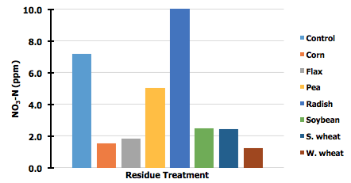

Figure 1. Total N mineralization by crop residue over time for a Heimdahl fine sandy loam soil (4 % SOM) over a 20-week incubation period. The control treatment is the soil alone without residue added.

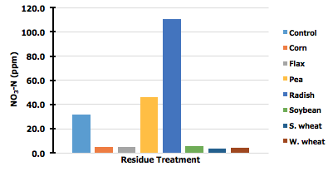

Figure 2. Total N mineralization by crop residue over time for a Fargo silty clay soil (6 % SOM) over a 20-week incubation period. The control treatment is the soil alone without residue added.

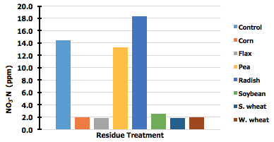

Figure 3. Total N mineralization by crop residue over time for a Forman clay loam soil (5 % SOM) over a 20-week incubation period. The control treatment is the soil alone without residue added.

**NC1178 Report 2019**

Rattan Lal

The Ohio State University

Columbus, OH 43210

Report distributed at the annual NC1178 meeting in Brookings,

South Dakota State University from 24-25 July 2019.

**1. Impact Nugget:  A concise statement of advancements, accomplishments and impacts.**

Corn, grain, and stover yields over a long period (3.5 years) will be related to management-induced changes in soil properties. Residue management may impact soil organic carbon stock and other soil properties which impact agronomic products.

**2. New Facilities and Equipment. Include production areas, sensors, instruments, and control systems purchased/installed.**

PAS equipment to in-situ measure the gaseous flux from soil for CO2, CH4, & N2O.

**3. Unique Project Related Findings.  List anything noteworthy and unique learned this year.**

* Delayed seeding on poorly drained and cooler clayey soil and slow seeding growth at Hoytville may be one of the factors for lower productivity on mulched soil.
* Both the grain (7.4 Mg/ha) and stover yields (5.0 Mg/ha) were lower for the poorly drained clayey soil at Hoytville than that those (11.0 and 10.5 Mg/ha, respectively) for a well-drained loamy soil at South Charleston (Tables 1 & 2).

Residue Retention and Corn Grain Yield

The data in Table 1 show that the rate of residue retention did not significantly affect the corn grain yield at either of the two locations. The average grain yield was 7.4 Mg/ha for Hoytville compared with 11.0 Mg/ha for South Charleston (Table 1). However, the trend of relative grain yield (with baseline for the 100% residue retention) in relation to the residue retention differed among the two sites. For example, the residue retention of 200% decreased the corn, grain yield by 11% for poorly-drained soil at Hoytville but increased it by 11% for the well-drained soil at South Charleston. The residue retention of 0% (complete removal) had no impact on grain yield for the Hoytville location.

Table 1: Effects of Residue Management on Corn Grain Yield at South Charleston and Hoytville, Ohio, in 2018

|  |  |  |  |  |
| --- | --- | --- | --- | --- |
|  | **Corn Grain Yield (Mg/ha)** | | | |
| **Residue Retention (%)** | **South Charleston** | | **Hoytville** | |
| 200 | (110.7) | 11.4 a | (88.8) | 7.1 a |
| 100 | (100.0) | 10.3 a | (100.0) | 8.0 a |
| 75 | (101.0) | 10.4 a | (85.0) | 6.8 a |
| 50 | (106.8) | 11.0 a | (103.8) | 8.3 a |
| 25 | (107.8) | 11.1 a | (88.8) | 7.1 a |
| 0 | (111.7) | 11.5 a | (98.8) | 7.9 a |
| Average |  | 11.0 |  | 7.4 |

Residue Retention and Stover Yield

Similar to the grain yield, the residue retention treatments had no significant impact on the stover yield (Table 2). The average stover yield was 5.0 for Hoytville compared with 10.5 Mg/ha for South Charleston. Similar to the grain yield, the treatment of 200% residue retention also increased stover yield by 10.0% at South Charleston and decreased it by 2% at Hoytville. The texture and terrain-induced drainage conditions, with the attendant impacts on soil moisture and temperature regimes during the seeding (early May) and early silk stage (mid-July), were the determinants of contrasting trends at both locations.

Table 2: Effects of Residue Management on Corn Stover Yield at South Charleston and Hoytville, Ohio, in 2018

|  |  |  |  |  |
| --- | --- | --- | --- | --- |
|  | **Corn Stover Yield (Mg/ha)** | | | |
| **Residue Retention (%)** | **South Charleston** | | **Hoytville** | |
| 200 | (109.7) | 11.3 a | (98.0) | 5.1 a |
| 100 | (100.0) | 10.3 a | (100.0) | 5.2 a |
| 75 | (95.1) | 9.8 a | (86.5) | 4.5 a |
| 50 | (97.1) | 10.0 a | (113.5) | 5.9 a |
| 25 | (104.9) | 10.8 a | (88.8) | 4.6 a |
| 0 | (102.9) | 10.6 a | (92.3) | 4.8 a |
| Average |  | 10.5 |  | 5.0 |
| * Figures followed by the same letter are statistically similar | | | |  |
| * Figures in parentheses are % yield with reference to 100% residue retention | | | | |

Residue Retention and the Harvest Index

The data in Table 3 about the harvest index (HI) also show no statistically significant differences among residue retention treatments. The average HI was 59.8% for Hoytville compared with 56.5% for South Charleston. Furthermore, the least HI for the 0% residue retention (drought) and the high soil temperature (supra-optimal) was observed under bare and un-mulched conditions for the well-drained loamy soil at South Charleston. Furthermore, the least HI for the 200% residue retention at Hoytville (58.0%) is also in accord with the hypothesis of the exaggeration of anaerobiosis, and sub-optimal temperatures for the poorly-drained clayey soil during early spring at the seeding stage.

Table 3: Effects of Residue Management on the Harvest Index at South Charleston and Hoytville, Ohio, in 2018

|  |  |  |
| --- | --- | --- |
|  | Harvest Index (%) | |
| Residue Retention (%) | South Charleston | Hoytville |
| 200 | 59.8 a | 58.0 a |
| 100 | 54.9 a | 60.2 a |
| 75 | 57.9 a | 60.6 a |
| 50 | 55.0 a | 58.5 a |
| 25 | 57.1 a | 60.4 a |
| 0 | 54.3 a | 61.0 a |
| Average | 56.5 | 59.8 |

**4. Accomplishment Summaries.  Draft one to three short paragraphs (2 to 5 sentences each) that summarize research or outreach accomplishments that relate to the project objectives.  Please use language that the general public can readily comprehend.**

* The high inter-annual variability in response of corn to residue retention treatment depends on the rainfall amount and its distribution during the growing season. During the season of rainfall deficit (drought year), crop response is positive with regards to residue retention. During the season of excess rainfall, crop response is negative to a high rate of residue retention.
* In general, clayey soils with impeded internal drainage respond negatively to high rates of residue retention and above-normal rainfall during Spring.

**5. Impact Statements.  Please draft 2 or 3 impact statement summaries related to the project objectives.  Statements should be quantitative when possible and be oriented towards the general public.  This is perhaps the most difficult yet most important part of the report.**

The data generated from the multi-location, long-term residue management project has ecological, economic and social impacts as follows:

1. Ecologically, it improves soil health, soil carbon budget, water quality and soil biodiversity.
2. Economically, it increases crop growth and yield, especially in drought/erosion prone and well-drained soils (e.g., South Charleston).
3. Socially and culturally, it improves aesthetic value of the soil and the landscape.

**6. Published Written Works.  Include scientific publications, trade magazine articles, books, posters, websites developed, and any other relevant printed works produced.  Please use the formatting in the examples below.**

*Refereed Journal Articles*

Lal, R. 2018. Promoting “4 per thousand” and “adapting African agriculture” by south-south cooperation: conservation agriculture and sustainable intensification. Soil & Tillage Research 188:45-40.

Yadav, G.S., R. Lal. and R.S. Meena. 2019. Long‐term effects of vehicular passages on soil carbon sequestration and carbon dioxide emission in a no‐till corn‐soybean rotation on a Crosby silt loam in Central Ohio, USA. Journal of Plant Nutrition and Soil Science, 182(1):126-136.

Yadav, G.S., R. Lal, R.S. Meena, and B. Rimal. 2019. Long-Term Effects of Different Passages of Vehicular Traffic on Soil Properties and Carbon Storage of a Crosby Silt Loam in USA. Pedosphere 29(2):150-160.

**7. Scientific and Outreach Oral Presentations.  Include workshops, colloquia, conferences, symposia, and industry meetings in which you presented and/or organized.**

Lal, R. 2018. Soil organic carbon for climate, food, and other ecosystem services. French Embassy, 19th June 2018, Washington, D.C.

Lal, R. 2018. Evolution of conservation agriculture. 21st ISTRO Conference, 24-27 September, Paris, France.

Lal, R. 2018. Conservation agriculture. Ministry of agriculture and rural affairs (MARA), China 22nd October, Ohio State University, Columbus, Ohio.

**8. Fund leveraging, specifically, collaborative grants between stations and members**.

**9. Other relevant accomplishments and activities**.

**NC1178 2019 Report**

Sandeep Kumar, Associate Professor; Jasdeep Singh, Graduate Research Assistant; Navdeep Singh, Graduate Research Assistant

Department of Agronomy, Horticulture and Plant Science, South Dakota State University, Brookings, SD

**Impacts of Cover Crops, Diverse Rotations and Grazing on Soil Hydrological and Microbiological Properties**

1. **Impact Nugget**: Diversified production system such as cover crops, crop rotation, and livestock grazing are known to provide many functional complementary benefits to soils, mainly due to increased soil organic carbon (SOC) and total nitrogen (N) contents and therefore can be beneficial in improving soil physical and biochemical properties, and hence crop productivity. A study of three crop rotations [maize (*Zea* *mays* L.)-soybean (*Glycine* *max* L.) (2-yr); maize-soybean-oat (*Avena* *sativa* L.) (3-yr); maize-soybean-oat-wheat (*Triticum* *aestivum* L.) (4-yr)] in combination with no-till (NT) and conventional-till (CT) is under progress since 1991 in Beresford, South Dakota. Cover crops has introduced into this trial in fall of 2013 and being investigated at two points in the crop sequence. Winter rye is planted after maize harvest in every rotation and broadleaf blend of legumes and brassica spp. after harvesting small grains in 3- and 4-yr rotations. In the year of 2018-19, we finished two different tasks: (i) evaluating performance of NT and CT in 2-yr rotation through Decision Support System for Agrotechnology Transfer (DSSAT) model, (ii) assessment of economic performance of the cropping systems by using yield and price data from last 5-yr period. The results from the long-term simulations suggest that NT performs better than the CT with respect to crop yield and biomass production, and can enhances SOC over long time. Further, we observed that DSSAT model holds enormous potential in modelling crop growth and yield at the regional level. From the above mentioned second objective, we found interactive impact of rotation for corn and soybean yields with cover type and tillage systems, respectively. Corn yield was increased with diversified rotations (3- and 4-yr) under no cover crop plots, however, it decreased significantly after following the blend in contrast to the 2-yr annual rotation. Therefore, yield penalties due to planting of mixture of cover crop spp. with financial consequences was observed in 3- and 4-yr rotation, however, equivalent net returns with and without winter rye with 2-yr rotation under NT system highlights an opportunity to gain the economic as well as soil quality benefits without compromising yield on following crop. Furthermore, the NT system significantly reduced the corn yield but increased the soybean yield under 2-yr rotation as compared to the CT system, and thereby both tillage systems were observed to be economically equivalent based on market returns over total production costs

**2. New Facilities**: The addition of GC-MIDI unit in the lab for analyzing the PLFA, LECO CN Analyzer.

**3. Unique Project Related Findings**:

**4. Accomplishment Summary**: (i) **Study 1:** Modelling Crop Yield and Soil Organic Carbon under Long-Term Conventional and No-Till Maize - Soybean Production Systems

The objectives of this study were to (1) evaluate the Cropping System Model (CSM)- CERES-Maize and CSM-CROPGRO-Soybean model between no-till (NT) and conventional-till (CT), and (2) compare the long term impacts of CT and NT on crop yield and soil organic carbon (SOC). The two crop models, available in the Decision Support System for Agrotechnology Transfer (DSSAT), were calibrated and evaluated using maize and soybean yield data from 2006 through 2011 under CT and NT treatments. For the comparison of crop yield, the coefficient of determination for CERES-Maize for calibration and evaluation phase was 0.94 and 0.94, respectively, while the index of agreement for the calibration and evaluation phase was 0.93 and 0.86, respectively. Similarly, the coefficient of determination for CROPGRO-Soybean for calibration and evaluation phase was 1.00 and 0.65, respectively, while the index of agreement for the calibration and evaluation phase was 0.99 and 0.85, respectively. The results from the long-term simulations suggest that NT performs better than the CT with respect to crop yield and

biomass production, and enhances SOC over long time.

**Study 2. Measurements of corn yield and Economic Analysis.**

**Results:** The yield and price data for 5-yr under all the studied cropping systems was collected and analyzed. This study showed that crop yield of corn and soybean and their profit increased as the rotations became more diversified with small grains (oats and winter wheat). Further, this study also demonstrates the yield and economic insights of integrating cover crops such as blend of legumes and brassicas after small grains, and winter rye after the corn harvest. The inclusion of winter rye in any crop rotations did not affect the succeeding soybean yield. In contrast, planting cover crop mixtures resulted a significant loss in succeeding corn yield as compared to the no cover crop under 3- and 4-yr rotation. In this study, NT system increased soybean yield but compromised the yields of corn and small grains. Even so, due to the reduced cost, NT generated economically equivalent returns as compared to the CT but improved the BCRs. Although we observed soil quality benefits from the conservation practices during this long-term experimental study (Alhameid et al., 2017), however, in the context of overall profitability, the diversified cropping system in this study lagged behind the traditional corn-soybean system which could be attributed to the relatively lower profits and more yield variation from small grains as compared to the corn and soybean crops.

**Table 1.** Mean effects of rotation, tillage and cover type on crop yield and coefficient of variation in the long-term cropping system study, Beresford, SD, 2014-2018.

|  |  |  |  |  |
| --- | --- | --- | --- | --- |
| **Sources of variation** | **Corn** | **Soybean** | **Oat** | **Winter wheat** |
| **Yield (Mg ha-1)** | | | |
| **Rotation (R) †** |  |  |  |  |
| 2-yr | 11.36 b**††** | 3.86 | - | - |
| 3-yr | 11.48 b | 3.99 | 4.08 | - |
| 4-yr | 11.88 a | 4.02 | 3.93 | 4.30 |
| **Tillage (T)** |  |  |  |  |
| NT | 11.27 b | 3.99 | 3.96 | 4.13 |
| CT | 11.88 a | 3.93 | 4.06 | 4.47 |
| **Cover type (C)** |  |  |  |  |
| CC | 11.47 | 3.91 | - | - |
| NC | 11.68 | 4.01 | - | - |
|  | **Coefficient of variation (%)** | | | |
| 2-yr | 14.5 | 15.6 | - | - |
| 3-yr | 15.6 | 11.5 | 23.2 | - |
| 4-yr | 12.8 | 11.7 | 31.0 | 27.9 |
|  |  |  |  |  |
| NT | 14.7 | 12.3 | 25.6 | 25.3 |
| CT | 13.5 | 13.4 | 28.2 | 31.3 |
|  |  |  |  |  |
| CC | 15.3 | 13.5 | - | - |
| NC | 13.5 | 12.5 | - | - |

**†**2-yr, 3-yr, and 4-yr are maize-soybean, maize-soybean-oat, and maize-soybean-oat-winter wheat rotation respectively. ††Within each factor, means in the same column followed by the same letters are not statistically significant at P <0.05 (LS Means). NT, no-tillage; CT, conventional tillage. CC, cover crop; NC.

**Table 2.** Mean annual gross revenue, cost of production, and net returns of corn-soybean (2-yr), corn–soybean–oats (3-yr), and corn–soybean–oats – winter wheat (4-yr) rotations with cover crops (CC) and no-cover crop (NC) under no-till and conventional-till systems, averaged across the 2014 to 2018 growing seasons in the long-term cropping system study at Beresford, SD.

|  |  |  |  |  |  |  |  |  |  |  |  |  |
| --- | --- | --- | --- | --- | --- | --- | --- | --- | --- | --- | --- | --- |
|  | **-------------------------- No-till -----------------------------** | | | | | | **---------------------Conventional-till----------------------** | | | | | |
| **Enterprise item** | **2-yr** | | **3-yr** | | **4-yr** | | **2-yr** | | **3-yr** | | **4-yr** | |
|  | **CC** | **NC** | **CC** | **NC** | **CC** | **NC** | **CC** | **NC** | **CC** | **NC** | **CC** | **NC** |
| **Income** | **$ ha-1** | | | | | | **$ ha-1** | | | | | |
| Corn | 741.70 | 687.83 | 438.51 | 476.93 | 363.02 | 370.85 | 757.99 | 717.27 | 495.30 | 506.58 | 368.66 | 385.89 |
| Soybean | 660.99 | 669.15 | 426.92 | 434.67 | 327.07 | 333.99 | 594.90 | 624.32 | 434.61 | 457.79 | 330.49 | 333.95 |
| Oats | - | - | 209.80 | 209.80 | 152.63 | 152.63 | - | - | 214.70 | 214.70 | 156.01 | 156.01 |
| Wheat | - | - | - | - | 172.26 | 172.26 | - | - | - | - | 186.58 | 186.58 |
| **Gross revenue** | 1402.7 | 1357.0 | 1075.2 | 1121.4 | 1015.0 | 1029.7 | 1352.9 | 1341.6 | 1144.6 | 1179.1 | 1041.7 | 1062.4 |
| **Production costs** |  |  |  |  |  |  |  |  |  |  |  |  |
| Machinery† | 213.24 | 192.96 | 209.09 | 182.01 | 207.70 | 187.40 | 263.20 | 242.90 | 259.25 | 232.20 | 245.32 | 225.04 |
| Seed | 195.30 | 182.93 | 149.95 | 133.85 | 124.39 | 112.31 | 195.30 | 182.93 | 149.95 | 133.85 | 124.39 | 112.31 |
| Fertilizer | 183.62 | 183.62 | 161.35 | 161.35 | 168.08 | 168.08 | 183.69 | 183.62 | 161.35 | 161.35 | 168.08 | 168.08 |
| Pesticides | 94.73 | 73.01 | 74.09 | 56.86 | 61.78 | 48.87 | 94.73 | 73.01 | 74.09 | 56.86 | 61.78 | 48.44 |
| **Crop insurance** | 51.94 | 51.94 | 43.04 | 43.04 | 41.66 | 41.66 | 51.94 | 51.94 | 43.03 | 43.03 | 41.27 | 41.27 |
| **Total cost** | 738.83 | 684.46 | 637.52 | 577.11 | 603.61 | 558.32 | 788.86 | 734.40 | 687.67 | 627.29 | 640.84 | 595.14 |
| **Net returns** | 663.86 | 672.52 | 437.71 | 544.29 | 411.37 | 471.41 | 564.03 | 607.19 | 456.94 | 551.78 | 400.90 | 467.29 |
| **Benefit-cost ratio** | 1.90 | 1.98 | 1.69 | 1.94 | 1.68 | 1.84 | 1.71 | 1.83 | 1.66 | 1.88 | 1.63 | 1.79 |

†Machinery expenses calculated using custom rate

**Study 3. Cover crops and grazing impacts on soils.**

***Task 1.* Assessing soil surface greenhouse gas emissions from integrated crop livestock system.** Integrated crop-livestock system (ICLs), involving grazing of cover crops, can help in mitigating soil surface greenhouse gas (GHG) emissions (especially carbon dioxide, CO2; methane, CH4; and nitrous oxide, N2O), when managed properly. However, the impacts of ICLs on GHG emissions are poorly understood. The objective of this study was to evaluate the impacts cover crops (CC) and grazed CC have on GHG fluxes under ICLs at two sites (North Brookings, and North West Brookings) located in South Dakota. Study treatments included: (i) legume dominated CC (LdC), (ii) ICLs with cattle grazing the LdC (ICLLdC), (iii) grass dominated CC (GdC), (iv) ICLs with cattle grazing the GdC (ICLGdC), and (v) control (without CC or grazing).The GHG monitoring occurred weekly during the growing seasons in 2016, 2017 and 2018. Data showed that cumulative CO2 and N2O fluxes in N-Brookings were reduced by ICLGdC (4042.3 kg C ha-1 for CO2 and 1498.7 g N ha-1 for N2O)compared to that of ICLLdC (4819.1 kg C ha-1 for CO2 and 2017.3 g N ha-1 for N2O), indicating the superiority of ICLGdC over the ICLLdC in reducing the GHG emissions. However, no effect from ICLs on cumulative CO2, and N2O fluxes were found over the study period at NW-Brookings. Cumulative CH4 fluxes were not affected by ICLs at either site. This short-term investigation showed that ICLs does not negatively impact soil surface GHG fluxes compared to the ungrazed CC.



**Fig. 1.** Trends of daily greenhouse gas fluxes as influenced by cover cropping and integrated crop livestock system treatments at North West Brookings site. LdC, legume dominated cover crop blend; GdC, grass dominated cover crop blend; NC, no cover crop; ICLLdC, integrated crop livestock system with grazing of legume dominated cover crop blend; ICLGdC, integrated crop livestock system with grazing of grass dominated cover crop blend. 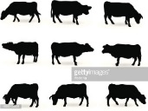, cattle grazing.

***Task 2.* Response of near-surface soil hydrological properties measured using computed tomography and classical approaches to different land uses**

Soil porosity is influenced by management practices including grazing, cover crops and tillage. Porosity estimated by conventional methods does not provide information on spatial distribution of pores and geometrical pore network. Additionally, these methods are time consuming and some are destructive. Computed tomography (CT) techniques are non-destructive and provide spatial and geometrical characteristics of soil pores. The objective of this study was to quantify CT-measured soil pore-sizes as influenced by land use systems and correlate these parameters with the soil hydrological and physical properties such as saturated hydraulic conductivity (*K*sat), bulk density (ρb), and pore-size distribution (PSD). Study sites were located in South Dakota; one at farmer’s field (long-term integrated-crop livestock system) and the other at South East Research Farm (short term integrated-crop livestock system) of South Dakota State University. Study treatments included: (i) native grazed pasture (NGP), (ii) integrated crop livestock system (ICLS), and (iii) maize-soybean cropping system. The preliminary data analysis showed that, land use significantly influenced soil physical and hydrological properties. At the farmer’s field, the CT measured macroporosity was significantly higher in NGP (0.092 m3 m-3) compared to the maize-soybean cropping system (0.028 m3 m-3). Higher porosity in NGP significantly enhanced the *K*sat (209 mm h-1) than that of ICLS (119 mm h-1) and maize-soybean cropping system (20 mm h-1). The ρb with maize-soybean cropping system was significantly higher (1.51 g cm-3) compared to the ICLS (1.18 g cm-3) and NGP (0.99 g cm-3). On the other hand, at research farm, CT measured pore parameters were not influenced by the land uses. The values of ρb ranged from 1.22 to 1.30 g cm-3, but the differences were not significant. This study showed that long term ICLS significantly enhanced soil hydrological properties, however, significant improvement in these soil properties was not visible in the short-term study.

**Table 3.** Average total number of pores (pores, macropores, and coarse mesopores), porosity (total porosity, macroporosity, and coarse mesoporosity), area of the largest pore (ALP) of macropores measured by computed tomography under different land uses at farmer’s field for 0-10 cm depth.

|  |  |  |  |  |  |  |  |
| --- | --- | --- | --- | --- | --- | --- | --- |
| **Parameter** | **Total**  **pores** | **Macro**  **pores** | **Coarse**  **mesopores** |  |  |  | **ALP** |
| **Total**  **porosity** | **Macro**  **porosity** | **Coarse mesoporosity** |
|  |  |  |  | ----------------m3 m-3--------------- | | | mm2 |
| Treatment* |  |  |  |  |  |  |  |
| CNT | 7387c† | 2544b | 4844c | 0.031b | 0.028b | 0.003c | 60.4b |
| NGP | 25772a | 11252a | 14519a | 0.104a | 0.092a | 0.011a | 134.4a |
| ICLs | 19841b | 8940a | 10901b | 0.094a | 0.085a | 0.008b | 84.5b |
|  | Analysis of variance (*P>F*) | | | | | | |
| Treatment | 0.0003 | 0.0007 | 0.0005 | 0.0172 | 0.0218 | 0.0005 | 0.0076 |

*CNT, control; NGP, native grazed pasture; ICLs, integrated crop livestock system

†Means with different letters within a column are significantly different at *P*<0.05.

1. **Impact Statements**:

* Profitable crops those could beneficial for soils need to be identified.
* Long-term diverse crops rotations can increase the soil organic carbon.

1. **Published Written Works**

* Maiga, A., A. Alhameid, S. Singh, A. Polat, J. Singh, S. Kumar, and S. Osborne. 2019. “Responses of soil organic carbon, aggregate stability, carbon and nitrogen fractions to 15 and 24 years of no-till diversified crop rotations”. *Soil research,* 57(2), pp. 149-157.
* Alhameid A., J. Singh, U. Sekaran, S. Kumar, and S. Singh. 2019. “Soil Biological Health: Influence of crop rotational diversity and tillage on soil microbial properties”. *Soil Science Society of America Journal* *(In press).*
* Alhameid A., J. Singh, U. Sekaran, S. Kumar and S. Singh. Crop rotational diversity impacts soil physical properties under long-term no-and conventionally-tilled soils (*Under review*).
* Singh, J., T. Wang, S. Kumar, Z. Xu, P. Sexton, J. Davis, and A. Bly. “Economics of Cropping Systems Featuring Different Rotations, Tillage and Cover Crops”. *Agronomy Journal* *(Submitted).*
* Singh, J. and S. Kumar. “Seasonal changes of soil carbon fractions and enzymatic activities in response to winter cover crops under long-term rotation and tillage systems”. *European Journal of Soil Science* *(Submitted)*

1. **Scientific and Outreach Oral Presentations:**

* Singh J., S. Kumar, and P. Sexton. 2019. “Inclusion of winter cover crops in long-term rotation and tillage system: Effect on soil biochemical properties” Soils Across Latitudes. SSSA 2019 annual meeting, San Diego, CA.
* Singh J., T. Wang, S. Kumar, J. Davis, and P. Sexton. 2019. “Economics of Cropping Systems Featuring Different Rotations, Tillage and Cover Crops.” Soils Across Latitudes. SSSA 2019 annual meeting, San Diego, CA

1. **Fund leveraging:** Singh J., S. Kumar, P. Sexton, and A. Bly. 2019. “Field evaluation of traffic-induced compaction and its potential impact on soil physical characteristics and crop yield.” NCR-SARE, Graduate Grant. ($14, 982) Oct. 2019- Dec. 2021.

1. **Other Activities: None**

**NC-1178 Annual State Report**

**Year:** 2019

**Institution:** University of Wisconsin-Madison

**Committee Representative:** Francisco J. Arriaga

1. **Impact Nugget:**

Soil organic carbon content is not always affected by agricultural management practices; however, soil physical properties appear to be more sensitive to management. Soil aggregation in particular influences soil health in general and has feedback mechanisms with other soil properties, namely biological ones.

2. **New Facilities and Equipment:**

A new method developed by Rawlins et al. (2015) to measure soil aggregate stability using laser light scattering has been adapted for use in Wisconsin with good results. We are also employing scanning electron microscopy (SEM) to study organic carbon occlusion within aggregates.

Rawlins, B.G., G. Turner, J. Wragg, P. McLachlan, and R.M. Lark. 2015. An improved method for measurement of soil aggregate stability using laser granulometry applied at regional scale. European Journal of Soil Science https://doi.org/10.1111/ejss.12250

3. **Unique Project Related Findings:**

Cereal rye as a cover crop increased soil aggregation and microbial activity, which in turn improved soil health. Further, soil phosphorus losses in runoff were reduced by 50% when a cover crop was used. The interaction of tillage with runoff and phosphorus losses varies with season, that is frozen versus non-frozen soil. Fall tillage decreased runoff and phosphorus losses during the frozen season compared to no-tillage, but during non-frozen conditions the opposite is true. This highlights the complexity of soil systems and challenges for agroecosystem management.

4. **Accomplishment Summaries:**

Cover crops are effective at reducing runoff, sediment and phosphorus losses from agricultural lands, but their effectiveness is tied to the amount of cover crop growth. Cover crops that are managed to produce more growth are better at reducing runoff, sediment and phosphorus losses. Using cover crops in agricultural fields can be part of a more comprehensive strategy to mitigate floods.

A soil with better aggregation has improved water infiltration capacity. Recent research findings indicate that plant roots are crucial for soil aggregate formation, more than manure additions. However, the type of soil also has an important influence on aggregate formation, and thus the infiltration capacity of soil.

5. **Impact Statements:**

Soil management practices of agricultural fields have an impact on soil aggregation, which in turn affects soil health and water quality. Management practices that improve soil health can be part of a comprehensive strategy to reduce flooding impacts.

6. **Published Written Works:**

Huang, J., A.E. Hartemink, F.J. Arriaga, and N.W. Chaney. 2019. Unraveling location-specific and time-dependent interactions between soil water content and environmental factors in cropped sandy soils using Sentinel-1 and moisture probes. J. of Hydrology 575:780-793.

Ozlu, E., S.S. Sandhu, S. Kumar, and F.J. Arriaga. 2019. Soil health indicators impacted by long-term cattle manure and inorganic fertilizer application in a corn-soybean rotation of South Dakota. Scientific Reports 9:11776.

Stock, M.A., F.J. Arriaga, P.A. Vadas, and K.G. Karthikeyan. 2019. Manure application timing drives energy absorption for snowmelt on an agricultural soil. J. of Hydrology 569:51-60.

Stock, M.N., F.J. Arriaga, P.A. Vadas, L.W. Good, M.D. Casler, K.G. Karthikeyan, and Z. Zopp. 2019. Fall tillage reduced nutrient loads from liquid manure application during the freezing season. J. Env. Qual. 48(4):889-898.

Vadas, P.A., M.N. Stock, F.J. Arriaga, P.A. L.W. Good, K.G. Karthikeyan, and Z. Zopp. 2019. Dynamics of measured and simulated dissolved phosphorus in runoff from winter-applied dairy manure. J. Env. Qual. 48(4):899-906.

Chawner, M.M., M.D. Ruark, M. Ballweg, R. Proost, F.J. Arriaga, and J. Stute. 2018. Does cover crop radish supply nitrogen to corn? Agron. J. 110:1513-1522.

Vadas, P.A., *M.N. Stock, G.W. Feyereisen, F.J. Arriaga, L.W. Good, and K.G. Karthikeyan. 2018. Temperature and manure placement in a snowpack affect nutrient release from dairy manure during snowmelt. J. Environ. Qual. 47:848-855.

7. **Scientific and Outreach Oral Presentations**:

Scientific:

Arriaga, F.J. Sustainable use of crop residues for bioenergy: USA research. Presented at the Agricultural Residues for Bioenergy: Problems and Solutions Workshop, September 27, 2018, Kiev, Ukraine.

Adams, L.C., and F.J. Arriaga. Improving soil health of dairy forage production systems with reduced tillage and cover crops. Presented at the Soil Science Society of American Annual Conference, January 6-9, 2019, San Diego, CA.

Ozlu, E., and F.J. Arriaga. Coupled interactions of soil aggregation and carbon stabilization. Presented at the Soil Science Society of American Annual Conference, January 6-9, 2019, San Diego, CA.

Wills, S., M. Robotham, D. Lindbo, J. Nemecek, D. Osmund, J. Heitman, D. Presley, P. Tomlinson, H. Tao, P. DeLaune, K. Lewis, G. Liles, F. Arriaga, and L. Adams. Putting Soil Health Indicators in Context: A project using dynamic soil properties and soil survey to provide references and potentials. Presented at the Soil Science Society of American Annual Conference, January 6-9, 2019, San Diego, CA.

Outreach:

Arriaga, F.J. What do Cornell and Haney assessments actually mean? Where are they appropriate? Where should they be used? Are they relevant in Wisconsin? Presented during the Advanced Soil Health Training for WI-NRCS, October 16, 2018, Marshfield, WI.

Arriaga, F.J. What a soil pit DOESN'T say about your soil’s health: What to look for below the surface? Presented during the Advanced Soil Health Training for WI-NRCS, October 16, 2018, Marshfield, WI.

Arriaga, F.J. The value of tillage: How does tillage affect other field practices? Presented during the Discovery Farms 7th Annual Conference, December 12, 2018, Wisconsin Dells, WI.

Arriaga, F.J. What is the deal with tillage? Presented during the Wisconsin Agribusiness Classic Annual Conference, January 15-17, 2019, Madison, WI.

Arriaga, F.J. What happens to soil when we till? Presented during the Wisconsin Cover Crop Conference, January 20, 2019, Madison, WI.

Arriaga, F.J. Do soil conservation practices lead to soil health and water quality improvements? Presented during national webinar hosted by the North Central Region Water Network and sponsored by the Soil Health Nexus, March 13, 2019.

Arriaga, F.J. How to measure soil health. Presented during the Central Wisconsin Soil Health Conference, March 25, 2019, Marshfield, WI.

Arriaga, F.J. Relating soil health and function to water quality. Presented during the Informational Hearing Nitrate Work Group convened by Wisconsin Representative Kitchen, May 21, 2019, Madison, WI.

Arriaga, F.J. Relating soil health and function to water quality. Presented during the How to Teach Soil Health Workshop organized by the Soil Health Nexus, May 29-30, 2019, Columbia, MO.

Arriaga, F.J., L. Adams, and M. Bertram. Rye cover crop in dairy forage production: Environmental and yield benefits. Presented during the Calumet County Forage Council Field Day, August 19, 2019, Brillion, WI.

Arriaga, F.J. Cover crop considerations. Presented during the Tri-County Practical Cover Crop Field Days, August 20-21, 2019, Ferryville, West Salem and Tomah, WI.

8. **Fund leveraging, specifically, collaborative grants between stations and members:**

The work highlighted here has been funded by sources other than Hatch. Some of these sources include USDA-NIFA, Wisconsin Fertilizer Research Council, Bayer, and internal the Rothermel-Bascom Professorship in Soil Science of the College of Agricultural and Life Sciences.

9. **Other relevant accomplishments and activities:**

N/A

**NC1178 Report 2019**

Lisa Tiemann

Michigan State University

**1. Impact Nugget:  A concise statement of advancements, accomplishments and impacts.**

Research willIncrease our understanding of the impacts of crop residues, and residue diversity, including cover crops and perennial crops, on microbial processes that control SOM accrual and depletion and soil C storage.

**2. New Facilities and Equipment. Include production areas, sensors, instruments, and control systems purchased/installed.**

Elementar Vario TOC select with TNb and auto sampler.

**3. Unique Project Related Findings.  List anything noteworthy and unique learned this year.**

* Interseeding cover crops in corn reduces potential for N loss via nitrifier coupled denitrification and increased corn tissue N content.
* Nitrogen application to perennial bioenergy crops increases aboveground NPP, but reduces belowground NPP and does not alter soil nitrogen pools or nitrogen cycling process rates.

**4. Accomplishment Summaries.  Draft one to three short paragraphs (2 to 5 sentences each) that summarize research or outreach accomplishments that relate to the project objectives.  Please use language that the general public can readily comprehend.**

In an experiment focused on the belowground effects of cover crop diversity at the Montcalm Research Center (MRC), part of Michigan State University AgBioResearch, there are 8 cover crop treatments including: 1) annual ryegrass (AR); 2) cereal rye (CR); 3) hairy vetch (HV); 4) Austrian winter pea (AWP); 5) AR with HV; 6) CR with AWP; 7) all four cover crops together and; 8) a no cover crop control. Soil sampling is done throughout the year, but primarily between harvest and planting when activity of cover crops or degradation of cover crop residues is greatest. We have found that 2 cover crop species (representing 2 different plant functional groups) has the greatest benefit with regards to building soil organic matter and nitrogen provisioning to cash crop.

**5. Impact Statements.  Please draft 2 or 3 impact statement summaries related to the project objectives.  Statements should be quantitative when possible and be oriented towards the general public.  This is perhaps the most difficult yet most important part of the report.**

Data generated from multiple lines of research will help farmers reduce soil degradation, increase soil health and fertility and maintain soil services. Information generated in this

project will provide an analysis of the interaction of cropping system diversity impacts on soil organic C and system resiliency. These are critical factors for crop production in Michigan. More specifically, the research will:

* Increase understanding of the impacts of crop residues, including cover crops and perennial crops, on microbial processes that control SOM accrual and depletion and soil C storage.
* Increase scientific knowledge concerning soil processes, which will foster improved management of our resources and enhanced environmental quality. This knowledge can also be used by policy makers and land managers to make informed decisions about policies and production practices that promote soil conservation and sustainability.

**6. Published Written Works.  Include scientific publications, trade magazine articles, books, posters, websites developed, and any other relevant printed works produced.  Please use the formatting in the examples below.**

*Refereed Journal Articles*

Petipas, R. H., McLachlan, E., Bekkerring, C., Bowsher, A., Jack, C., White, R.A., Younginger, B., **Tiemann, L. K.**, Evans, S. and Friesen, M. L. (*in press*). Interactive effects of microbes and nitrogen on *Panicum virgatum* root functional traits and patterns of phenotypic selection. *International Journal of Plant Sciences. In press.*

Wander, M., Cihacek, L. J., Coyne, M., Drijber, R. A., Grossman, J. M., Gutknecht, J., Horwath, W. R., Jagadamma, S., Olk, D. C., **Tiemann, L. K.**, Ruark, M., Snapp, S. S., Whitman, T., Weill, R. and Turco, R.F. (2019). Developments in Soil Quality and Health: Reflections by the Research Committee on Soil Organic Matter Management. *Frontiers in Environmental Science, 7,* 109.

Smercina, D. N., Evans, S. E., Friesen, M. L., and **Tiemann, L. K**. (2019). To Fix or Not to Fix: Controls on Free-Living Nitrogen-Fixation in the Rhizosphere. *Applied and Environmental Microbiol*ogy, *85* (6), e02546-18.

**7. Scientific and Outreach Oral Presentations.  Include workshops, colloquia, conferences, symposia, and industry meetings in which you presented and/or organized.**

Tiemann, L. K., Smercina, D., Cole, J., Evans, S. E. and M. L. Friesen. Connecting nitrogen transformations mediated by the rhizosphere microbiome to perennial cropping system productivity in marginal lands. Invited, Organized Oral Session, August 15, 2019, Ecological Society of America Annual Meeting, Lexington, KY.

Tiemann, L. K., Miesel, J. R., Nash, J., Warnock, D. D. Biological Interactions with Biochar: Who benefits? Tree seedlings, Weeds or Microbes? Invited presentation, Biochar for Green Development Workshop, Nanjing Agricultural University, June 5, 2019, Nanjing, China.

*Building Healthy Soils*. Invited presentation, Global Alliance in Sustainable Development meeting at Somaiya Vidyavihar University, Mombai, India, May 20, 2019.

Tiemann, L. K., Snapp, S., Witcombe, A., C. Gwenambira, Nord, A. and P. Hayford. Functional crop diversity in tropical agriculture supports multifunctional soil properties. Invited talk, Soil Science Society of America International Soils Meeting, January 6-9, 2019, San Diego, CA.

Kasmerchack, C., Tiemann, L. K. Decomposition of residues and residue mixtures depends on management intensity and soil health. Soil Ecology Society Biennial Meeting, May 29-31, 2019, Toledo OH.

Nash, J., Tiemann, L. K., Miesel, J. R., Warnock, D. D. Who benefits from biochar? Ecological and biogeochemical interactions in a perennial cropping system. Soil Ecology Society Biennial Meeting, May 29-31, 2019, Toledo OH.

Reid, M., Gonzalez, J., Smercina, D., Tiemann, L. K. Bioenergy crop residues alter decomposition dynamics of soil organic matter. Soil Ecology Society Biennial Meeting, May 29-31, 2019, Toledo OH.

Curtright, A., Renner, K., Sprague, C., Tiemann, L. K. Nitrogen Cycling is Affected by Interseeding Cover Crops into Corn. Soil Ecology Society Biennial Meeting, May 29-31, 2019, Toledo OH.

Tiemann, L. K., Smercina, D., Evans, S. E., Friesen, M. Environmental and plant mediated controls on free-living N-fixation. Soil Ecology Society Biennial Meeting, May 29-31, 2019, Toledo OH.

Bell-Dereske, L., Tiemann, L. K., Friesen, M., Cole, J., and Evans, S. E. The response of bacterial communities to nitrogen fertilization depends on temporal and spatial scale. DOE Genomics Science Program PI Meeting (Poster). Tysons, VA. February, 25 2019.

Tiemann, L. K., Curtright, A., Renner, K., Sprague, C. and Brooker, A. Nitrogen Use Efficiency and Internal Nitrogen Provisioning with Interseeded Cover Crops as an Indicator of Soil Health Status. Soil Science Society of America International Soils Meeting, January 6-9, 2019, San Diego, CA.

Wander, M., Grossman, J. M., Drijber, R. A., Gutknecht, J., Jagadamma, S., Cihacek, L. J., Turco, R. F., Tiemann, L. K., Ruark, M., Horwath, W. R., Whitman, T., Snapp, S. S., Weil, R. R., Olk, D. C., Coyne, M. NCERA-59's Reflections on Soil Health and Soil Quality. Soil Science Society of America International Soils Meeting, January 6-9, 2019, San Diego, CA.

**8. Fund leveraging, specifically, collaborative grants between stations and members**.

**9. Other relevant accomplishments and activities**.

1.
2.