Accomplishments:

WERA-1013 scientists in multiple states have developed and distributed new native plant products for use by the western U.S. nursery industry. In Idaho, for example, this strategy was executed throughout the project period, 2013-2017. With support from federal Hatch funds, an Idaho State Department of Agriculture Nursery and Landscape grant, and an Idaho State Department Specialty Crops Grant, a new and unique native plant wholesale and retail production nursery was established. The company, Native Roots, LLC, was created in 2011 based on inventory held by the University of Idaho. The company invested funds into productions infrastructure and began producing seed during that first year. Native Roots, LLC built a market for the native plants produced WERA-1013-related research and in 2016 began turning sufficient profits to return royalties to the university. More than 150 species of native plant products (as species) have been legally transferred to a Native Roots, LLC marketing partner. Within the last five years, Native Roots, LLC has released 27 distinct native plant products for public consumption. Recently, Native Roots, LLC initiated contact with Plant Select of Colorado to market plants released by the University of Idaho. The Colorado group is represented by James Klett, the Colorado representative to WERA-1013.

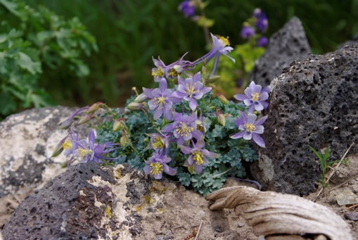

Aquilegia scopulorum, the rock columbine, one of the native plant products being marketed by Native Roots, LLC.

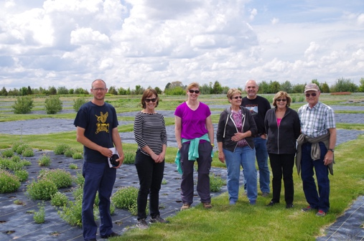

Field day at the seed production facility of the University of Idaho industry partner, Native Roots, LLC.

Continuous production of newly commercial native plants requires ongoing research protocols. In Idaho, these include collecting native species in situ, evaluation of species for horticultural potential in common gardens at the Aberdeen R & E Center, selection of seed from superior plant accessions, increasing seed for distribution to industry, and assisting industry in marketing activities. Extensive plant collection excursions were completed by representatives of WERA-103 at several destinations during this project period. These included: 2013 – a three-week excursion covering western Colorado and northern New Mexico; 2014 – a series of day trips into assorted mountain ranges in central Idaho and southern Utah; 2015 – a 10-day excursion into the eastern Cascades of Washington; 2016 – three days in the Deep Creek Range in western Utah and a week in the Frank Church Wilderness; and 2017 – four days collecting in the Uinta Basin of Utah. During the same period, brief collection excursions were completed at the St. Anthony sand dunes of Idaho, Mount Nebo in Utah, the Gospel Hump region of Idaho, the Targhee area of Wyoming, Sawtell Peak in eastern Idaho, the Lost River Range in central Idaho, and the Clearwater River region in northern Idaho. Since the inception of this project, approximately 3,350 plant accessions, comprising 1,140 species, have been collected and transferred to the Aberdeen R&E Center for testing.
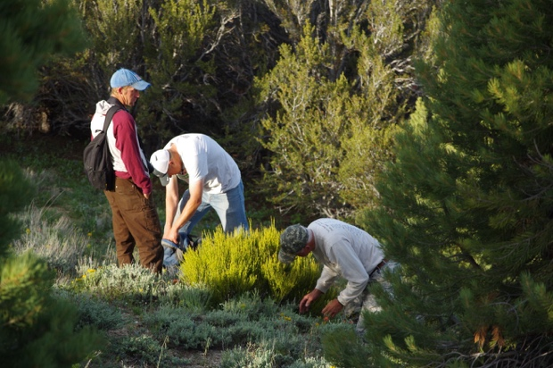

Plant collection team, including members of WERA-1013, harvesting cuttings of Ephreda viridis.

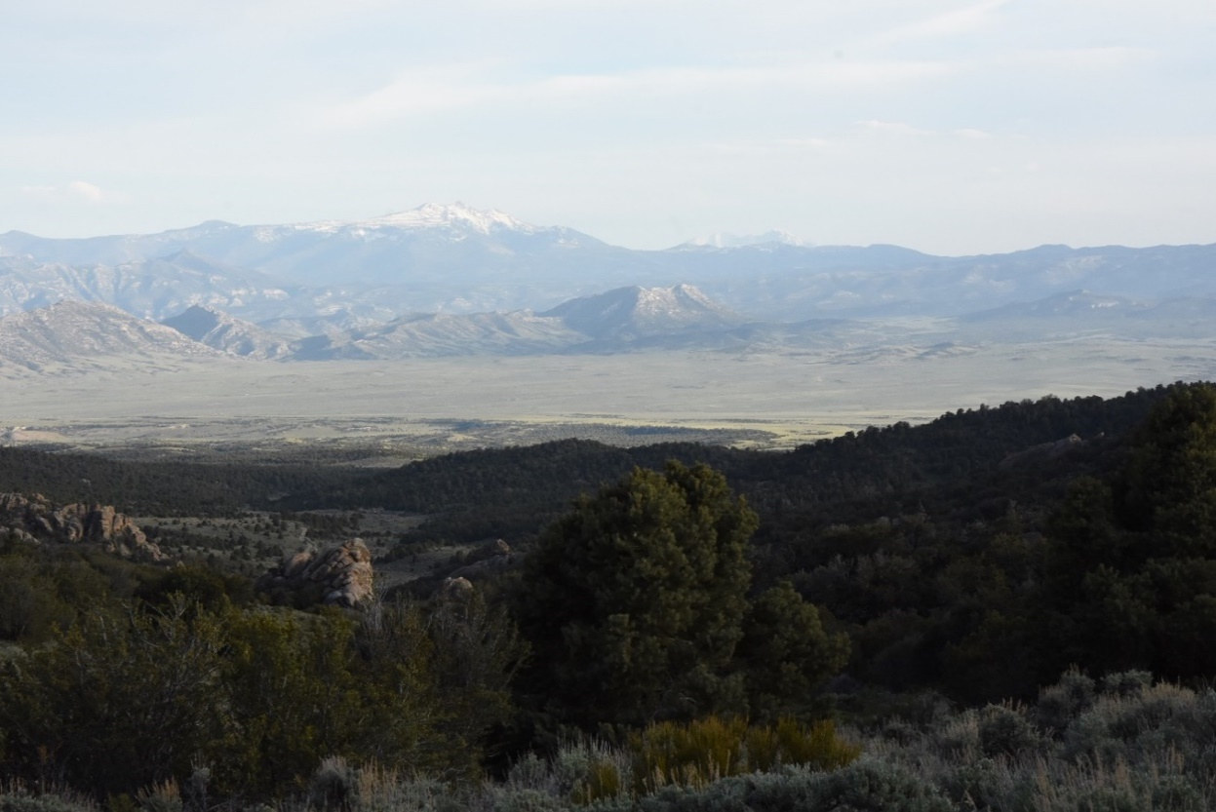

Plant collecting area in the Kern Mountains of Nevada.

During this WERA-1013 five-year reporting period, a multi-pronged educational program has been developed for the purpose of educating the public on topics related to native plant landscaping, designing pollinator and habitat gardens, and water conservation. One of the primary tools employed was the cooperative establishment of native plant demonstration gardens at schools, parks, museums, and other public places. Significant contributions, including consultation on design, providing plant materials, and/or assisting with installation, were provided to the Idaho Botanical Garden, Sawtooth Botanical Garden, University of Idaho Arboretum, USDA-ARS Small Grains and Potato Research Facility, Twin Falls County Extension Office, Ada County Extension Office, Harriman State Park Visitors Center, BYU-Idaho Horticulture Garden, College of Southern Idaho Native Plant Garden, Pocatello Charter School, Butte County High School, Jefferson Elementary School, Sho-Ban Tribal High School, the Sacajawea Center, and the Aberdeen NRCS Plant Materials Center. Additionally, plants were provided free of charge for planting in 31 other public and private gardens.

In 2015, the Native Plants of the Wild West Facebook page was published for the purpose of providing weekly insights into the native plant domestication project. Through the page, followers can access project reports and informational sheets. Education was provided via tours of research plots and demonstration gardens at the Aberdeen R & E Center and the Native Roots, LLC.

Additional education has been provided through workshops and conferences in Idaho and throughout the region represented by WERA-1013. Training related to native plant landscaping has been provided to the general public, to Master Gardeners during advanced training, and to horticulture professionals at meetings hosted by the Idaho Nursery and Landscape Association and the Utah Nursery and Landscape Association.

Efforts related to WERA-1013 in Wyoming have focused on a different application for native plants, their use for fresh cut flower production. Over the past five years, native plants have been grown in two high tunnels oriented perpendicular to one another. In a greenhouse in Laramie, Wyoming, several cultivars of Helianthus annuus, as well as three cultivars of native Centaurea, Gomphrena, and Celosia have been produced. The greenhouse has proven to be a more favorable production environment than the high tunnels. The University of Wyoming AAS Display Garden benefited from a collaboration with All-America Selections (AAS) (http://all-americaselections.org/). Selections in the garden include cultivars of native plants such as Echinacea purpurea ‘Powwow Wild Berry’ (2010 official AAS winner), Gaillardia aristata ‘Arizona Apricot’ (2011 winner), Gaillardia ‘Mesa Yellow’ (2010 winner), and Echinacea hybrida ‘Cheyenne Spirit’ (2013 winner). A Wyoming Department of Agriculture Specialty Crop Grant has been awarded to study using of AAS selections as taxa for production of cut flowers. Another collaboration was a green roof on one of the newer buildings on the University of Wyoming campus, the Berry Biodiversity Building. The green roof was originally planted with Wyoming natives, 26 species of which were grown from seeds by the Wyoming representative to WERA-1013. The University of Wyoming has hosted the WERA-1013 web site (http://www.wyoextension.org/westernnativeplants/) throughout this project period.

The northern portion Nevada, a state represented in WERA-1013, is an unusual market. Being a “boom-and-bust” state, native plant nurseries come and go, with the only stable source of plant materials in northern Nevada being the Washoe State Tree Nursery, run by the Nevada Division of Forestry. Their main mission is to supply plant materials adapted to the Great Basin and Sierra Nevada for restoration and conservation projects. The program is not intended to provide landscaping materials, and the land to be restored must be entirely outside the city limits of any incorporated city of the state. As a result, most urban homeowners purchase native plants online from vendors outside of Nevada. Researchers in Nevada have sought to develop the market for native plants by working with master gardeners and green industry professionals to teach about the water-conserving benefits of native plants, and to encourage their greater use in urban landscapes. Because of the limited access to native plants in local nurseries, workers in Nevada have collaborated with various local organizations, including those in the Nevada master gardener program, to offer native plant seedlings for sale at their annual plant sales in spring. The WERA-1013 representative from Nevada also provides guest lectures in the Department of Natural Resources and Environmental Sciences at UNR to encourage Environmental Science students to consider a career in native plant propagation and production, in the hopes some might consider opening a local native plant nursery.

In 2017, two new opportunities were pursued that have great potential to increase exposure of western Nevada green industry members to the benefits of native plant landscaping. First, Nevada Extension, in collaboration with the Nevada Landscape Association, the Wilbur D. May Arboretum, and the Truckee Meadows Water Authority, were approved to administer the Qualified Water Efficient Landscaper (QWEL) certification program developed by the Sonoma County Water Saving Partnership and endorsed by the U.S. Environmental Protection Agency. This innovative new program has adopted the watershed approach to landscaping, which focuses on utilizing natural precipitation rather than landscape irrigation by use of native and climate-adapted plants in landscaping. Second, Nevada Extension leads the planning process of the Nevada Landscape Association’s annual conference. This year, we attracted the attention of the Nevada Chapter of the American Society of Landscape Architects, who have proposed to participate in our January 2018 conference. Their presentation will be a panel discussion on “Maintaining Unconventional Landscapes: Can Landscape Architects and Contractors Work Together?” It was spurred by the efforts of local landscape architects hired to design native plant landscapes in our public spaces, and the need to involve landscapers in the process to assure proper maintenance of those spaces to encourage native plant flowering and reseeding efforts. This unprecedented collaboration between these two groups will also lead to revisions to the Nevada Landscape Association landscaping guidelines, provided to all members.

Efforts to market additional species of native plants often take advantage of local citizens who are enthusiastic about landscape and environmental improvement. For example, master gardeners in Montana volunteer hours to help with maintenance, data and seed collection, and seed cleaning of the native perennial research/demonstration garden. Master Gardeners and other groups of gardeners were educated on the plants in the garden via researcher-led tours during this reporting period.

Short-term Outcomes:

WERA-1013 participants achieved a variety of outcomes during this reporting period, summarized below by category.

Development of new/improved native plants. Since the inception of the Idaho native plant domestication project, 163 native plant products with commercial potential have been legally transferred to the Native Roots, LLC marketing partner. Fifty-two of the transferred plant products are now in commerce. Native Roots, LLC has created partnerships with production, wholesale, and retail nurseries in several Rocky Mountain states. In Utah, woody plants identified during this project period for release include Cercocarpus ledifolius var. intricatus ‘Hoodoo’ and ‘DoubleDown’, Cercocarpus montanus ‘USU-CEMO-001’, Mahonia repens ‘Semi-Gloss’, and Acer saccharum var. grandidentatum ‘Alice.’ In addition, both ‘Hoodoo’ and USU-CEMO-001 are being evaluated by the Plant Select of Colorado program. The Plant Select program is represented by James Klett, the Colorado representative to WERA-1013. We have also cooperated closely with Red Butte Gardens at the University of Utah in both making plants available for evaluation and also assisting them in the preservation of the rare Cottam Oak germplasm collection located at the garden through grafting specimens that have been lost through construction projects. Outside the scope of this project, the Utah State University Botanical Center (Richard Anderson, Jerry Goodspeed, and JayDee Gunnell) has also released Tetraneuris acaulis var. arizonica ‘Sol Dancer’, Epilobium canum subsp. garrettii ‘Wasatch Fire’, Penstemon platyphyllus ‘Uvatung’, and Salvia dorrii var clokeyi ‘Purple Chip.’ Native plant research at Utah State University is housed within the Center for Water Efficient Landscaping. As a result, the focus is landscape water conservation within the state and region, a goal that includes identification of superior native plants that require comparatively small amounts of water to thrive. Trips by WERA-1013 scientists dedicated to collecting wild germplasm for evaluation have been important early steps in the development of new commercial taxa. Examples of trips during the period of this project, led by various WERA-1013 participants are listed below.

2014: Angel Lake, Humboldt Range, Nevada; Sonoma Canyon, Winnemucca, Nevada; Lake Tahoe, Nevada; and Diamond Mountain, Colorado

2015: Cedar Canyon, Utah

2016: Hamlin Valley, Utah; Coral Pink Sand Dunes, Utah; Deep Creek Range, Utah; and Wasatch Front Range, Utah; East Bay Area of Calfornia

2017: Toiyabe Mountains, Austin, Nevada; Shellbourne Range, Nevada; Van Wagoner Canyon, East Tintic Range Utah; Hamlin Valley, Utah; Clear Creek Canyon, Raft River Mountains, Utah; Simpson Springs, Utah; East Bay Area of Calfornia

Plants of interest collected during these trips include accessions of Acer glabrum, Acer saccharum var. grandidentatum, Arctostaphylos patula, Betula occidentalis, Ceanothus prostratus, Ceanothus velutinus, Cercocarpus ledifolius, Cercocarpus ledifolius var. intricatus, Cercocarpus montanus, Ericameria spp., Fraxinus anomala, Mahonia repens, Paxistima myrsinites, Quercus vaccinifolia, and Ptelea crenulata. In addition, recent work with Pinus monophylla has focused on sampling trees with the intent of selecting superior pine nut-producing trees. Trees from Box Elder, Juab, and Iron Counties in Utah, and White Pine and Lander Counties in Nevada, are being studied for their production potential based on cone scars from the previous five to seven years.

Increased awareness. In various participating states, educational information concerning water-wise landscaping and the value of native plants is delivered through web sites, workshops, and conferences. As a result, citizens of the western U.S. have a greater awareness of the value of drought-tolerant options for their land. Success of this information is demonstrated through increasing demand for native plants in retail businesses. In Wyoming, there has been increased awareness of species available for cut flower production. Potential growers of fresh cut sunflowers, Centaurea, Gomphrena, and Celosia also learned basic production strategies for growing as a niche, local product. The cut Helianthus project and this year’s work using Centaurea, Gomphrena, and Celosia have been used to garner a Wyoming Department of Agriculture Specialty Crop Grant for 2018 and 2019. The AAS Display Garden provides new plants, some of which are natives, to evaluate for backyard gardeners and cut flower growers alike. Growers also have information on several species of cut flowers successfully grown in a greenhouse and high tunnels. Results of these studies is published each year in the UW Agricultural Experiment Station Field Days Bulletin (http://www.uwyo.edu/uwexpstn/publications/index.html). Activity on the WERA-1013 native plants web site in FY17 was up about 500 views from 2,016 (FY16) to 2,542. Views seem to have leveled off after a high in FY15 of over 10,000. In Montana, presentations and tours gave both commercial growers and home gardeners exposure to native plants, and master Gardeners gained hands-on experience with native plants.

Connecting supportive stakeholders and supporters. In Nevada, work through the Nevada Native Plant Extension Project during this project period has brought together the efforts of multiple local organizations: Nevada Landscape Association, Wilbur D. May Arboretum, Truckee Meadows Water Authority, the City of Reno, and the Nevada Chapter of the American Society of Landscape Architects for the common goal of bringing native plant landscaping to western Nevada for water conservation and pollinator protection benefits.

Plant propagation. Reliably multiplying plants of targeted species often is a barrier to commercialization. Therefore, several WERA-1013 scientists conduct propagation research. During this project period, such research has focused on seed germination of Ptelea crenulata, mound layering of bigtooth maple and gambel oak, grafting of gambel oak hybrids by chip budding or hot-tube whip-and-tongue grafting on Quercus gambelii or Quercus montana rootstocks, using Nearing frames as a low-cost propagation structure for creeping Oregon grape and curl-leaf mountain mahogany, early etiolation and layering of gambel oak and bigtooth maple, optimized propagation of ‘DoubleDown’ little-leaf mountain mahogany, propagation of single-leaf ash by cutting and budding, propagation of Ceanothus prostratus by cuttings and layering, propagation of Cercocarpus ledifolius (Weber Basin) and C. montana (Diamond Peak) by cuttings, and propagation of Pinus monophylla by top-working Pinus edulis rootstocks using various grafting techniques. WERA-1013 participants have developed methods of propagating both bigtooth maple and gambel oak from mound layers. However, it is debatable whether the success rate is high enough to be economical in a commercial application. The research needs to be followed up using test cases in commercial nurseries to determine the actual value.

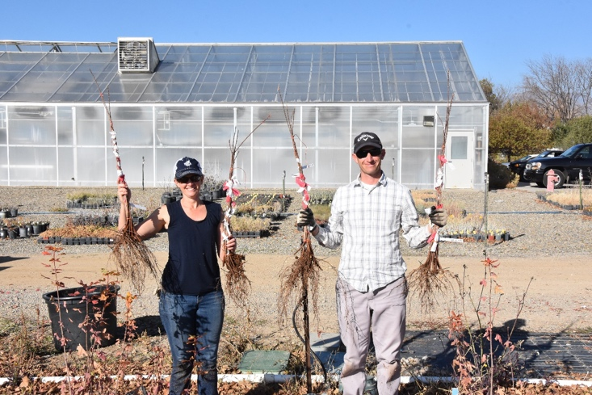

Bigtooth maple rooted layer harvesting in 2016.

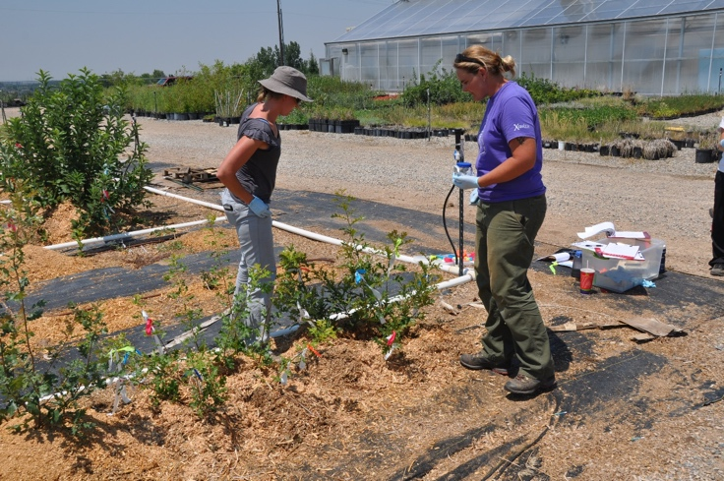

Layering of bigtooth maple selections.

Results from other propagation research have been mixed, depending on plant material. Q. gambelii X Q. turbinella (Cottam A-6540) have had less than 10% success when budded to Q. gambellii rootstocks. Even when the buds have taken and shoot growth initiated, they are prone to complete collapse later in the summer, presumably due to the inability of the scion to meet evaporative demand. In contrast, Q. macrocarpa X Q. gambelii (Cottam A-6474) had approximately 40% bud take, with dramatic scion growth. The only post-grafting failure of successful Q. macrocarpa hybrid scions was due to a heavy scion breaking off of the stock. Grafting of a third Cottam hybrid (A-5215 onto Q. montana) was done by using the hot-tube technique. This resulted in 60% success, but as with the turbinella hybrid, several of the scions collapsed later in the season. The scions were also quite brittle, with laterals breaking off of the main shoot (not the graft union). A selection of Ceanothus prostratus from near Lake Tahoe was found to be easy to propagate both from cuttings or by layering. Terminal shoots collected in the wild had 39% rooting (n=33) after 38 days when treated with Hormodin #1. Subsequent cuttings from this parent material had 87% rooting when propagated from greenhouse-grown stock plants and treatment with Hormodin #2. Selections of pinyon pine are under evaluation for propagation by grafting. The intent is to determine if trees that yield few nuts can be grafted over to a superior clone that would allow increased productivity from trees in wild or marginally productive lands. To date, protocols include tip and side grafts on various sizes of stock branches, and using various treatments to determine the most successful grafting technique with mature trees.

Evaluation of plants in the landscape. Newly selected native plants must be tested under field (landscape) conditions to confirm their capacities to withstand abiotic and biotic pressures. Many native plants selected by WERA-1013 workers have been propagated by cuttings, but root rots cause mortality during and after propagation. Although the exact cause of the root pathology is unknown, at least one evaluation has indicated that the pathogen is some form of Phytophthora. The root rot problem has become a significant impediment to the research and in an effort to overcome it, one WERA scientist recently spent a week visiting the Tree of Life Nursery in Southern California. Tree of Life Nursery has had significant problems dealing with P. ramorum and P. cinnamomi in their native plant production. The knowledge gained during this visit is being applied to research on production practices for native plants. Another biotic challenge being overcome pertains to Shepherdia argentea X S. rotundifolia ‘Torrey’, a shrub released by Utah State University because of its superior form and silver cast. Unfortunately, this taxon is susceptible to decline and failure in both the nursery and the landscape. One of the parents (S. rotundifolia) is not produced commercially because the mortality rate is so high, even though it is relatively easy to propagate. In an attempt to determine the cause of landscape failure, WERA-1013 researchers initiated a field study in 2016 comparing plants grown with and without inoculation from native soils under S. rotundifolia and with and without irrigation. Unfortunately, the potential of cross contamination of soils in pots grown in the same vicinity has rendered that portion of the experiment invalid, but to date there has been no significant effect of any treatment on plant performance in the landscape once established, and there has been no mortality to date. Overall, research to date shows that woody native plants in landscape situations requires care to avoid or overcome a wide range of challenges. WERA-1013 scientists will remain focused on these issues, which range from trunk damage to impacts of insects and diseases.

Outputs:
Drought-tolerant plant materials have been selected/developed and distributed in multiple states that participate in WERA-1013. Some materials are being trademarked rather than patented.
Extension programming, including an impactful web presence, and contributions to workshops, conferences, and publications aimed at education on topics related to water-conserving landscape practices, and on techniques for propagation of native woody plants.
A relatively new initiative on using native plants for production in the cut-flower trade.
In Nevada, a dramatic increase in the number of individuals reached by the collective educational efforts of multiple agencies, led by the Nevada Native Plant Extension Project, to educate landscapers, nursery workers, master gardeners, homeowners, and university students about the benefits of native-plant landscaping, and real-life demonstration and instruction about how to protect and maintain such landscapes.

A non-profit restoration project in Montana was provided with native plant material for use in their projects.

Recent outputs from Utah include an on-line publication, Nurturing Native Plants: A Guide to the Vegetative Propagation of Native Woody Plants of Utah, a publication titled Combinations for Conservation: Recommended Plant Groupings for Low-Water Landscapes, and presentations at meetings of the Utah Nursery and Landscape Association, the American Society for Horticultural Science, the International Plant Propagator’s Society – Western Region, the Salt Lake County Watershed Conference, the and Utah Small Farms Urban Ag conference.

Activities:
WERA-1013 research activities involve domestication of native plants by using methods developed specifically for this purpose: collection from wild populations, field establishment, evaluation, selection, and improvement through bulk selection. The longstanding Plant Select program in Colorado has interacted with WERA-1013 scientists in other states in these efforts. Extension activities include featuring native plants in public gardens. For example, a demonstration garden for native plants has been established by Nevada Extension during this project period, and participants in WERA-1013 have cooperated with groups such as the Utah Public Garden Network to assist in developing and managing low-water demonstration gardens. In Montana, research plots for native grasses in median strips were maintained and monitored in cooperation with the City of Bozeman, and native plant beds were reestablished for a study on mulch and sun vs. shade for 4 native species. A key activity in Utah has been participation in the Center for Water Efficient Landscaping. This has allowed WERA-1013 participants to reach across campus to other programs and enhance graduate student training. Utah-based research on pinyon pine has been especially interactive due to the interest in pine nuts across the western United States. Collaborations have been forged with county extension personal, as well as with Bonnie Bobb of Western SARE and Johnnie Bobb, Chief of the Western Shoshone Nation.
Numerous forms of instruction and outreach on topics related to native-plant landscaping and water-conserving landscape design have been offered to professionals in the green industry and to the general public. Such efforts sometimes are coordinated with local master gardener groups, which receive training from WERA-1013 participants, or are important components of large field-day events, such as the University of Wyoming’s Laramie Research and Extension Center Field Day on August 26, 2017, during which research on Helianthus, Centaurea, Gomphrena, and Celosia results were highlighted. The overarching theme of such activities is to raise awareness of the benefits of native plants to citizens in the western region, and beyond.

Milestones:
Important milestones of WERA-1013 have been achieved across the western region. In Idaho, the most critical milestone has been delivery of potentially valuable and publicly acceptable plant products. By the summer of 2017, 163 native plant products with potential market value, developed through the native plant domestication project, were transferred to an industry partner. Fifty-two of these native plant products are offered for sale by Native Roots, LLC and their partnering companies. A secondary Idaho milestone is delivery of information on native plant use via field days, demonstration gardens, instructional publications, workshops and conferences, and a web presence (including detailed native plant descriptions posted on the WERA-1013 web site).
In Nevada, a core group of individuals, organizations, and agencies that collectively are demonstrating the need for, and creating infrastructure to support, a movement towards an increase in native-plant landscaping in western, urban portions of the state represented an achieved milestone. Train-the-trainer education and personal-professional networking over the past five years proved to be effective strategies.
A milestone being pursued in Montana is to demonstrate cultural requirements and protocols for establishment of grasses in median strips to city planners, engineers, and maintenance workers.
Looking forward, the next milestone for the Wyoming-based cut flower project is planning and carrying out the 2018 version. An undergraduate student has agreed to assist in seeding, transplanting, managing, and harvesting the cut flowers in the greenhouse and two high tunnels.
Upcoming milestones of WERA-1013 work in Utah are to identify plants that have potential for low-water landscaping and alternative agricultural production, and to establish a nursery of superior Pinus monophylla trees in Cache Valley for further evaluation and study by the end of 2018. Utahans also anticipate releasing four selected plants by the end of 2018, pending acceptable evaluations.
Continuous milestones in many states are the releases of educational materials on the propagation, production, and utilization of native plants for low-water landscaping. In Utah, published reports are anticipated within the next two years for several key research projects with bigtooth maple, gambel oak, and littleleaf mountain mahogany.

Impact Statements:

WERA-1013 researchers have achieved, or anticipate achieving, significant impacts, which include the following.

Superior plants for water conservation have been selected, propagated, promoted, and made available to industry.

During this reporting period, 32 undergraduate students affiliated with institutions that participate in WERA-1013 were involved with pilot research on propagation of native perennials from seed.

Long-term impacts of the native plant program based in Idaho will be two-fold, 1) enhanced profitability of marketing native plants, thereby making a larger palette of high-quality plants available for use by consumers, and 2) increased public awareness of native plants, and increase the ability and willingness to landscape using water-conserving designs. The ultimate impact will be water conservation through public acceptance of drought-tolerant plants and water-conserving landscape practices.

Across the region, awareness of native plants, their attributes, and the benefits of using them in managed landscapes will increase, as demonstrated by data on views on blogs, the WERA-1013 web site, and attendance at outreach events, including garden talks and walks, where data on participants’ perceptions of the AAS plant material will be gathered. Participation in the AAS program as an official Display Garden will continue, and as citizens and growers continue to provide input on the cultivars displayed, growers will increase their production of these cultivars, and the general public will increase their purchase and use of these materials in their landscapes. The web site will be a source of useful information for many years to come.

Fresh cut sunflower production and use is expected to increase within the western region.

As in other participating states, WERA-1013 will lead to increased consumer knowledge and acceptance of native-plant landscaping within Nevada, and will inform consumers about where and how to acquire native plant materials.

Activities and resources related to the WERA-1013 project will increase recognition within local nurseries of the growing market in western Nevada for native plants and the value of marketing them for their water-conservation and pollinator-protection benefits. Related to this outcome will be increase communication among local landscapers, contractors, and landscape architects so that landscape designs with native plants can be successfully implemented, installed, and maintained for longevity and, ultimately, water conservation.

Work accomplished through the WERA-1013 project has led to acquisition of funding to support scholarship with native plants, and ultimately to conserve water. For example, synergy among this project and various resources at Utah State University is partly responsible for USU Extension receiving an on-going state funding line of $950,000 per year for use in water-related research and Extension programming. In addition, USU scientists also received funding from the Specialty Crop Block Grant program through the Utah Department of Agriculture and Food, and the J. Frank Schmidt Nursery Family Grant program.

Publications: (2016-2017 only)

Balestri, F. and W.R. Graves. 2016. Pretreatment effects on seed germination of two Nyssa species. HortScience 51:738-741.

Bujak, C. and T.A.O. Dougher. 2017. Improved germination of silverleaf phacelia (Phacelia hastata var. hastata [Douglas ex Lehm.]) Native Plants Journal 18(1):42-49.

Bujak, C. and T.A.O. Dougher. 2017. Classification of seed dormancy and treatment of
gibberellic acid to improve germination of Arrowleaf balsamroot Native Plants Journal 18(1):3241.

Love, S.L., Hutchinson P.J.S., Price W.J. 2017. Managing weeds during wildflower meadow establishment in the arid Intermountain West: efficacy of a grass-first strategy for sites with heavy annual weed pressure. Native Plants Journal 17 (3):216-229.

Love S. 2017. Penstemon spotlight – Penstemon janishiae. Bulletin of the American Penstemon Society 76:8-27.

Native Plants for the Intermountain West. http://www.wyoextension.org/westernnativeplants/. Accessed 19 November 2017.

Panter, K. 2017. Fresh cut flower production. University of Wyoming Agricultural Experiment Station Field Days Bulletin. 11. http://www.uwyo.edu/uwexpstn/publications/field-days-bulletin/2017-field-days-bulletin.pdf. Accessed 19 November 2017.

Kratsch, H., Skelly, J.A., Hill, G., and Donaldson, S. 2017. Using Cluster Analysis to Target Educational Messages to Consumers. Journal of Extension 55(1) Article 1FEA1. Available at: https://www.joe.org/joe/2017february/a1.php.

Sriladda, C., Kratsch, H., Larson, S., Monaco, T., Shen, F.-A., Kjelgren, R. K. 2016. Interspecific Hybrid of Xeric Shepherdia rotundifolia and Riparian Shepherdia argentea: Description, and Traits Suitable for Low-water Urban Landscapes. HortScience. 51(7):822-828.
Wheaton, A. and L.A. Rupp, Eds. 2016. Combinations for Conservation: Recommended Plant Groupings for Low-Water Landscapes. Utah State University Extension.

Rupp, L.A. 2016. Nursery propagation of Gambel oak and serviceberry for niche market use. Final Report to the Utah Department of Agriculture and Food Specialty Crop Block Grant Program.

Rupp, L.A. 2016. Propagation of Gambel Oak (Quercus gambelii) by Layering. Proceedings of the International Plant Propagators Society – Western Region Conference, Tempe, Arizona. In press.

Rupp, L.A. 2016. Bigtooth maple (Acer saccharum Marshall ssp. grandidentatum (Nutt.) Desmarais [Aceraceae]) and gambel oak (Quercus gambelii Nutt. [Fagaceae]). Native Plants Journal. 17: (3) 213. Cover photograph.

Rupp, L.A. 2017. Creeping Oregon grape (Mahonia repens (Lindl.) G. Don [Berberidaceae]). Native Plants Journal 18: (1) 1. Cover photograph.

Rupp, L.A. 2017. Western skunk cabbage (Lysichiton americanus Hulten & H. St. John [Araceae]). Native Plants Journal 18: (2) 89. Cover photograph.

