Final Report
NCERA-224 Annual Meeting
Kanuga Conference Center
Hendersonville, NC
October 22-23, 2016

Meeting Itinerary:
Friday, Oct. 21 Arrival and check in begin at 4:00 pm
Saturday, Oct. 22
8:00 – 8:45 am Breakfast
9:00 – 9:05 am Welcoming remarks
9:05 – 10:15 am State reports
10:15 – 10:30 am Break with refreshments
10:30 – 11:55 am State reports (continued)
12:00 pm Lunch
1:30 – 3:15 pm State reports (continued)
3:15 – 3:30 pm Break with refreshments
3:30 – 5:15 pm State reports (continued)
6:00 – 6:45 pm Dinner

Sunday, Oct. 23
8:00 – 8:45 pm Breakfast (must be checked out of room by 10:00 am)
9:00 – 10:15 am State reports (continued)
10:15 – 10:30 am Break with refreshments
10:30 – 11:55 am Final business meeting
12:00 – 12:45 pm Lunch
1:00 pm Departure

Participants: Adams, Gerard (gadams3@unl.edu) - University of Nebraska;
Kunkel, Brian (bakunkel@udel.edu) - University of Delaware;
Liesch, P.J. (pliesch@wisc.edu) - University of Wisconsin;
Rebek, Eric (eric.rebek@okstate.edu) - Oklahoma State University;
Rodriguez-Salamanca, Lina (lina@iastate.edu) - Iowa State University;
Smitley, David (smitley@msu.edu) - Michigan State University

Delaware & Southeastern Pennsylvania

University of Delaware Cooperative Extension:
Brian Kunkel & Nancy Gregory

Regional Weather

Spring for 2016 received more rainfall than the historical average. Our summer was drier than the past couple years.

Insect and Disease Highlights

Insects

Of the 630 samples received and processed in the UD Plant Diagnostic Clinic, 31 were insect identifications. Many more had some insect involvement or were received as disease identifications or trouble-shooting for poor plant growth. Black timber beetle (Xylandrus germanus) on yellowwood and miscanthus mealybug were identified.

This year had normal population levels of our most common scale species such as Pulvinaria scales (Cottony Taxus/Camellia Scale).

Caterpillars were not as common as previous years; however, we still encountered a number of non-pest caterpillars causing incidental damage to various plants including various leaf tiers and leaf rollers on sycamores, oaks, and other plants. Caterpillar pests such as Malacosoma americanum (Eastern tent caterpillars), both generations of Hyphantria cunea (Fall webworms), readily seen this summer and fall, and bagworms, Thyridopteryx ephemeraeformis, had typical populations this year. Roseslug sawflies continued to cause defoliation on roses throughout the state and were locally abundant in some areas into August. Other minor pests encountered this year include boxwood leafminer (Monarthopalpus flavus), and carpenter bees. Japanese beetle populations were abundant this summer also, but not as widespread compared to 2015.

Podosesia syringae (Lilac/Ash borer) emergence holes continue to be confused as emerald ash borer attacks on ash trees. This summer we found our first record of emerald ash borer in Delaware on a purple sticky trap. Monitoring for EAB continues in Delaware by Department of Agriculture in all counties to determine the extent of the infestation. Emerald ash borer was found in New Castle County, Delaware.

Soft scales were not as problematic this past summer compared to previous summers. For example, Indian wax scale (Ceroplastes ceriferus) populations continue to be low and is probably partially due to the cold winters we have had the past couple years.
Many armored scale samples were diagnosed this summer including Chionaspis pinifoliae (pine needle), Fiorinia externa (elongate hemlock), Melanaspis tenebricosa (gloomy), Lepidosaphes ulmi (oystershell), Melanaspis obscura (obscure) and Lopholeucaspis japonica (Japanese maple) scales. Landscape companies continue to report Japanese maple scale as one of their most common and difficult pests to manage.

Other sucking insect pests such as lace bugs and aphids were minor problems reported during the year.

Nurseries in the mid-Atlantic continue to struggle with Systena frontalis (redheaded flea beetle) control. This year, multiple trials were conducted evaluating insecticide efficacy, effect of weed management material, and movement. Additional trials targeting larvae were attempted but failed due to age of plants and extent of developed root systems. Additional trial will continue to examine entomopathogens and application time and efficacy of additional products.

2015-2016 Research Highlights:

Summary of redheaded flea beetle (RHFB, Systena frontalis) projects:
• Beauveria and Metarhizium still need to be tested against second-generation larvae in field situations. Trials with applications other than a root dip may be useful.
• Timing of application and evaluation period until impact for Mainspring, Acelepryn, or other anthranilic diamide class insecticides should be investigated.

Summary of root aphids trial (Bigelowia):
• Treatments applied and evaluation should be complete in mid-November.

Summary of Miscanthus mealybug trial on miscanthus:
• Treatments applied and data obtained for 0, 7, 14, and 28 DAT. Analysis being conducted on data and final evaluation will occur prior to end of 2016

Summary of Japanese beetle data on lindens and elms:
• Data has been collected for fall drenches in 2015, spring drenches in 2016, and summer foliar applications in 2016 and are being analyzed.
• Early observations appear to indicate the foliar applications of Acelepryn and Mainspring significantly reduce the amount of Japanese beetle damage done to Linden and Elm trees during the summer of 2016.

Diseases

Ornamentals constituted approximately 56% of approximately 680 samples between October 1, 2014 and September 30, 2015. Included were deciduous and woody ornamentals, annuals, perennials, and turf. Identifications included diseases, cultural issues, insects, plants, weeds, and mushrooms. Most samples were from Delaware (80%), but others were received from surrounding states including MD, VA, NJ, and PA. Of the 350 ornamental plant samples, physiological or environmental stress was a factor in many samples, while insects were the problem or a factor in some. Many landscape ornamentals newly planted in the past 2 or 3 years suffered from environmental stress, often leading to further issues with disease organisms and insects. Rains in the spring and early summer were adequate but often heavy which led to saturated soils and problems with root rot and poor establishment of root systems. An extended dry period in late August and September led to further root stress. Phytophthora root rot was confirmed on juniper, holly, white pine, blue spruce, Concolor fir, camellia, and Miscanthus. Swiss needlecast is a severe problem on Douglas fir in Christmas tree plantings. Foliar nematodes were common on perennials such as peony and hosta. Rose rosette disease continues to spread through cultivated and hybrid rose plantings. Boxwood blight continues to be a threat to the nursery industry. Bacterial leaf scorch was severe on oaks despite adequate rains. Some common turf diseases included Pythium blight and dollar spot.

New Reports – Downy mildew was confirmed on Rudbeckia, coleus, and basil and continued to be a problem on Impatiens walleriana and Impatiens balsamina. Sclerotium rolfsii was detected on Pachysandra procumbens and other perennials. Phyllosticta leaf spot was detected on Trillium sp. CMV was detected on lobelia, along with TSWV on dahlia. Several new weeds were reported in Delaware, including fig buttercup (Ranunculus ficaria), puncturevine (Tribulus terrestris), and sweetroot (Osmorhiza sp.)

Pathogens of regulatory significance – Bacterial black leg caused by Dickeya dianthicola was found on potato and Dickeya sp. on green bean, and the bacteria have the potential to occur on other hosts in the Solanaceae.

2015-2016 Publications & Notables:

Kunkel and Gregory contributed weekly columns on insects and diseases to Ornamentals Hotline, a grower newsletter published and distributed by University of Delaware Cooperative Extension to over 150 subscribers. Kunkel was interviewed by local newspapers about various insect pests. Kunkel and Gregory continue to work on updating and creating new fact sheets for professionals in the mid-Atlantic region.
The Ornamentals Task Force at the University of Delaware continues to offer training sessions for green industry professionals at their business. The disease and entomology workshops are provided to Delaware green industry professionals in addition to “pest walk” tours in New Castle and Sussex counties.

Master Gardener training was also conducted by Kunkel and Gregory.

Thrips and Testing of New Chemicals for Control in Greenhouses. S. Gill, S. Klick, & B.A. Kunkel 2016. Ball Publishing.

Up Close and Personal with the Redheaded Flea Beetle. B. A. Kunkel 2016. Tennessee Green Times. Tennessee Nursery and Landscape Association

Iowa

Iowa State University
Plant & Insect Diagnostic Clinic
Lina Rodriguez Salamanca and Laura Jesse

The Plant and Insect Diagnostic Clinic (PIDC) at Iowa State University, member of the National Plant Diagnostic Network (NPDN), North Central Region (NCPD), has since 2015 hired a plant pathologist (Lina Rodriguez Salamanca) who focuses on horticultural, forest, and ornamental crops diagnostics and extension. Lina is the representative for the NCERA224: NCR-193 for the state of Iowa. Laura Jesse, Entomologist and clinic director, will also be included on representative list for the following years with the understanding that only one representative will travel to the meeting.

Clinic report
From January to October 21, 2016, the PIDC clinic received 980 samples, 456 of trees, woody ornamentals, and annual ornamentals. Of the 456 samples, 220 were diagnosed with disease, 85 with insect damage, and 67 with abiotic disorders. Insufficient samples and undetermined cause of symptoms accounted for 60 and 24 samples, respectively.

Diseases
Oak wilt is a deadly disease on oak in the Midwest. Early detection can help focus management practices and protect nearby healthy oak trees. Established protocols for confirmation culturing the fungal pathogen have been standard in NCPDN diagnostic clinics. However, it is critical for diagnosticians to receive a sample that has been collected following the forest service protocol, “Collect Field Samples and Identify the Oak Wilt Fungus in the Laboratory”, available at: (http://www.na.fs.fed.us/spfo/pubs/howtos/ht_oaklab/toc.htm). Arborists, woodland managers, and homeowners struggle to collect the proper samples for testing. A 3-min video titled, “Special Type of Sample Needed when Testing for Oak Wilt”, was produced in summer 2016 and is available at https://www.youtube.com/watch?v=Fkgomb4pvsM. As of October 21, 2016, the video had 45 views.

Additionally, the PIDC implemented a molecular marker for detection of oak wilt developed by Yang et.al. 2015. This molecular marker allows for a 2-day turnaround, instead of the 2 weeks necessary for fungal colony growth. Diagnosticians from the NCPDN met in April 2016 to discuss their plans for implementation of different protocols to detect Ceratocystis fagacearum (causal agent of oak wilt). A follow-up conference call to report progress will be held in late fall 2016.

Insects
Emerald Ash Borer (EAB) has been confirmed in 10 additional counties in 2016, for a total of 38 out of the 99 counties in Iowa. In 2015, videos and other educational materials were developed and compiled at https://www.extension.iastate.edu/psep/EmeraldAshBorer.html.
Brown Marmorated Stink Bug (BMSB) has been confirmed in 2 more counties in Iowa. BMSB reports continue to increase; we are at 14 confirmed counties with more being added as people notice them invading homes.

Factsheets, newsletters, and other publications
Jesse and Rodriguez contributed with biweekly newsletter articles for the Horticulture & Home Pest News (ipm.iastate.edu/ipm/hortnews/).
Rodriguez contributed with the update of the Category 3, Ornamental, Turf, and Greenhouse Pest Management -- Iowa Commercial Pesticide Applicator Manual.
Rodriguez contributed with 3 video recordings for the Ornamental, Turf, and Greenhouse Pest Management -- Iowa Commercial Pesticide Applicator Resources for both 2015 and 2016. The videos were titled, “Impatiens Downy Mildew: Management in the Greenhouse”, “Disease Management and Fungicide Resistance Prevention: FRAC”, and “Emerging Tospovirus in Greenhouse Crops”.
Rodriguez contributed to updating Chapter 15: Plant Pathology for the 2016 Master Gardener Book.
Jesse contributed to updating the Integrated Pest Management (IPM) chapter for the 2016 Master Gardener Book.
[Updated] Ticks and Tick-borne Diseases in Iowa. H. Joel Hutcheson , Ken Holscher , James W. Mertins , Laura Jesse , Donald Lewis. https://store.extension.iastate.edu/Product/Ticks-and-Tick-borne-Diseases-in-Iowa
[Updated] Scale Insects on Ornamental Landscape Plants. Donald Lewis , Mark Shour , Laura Jesse.
https://store.extension.iastate.edu/Product/Scale-Insects-on-Ornamental-Landscape-Plants

Michigan

David Smitley
Michigan State University

PROJECT TITLE:
Producing Nursery and Greenhouse Plans in Michigan that are Safer for Pollinators in the Yard and Garden

INVESTIGATOR:
David Smitley
Department of Entomology
288 Farm Ln/Rm 243 Nat Sci Bldg
Michigan State University
East Lansing, MI 48824
smitley@msu.edu
517-977-4093

PROJECT SUMMARY:
Two experiments were designed to test the impact of imidacloprid drenches applied to greenhouse or nursery plants on bumble bees after plants are sold. A third experiment was conducted to determine how long before shipping should growers avoid using a foliar spray of a standard insecticide in order to avoid leaving harmful residues on flowers. A more rapid decline in colonies of bumble bees caged for 3 weeks with annual flowers in pots drenched with imidacloprid, compared with colonies caged with flowers soil-drenched with water suggests that soil drenches of imidacloprid made in spring of the year that annuals or perennials are sold will be harmful to bees feeding on those flowers later in spring or summer. This conclusion is supported by the greater number of dead bees found in colonies held with imidacloprid-treated plants, and high levels of imidacloprid in the dead bees. Excellent survival of bumble bees after being confined with Tilia trees which had been treated the previous year in early July with an imidacloprid drench suggests that treatments made a year before trees are sold will not be harmful to bees. Analysis of pure nectar from Tilia flowers indicate a mean concentration of 1.27 ppb of imidacloprid in the nectar, a concentration that is unlikely to be harmful to pollinators. The results of an experiment with four types of annual flowers indicates that annual flowers can be sprayed 3 or more weeks before the shipping date without leaving harmful residues on flowers. Systemic movement of imidacloprid to flowers following a foliar spray did not appear to be a problem. As research continues on how to produce greenhouse and nursery plants that will be safe for pollinators after they are sold and planted in the yard and garden, it is becoming increasingly clear that growers should focus their efforts on plants that are highly attractive to bees. Many of the most popular annual flowers and many trees and shrubs are not frequently visited by bees, and therefore production practices are not expected to impact bees. However many perennials, some trees and shrubs, and a few annual flowers are highly attractive to bees. For these plants it is important to avoid soil applications of a systemic insecticide in spring of the same year that they are sold, and avoid spraying open flowers the least three weeks before shipping.

PROJECT PURPOSE
- Determine the impact of an imidacloprid soil drench made to annual flowers growing in pots or to container-grown trees on bumble bees visiting the same plants after they are sold at a garden center.
- Determine the impact of a foliar spray of imidacloprid to annual flowers on bumble bees when sprays are applied at 1, 2 or 4 weeks before the shipping date

PROJECT ACTIVITIES
- Impact of an imidacloprid basal drench applied to annual flowers grown in 12” pots on bumble bees. One popular cultivar each of petunia, verbena, geranium, marigold, portulaca, salvia and begonia were grown in the greenhouse with standard production practices (Figure 1). At 5 weeks before the finish date, half of all the plants were drenched with imidacloprid at the labeled rate. The remaining plants were drenched with water. One week after the finish date, four plants of each type were put into 16 different screen tents (Figure 2). Half of the tents were filled with imidacloprid-treated plants and half with control plants. One bumble colony was placed in each screen tent for 3 weeks. After the exposure period, bumble bee colonies were moved to shelters and allowed to forage freely.

Results
Of the seven types of annuals grown in pots, four of them absorbed imidacloprid from the soil and transported it to flower tissues, as determined by analysis of whole flowers collected during the screen-tent exposure period. The concentration of imidacloprid found in whole flowers varied from 0 for geranium and marigold, to 292 ppb in petunia (Table 1). Imidacloprid concentrations in whole flowers of petunia, verbena, portulaca and begonia were high enough (> 25 ppb) that undesirable levels of imidacloprid could appear in nectar or pollen, although pollen and nectar samples were not collected and
analyzed in this study. Because no imidacloprid was found in whole flowers of marigold or geranium, and only 5 ppb in whole flowers of salvia, it is possible that these types of plants could be treated with an imidacloprid soil drench in the greenhouse or nursery without posing any risk for pollinators after the plants are shipped and sold (Table 1). One of the active imidacloprid metabolites, imidacloprid-OH, was found in low concentrations in salvia and begonia. The olefin metabolite of imidacloprid was not detected in the same flower samples.

Figure 1. Marigold, geranium (below) and five other popular annual flowers were grown in 12” pots. Half of all pots received a soil drench treatment of imidacloprid at 5 weeks before shipping.
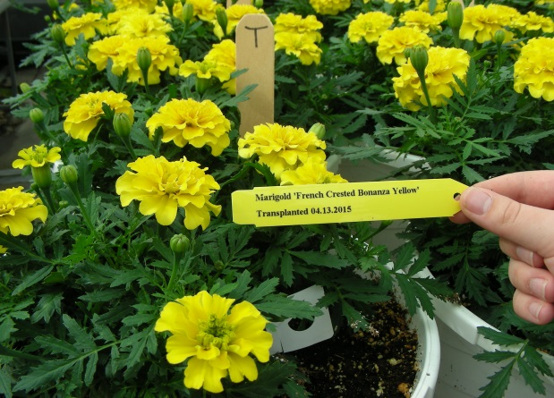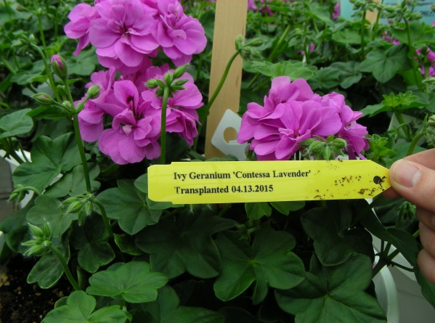

Figure 2. Potted annuals were kept in screen tents with one bumble bee colony per tent for an exposure period of 10 days.
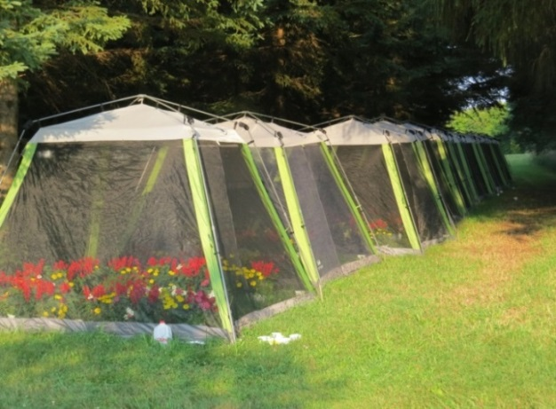

Table 1. Concentrations of imidacloprid and imidacloprid 5-OH found one week after shipping in the whole flowers of 7 types of annual flowers treated 5 weeks prior to the
shipping date with an imidacloprid soil drench at the labeled rate. Data are means
± SE imidacloprid in ppb (parts per billion).
Plant type | Imidacloprid (ppb) | Imidacloprid 5-OH (ppb)
Petunia | 292 ± 108 | 0
Verbena | 51 ± 5.0 | 0
Geranium | 0 | 0
Marigold | 0 | 0
Portulaca | 30 ± 11.1 | 0
Salvia | 5 ± 2.0 | 1.0 ± 0.4
Begonia | 34 ± 7.8 | 13 ± 5.6

The number of bees per colony declined in both treatments, but colonies in screen tents with imidacloprid-drenched plants declined more rapidly (Figure 3). In the first half of this experiment (until a Julian day of 170) bumble bees were held in a cold room (3°C) for 20 – 30 minutes for marking with a dot of paint and counting. However, because all colonies were declining in numbers we switched to using a CO₂ method, which was less harmful to the bees. After that time (day 170) the number of bees per colony in the control treatment remained fairly stable, while the number of bees continued to decline in the imidacloprid-drench treatment (Figure 3). Also, more dead bees were found in screen tents with treated plants, and the dead bees contained fairly high levels of imidacloprid and the 5-hydroxy metabolite of imidacloprid (Table 2).

Table 2. Dead bees collected from screen tents at end of 10-day exposure period with imidacloprid-drenched plants or control plants. Data are means ± SE amount of imidacloprid, olefin metabolite or 5-hydroxy metabolite found in dead bees.
Treatment | Number of dead bees collected | Imidacloprid  (ppb) | Imidacloprid olefin (ppb) | Imidacloprid  5-hydroxy (ppb)
Imidacloprid basal drench | 3.86 ± 0.69 | 83.0 ± 63.5 | 16.5 ± 12.3 | 119.4 ± 61.5
Control | 1.38 ± 0.25 | 0 | 0 | 0
Figure 3. Survival of bumble bee colonies confined in screen tents with annual flowers for three weeks in June, 2015, then moved to shelters and allowed to forage freely outdoors in a pasture area. Each screen tent contained twenty 12” pots of flowers previously drenched with imidacloprid or with water (Control). Data are mean number of bees per colony (n = 8). A star above a pair of data points indicates that the control mean was significantly different from the treatment mean on that date (P = 0.05).
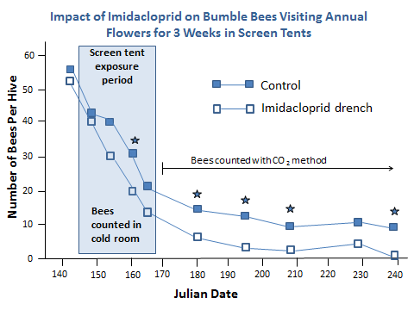

2. Impact of an imidacloprid basal drench applied to base of container-grown Tilia trees in early July 2014, on bumble bees caged with the same trees in June 2015 (Figure 4). Tilia americana and Tilia cordata trees were grown in pot-in-pot containers at the Horticulture Farm at Michigan State University. Half of the trees received a basal soil drench of imidacloprid, applied at the labeled rate, in early July, 2014, after the trees had finished blooming and most of the flowers had dropped. The Tilia trees were moved into screen tents on June 15, 2015, when they first started blooming. One bumble bee colony was placed into each screen tent at this time and remained in the tents for 10 days. Bumble bees were counted weekly or biweekly for the rest of the summer, until August 27th. Queen cells were counted at the end of the summer. Tilia flowers from all trees in screen tents were collected on day 5 of the 10-day exposure period. A nectar wash method was used to determine the amount of imidacloprid in the nectar.

Figure 4. Screen tents used for enclosing bumble bee colonies with treated or control Tilia trees for a 10-day period. Clean marigold and portulaca were included as a source of pollen.
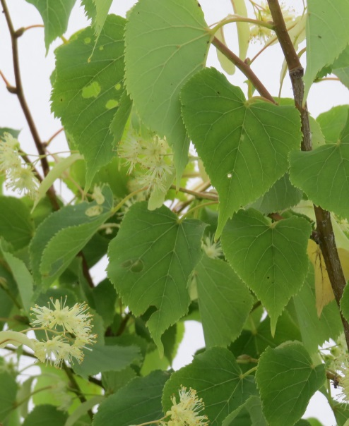
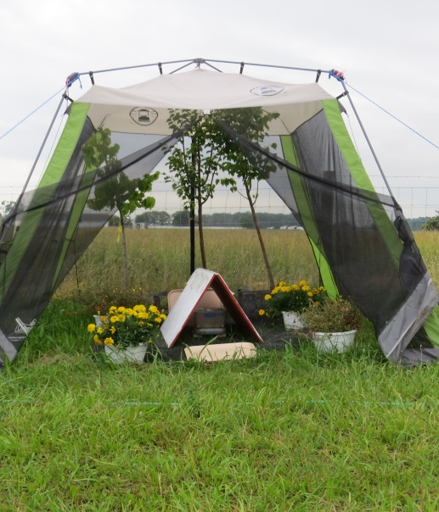

Results
Bumble bee survival was very good in both treatments. All counts were made using the CO₂ method, which suggests that using CO₂ is far better for the bees than counting them in a cold room, as we did in the beginning of the previous experiment. Imidacloprid drenches made a year earlier had no impact on the number of bumble bees per colony throughout the growing season, or on the number of queens produced per colony (Figure 5). Control colonies averaged 7.8 new queens produced per colony at the end of the summer, while colonies in the imidacloprid treatment averaged 5.8 queens per colony. No imidacloprid metabolites were found in nectar from flowers on control trees. The nectar from trees that had received a soil drench of imidacloprid one year earlier contained a mean of 1.27 ppb of imidacloprid (Table 3). Imidacloprid metabolites were not detected in the nectar. This concentration of imidacloprid is unlikely to be harmful to pollinators.
Figure 5. Survival of bumble bees after being caged with Tilia trees for 10 days in June, 2015, when the trees were blooming. Trees in the imidacloprid drench treatment were drenched in early July, 2014. Data are means of four colonies per treatment.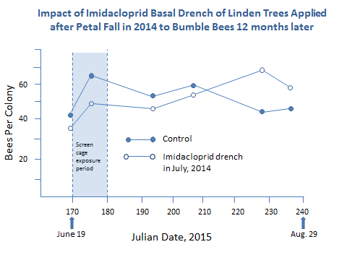
Table 3. Imidacloprid and active metabolites found in Tilia cordata nectar one year after a basal soil drench of imidacloprid was applied at the label rate. Flowers were collected from the container-grown grown trees in June of 2016. Data are ppb of imidacloprid in dry flower tissue (whole flowers), ppb imidacloprid in nectar wash based on dry weight of flower tissue (nectar wash), and ppb of imidacloprid found in pure nectar (pure nectar).
Sample | Treatment | Imidacloprid (ppb) | Imidacloprid 5-OH  (ppb) | Imidacloprid olefin (ppb)
Whole flowers | drenched | ND | 2.50 | ND
 | drenched | ND | 0.97 | ND
 | drenched | ND | 3.91 | ND
 | drenched | ND | 3.12 | ND
 | drenched | ND | 2.01 | ND
 | drenched | ND | 5.58 | ND
 | drenched | ND | 1.27 | ND
 | control | ND | ND | ND
 | control | ND | ND | ND
 | control | ND | ND | ND
 | control | ND | ND | ND
 | control | ND | ND | ND
 | control | ND | ND | ND
 | control | ND | ND | ND
Nectar Wash | drenched | 1.45 | ND | ND
 | drenched | 4.20 | ND | ND
 | drenched | 6.88 | ND | ND
 | drenched | 40.13 | ND | ND
 | drenched | 3.07 | ND | ND
 | drenched | 4.15 | ND | ND
 | drenched | 6.75 | ND | ND
 | Drench mean | 9.52
 | control | ND | ND | ND
 | control | ND | ND | ND
 | control | ND | ND | ND
 | control | ND | ND | ND
 | control | ND | ND | ND
 | control | ND | ND | ND
 | control | ND | ND | ND
Pure nectar | drenched | 0.79 | ND | ND
 | drenched | 0.09 | ND | ND
 | drenched | 0.09 | ND | ND
 | drenched | 1.98 | ND | ND
 | drenched | 0.09 | ND | ND
 | drenched | 0.11 | ND | ND
 | drenched | 5.77 | ND | ND
 | drench mean | 1.27
 | control | ND | ND | ND
 | control | ND | ND | ND
 | control | ND | ND | ND
 | control | ND | ND | ND
 | control | ND | ND | ND
 | control | ND | ND | ND
 | control | ND | ND | ND

3. Dislodgable residue of imidacloprid on the flowers of annuals sprayed 1, 2 and 4 weeks before shipping. In a third experiment flowers were sprayed with imidacloprid at 1, 2, and 4 weeks prior to shipping. This experiment was conducted in spring of 2015, with four types of annual flowers grown by Dr. Eric Runkle in the MSU horticulture greenhouses. Plants were grown with standard grower production practices. Whole flowers were collected on the shipping date, dried, weighed, covered with dichloromethane and agitated for 30 s. The solvent was decanted and reduced before HPLC analysis for imidacloprid residue.

Results
Very little dislodgable residue was recovered from flowers sprayed 4 weeks or more before shipping (< 2 ppb), and it is unlikely that this would have any impact on bees (Table 4). Some dislodgable residue was recovered from flowers sprayed 1 or 2 weeks before shipping (< 6 ppb), but it is not known if this enough to affect bees. These results suggest that it would be safe for bees to land on flowers sprayed a week or more before shipping with imidacloprid, but more research is needed to determine the concentration of imidacloprid in pollen or nectar following foliar sprays applied at 1 – 4 weeks before shipping.

Table 4. Results from a 2015 experiment designed to determine how much dislodgable residue is present on flowers sprayed at 1, 2, or 4 weeks before shipping.
Weeks before shipping | Plant type | Olefin  (ppb) | Imidacloprid  (ppb)
1 | Portulaca | 0 | 5.4 ± 1.7
1 | Verbena | 0 | 4.0 ± 0.8
1 | Salvia | 0 | 0.7 ± 0.2
1 | Marigold | 0 | 1.8 ± 1.1
2 | Portulaca | 0 | 5.8 ± 0.8
2 | Verbena | 0 | 3.4 ± 0.4
2 | Salvia | 0 | 0.9 ± 0.3
2 | Marigold | 0 | 0.3 ± 0.2
4 | Portulaca | 0 | 1.8 ± 1.0
4 | Verbena | 0 | 1.1 ± 0.52
4 | Salvia | 0 | 1.9 ± 0.9
4 | Marigold | 0 | 0.8 ± 0.3
Nebraska

Gerard C Adams
Department of Plant Pathology
University of Nebraska Lincoln (UNL)
Lincoln, NE 68583-0722

Emerald Ash Borer
In 2016 Nebraska experienced the long expected arrival of the Emerald Ash Borer which first appeared in Omaha and has not yet been found elsewhere. In nearby Lincoln, City arborist crews have removed some non-infected large ash trees along bridges that are a part of the EAB response strategic plan.

Thousand Cankers Disease
No evidence of infestation by the thousand canker disease of walnuts has yet been discovered in Nebraska even though the State has a walnut beetle trapping survey and has investigated instances of shipment of raw walnut timber products into western Nebraska from suspect States. Eastern Nebraska does have black walnut stands planted by landowners for nut and timber production which is expected to suffer greatly when TCD arrives. Contingency plans appear to involve replacing walnut with northern pecan selections derived from decades-long pecan evaluations by UNL and the Walnut Growers Association in Nebraska. Nebraska does have a quarantine for TCD: “NEBRASKA THOUSAND CANKERS DISEASE OF WALNUT QUARANTINE #5072010”.

Diagnostic Clinic:
Two major events impacted the Diagnostic Clinic in 2016. Firstly, a new bacterial leaf streak disease of maize was discovered by Dr. Kevin Korus and Prof. Tamra Jackson-Ziems and verified through advanced molecular characterization methods with University of Colorado (Prof. Jan Leach) as caused by Xanthomonas vasicola pv. vasculorum (Xvv). After long-lasting frustration and negotiation, APHIS allowed the plant pathologists to report (speak) the disease discovery and provide initial management recommendations to affected and other growers. APHIS does not consider it to be of quarantine significance and will treat it as other bacterial diseases of corn such as Goss’s bacterial blight. The experience was a humiliating humbling one for all scientists involved, in my opinion.

Secondly, diagnostician Dr. Kevin Korus transferred to University of Florida diagnostic group soon after receiving his PhD as a Doctor of Plant Health, from UNL.

Elm
Plans to graft 25 selections of elms, including new Asian elm selections of excellent horticultural and amenity characteristics, onto diploid and tetraploid rootstock (as needed), were initiated with 500 wedge grafts using dormant scion wood. The most experienced UNL grafters completed the task because experienced walnut growers and nursery personnel were overwhelm with demands on their time due to an unusually early spring. Unexpectedly, few grafts succeeded despite optimal mist chamber and greenhouse conditions and care during healing. Only 77 exotic new selections survived and this prevented plans for replicated experimental trails. The trees were out-planted for public evaluation at the UNL Prairie Pines forest.

Research in tree pathology: Root pathogens of alder
A multi-year effort involving several graduate, undergraduate students and a postdoctoral researcher, completed a two-gene phylogenetic analysis of the Phytophthora and Pythium occurring in the rhizosphere under declining Alnus tenuifolia. The study compared oomycete flora from 30 sites in southcentral and interior Alaska, 30 sites in the Colorado Rocky Mountains, and one native plants nursery in the Colorado Rocky Mountains at equivalent elevation and locality to the native stands.
Twelve phylogenetic trees were constructed separately by long-recognized subclades to accurately identify known and unknown species within Phytophthora, Pythium, Phytopythium and Halophytophthorsa. The two geographically separated natural alder ecosystems had unique and different communities of rhizosphere oomycetes with differing oomycete pathogens of alder. Many new oomycete species (taxa) were found. The nursery was unlike the native stands and had species of oomycetes indicative of international introduction and/or inter-nursery spread and also did not have many of the locally abundant alder rhizosphere oomycetes. The study establishes the rhizosphere community at this time and should be of value in recognizing and confirming introduction and spread of invasive forest oomycetes in the future.

New canker disease causing branch dieback and mortality of western Hemlock
Western hemlock in the Tongass National Forest is suffering from an unknown diffuse canker disease where the cankers rapidly run from foliage to twig, to branch and sometimes to the trunk causing necrosis of the cambium and phloem if the current year. Some of the cankers continue activity into a second year. Dozens of fungi have been isolated from the advancing canker margins and then tested in highly replicated inoculation trials at Tongass sites judged to be of high stress and low stress based on nearby natural canker incidence on similar age and class trees. Koch’s Postulates were completed and two or more weakly pathogenic fungi were identified and well as one virulent canker pathogen Discocainia treleasei. However, we concluded that D. treleasei was infrequently isolated and therefore not distinctively proven as the cause of the widespread branch dieback and mortality. Therefore, new technology and technology transfer has been introduced because of difficulty in verifying a specific pathogen is the causal agent. Initial isolations from cankers occurred at UNL following transport and cankers were not all of similar characteristics. In 2016 in field isolation of genomic DNA onto Whatman FTA cards at the moment of exposure of the symptomatic cambium and cambium chips were immediately placed into malt extract agar plates. PCR inhibitors were removed by special methodology from FTA cards and PCR-amplifiable DNA were readily obtained. Current studies are identifying the fungal DNA captured on the FTA cards using illumina next generation sequencing. Identification of about 60 cultures obtained from in-field isolations are also being identified using Sangar DNA sequencing.

Rapid field PCR nanotechnology for tree disease diagnosis
UNL Hendrik Viljoen, professor and department chair of chemical and biomolecular engineering and student researcher Heather Newell have developed a PCR field method which was verified in trials in Florida on wood pieces of avocado trees having Laurel Wilt caused by the fungus Raffaelea lauricola which is transmitted by the redbay ambrosia beetle. The real-time portable rapid (3 min) PCR-DNA analysis of the avocado trees is particularly challenging because wood shavings or root samples must first be ground in a buffer solution to release the DNA molecules. Heather invented a superior new grinding drill bit based on automotive tap-and-die hardware during her garage mechanic work with her boyfriend.

While Prof. Henk and new graduate student Heather continue to perfect design and development of the rapid field PCR nanotechnology, they have enlisted Gerry Adams, UNL Plant Pathology, to find suitable tree disease applications of the methodology, and to help in bioinformatics optimization for specific causal agents, tree tissues, and field conditions. Dr. Adams’ plans are to seek coordinated cooperation from several diagnosticians at plant disease diagnostic clinics in targeting select disease diagnosis involving woody plants. The team is specifically aiming to develop the technology such that single tests remain affordable and near US$1.00 each. Competitive technology is appearing on the market but single test costs are currently about US$30.00.

Oklahoma

Eric Rebek
Dept. of Entomology and Plant Pathology
Oklahoma State University

Insect Highlights:

Emerald ash borer - The most notable insect detection for 2016 was the discovery of emerald ash borer (EAB), Agrilus planipennis, in Oklahoma. One beetle was recovered from a purple panel trap in Delaware County near the Grand Lake area on October 16, 2016. The Oklahoma Dept. of Agriculture, Food, and Forestry and USDA-APHIS were notified of the confirmed identification and these agencies, in turn, shared the news with Oklahoma Cooperative Extension Service. The Oklahoma EAB Action Plan (http://www.forestry.ok.gov/Websites/forestry/images/EAB/EAB%20Action%20Plan,%202015.pdf), created in 2015, was released to the general public for information about the state’s response to this invasive species. An independent contractor will proceed with additional monitoring efforts for EAB around the Grand Lake area and throughout northeastern Oklahoma in 2017. As part of the EAB Action Plan, my involvement has included producing extension materials and pest alerts as well as providing information to Oklahoma stakeholders via presentations at workshops and meetings. Details of this activity is included below.

Crapemyrtle bark scale – This invasive scale pest infests crapemyrtles throughout the southern U.S. First detected in the Fort Worth-Dallas Metroplex of north Texas in 2004, crapemyrtle bark scale (CMBS), Eriococcus lagerstroemiae, has been spreading rapidly from human-assisted movement over the past five years. This scale insect is now found infesting crapemyrtles in Carter, Marshall, Bryan, Canadian, Oklahoma, Payne, Comanche, and Tulsa Counties. I am not recommending the use of neonicotinoid insecticides for treatment of CMBS in Oklahoma because of the potential to harm pollinators; crapemyrtles are frequently visited by honey bees, bumble bees, and other pollinators and they remain in bloom for most of the growing season in Oklahoma. I am recommending a combination of dormant oil applications and removal of scales and egg sacs via washing and scrubbing the bark until other options are available.

Fall webworm – 2016 was the largest and most widespread infestation of fall webworm (FWW), Hyphantria cunea, for the state of Oklahoma on record. Infestations of FWW were heavy early on, with observations first made in early June. I responded to many emails and phone calls about managing this native insect pest throughout the summer and early fall. Many trees were completely defoliated and engulfed in webbing by the end of the season, but this damage is only aesthetic in most cases.

Oak itch mite – The oak itch mite was first reported in Oklahoma during the fall of 2015. Reports of homeowners and landscape personnel being bitten by these critters has been on the rise ever since, and 2016 was a banner year for oak itch mite. This mite is a predator of oak leaf gall midge. Extension recommendations have followed those from other states; i.e., the focus has been on prevention of bites by wearing protective clothing while doing yard work. Insecticide treatments don’t work for such large trees and mites/midges hidden within leaf galls. Winter temperatures that have been warmer than usual the past few years may be exacerbating the problem by enhancing overwintering survival of the mite and midge.

Miscellaneous pests – I have responded to emails and phone calls regarding a myriad of other ornamental pests. These include woodborers, mealybugs, tent caterpillars, redheaded pine sawfly, redbud leaffolder, and Japanese beetle. I also have dealt with the occasional question about Africanized honey bees, digger wasps (e.g., cicada killers), mosquito management, bed bugs, and termites.

Extension Publications – New

Rebek, E.J. 2016. Entomology Basics. Chapter 8 of Master Gardener Manual. E-1034, Oklahoma Cooperative Extension Service.

Rebek, E.J. 2016. Signs and Symptoms of Emerald Ash Borer. L-443, Oklahoma Cooperative Extension Service.

Extension Publications – Revised

Rebek, E.J. 2016. Commercial Management of Turfgrass Insects and Mites. CR-7195, Oklahoma Cooperative Extension Service.

Rebek, E.J. 2016. Management of Insects and Mites in Tree Nurseries. CR-7092, Oklahoma Cooperative Extension Service.

Rebek, E. and M. Schnelle. 2016. Managing Storm-Damaged Trees. EPP-7323, Oklahoma Cooperative Extension Service.

Rebek, E.J. 2016. Detection, Conservation, and Augmentation of Naturally Occurring Beneficial Nematodes for Natural Pest Suppression. EPP-7670, Oklahoma Cooperative Extension Service.

Olson, J., E. Rebek, and M. Schnelle. 2016. Rose Rosette Disease. EPP-7329, Oklahoma Cooperative Extension Service.

Rebek, E.J. 2014. Management of Turfgrass Insects and Mites, OSU Extension Agents’ Handbook of Insect, Plant Disease, and Weed Control. E-832, Oklahoma Cooperative Extension Service.

Rebek, E.J. 2014. Commercial Ornamentals and Christmas Trees Insect and Mite Control Suggestions, OSU Extension Agents’ Handbook of Insect, Plant Disease, and Weed Control. E-832, Oklahoma Cooperative Extension Service.

Rebek, E.J. 2014. Insect Control Suggestions for Ornamentals – Trees, Shrubs, and Flowers (For Homeowners), OSU Extension Agents’ Handbook of Insect, Plant Disease, and Weed Control. E-832, Oklahoma Cooperative Extension Service.

Rebek, E.J. 2014. Greenhouse Floral Crops Insect and Mite Control Suggestions, OSU Extension Agents’ Handbook of Insect, Plant Disease, and Weed Control. E-832, Oklahoma Cooperative Extension Service.

Rebek, E.J. 2014. Home Garden Vegetable Insect Control, OSU Extension Agents’ Handbook of Insect, Plant Disease, and Weed Control. E-832, Oklahoma Cooperative Extension Service.

Trade Articles and Newsletters

Rebek, E.J. and R. Grantham. 2016. Oak Gall Midges Are At It Again! Pest e-Alert, April 15, 2016 (Vol. 15, No. 13).

Rebek, E.J. 2016. Common Leafhoppers of Horticultural Importance. Pest e-Alert, April 18, 2016 (Vol. 15, No. 14).

Rebek, E.J. 2016. Grapevine Oddities: Grape Gall Midges. Pest e-Alert, June 20, 2016 (Vol. 15, No. 23).

Rebek, E.J. 2016. Fall Webworm Emerging Ahead of Schedule. Pest e-Alert, June 27, 2016 (Vol. 15, No. 25).

Rebek E.J. 2016. Fall Armyworms Marching Across Oklahoma Turfgrass. Pest e-Alert, September 9, 2016 (Vol. 15, No. 34).

Rebek, E.J. 2016. First Detection of Emerald Ash Borer in Oklahoma. Pest e-Alert, October 31, 2016 (Vol. 15, No. 34).

Other Extension Activities

In addition to delivering 35 extension presentations to a variety of stakeholders across Oklahoma, I appeared on the OETA TV show, Oklahoma Gardening, focused on neonicotinoids and bees. Also, I appeared on one segment of another OETA TV show, SUNUP, discussing bees and wasps.

Wisconsin

P.J. Liesche and R. Chris Williamson
Dept. of Entomology
University of Wisconsin-Madison

- Emerald Ash Borer – EAB has now officially ben confirmed in 42 of the 72 Wisconsin counties. The northern half of the state still has few finds, but EAB is well established across the southern half of the state. Our first confirmed EAB detection occurred in 2008 in the state.

- Scale Insects: both Magnolia scale and lecanium scales were abundant in 2015 and activity continued into 2016. Many reports came in to the UW Insect Diagnostic Lab scale activity resulting in sooty mold and ant/wasp activity.

- Scarab Beetles: several scarab species had notable activity in 2016
I. Rose Chafers were quite active in parts of the state with sandy soil. Damage to a wide range of ornamental plants and fruit was noted.
II. Japanese Beetle numbers had been low during the summers of 2014 and 2015 (possibly due to extreme cold of 2014 winter); numbers rebounded in summer of 2016. Damage to ornamental plants by adult beetles and turf injury due to larval feeding noted.
III. European Chafers have become established in Door County, WI. Damage to ornamental plants by adult beetles and turf injury due to larval feeding noted.
IV. Northern Masked Chafers have become established in south central Wisconsin. Grub damage in turfgrass areas occurred.

- Gypsy Moth numbers have been relatively low in the state the past few years. However, reports from the summer months indicated that large numbers of egg masses have been found in some locations, potentially indicating higher numbers of gypsy moths in 2017.

- Invasive Leaf Beetles: two species have showed up and become established in the last two years
I. Lily Leaf Beetle was first detected in the spring of 2014 in central Wisconsin (Wausau area). Additional detections in surrounding counties to the north and south were noted in 2016.
II. Viburnum Leaf Beetle was detected in the Milwaukee area in fall of 2014 and several new infestations were detected in 2015 and 2016 in southeastern Wisconsin.

- Brown Marmorated Stink Bug was first detected in Wisconsin in 2010. From 2010-2014, numbers of this insect remained low, with only a handful of lone adults reported in fall/winter/spring of each year. In 2015, BMSB populations had increased notably with dozens of detections in the state. Dane County (Madison, WI) has had the highest level of BMSB activity. During the summer of 2016, juveniles were reported on several occasions. Trapping efforts have been initiated in the state to survey for the insect in orchards and similar areas and BMSB has been picked up in traps. Plant damage has not yet been noted in the state but is probably only a matter of time.

- Fruit Pests
I. Spotted Wing Drosophila has become well established in Wisconsin over the past ~6 years since first detected (2010). SWD can be found statewide and typically becomes active around the same time as Japanese beetles in the state (early July). The peak of activity is in August and September, which coincides with the late-season raspberry crop.
II. Blueberry Maggot was recently detected in low numbers on sticky card traps in central Wisconsin (Sauk and Adams counties).

- Nuisance Insects in the Landscape
I. Multicolored Asian Lady Beetle numbers have been high the past few years and reports of activity have been common this fall
II. Boxelder Bug numbers have been low in 2014 and 2015, likely due to rainy conditions. Despite the rainy summer, their populations have been notably higher this fall.
III. Western Conifer Seed Bugs have been reported more frequently in the state, although this is likely an artifact of their misidentification by the general public as kissing bugs. The UW Insect Diagnostic Lab created a side-by-side ID guide to help distinguish between the two (ID guide: http://labs.russell.wisc.edu/insectlab/2015/12/08/was-that-a-kissing-bug/)

- “New” Records for Wisconsin
I. Blueberry maggot (as noted earlier)
II. Little Fire Ants were found in the Milwaukee Domes (tropical forest biome building) and likely were introduced in infested plant materials
III. Red Imported Fire Ants were found in the Fox River Valley in August of 2016; the ants were found in train cars that had recently traveled to Wisconsin from Mississippi. The train cars have been treated by a pest control company and no further activity has been noted
IV. Two-Banded Japanese Weevil was detected in Madison, WI (Dane County) in summer of 2016. Origins unknown.

- “Other” Cases of Interest
I. An infestation of Brown Recluse Spiders was noted in two connected buildings in Appleton, WI.

Factsheets and other Publications for 2016:
[Updated] “Homeowner Guide to Emerald Ash Borer Treatments” Factsheet. R. C. Williamson and P. J. Liesch. https://pddc.wisc.edu/wp-content/blogs.dir/39/files/Fact_Sheets/FC_PDF/Homeowner_Guide_to_EAB_Insecticide_Treatments.pdf
[Updated] “Professional Guide to Emerald Ash Borer Treatments” Factsheet. R. C. Williamson and P. J. Liesch. https://pddc.wisc.edu/wp-content/blogs.dir/39/files/Fact_Sheets/FC_PDF/Professional_Guide_to_EAB_Insecticide_Treatments.pdf
[Updated] “Insect Pest Management for Greenhouses” Poster. R. Chris Williamson, Samuel Soper, P.J. Liesch. https://learningstore.uwex.edu/Insect-Pest-Management-for-Greenhouses-P1175.aspx
[Updated] “Social Wasps and Bees in the Upper Midwest” Factsheet. Online Factsheet. J. Hahn, L. Jesse and P.J. Liesch. http://www.extension.umn.edu/garden/insects/find/wasp-and-bee-control/
[New] “Wisconsin Bee ID Guide” Visual Guide. P. J. Liesch, C. Stewart, and C. Wen. http://hort.uwex.edu/articles/wisconsin-bee-identification-guide/

[New] “Conservation of Native and Domestic Pollinators in Managed Turfgrass Landscapes” Bulletin. J. Larson, R. C. Williamson, and P.J. Liesch. https://learningstore.uwex.edu/Conservation-of-Native-and-Domestic-Pollinators-in-Managed-Turfgrass-Landscapes-P1812.aspx

Other Activities in 2016:
The National Turfgrass Entomology Workshop was held in Sheboygan, WI August 21st – 22nd, 2016 at Blue Harbor Resort. The meeting was attended by ~75 entomology and turfgrass professionals from academia, industry, and other groups. National BMPs are under development as a result of the meeting.

