S-1075 Multistate Project 2026
Annual Meeting and Symposium on Science and Technology Driving the Bioeconomy
July 9-10, 2026 | Lexington, Kentucky
Meeting Minutes

Organizers

Meeting Logistics
Chair - Tyler Barzee - tjbarzee@uky.edu
Vice Chair - Abigail Engelberth - aengelbe@purdue.edu
Secretary - Sun Ferreira - sunfer@uark.edu

Student Travel Award
Tyler Barzee - tjbarzee@uky.edu
Chris Saffron - saffronc@msu.edu

Abstract Submission and Proceedings
Ken Rausch - krausch@illinois.edu
Mike Tumbleson - mtumbles@illinois.edu

Meeting Location and Website
The meeting was held at the UK Martin-Gatton Agricultural Sciences Building, 1312 Nicholasville Road, Lexington, KY 40503. The meeting website was https://bae.mgcafe.uky.edu/s1075

Day 1: July 9, 2026
Time | Session / Activity
8:00-8:25 am | Registration and breakfast.
8:25-8:30 am | Welcome and opening remarks.
8:30-10:00 am | Invited speakers.
10:00-10:20 am | Coffee break.
10:20-10:40 am | Executive updates and S-1075 history/future value.
10:40 am-Noon | Station updates.
Noon-1:45 pm | Lunch and student poster competition, Session 1.
1:45-2:45 pm | Business meeting.
2:45-3:15 pm | Coffee break and student poster competition, Session 2.
3:15-4:00 pm | Tour of James B. Beam Institute for Kentucky Spirits.
4:00-5:00 pm | Special issue brainstorming and research collaboration breakout sessions.
5:00-7:00 pm | Dinner, networking, and student poster awards.

Welcome and Opening Remarks
Dr. Tyler Barzee welcomed participants to the S-1075 Annual Meeting and provided housekeeping remarks. Dr. James Matthews, Associate Dean for Research, Kentucky Agricultural Experiment Station, Martin-Gatton College of Agriculture, Food and Environment, welcomed the group and highlighted the new building and related programs.

Invited Speaker #1: Dr. Kaushlendra Tingi
National Program Leader, USDA-NIFA Institute of Bioenergy, Climate, and Environment
Dr. Tingi introduced himself and described his experience with federal agencies, land-grant institutions, and multistate projects. He noted that S-1075 was his first multistate project and recognized the group for its continued contributions and support of USDA-NIFA review activities.
He reminded participants that multistate projects are funded through annual appropriations and must comply with relevant requirements, including acknowledgement of NIFA support.
He discussed priorities relevant to future funding, including increasing profitability for farmers and ranchers and expanding the use of agricultural by-products and co-products.
He emphasized strengthening American agricultural products and encouraged S-1075 members to contact him as needed for support.

Invited Speaker #2: Dr. Tim Rials
Professor, Department of Forestry, Wildlife, and Fisheries; Director, Center for Renewable Carbon; and Associate Dean of AgResearch, University of Tennessee Institute of Agriculture
Dr. Rials presented on maximizing the value of the bioeconomy and discussed the role of Hatch and multistate projects in addressing complex, shared challenges through coordinated networks.
He reviewed key legislation supporting land-grant activities and explained how multistate projects are organized within regional agricultural innovation systems.
He described different types of multistate projects, including S, SERA, SAC, and SDC projects.
He emphasized that project reviews reward integrated collaboration rather than siloed efforts and noted that annual reporting should clearly demonstrate progress toward the project objectives.
He encouraged objective documentation of advancement and progress to maintain multistate project status and suggested considering recognition and performance awards as part of the project.
He also highlighted University of Tennessee activities, including circular bioeconomy systems, Sun Grant history and partnerships, workshops, and regional initiatives under development.

Invited Speaker #3: BioMADE - Laura Vitko and Mike Smanski
Laura Vitko, Director of Strategic Partnerships, and Mike Smanski, Technical Fellow, presented an overview of BioMADE and its role in strengthening domestic biomanufacturing capacity.
They described BioMADE as a membership-based institute supporting technology development, education and workforce development, and safety and security.
The speakers noted that BioMADE supports projects with higher technology readiness levels, particularly scalable projects in approximately TRL 4-7 rather than early proof-of-concept work.
BioMADE membership is institutional and provides access to funding opportunities, committees, subcommittees, a member portal, and project information.
They highlighted BioMADE pilot-scale fermentation capacity being developed in California, Iowa, and Minnesota, with facilities focused on food-grade products and chemical applications.
Members interested in learning more were encouraged to contact Laura Vitko.

Invited Speaker #4: Mark Elless
Technology Manager, Alternative Fuels and Feedstocks, U.S. Department of Energy Office of Critical Minerals and Energy Innovation
Mark Elless discussed the reorganization of the office and presented priorities related to alternative feedstocks, alternative fuels, critical minerals, and energy innovation.
He described the office priorities, including reducing reliance on foreign fertilizers, improving the use of nuclear energy, supporting clean water for artificial intelligence, advancing geologic hydrogen, and improving chemical production performance.
He discussed feedstock portfolio goals focused on improving and optimizing feedstock production, quality, flowability, and conversion readiness.
He highlighted prior and ongoing work related to municipal solid waste, biomass feedstock utilization, national user facilities, bio-based fertilizers, and opportunities to strengthen domestic production.
During the question-and-answer period, he noted that funding levels have been relatively consistent while the office awaited final FY27 budget details.

Executive Updates and S-1075 History
Tyler Barzee discussed the special issue associated with S-1075 and emphasized that it provides a strong opportunity to showcase collaboration among project members.
Mike Tumbleson provided historical context on S-1075 and highlighted the value of the project for graduate students, postdoctoral researchers, and faculty. He emphasized the importance of supporting agricultural innovation, improving abstract submissions, maintaining complete participant information, and preparing for the next project rewrite.

Station Updates
Station representatives provided five-minute annual updates. See the submitted slides and station reports for detailed updates from individual stations.
Kansas
Alabama
California
Mississippi
Minnesota
Pennsylvania
Indiana
Michigan
Arkansas
North Dakota
Texas
South Dakota
Missouri
Virginia
Kentucky
Washington

S-1075 Business Meeting Summary
The business meeting began at 1:52 pm.

Approval of 2025 Minutes
Motion to approve the 2025 meeting minutes was made by Mark Wilkins and seconded by Mike Tumbleson.
The minutes were approved by voice/acclamation.

New Business and Project Renewal
The group discussed the current S-1075 project cycle, which began in 2023.
The renewal proposal must be submitted by September 2027.
The group discussed initiating proposal preparation now, with the goal of having a draft ready for review at the 2027 meeting at Purdue University in West Lafayette, Indiana.
The group discussed whether the project objectives should be revised. Suggested additions included artificial intelligence and machine learning, as well as a stronger emphasis on circularity within Objective 3.
Abigail Engelberth suggested a high-level group discussion of objectives, followed by detailed writing and wordsmithing by a committee.
Members noted that the current proposal can be found in NIMSS. The timeline should be confirmed with Dr. Rials and Dr. Tingi, and the Southern region agricultural coordinator should be contacted.

2027 Meeting Planning
The group discussed moving the meeting into the academic year. Prior scheduling in summer was intended to coordinate with ASABE and reduce travel burden, while also supporting student participation.
A tentative placeholder was proposed for the week of August 9, 2027, in West Lafayette, Indiana. Final dates will be confirmed.

Election of 2027 Secretary
The group clarified that the elected secretary will chair the 2029 meeting but will not necessarily be required to host that meeting.
Abigail Engelberth nominated Haibo Huang from Virginia.
Mark Wilkins moved to close nominations, and Abigail Engelberth seconded the motion. The motion was approved by acclamation.
Mark Wilkins moved to accept Haibo's nomination, and Chris Saffron seconded the motion.

Adjournment
Mark Wilkins moved to close the business meeting, and Abigail Engelberth seconded the motion.

Special Issue and Breakout Session Summaries

Bioresource Technology Special Issue
The group discussed the Bioresource Technology special issue tentatively titled "Collaborative Advances in the Science and Engineering of Circular Bioeconomy (S1075 Symposium 2026)." Key dates discussed included manuscript submission by January 31, 2027, and acceptance by May 31, 2027.
Anticipated topics include integrated biobased production; biomass production, characterization, and preprocessing; circular bioeconomy; process development and technology translation; integrated waste management; bioplastics; TEA/LCA; machine learning; artificial intelligence; and self-driving laboratories.
The target publication plan included approximately 20 published papers from an expected pool of about 50 submissions, including 6-7 literature review papers and approximately 15 research papers.

Breakout Sessions
Breakout sessions were organized around multistate project themes, including feedstocks, conversion, and modeling. Participants discussed current research interests, potential S-1075 collaborations, manuscript plans, and future collaborative proposal opportunities.
Topic | Interested Participants
MSW characterization and CFD modeling of segregation particle behavior | Susil (Auburn); Hasan (Auburn); Jian (UK)
Bioplastics: production/manufacturing, commercialization, and fate | Ruihong (UC Davis); Haibo (Virginia Tech); Tyler (UK); Jikai (Kansas State); Bishnu (SDSU); Monono (NDSU)
Comparative TEA/LCA | Chris (MSU); Abby (Purdue); Juliana (Penn State); Haibo (Virginia Tech); Jikai (Kansas State)
Primary data needs for TEA/LCA in biomanufacturing, with AI opportunities | Juliana (Penn State); Abby (Purdue); Chris (MSU)
Combustion behavior of bio-oil, SAF, and diesel | Hasan (Auburn); Bin (WSU); Monono (NDSU)
Comprehensive assessment of inputs, outputs, costs, bottlenecks, and the valley of death for bioproducts | David (Missouri); Abby (Purdue); Sun (University of Arkansas); Prasanth (University of Minnesota)
Fungal fermentation, scale-up challenges, and variability | Bishnu (SDSU); Tyler (UK); Sun (University of Arkansas); Ruihong (UC Davis); Ananda (SDSU); Keya (UK); Suvro (UK); Juliana (Penn State); Prasanth (University of Minnesota)
Metabolic engineering and synthetic biology | Yi Wang (UC Davis); Zhiliang Fan (UC Davis); Wei Liao (MSU)
Biofertilizer, including nitrogen and phosphorus distinctions | Lin Wei (SDSU); Tyler (UK); Xiaowei Chen (University of Minnesota)
Policy implications and recommendations | Chris (MSU)
Biomining and resource recovery | Jian (UK); Yi Wang (UC Davis); Xiaowei Chen (University of Minnesota)

The group also discussed improved methods for storing and accessing project documents. Abigail Engelberth suggested using Microsoft Teams, although members noted that the hosting institution would need to be determined. Sun Ferreira will send an email compiling the breakout groups and interested participants.

Student Poster Awards
The following five students were selected for best poster presentations and received $100 gift cards:
Suvro Talukdar
Yosselin Castro-Islas
M. M. Mahdi Hasan
Tosin O. Olanrewaju
Pradip Adhikari

Day 2: July 10, 2026 (Optional Tours)
Time | Session / Activity
8:00-8:15 am | Assemble in the Orange Lot in front of the C.E. Barnhart Building and depart for the first tour.
8:45-10:00 am | Tour of the University of Kentucky Center for Applied Energy Research (CAER), 2540 Research Park Drive, Lexington, KY 40511.
10:00-10:30 am | Travel to the next tour.
10:30 am-12:30 pm | Tour of Alltech headquarters in Nicholasville, KY.
12:30-1:30 pm | Lunch at Connemara.
1:30-2:00 pm | Return to the University of Kentucky.
2:00-3:30 pm | Complete any remaining business.
3:30 pm | Meeting adjourned.

Meeting Logistics and Follow-Up Items
Registration fees were $150 for in-person attendees before June 19, increasing to $200 after that date. Virtual registration was $100.
Registration covered breakfast, lunch, tea/coffee, dinner, proceedings, and transportation and lunch for participants joining the July 10 tours.
Station representatives were asked to upload station update slides by 11:59 pm on July 8, 2026.
Station reports were due by August 1, 2026.
The official hotel was The Campbell House Lexington, Curio Collection by Hilton.
Lexington Blue Grass Airport is approximately 15 minutes from the university and hotels. Uber/Lyft, taxis, and rental cars were available.
Parking was available in the Orange Lot near the College of Agriculture buildings. Participants driving to campus were asked to request a parking permit during registration.

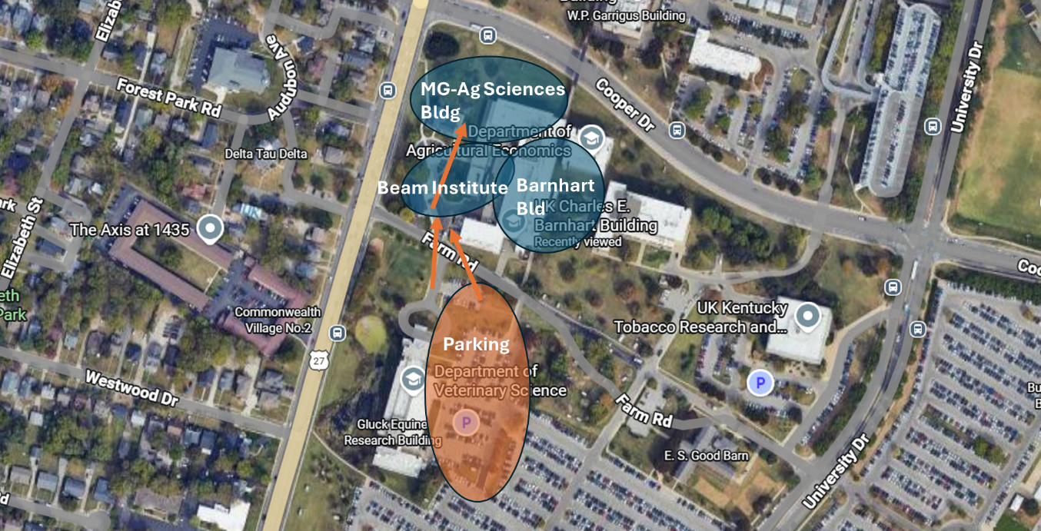
Parking map for the Orange Lot near the College of Agriculture buildings.
Notes revised and summarized by:
Sun Ferreira, PhD
Assistant Professor, University of Arkansas
sunfer@uark.edu

