2025 NE 2140 meeting minutes.
The annual meeting of NE 2140 was held October 16-17 2025 at Michigan State University, hosted by Marisol Quintanilla. The meeting was attended by K-H Wang (Univ. of Hawaii), M. Kantor (Penn State), W. Crow (Univ. of Florida), E. Bernard (Univ. of Tennessee), G. Bird (MSU), N. Mitkowski (Univ. of Rhode Island), J. Kotcon (Univ. of West Virginia), M. Quintanilla (MSU), C. Taylor (Ohio State), H. Melakeberhan (MSU) and A. Bekkerman (Univ. of New Hampshire). Additional graduate students and staff were present randomly though out the day to see specific state presentations.
Welcome and introduction to the meeting was provided by Dean Bekkerman.
State Reports began at 8 am, presented from Pennsylvania, Tennessee, Michigan, Rhode Island, Hawaii, Ohio, Florida, Georgia, and West Virginia.
Old Business: None
New Business: Dr. Crow volunteered to author the rewrite of the new project. The deadline for submission is December 1. He will work with participants to develop the next version and will require input. The annual group report will wait until the new project is developed. Submission of the annual report should happen shortly after Christmas.
Anton Bekkerman has volunteered NH as our next regional meeting site. Details still pending.

Submitted,
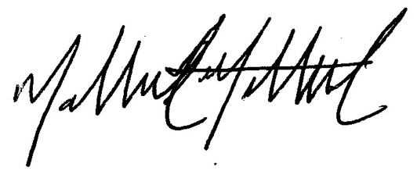
Nathaniel Mitkowski

