2024 SERA-IEG-6 Multistate Research Activity
Accomplishments Report
Project/Activity Number: SERA6: Methodology, Interpretation, and Implementation of Soil, Plant, Byproduct, and Water Analyses
Period Covered: June 2023- June 2024
Date of This Report: January 8, 2026

ANNUAL MEETING PARTICIPANTS (SERA-IEG-6)
Alford, Shannon sralfor@clemson.edu Clemson U; Davis, Jessica Jld0084@auburn.edu Auburn U; Florence, Robert rfloren2@utk.edu U of TN (virtual); Gan, Huijie huijiegan@vt.edu VA Tech U; Hardy, David david.hardy@ncagr.gov NC DA; Hicks, Kristin kristin.hicks@ncagr.gov NC DA; Jean, Yvens yjean@ufl.edu U of FL; Jones, Keri kkd1@msstate.edu MS St U (virtual); Lessl, Jay jlessl@uga.edu U of GA (virtual); Majs, Franta fmajs@agcenter.lsu.edu LA St U; Nathan, Manjula nathanm@missouri.edu U of MO; Adotey, Nutifafa nadotey@utk.edu U of TN; Osmond, Deanna dosmond@ncsu.edu NC St U; Parvej, Rasel mrparvej@agcenter.lsu.edu LA St U; Pena-Yewtukhiw, Eugenia Yewtukhiw@mail.wvu.edu WV U; Phillips, Mike jmp0133@auburn.edu Auburn U; Provin, Tony t-provin@tamu.edu TX AMU; Reed, Vaughn vr401@msstate.edu MS St U; Slaton, Nathan nslaton@uark.edu U of AR; Tubana, Brenda btubana@agcenter.lsu.edu LA St U; Villines, Cheri cvilline@uark.edu U of AR; Wang, Jim JJWang@agcenter.lsu.edu LA St U
BRIEF SUMMARY OF MINUTES OF MEETING(S): Host- Daniel Kaiser, Associate Professor and Extension Soil Fertility Specialist, University of Minnesota; Bloomington, MN
Quadrennial Joint Regions Soil-Testing Meeting (SERA-IEG-6 with NCERA-013, NECC-1012), SERA-IEG-6 Meeting, NRSP-11 Meeting
***42 attendees in person from 3 regions (NCERA-013, SERA-IEG-6, NECC-1012); majority of attendees were from Southern region SERA-IEG-6 group***
Link to 2024 Minutes https://soillab.tennessee.edu/wp-content/uploads/sites/129/2025/07/2024.pdf

Monday June 3
NRSP 11 Meeting (main room) -9:00 – 12:00 pm CDT

Joint Regions Meeting (main room)
Session 1: 1:00 – 2:45 – Regional and national efforts in soil testing and database development Panel (Moderator: Nathan Slaton)
- Long term data management/control for correlation and calibration research (virtual) – Sylvie Brouder
- Data Management though Ag Data Commons (Virtual) – Michal McCullough, Data Curator/Metadata Librarian, USDA - National Agricultural Library
- Land Grant Institution perspective - Shannon Farrell U of MN Libraries
- 2:30: Sponsor : FIA
Sponsor Break 2:45 – 3:00
Session 2: 3:15 – 5:30 – Current efforts in soil testing and soil test correlation (Moderator: Manjula Nathan)
- 3:15: Spatial and temporal soil sampling variability affects soil-test P and K concentrations and fertilizer recommendations - Muhammad Rasel Parvej, LSU
- 3:45 A retrospective of developing P and K guidelines for Iowa – Antonio Mallarino, ISU
- 4:30 Targeting the Unsampled Acre – Craig Struve, Soil View
- 5:00: Sponsor: ALTA
- 5:15: Sponsor : Elementar
5:30-6:30 (reception to allow for conversing with vendors)

Tuesday June 4
Joint Regions Meeting (continued, main room)
Session 3: 8:00 – 9:45 – Sulfur the fourth primary macronutrient? (Moderator: John Spargo)
- 8:00: The Sulphur Institute report - David Vincent
- 8:25: Sulfur response in the south: experiences and challenges with soil testing for S – Brenda Tubana LSU
- 8:50: Identifying sulfur deficiencies with soil and plant tissue testing in Minnesota – Daniel Kaiser U of MN
- 9:10: Sulfur research in the Northeast - John Spargo
- 9:35: Sponsor: TSI
Sponsor Break 9:50 – 10:00
Session 4: 10:00 – 12:10 – Liming and soil carbon (Moderator: John Jones)
- 10:00: Survey on lime guidelines in the U.S. – John Jones
- 10:20: Lime work in the Northeast – Amy Shober
- 10:40: Soil health and carbon testing – Andrew Margenot UI (Virtual)
- 11:55: Sponsor : TSP
12:10 - 1:30 – Catered (working) lunch
Session 5: 12:30 – 1:45 – Sponsor Time (Moderator: Daniel Kaiser)
- 12:25: Sponsor: Spectro
- 12:40: NAPT report -Bryan Hopkins
- 1:00: ALP report - Bob Miller
- 1:20: Manure Database Update - Melissa Wilson/ Nancy Bohl Bormann
2:00 - 5:00 – Offsite Tour to MN Landscape Arboretum (https://arb.umn.edu/) to learn what is going on at the arboretum and how the arboretum is connecting urban MN with what is going on in rural MN
6:00 pm load buses for dinner reservations
6:30 - 9:00 pm – Sunset diner cruise on the Mississippi (https://riverrides.com/)

Wednesday June 5
8:00-12:00 - NCERA013, SERA6, NECC1012 individual workgroup meetings (breakout rooms - 3)
Noon - Adjourn

SERA6 Meeting June 5
*** Attendees: 14 in person, 8 online***
8:00-8:05 AM Welcome, Jim Wang LSU, SERA6 Chair
8:05-8:30 AM Regional Soil Testing: Validation of P and K fertilizer Recommendation for soybean in Tennessee - Nutifafa Adotey, UT
8:30-9:20 AM Exploring Myth of Unresponsive Soil Test Recommendations: Survey Results and Discussion- Tony Proven, Texas A&M
9:20-10:20 AM State Report
10:20-10:30 Am Break
10:30-12:00 AM Business Session
- Admin Reports Research advisor
- Extension advisor
- Committee Functions
- Publications
- Election of Secretary
- 2025 Meeting site/Introduction
ADJOURN

Business Session Minutes
Mike Phillips, Extension Director at Auburn University, was introduced as our new Extension Administrative Advisor.

There was a discussion of what should be included in the state reports and how much time should be devoted to the oral reports on the agenda. Franta suggested we include the number of staff in the report. Tony Provin questioned the objective of the state reports. Jim Wang mentioned that the state reports inform administrators of activities and track activities of the group. The group in attendance agreed to present our reports as usual to allow for discussion. It was suggested that a template could be distributed to the group to facilitate assembling all the needed information from each state.
State reports were provided by the following participants:
AL- Jessica Davis (Auburn)
AR- Nathan Slaton (U of Arkansas)
FL- Yves Jean (U of Florida)
GA- Jay Lessl (U of Georgia); online
KY- not represented at meeting
LA- Franta Majs (Louisiana State U)
MS- Keri Smith (Mississippi State U); online
NC- David Hardy, Soil (North Carolina Department of Ag)
NC- Deanna Osburn for NCDA (North Carolina State U)
OK- not represented at meeting
PR- not represented at meeting
SC- Shannon Alford (Clemson U)
TN- Robert Florence (U of Tennessee); online
TX- Tony Provin (Texas A&M U)
VA- represented by faculty, but no state report at meeting
WV- Eugenia Pena-Yewtukhiw; document only

Jessica Davis of Auburn U was nominated for the incoming Secretary position. There was no discussion, and she was elected to the role.

Mike Phillips introduced himself and suggested we home in on impact-economic and sustainability for example. We need to get our group’s info up to date in NIMMS. Eugenia asked about the general state of Extension and wanted Mike’s perspective. Mike also commented that we can do a better job of multi-state collaborations, especially to advise new faculty and lab directors.

Nathan Slaton spoke about the fact that a new Research Advisor will be assigned since Nathan McKinney (U of AR) has retired. He also spoke about the need for some continuity of what is included in the state report with room for flexibility.

There was a discussion initiated by Kristin Hicks regarding the location for our meeting in 2025. Tony Provin (TX) is slated to host the next meeting, but Kristin is already hosting the International Symposium for Soil and Plant Analysis in NC in June 2025. The group agreed to meet in NC and to set aside significant time to meet as SERA6 while there. TX will postpone hosting until 2026.
Photos are available at: https://soillab.tennessee.edu/sera-6/sera-6-photos/sera-6-2024-photos/

ACCOMPLISHMENTS
OUTCOMES
Agricultural Analysis for Stakeholders and Researchers: Eleven laboratories (AL, AR, FL, GA (virtual), LA, MS (virtual), NC, SC, TN (virtual), TX, WV) provided oral reports at the annual meeting. Ten of those reported, via written reports, routine soil analysis on 763,250 soil samples for clients and researchers including fertilizer and lime recommendations on a large percentage of the samples (stakeholder or non-research samples). Analyses were also completed on 20,060 water samples, 54,208 plant samples, 12,611 forage samples, and 16,999 byproduct/manure samples, facilitating sound nutrient management, animal health, and water quality (Appendix, Figure 1 & Table 2).
OUTPUTS
Manure DB: A project lead for the national Manure DB project (http://manuredb.umn.edu/), Dr. Nancy Bormann, presented the effort to the SERA6 group at the 2023 meeting and sought collaborators. Several laboratories in the Southern region contributed or plan to contribute data to the project. Those collaborators who had already contributed data were invited to a dinner meeting for a project update along with the stakeholder advisory team, which was held Monday June 3 from 6-8pm. The project will be ongoing as datasets are requested for continuing years.
FRST Project: Deanna Osmond, NC State, led an effort to develop a national soil testing project which was approved by agInnovation and officially started in October 2023 as the eleventh National Research Support Project (NRSP11). NRSP11 is managed by an executive committee co-led by Dr. Osmond and Dr. Slaton and includes representatives from each of the four regional soil test multistate groups. Many of the FRST collaborators are members of one of the four existing multi-state soil testing projects: NCERA-13, NECC-1012, SERA-6, and WERA-103. (From NRSP-11 Project Outline). SERA-6 is represented on the NRSP11 executive committee by Dr. Luke Gatiboni (regional lead) and Nathan Slaton (Overall Project Lead). Official members of NRSP11 from the South Region include Gerson Drescher (University of Arkansas), Luke Gatiboni (North Carolina State University), David Kissel (retired, University of Georgia), Jay Lessl (University of Georgia), Rao Mylavarapu (University of Florida), Nathan Slaton (University of Arkansas), & Jim Wang (Louisiana State University), but many other members participate. The South Region has representatives on the Lime Survey Committee [Nathan Slaton, Frank Sikora, Deanna Osmond (R)], lime calibration committee [Shannon Alford, Luke Gatiboni, David Kissel (R), Deanna Osmond, Vaughn Reed, Nathan Slaton], Sulfur Minimum Dataset Committee (Luke Gatiboni, Deanna Osmond, Nathan Slaton] Calibration Committee, and Soil Test Survey Committee (Luke Gatiboni, Deanna Osmond, Nathan Slaton].
Listserv: The SERA6 groups maintain an active listserv to support laboratory operations and personnel decisions. The listserv is hosted by UGA and updated annually to maintain current participants. In 2024, 13 topics were discussed amongst the laboratories using the listserv. (Appendix, Table 1)
Website: SERA6 has maintained a website for its members and the public to access for decades, hosted by Clemson University and more recently by University of Georgia. Updates have been made in recent years.
The website address for the webpage is https://aesl.ces.uga.edu/sera6/.
ACTIVITIES
- Soil Depth Study: Starting in 2022, ten states [AR (8), FL (4), GA (6) LA (5), MS (6), NC (6), OK (5), TN (8), VA (10), & WV (4)] contributed 62 total soils for the Soil Sample Depth Project coordinated by the FRST Project activity led by Dr. Steve Cullman (Oregon State Univ). A manuscript is being developed with all contributors as co-authors. The activity was reported in 2023 but the effort of summarizing the data continues and is led by Dr. Culman, who is now at Oregon State Univ.
- Lime Calibration Study: Thirteen states (AL, AR, FL, GA, KY, LA, MS, NC, SC, TN, TX & VA) collected 40 soils (33% of total soils) for the national lime calibration trial coordinated by the FRST project lime activity led by Bob Miller, ALP. The study will use acidic soils from around the USA to conduct laboratory incubations to examine soil pH response to lime rate for calibrating state lime recommendations. This study is ongoing and will proceed with soil processing and transportation to Arkansas in early 2025 for lab incubation.
- Tony Provin and Jim Wang surveyed SERA6 soil test lab directors and Extension soil fertility specialists in about the accuracy of soil-test-based recommendations in the southeastern USA. The survey results were presented at the ASA-CSSA-SSSA International Meeting held in San Antonio, TX in Nov 2024. (See abstract citation in publications).
IMPACTS
- The most tangible short-term impact of the SERA6 workgroup to stakeholders is the collective service provided to the agricultural industry in the Southern region. Collectively, the twelve (12) reporting SERA6 laboratories provided soil testing for more than 763,000+ soil samples, 32,000+ water and forage samples, 54,000+ plant samples, and 16,000+ byproduct/manure samples. (Appendix, Figure 1 & Table 2). SERA6 members are major contributors to their institution/agency’s agricultural research, Extension, and service efforts. Many state labs provide additional testing for soilless media, feed, and other sample types such as fertilizer, nematodes, microbiological, soil health, and research.
- SERA6 members were co-authors of 2 papers generated by the FRST Project summarizing a national survey on soil test recommendations (Lyons et al., 2023) and the publication of a paper on the ALCC model for soil test correlation that also included an easy-to-use Excel Spreadsheet for modeling (Bolster et al., 2023). Progress was also made on submitting a paper on soil test correlation modeling to determine the Critical Sol Test Value for soil-test interpretation. The impact of these publications aligns with SERA6 objectives 3 and 4 (3 - To improve, update, unify, and calibrate soil test methods and protocols across the region, and 4 - To document, publish, disseminate science-based, unbiased analytical methods and interpretations) with the potential impact of bringing laboratory recommendations into greater agreement.
- The faculty and staff working the SERA6 laboratories are highly collaborative, and the group collectively serves as resources for one another with interactions at the SERA6 annual meeting, SERA6 LISTSERV, and NRSP11 committees. The members help each other troubleshoot lab problems, communicate about equipment performance and durability, lab supplies & services, and position vacancies (Table 1). Evidence of the impact is that 12 of the 15 (all except Kentucky, Oklahoma, Puerto Rico) states in the Southern Region were represented at the annual workgroup meeting, and the SERA6 group had the largest attendance of all the regional groups represented.
PUBLICATIONS

Bolster, C. H., Correndo, A. A., Pearce, A. W., Spargo, J. T., Slaton, N. A., & Osmond, D. L. (2023). A spreadsheet for determining critical soil test values using the modified arcsine-log calibration curve. Soil Science Society of America Journal, 87, 182–189. https://doi.org/10.1002/saj2.20498

Daniels, M.B., Fryer, M., Fernandes, S. B., Slaton, N.A., Sharpley, A.N., Webb, P., Riley, L., Burke, J., Berry, L.G., Roberts, T., & Robertson, B. (2023). Potassium losses in runoff from cotton production fields. Agronomy Journal, 115,1666–167. https://doi.org/10.1002/agj2.21335

Lyons, S. E., Clark, J., Osmond, D., Parvej, Md. R., Pearce, A., Slaton, N.A., & Spargo, J. (2023). The current status of US soil test P and K recommendations and analytical methods. Soil Science Society of America Journal, 87, 985-998. http://doi.org/10.1002/saj2.20536

Oliver, K.B., Popp, M.P., Fang, D., Anderson, J. D., Slaton, N.A., Drescher, G.L., Roberts, T.L., & J. Thompson (2023). Potassium fertilizer rate recommendations: short- vs. long term, profit-maximizing or not. Journal of Agricultural and Applied Economics, https://doi.org/10.1017/aae.2023.1

Ortel, C., Roberts, T. L., Hoegenauer, K., Poncet, A., Slaton, N. A., & Ross, W.J. (2023). Mapping variability of soybean leaf potassium concentrations to develop a sampling protocol. Agrosystems, Geosciences & Environment, 6, e20439. https://doi.org/10.1002/agg2.20439

Provin, T. L., Wang, J.J., Jones, K., Davis, J., Florence, R.J., Alford, S., Sikora, F.J., Slaton, N.A., Majs, F., Reed, V., Tubana, B., Mowrer, J.E., Arnall, B., & Osmond, D.L. (2024). A Perspective of SERA 6 Members on the Needs of Public Soil Testing Laboratories-Soil Fertility Recommendations. 2024 Canvas ASA, CSSA, and SSSA International Meeting. San Antonio, TX, 10-13 November 2024. https://scisoc.confex.com/scisoc/2024am/meetingapp.cgi/Paper/161744

APPENDIX: FIGURE AND TABLES
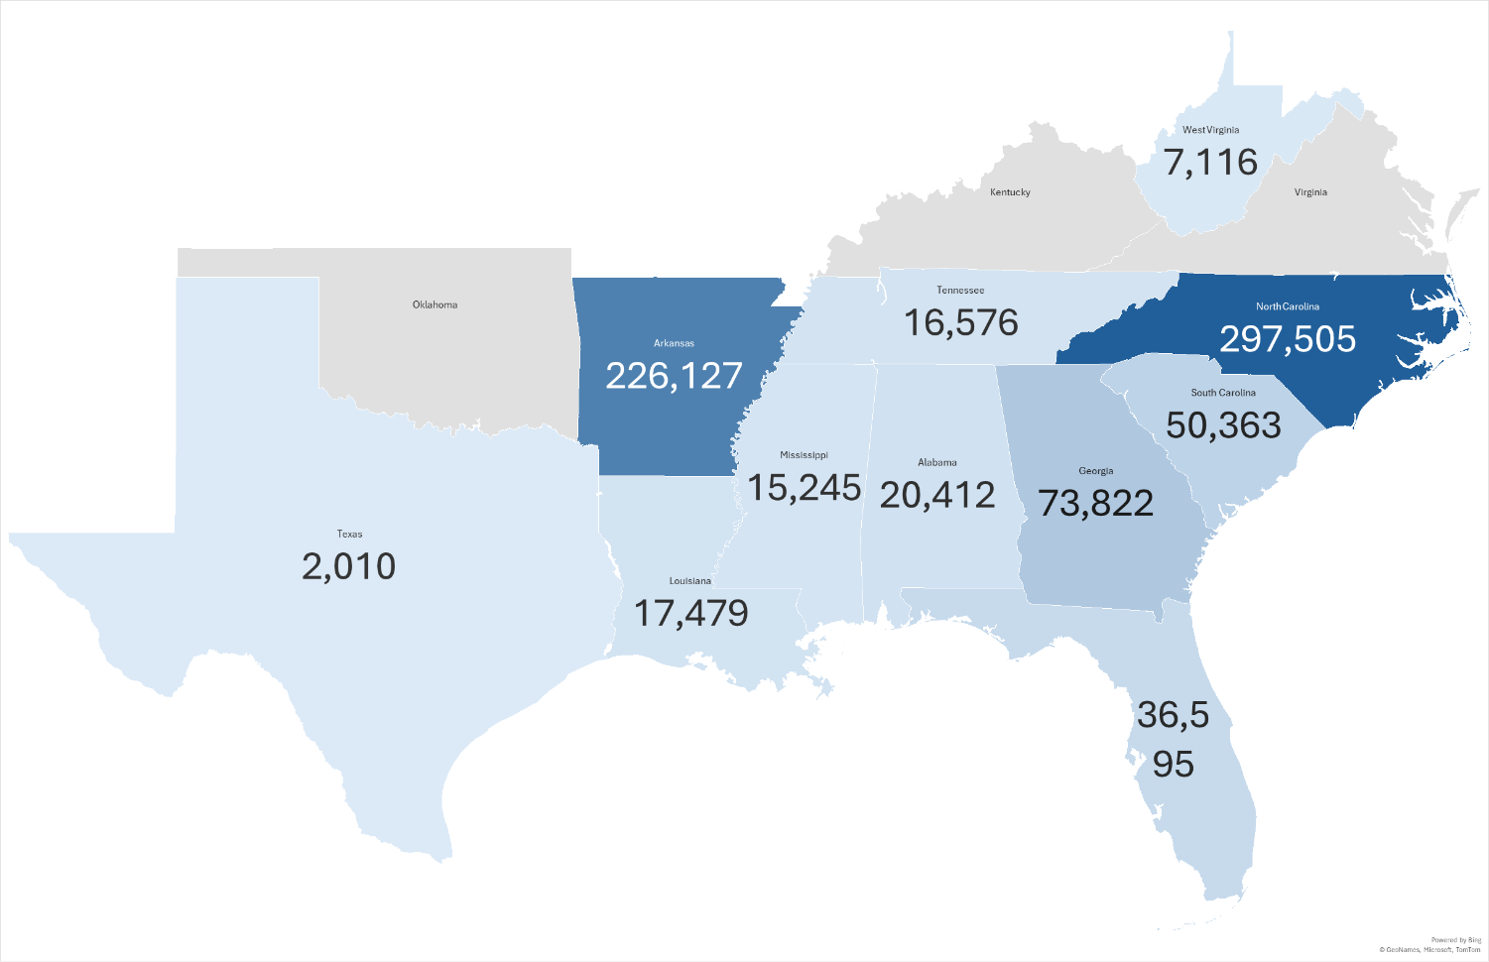
Figure 1. Soil Samples *Tested in Southern Region State Laboratories
*Numbers represent samples reported per state laboratory by the time of report generation, with not all state laboratories in SERA6 reporting. Zero is a default and not true zero.

Table 1. Use of SERA6 Workgroup Listserv for 2024
Date | Topic sent out | Originator | # Responses
2/2/2024 | Soil bag sources | Stephen F Austin | 4
3/3/2024 | QA position announcement open | UKY
4/15/2024 | Lab position open announcement | Mizzou
4/23/2024 | REMI Group Lab service contract experiences | UFL
4/29/2024 | Soil survey for non-yield responsive soils to added fertilizer | LSU | 2
5/2/2024 | Trouble with Fisher pH probes | Clemson | 7
5/15/2024 | Clients and access to an online portal for the lab | NCDA | 7
6/6/2024 | Experience with MARS microwave digestor | Clemson
8/2/2024 | Position open at lab | NCDA
9/5/20024 | Public facing sample entry | Clemson | 5
11/11/2024 | Soil extension specialist position open | UKY
11/26/2024 | Atomization of Walkey Black organic matter | UFL | 4
12/13/2024 | Issues with mold growing in buffer | OK State | 1

Table 2. Agricultural Samples Tested in Southern Region State Laboratories

