Minutes of NC-1023, USDA Multistate Project Meeting
October 5-7, 2025
University of Maryland
College Park, MD

Chair: Dharmendra Mishra (mishradh@purdue.edu)
Past-Chair: Juliana Leite Nobrega de Moura Bell (jdemourabell@ucdavis.edu)
Chair-Elect: Deepti Salvi (dasalvi@ncsu.edu)
Secretary: Kiruba Krishnaswamy (krishnaswamy@missouri.edu)
Admin Advisor: David Jackson (djackson@nebraska.edu)
Local Host: Rohan V. Tikekar (rtikekar@umd.edu)

Meeting Location:
UMD 4-H Youth Center
8020 Greenmead Dr, College Park, MD 20740

Attendees (38):

S. No. | First Name | Last Name | Affiliation
1. | Akinbode | Adedeji | University of Kentucky
2. | Seung Hoon | Baek | University of Hawaii
3. | Gail | Bornhorst | University of California, Davis
4. | Chang | Chen | Cornell University
5. | Ozan | Ciftci | University of Nebraska-Lincoln
6. | Clairmont | Clementson | North Dakota State University
7. | Ashim | Datta | Cornell University
8. | Qiao | Ding | Oregon State University
9. | Kirk | Dolan | Michigan State University
10. | Sundaram | Gunasekaran | University of Wisconsin
11. | Kang | Huang | Washington State University
12. | David | Jackson | University of Nebraska
13. | Soojin | Jun | University of Hawaii
14. | Mukund | Karwe | Rutgers University
15. | Kiruba | Krishnaswamy | University of Missouri
16. | Wenbo | Liu | Mississippi State University
17. | Luyao | Ma | Oregon State University
18. | Amir | Malvandi | University of illinois
19. | Kasiviswanathan | Muthukumarappan | South Dakota State University
20. | Gulustan | Ozturk | UW-Madison
21. | Oguz Kaan | Ozturk | University of Illinois
22. | Cicero | Pola | Iowa State University
23. | Deepti | Salvi | NCSU
24. | Rakesh | Singh | University of Georgia
25. | Pawan | Takhar | University of Illinois, Urbana-Champaign
26. | Juzhong | Tan | University of Delaware
27. | Kevin | Tarwa | University of Maryland
28. | Rohan | Tikekar | University of Maryland
29. | Logan | Trautwein | University of Maryland
30. | Ali | Ubeyitogullari | University of Arkansas
31. | Qingyang | Wang | Oregon State University
32. | Yi-Cheng | Wang | University of Illinois Urbana-Champaign
33. | Tao | Wu | University of Tennessee
34. | Ren | Yang | South Dakota State University
35. | Tianming | Yao | Rutgers University
36. | Jiyoon | Yi | Michigan State University
37. | Yanyun | Zhao | Oregon State University
38. | Haotian | Zheng | NC State University

Brief Summary of Minutes of Annual Meeting
The NC-1023 Annual Meeting was held on October 5–7, 2025, at the University of Maryland. The opening dinner was held at Restaurant near Maryland on October 5th and the meeting sessions started on Oct 6th at the University of Maryland, 4-H Youth Center. Prof. Tikekar opened the meeting with a warm welcome and logistical updates. He informed attendees that Prof. Mishra, the Chair, was unable to attend due to health reasons and announced that Prof. Salvi, the Chair-Elect, would preside over the session. Prof. Tikekar introduced Prof. Cheng-i Wei, Professor & Chair, Nutrition & Food Science, University of Maryland for the welcome address. Prof. Cheng-i Wei emphasized the importance of collaborative research in food safety and quality. He expressed support for the multistate group and the importance of collaborative work. Station members briefly introduced their station and expertise. Prof. Tikekar provided updates on federal priorities and funding opportunities through a presentation from USDA – Washinton updates. Prof. David Jackson provided administrative updates and reporting requirements for the NC-1023 project, completing the old project 2020-2025 and the start of new project 2025-2030. Prof. Jackson revisited the major milestones and outcomes for the project and provided guidelines to help report the progress accomplishments and encouraged the members to work on new objectives for the upcoming new project. Prof. Salvi moderated the morning presentations and was assisted by Prof. Tikekar, Prof. Bornhorst, and Prof. Krishnaswamy. The previous meeting minutes were approved. During the morning session, station updates were presented in alphabetical order. Additionally, new faculty members were given the opportunity to deliver a three-minute overview of their programs alongside their station reports. Prof. Gail Bornhorst presented an overview of the NC-1023 project plan for 2025–2030. During lunch, Prof. Dennis Heldman was remembered. The afternoon focused on strategic planning for the next five years, steering committee elections. Objectives already submitted to NIMSS were listed, and all groups were requested to work together. Prof. Karwe and Prof. Krishnaswamy led the discussion on Objective 1. Objectives 2 and 3 were led by Prof. Datta and by Prof. Tikekar. The groups worked on each objective of the 2025-2030 project. The business meeting was conducted to elect a new secretary and steering committee. Prof. Qingyang Wang was elected Secretary, Prof. Zhao and Prof. Dolan were elected as new steering committee members. Prof. Tikekar, Prof. Cifti, Prof. Takhar continued steering as committee members. Additional station reports were presented and completed. Working groups were formed to discuss joint proposals and multi-state initiatives before concluding the day with a networking dinner at Mulligan’s Restaurant.

The second day (Oct. 7, 2025) focused on collaboration and faculty engagement. Breakout groups aligned with project objectives discussed plans for joint proposals and next steps. Prof. Datta introduced resources for food physics and modeling, including a food properties database and active learning modules, inviting collaboration. The group explored strategies to expand the NC-1023 seminar series, incorporate webinars into courses. Assessment approaches such as pre/post evaluations, along with guidance on FERA regulations were discussed. Faculty support initiatives were proposed. Prof. Karwe suggested revisiting the ultra-processed foods topic through a webinar or panel discussion in collaboration with Prof. Nitin. The meeting ended at noon on October 7th, 2025. Detailed minutes are available upon request.

Sunday, October 5, 2025

- 6:00 - 8:00 pm Welcome Dinner
Welcome dinner was attended by all members. Discussions on the project and the planned activities with station representatives and ad-hoc committee members.

Monday, October 6, 2025

8:30 – 9:15 am
- Opening comments
Prof. Tikekar opened the meeting with a warm welcome. He informed attendees that Prof. Mishra, the Chair, was unable to attend due to health reasons and announced that Prof. Salvi, the Chair-Elect, would preside over the session. Prof. Salvi welcomed all stationed members in her opening remarks. She introduced the meeting goals.
- Welcome presentation
Dr. Cheng-i Wei, Professor & Chair, Nutrition & Food Science, University of Maryland, welcomed the group. He emphasized exploring agricultural innovation and highlighted the significance of multistate collaborative projects.
- Station Member Introductions
All station Members introduced themselves.
- Washington Update by Prof. Tikekar
    - USDA Presentation:
      - New USDA Secretary: Brooke L. Rollins.
      - NIFA updates: $41M AFRI funding, programs A1332, A1364, A1511, A1366 (focus on antimicrobial resistance in food chain).
      - FSOP (Food Safety Outreach Program), SBIR Phase 1 timeline, funding delays for Jan 2025 awards.
      - Discussion on budget cuts, political influence on funding, F\&A rates, and strategies for connecting with government relations for appropriations.
There was an engaging discussion regarding the continued support for maintaining the budget.

- NC 1023 Administrator Update
Prof. David Jackson welcomed everyone. His talk mainly focused on re-write for NC1023 project for 2025-2030.
Prof. Jackson emphasized that the focus should not be on individual activities but rather on collaborative efforts. He reiterated that the essence of the multistate project lies in producing outputs through collective collaboration.

- Steering Committee Report
The current Steering Committee includes Prof. Tikekar, Prof. Cifti, Prof. Takhar
The committee has been working with the current executive committee over last year.
For the next steering committee, the current eligible members
- Must be past chair
- Must be part for the last 5 year
- Must be present in the meeting
A new steering committee will be elected in this meeting
- Approval of Previous Meeting’s Minutes
The meeting minutes were approved unanimously.

9:45 – 10:15 am Break
A bio break was provided. Refreshments were served.

10.15 – 11:45 am Morning Session

- COFE 2026 overview by Prof. Soojin Jun

Prof. Jun provided an overview of the upcoming Conference of Food Engineering (CoFE) 2026. The event is scheduled for November 8–11, 2026, at Hilton Waikoloa Village, Big Island, Hawaii (estimated lodging cost: $200–$250 per night). The primary venue will be Moarchy, which has a seating capacity of approximately 1,600. Prof. Jun shared visuals of the location and invited members to suggest topics and provide input for the technical sessions. He noted that the call for abstracts will be announced in Spring 2026.

- Station Reports: Short updates from stations based on the alphabetical order of the station name.
Station reports (AR, CA, DE, GA, HA, IA, IL + 3min pitch)
- Arkansas (AR): Reported collaborations with multiple stations.
- California (CA): Shared ongoing projects and collaborations.
- Delaware (DE): Provided updates on station activities
- Georgia (GA): Presented collaborative efforts with other stations.
- Hawaii (HI): Prof. Jun’s postdoctoral researcher delivered the station update.
- Iowa (IA): Updates included work on plant-based protein simulation, hyperspectral imaging.
- Illinois (IL): Prof. Takhar introduced five members. Prof. Ozturk presented 3 min pitch, included solute/species transport in gases and protein-rich materials from microalgae for novel applications, including cold atmospheric processing. Prof. Malvandi discussed vacuum-assisted robotic drying technologies as part of the Center for Advanced Drying, emphasizing physics-based simulation and sensing for quality and safety. Prof. Datta inquired about aspects of food targeted by these technologies; Prof. Malvandi clarified the focus on moisture content monitoring.

- NC 1023 New Project Overview (2025- 2030) by Prof. Gail Bornhorst
Prof. Bornhorst provided an overview of NIMSS, including instructions on how to log in and participate in the new project. Members were strongly encouraged to engage in the upcoming project.
Prof. David Jackson emphasized the importance of aligning activities with the proposed objectives while allowing flexibility to broaden them under the established themes. Prof. Bornhorst also presented guidance on navigating the NIMSS platform.

Project Objectives 2020 – 2025
- Characterize physical, chemical, and biological properties of raw and processed foods, by-products, and packaging materials.
- Develop advanced and sustainable processing and packaging technologies to transform raw materials into safe, high quality, health-promoting, and value-added foods.
- Develop mechanistic and data-driven mathematical models to enhance understanding and optimization of processes and products that will ensure sustainable and agile food manufacturing for safe, high quality, and health-promoting foods.
- Adapt pedagogical strategies involving novel educational approaches to enhance and assess student learning of food engineering.
Objectives 1 and 2 from the 2020–2025 cycle were consolidated and streamlined to develop Objective 1 for the 2025–2030 project.

New Project Objectives 2025-2030
- Develop and characterize innovative food materials, sustainable processing, and packaging technologies to ensure safety and enhance the shelf-life, quality, functional, and nutritional properties of foods.
- Develop mechanistic and data-driven mathematical models to enhance understanding and optimization of food manufacturing.
- Utilize pedagogical strategies to integrate cutting-edge food engineering research into teaching and outreach programs to enhance student learning, technology implementation, and stakeholder engagement.

Objectives submitted to NIMSS were listed, and all groups were requested to work together.

12:00 - 1:00 pm Lunch - Provided at the meeting location
Lunch was provided on-site.
The NC-1023 members honored the legacy of Prof. Dennis Heldman for his outstanding contributions to food engineering. Prof. Karwe shared heartfelt memories accompanied by photographs, while Profs. Sastry and Daubert submitted written tributes reflecting on their experiences with Prof. Heldman and his remarkable impact on the discipline.

1:00 – 2:30 pm Planning for next 5 years (2025-2030)
Prof. Salvi facilitated the strategic planning discussion for the next five years and developed an interactive Google Sheet to coordinate multistate collaboration.
Prof. Krishnaswamy developed a QR code and an accompanying Google Form to conduct an on-site survey of topics of interest for the NC-1023 Project (2025–2030).

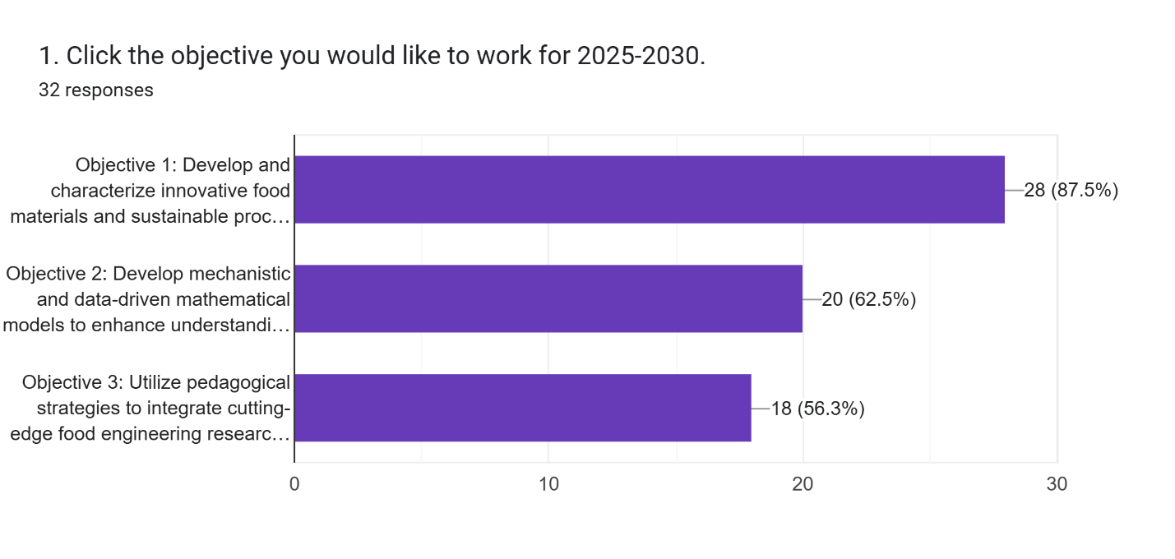
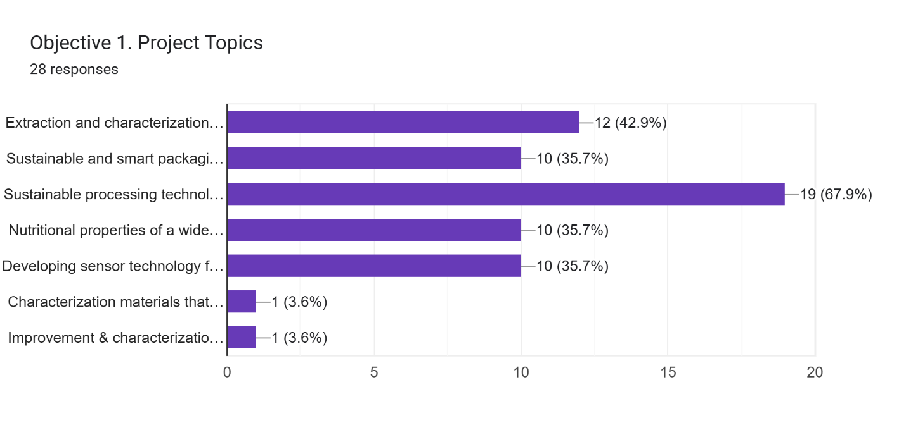
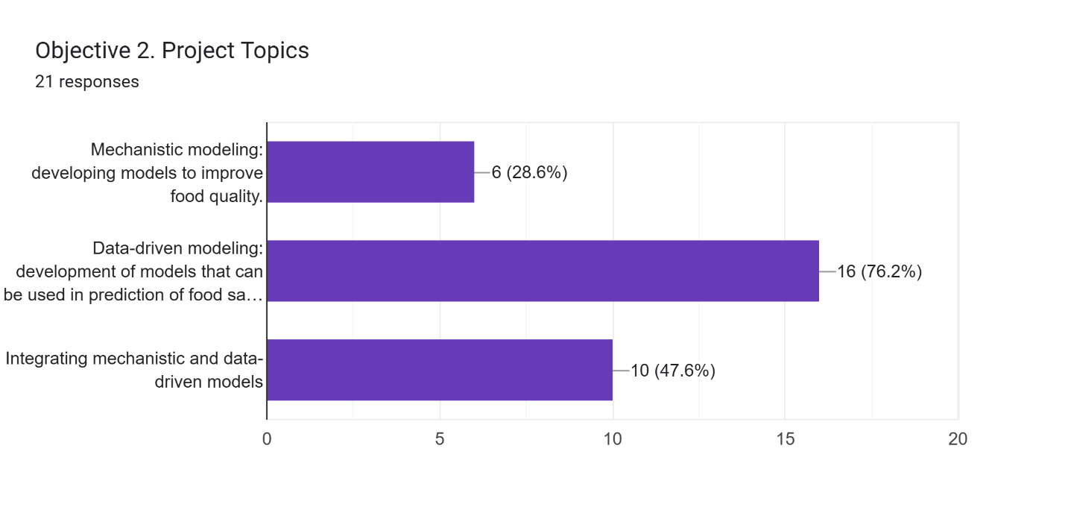
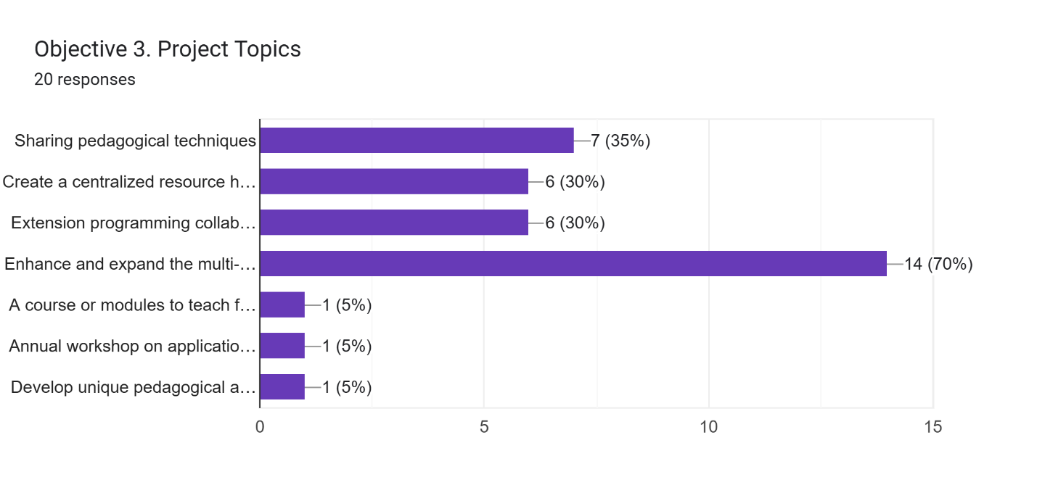
In the open survey section, members listed topics for potential collaboration. Responses included:
- Food freezing
- Food physics and modeling; development of food properties knowledge base
- Processing of millets; exploring the potential of AI in extrusion and winemaking
- Extraction technologies, including cold plasma
- Extraction and characterization of agri-food by-products for value-added foods and nutrition
- Sensor technology and smart packaging
- Ultrasound-assisted food processing
- Developing sensor technology to improve food quality and safety; sustainable and smart packaging solutions to reduce plastic waste and prevent food loss
- Parameter estimation and online outreach programs
- Protein ingredient functionality; food structure design involving rheology, tribology, colloid, and interface studies
- Commercialization of new technologies

Breakout Groups:
Objective 1: Develop and characterize innovative food materials, sustainable processing, and packaging technologies to ensure safety and enhance the shelf-life, quality, functional, and nutritional properties of foods.
Objective 1, under the leadership of Prof. Karwe and Prof. Krishnaswamy, was further divided into specialized working groups, with designated team leaders assigned to each group.
  - Extraction and characterization of agri-food by-products.
Team Lead: Prof. Yanyun Zhao, Prof. Tianming Yao
  - Evaluate sustainable extraction methods and novel characterization techniques of bioactive compounds and fibers from a wide range of fruit pomace
  - Advanced processing and conversion technologies will be investigated for sustainable utilization of by-products, including fermentation and fractionation
  - Utilize other eco-friendly extraction methods, including supercritical CO₂, subcritical water, ultrasound- assisted, and enzyme-assisted extraction
  - Establish a comprehensive database to catalog the chemical composition, bioactive profiles, fiber content, and other key characteristics of a wide range of agri-food by-products.
  - Sustainable and smart packaging solutions to reduce plastic waste and prevent food loss
Team Lead: Prof. Kang Huang, Prof. Shyam Sablani
- Some of the by-product extracts from the first area of collaboration, including the fiber-rich extracts, will be further to develop sustainable packaging materials
- Isolation and development of nanoscale fiber materials and their assembly to develop sustainable packaging materials with key mechanical, thermal, and surface properties
- Integration of sensing technologies with packaging materials to monitor food quality and safety characteristics and deliver trackability using state-of-the-art artificial intelligence technologies.

  - Sustainable processing technologies
Cold Plasma- Team Lead: Prof. Deepti Salvi, Prof. Juzhong Tan
- Focus on non-thermal atmospheric plasma processing and address the key challenges of standardization of plasma processing technology, including measuring the chemical and physical properties of different types of plasma systems and developing novel methods for dosimetry of plasma.
- Evaluate novel applications of plasma processing to improve food quality and safety
  - Nutritional properties of a wide variety of processed foods
Team Lead: Prof. Gail Bornhorst, Prof. Mukund Karwe, Prof. Kiruba Krishnaswamy
- Discover and characterize new, underutilized food sources (e.g., expanding new plant-based sources, millets, microbial-based ingredients, etc.) and by-products
- Evaluate the nutritional properties of foods using in vitro and in vivo digestion models
- Encapsulation of bioactive compounds isolated from plants and microbes and their characterization using in vitro and in vivo digestion
  - Developing sensor technology for improving food quality and safety
Team Lead: Prof. Cicero Pola, Prof. Ren Yang, Prof. Luyao Ma
- Develop sensor platforms that range from traditional analytical methodologies to nanomaterial-facilitated biosensors and validate these sensors for different types of applications.
- Platforms will be tested across multiple stations

Objective 2: Develop mechanistic and data-driven mathematical models to enhance understanding and optimization of food manufacturing.
Objective 2 was led by Prof. Datta.

- Mechanistic modeling: developing models to improve food quality.
  - Mechanistic models to describe oil or water transport as related to physical and chemical properties of food materials.
  - Species and solute transport models using hybrid mixture theory to elucidate the mechanisms and desirably control the interactions between nutritional components and physical attributes of products for food design and controlled release applications.
- Data-driven modeling: development of models that can be used in prediction of food safety and quality parameters.
  - Data-driven models will be developed to predict aspects of food safety and quality, including meat freshness, detection of allergens and pathogens, and evaluation of fruit and vegetable quality change during drying (KY, IL, MI, NY-Geneva).
  - Develop machine learning models using biosensor data from plasma processing for the optimization of plasma dosimetry for food safety and quality
- Integrating mechanistic and data-driven models
  - Integration of mechanistic and data-driven models to evaluate the performance of novel food pasteurization technology
  - Building an app that uses a surrogate model which learns from a mechanistic model to evaluate the microbial safety of drying processes
  - Knowledge base of food properties (NY-Ithaca station), will be combined with mechanistic and data-driven models to predict water activity and parameters critical for food thermal processing.

Objective 3: Utilize pedagogical strategies to integrate cutting-edge food engineering research into teaching and outreach programs to enhance student learning, technology implementation, and stakeholder engagement.
Objective 3 was led by Prof. Tikekar.
- Sharing pedagogical techniques
  - Quarterly webinar series titled “Scholarship in Food Engineering Education”
  - Implementation and assessment of instructional modules in existing courses toward preparing future workforce in food manufacturing. IRB approvals will be obtained as needed for assessment activities in ongoing courses.
- Create a centralized resource hub
  - Members’ expertise in extension education
  - Digital resources for computer-aided food manufacturing in NY-Ithaca
- Extension programming collaboration
  - Collaborate on BPCS school
  - Co-teaching a short course titled “Science of Food Safety”
  - Online educational resources on food processing and packaging technologies for industry stakeholders.
  - Opportunities to co-develop short courses relevant to the evolving needs of the food industry and academia.
- Enhance and expand the multi-state Seminar Series
  - Include additional speakers (industry, etc.)
  - Videos of speaker talks on the resource hub
  - Perform a pre-course and post-course assessment of student learning across at least 5 stations

2.30 – 3.00 pm Break
A bio break was provided. Refreshments were served.

3:00 – 3:45 pm Business meeting: Election (Steering Committee; Secretary; 2026 Meeting Location)
Prof. Salvi emphasized the need to address the election of a new secretary.
Prof. Bornhorst recommended confirming the steering committee election.
Prof. Krishnaswamy distributed a Google form via email to facilitate the voting process.
    - Elections
Secretory candidate: Prof. Qingyang (Carly) Wang
Steering Committee:
Elections for the Steering Committee were conducted following an open call for nominations.
Prof. Bornhorst reminded members to vote for one candidate per station, and Prof. Krishnaswamy distributed the Google forms to collect and finalize the election results.
Voting was completed by representatives from 21 stations, including Arkansas, Kentucky, Georgia, North Dakota, New York, North Carolina, Missouri, Illinois, Maryland, Michigan, South Dakota, Tennessee, California, Oregon, Delaware, Iowa, Washington, New Jersey, Hawaii, Wisconsin, and NY-Ithaca.

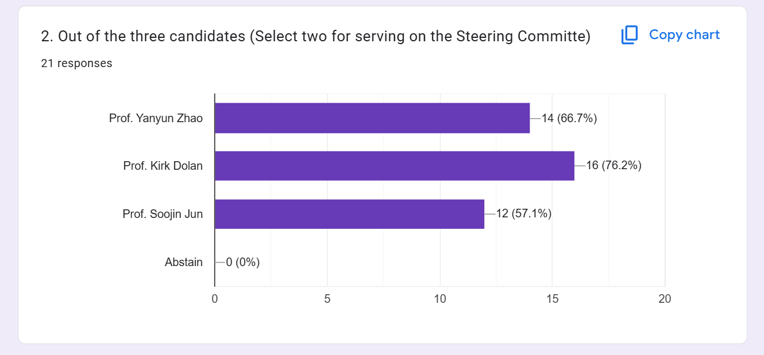

Results of the election
Steering committee members:
- Prof. Tikekar (Cont.)
- Prof. Cifti (Cont.)
- Prof. Takhar (Cont.)
- Prof. Dolan (Elected)
- Prof. Zhao (Elected)
Secretary: Prof. Wang

    - NC 1023 Annual Meeting location 2026
Hawaii was proposed as the venue, with discussions centered on aligning the meeting with the Conference of Food Engineering (CoFE) 2026. Prof. Salvi highlighted the possibility of hosting a joint meeting, and a straw poll indicated strong support for co-hosting with CoFE in Hawaii.
Prof. Adedeji suggested extending the NC-1023 meeting by one to two days following CoFE. Prof. Soojin Jun noted the existing contract with Hilton Waikoloa Village and offered to explore options for a joint arrangement.
Prof. David Jackson recommended incorporating professional development activities, including a half-day condensed NC-1023 meeting and co-organized sessions with CoFE. He emphasized the importance of mentioning workshops in the letter of support and submitting a letter of intent at least one year in advance to ensure participation.
As an alternative, Prof. Zhao proposed a contingency plan to hold the meeting in early spring 2027 in Oregon.

3:45- 5:00 pm Station Reports: Continued
Station reports continued with brief updates presented in alphabetical order. As all stations adhered to the schedule and provided efficient updates, members agreed to maintain the momentum and complete all station reports on Day 1. Consequently, the collaboration discussion was deferred to Day 2. All station reports, including the three-minute pitches, were concluded during the afternoon session prior to the dinner event.

5:00- 6:00 pm Transportation to dinner venue
Prof. Tikekar provided instructions on the dinner venue.

6:00 – 8:00 pm Dinner at Mulligan’s Restaurant

Tuesday, October 7, 2025

8:30 – 10:30 am Ad hoc committee meeting/Collaboration discussion

Prof. Bornhorst chaired the session, ensuring smooth facilitation of discussions.
Prof. Muthukumarappan provided an overview of the open Chair position at South Dakota State University.

- Collaboration Discussion
Participants divided into breakout groups aligned with the project objectives to develop their plans and outline next steps for moving forward.
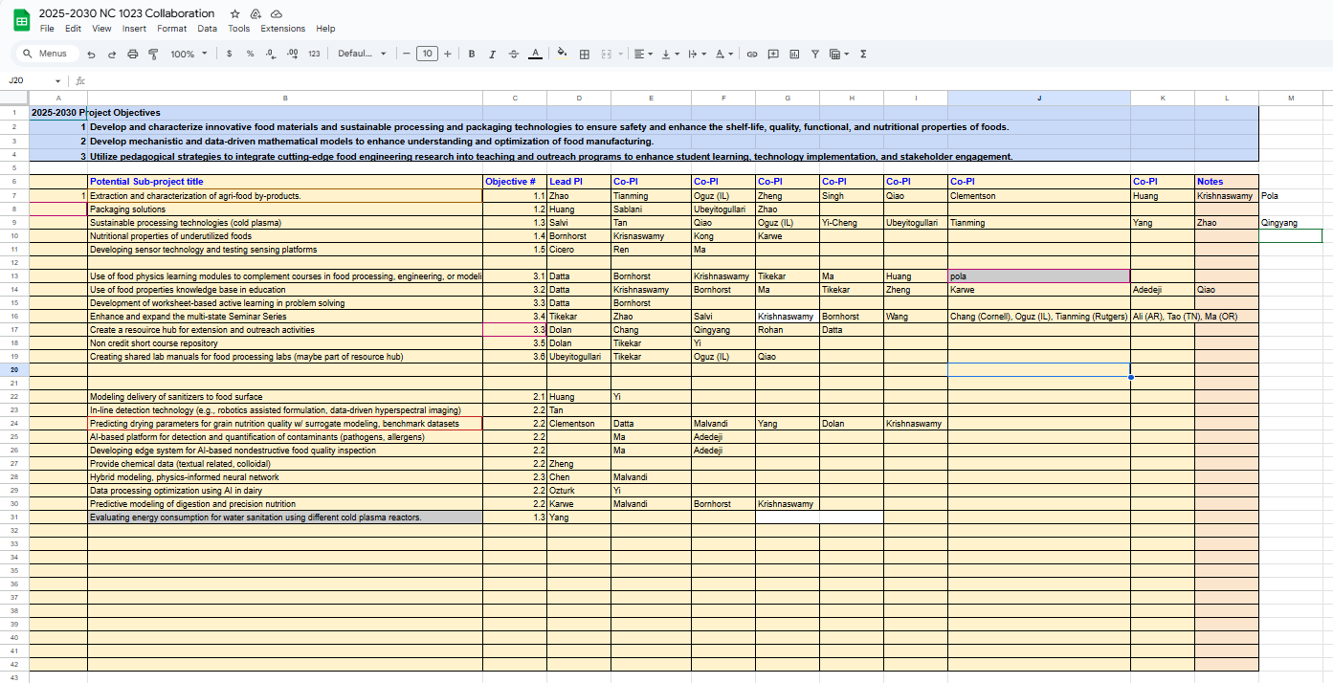

- Food Physics, Modeling, and Food Properties database (Prof. Data)
Prof. Datta introduced novel resources for food physics and outlined two collaborative projects open to all stations. He emphasized incorporating advancements in the field into instructional materials to train future generations. His group has developed modules that integrate application, theory, and modeling-based content for courses in food engineering, food processing, and food safety. Additionally, resources are available for developing modeling courses at the undergraduate level. These modules, which include active learning components rather than simple videos, have been successfully implemented at other universities (CA, TN) with positive student feedback. Prof. Datta is seeking collaborators to incorporate these modules into their curricula.

Food properties database
Prof. Datta also introduced the food properties database developed by his team, which includes numerous formulas for various materials to provide comprehensive property data. This database is currently being used in Cornell University. This resource significantly reduces time spent searching for research papers. The proposed mode of collaboration involves instant accessibility to the database and validation of models as they are generated. In an educational context, students can explore scenarios such as comparing the same food property across different materials or analyzing different properties within the same material. The database can be integrated into courses such as:
- Food Engineering
- Food Processing
- Food Properties
Prof. Datta is seeking collaborations in the following areas:
- Utilizing and contributing to the food properties database
- Developing a centralized repository of digital resources for the community
- Incorporating individual modules or full courses into curricula
- Applying modules specifically in food safety education
- Leveraging active learning tools such as worksheets
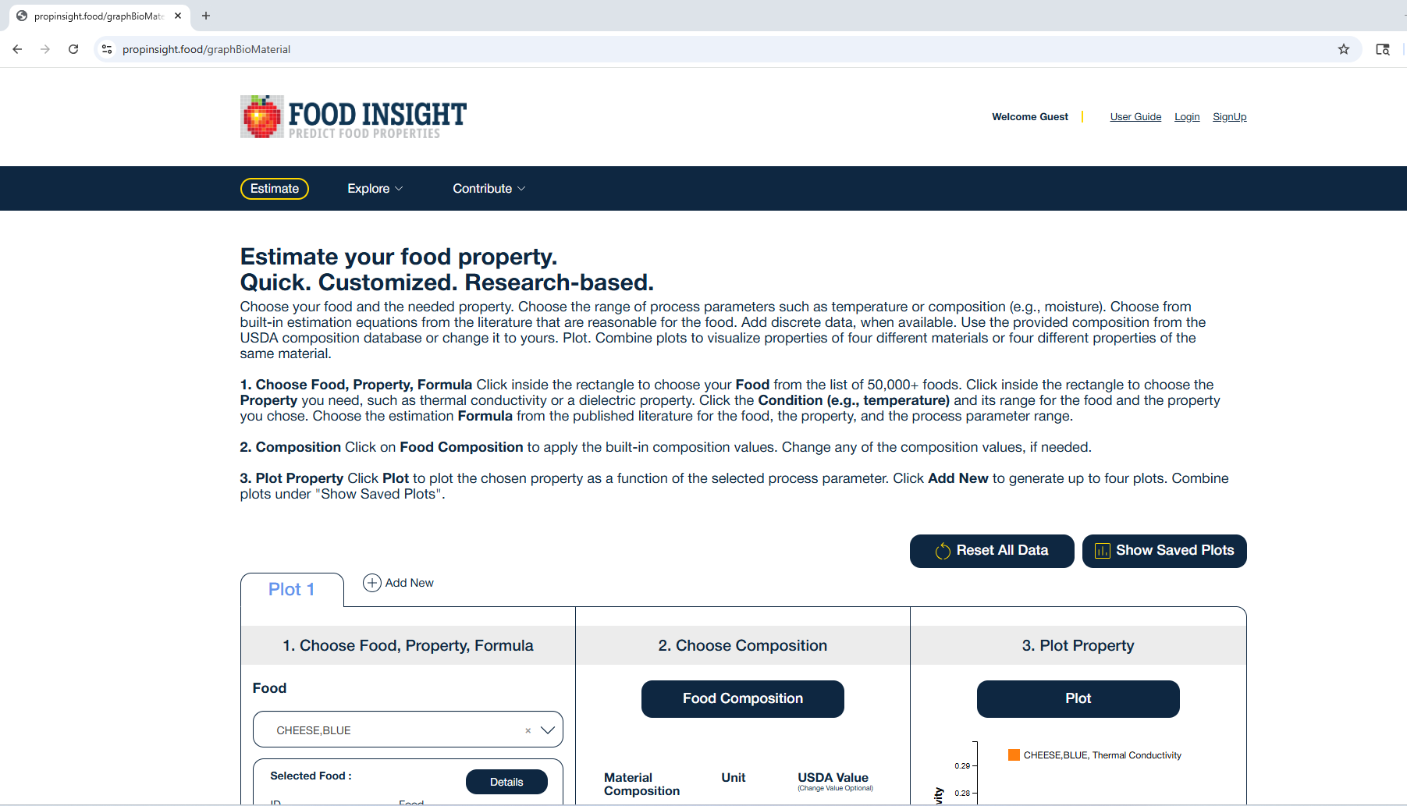

- Update on the NC-1023 Multi-institutional Food Engineering Course/Seminar series & Discussion
Prof. Tikekar introduced the session and highlighted the webinar series, inviting members to explore ways to incorporate it into courses—whether as seminar series, class assignments, or through flexible delivery modes. Prof. Zheng suggested broadening the pool of speakers. Prof. Ma proposed adding flash talks to provide students with opportunities to present. Prof. Tianming Yao recommended collaborative review papers involving students across stations. Prof. Datta emphasized the importance of evaluating learning outcomes through pre- and post-webinar assessments, noting that questions should be generic and feedback balanced. Prof. Bornhorst added that question design may depend on the speaker’s input. Prof. Krishnaswamy suggested incorporating reflective assignments via Canvas. The group discussed logistics for assessment and ensuring access to the course across multiple stations.
Prof. Datta reiterated the need for structured assessment. Prof. Jackson provided guidance on FERPA regulations. Prof. Gail Bornhorst and Prof. Tikekar proposed consolidating feedback through a single survey.

10:30 – 10:45 am Break
A bio break was provided. Refreshments were served.

10:45 am – 12:00 pm Faculty Support
Prof. Bornhorst, Prof. Adedeji and Prof. Krishnaswamy initiated the conversation regarding faculty support group. Prof. Krishnaswamy agreed to circulate a poll in Spring 2026 to gauge faculty interest in joining the faculty group. Prof. Wang raised questions regarding the meeting format and expected time commitment. Prof. Huang expressed interest in participating. Prof. Pola suggested involving faculty from other universities to provide guidance, noting that many junior faculty members already have mentoring structures within their institutions.

Prof. Karwe proposed revisiting the topic of ultra-processed foods, referencing a small group initiated during the 2024 NC-1023 meeting. He suggested organizing a webinar featuring a speaker or a panel discussion. Prof. Karwe will collaborate with Prof. Nitin to develop the presentation and finalize the format.

12:00 pm Box lunch/ adjourn

