NCERA-101 Receives the 2024 National Excellence in Multisatate Research Award during the agInnovations Annual Meeting in Raleigh, North Carolina on September 25th, 2024.
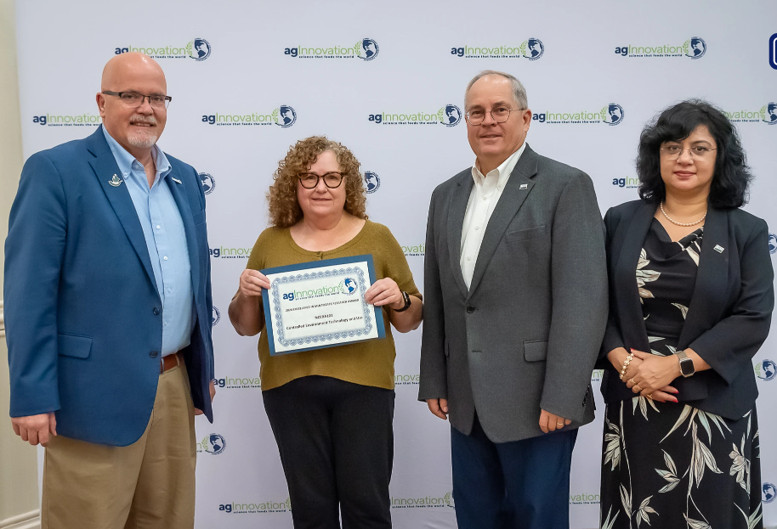
L-R: George Smith (Ag Innovations Chair and Senior Associate Dean of Research at Michigan State University), Carole Saravitz (NCSU Phytotron and NCERA-101 representative), Kevin Kephart (USDA-NIFA), Rubella Goswami (USDA-NIFA).

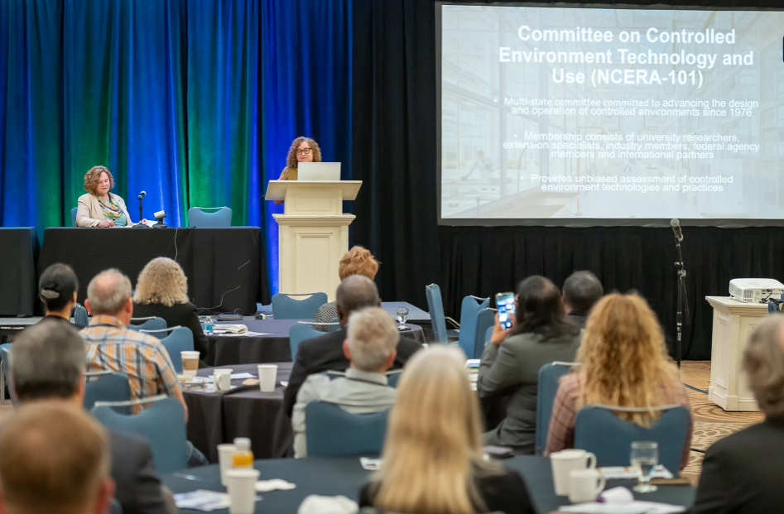
Carole Saravitz (NCSU Phytotron and NCERA-101 representative) gives a presentation about the history and activities of the NCERA-101 Committee during the award ceremonies.
https://www.aginnovation.info/post/aginnovation-celebrates-regional-and-national-excellence-at-2024-annual-meeting

