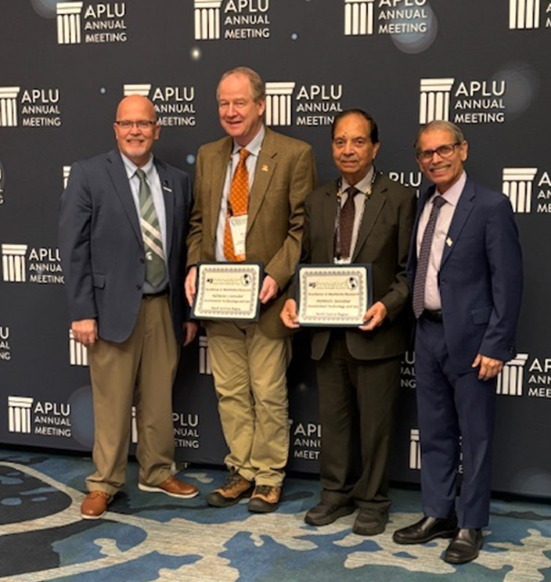
November 10, 2024. The NCERA-101 Committee on Controlled Environment Technology and Use receives the National Excellence in Multistate Research Award during the Association of Public Land-Grant Universities meeting in Orlando, FL.
In the picture from left to right: Dr. George Smith, Ag Innovations Chair and Senior Associate Dean of Research at Michigan State University, Dr. A.J. Both, Professor and Extension Specialist in the Department of Environmental Sciences at Rutgers University, Dr. Ramesh Kanwar, Administrative Advisor and Distinguished Professor in the Department of Agricultural and Biosystems Engineering at Iowa State University, and Dr. Manjit Misra, Director USDA National Institute of Food and Agriculture.
