2024 agInnovation Excellence in Multistate Research Award: Committee on Controlled Environment Technology and Use (NCERA-101)
For over 40 years, a committee of land-grant university researchers, Extension specialists, and industry and international partners has worked to advance the design and operation of controlled environments such as growth chambers and greenhouses with a focus on operational improvements and responsible resource consumption. Optimizing controlled environments is key to ensuring sustainable crop production, especially in the face of climate change and population growth. Controlled environments are also essential for research and education.
Bringing together members across North America and from different disciplines, this committee has been able to coordinate research and share diverse expertise, information, technology, and other resources, driving innovation and impact. For example, the committee circulates calibrated instruments and has developed widely used protocols, standards, and guidelines for controlled environments.
Led by land-grant universities, the committee provides unbiased development and assessment of technologies and practices for lighting, humidification/dehumidification, and water and nutrient use to improve controlled environment efficiency and sustainability. For example, growers using this committee’s findings to design greenhouses and update operational strategies have been able to realize energy savings of 5-30%. Such reductions save an average-sized greenhouse business an estimated $25,000 in annual operation and maintenance costs. Other studies led to lighting strategies that flower growers can use instead of labor-intensive black cloth to induce flowering, reducing labor costs by 43%. Committee members were also instrumental in developing the technology for and building a greenhouse complex in Arizona that has revolutionized how Bayer develops new corn varieties for animal feed. The year-round, highly automated hydroponic system requires 80% less water and nutrients and allows scientists to develop new breeding lines up to three years faster than with field production. Building the greenhouse complex also created around 40-60 new local jobs.
This committee’s work facilitated crop production in seasons and areas where they previously couldn’t be grown. For example, spinach typically can’t be grown during the long summer season in the southern U.S. even in a greenhouse, but findings on root zone cooling and heat tolerant cultivars will allow greenhouse growers to extend the season through early summer. Committee members have also helped NASA develop advanced plant growth chambers that meet the performance and quality needs for space applications.
Over the years, this committee has remained dedicated to fostering the next generation of controlled environment researchers, engineers, managers, and growers. Multiple members first participated as students and are now leaders in the field thanks to professional development and networking opportunities provided by the committee structure. The committee’s work has also been used to spark interest in STEM topics among millions of K-12 students and has influenced the expansion of controlled environment agriculture programs at multiple universities. In the last five years, committee members have published more than 800 peer-reviewed papers and technical reports. Workshops, events, webinars, YouTube series, and other outreach have helped thousands of growers and the public improve their knowledge and practice of controlled environment agriculture.
Altogether, this committee’s coordinated research, education, and outreach have played a major role in the expansion of the controlled environment industry. In 2024, controlled environment-related industries collectively contributed about $77 billion to the U.S. economy, and demand for controlled environment production and equipment continues to rise.
Project Funding & Participation
NCERA101: Controlled Environment Technology and Use is supported in part by USDA NIFA through Hatch Multistate Research Fund allocations to participating State Agricultural Experiment Stations at land-grant universities and other partners, which include: University of Alaska, University of Arizona, Brigham Young University, University of California, Clemson University, University of Connecticut, Cornell University, University of Delaware, Duke University, University of Florida, University of Georgia, University of Guelph, University of Hawaii, University of Illinois, Iowa State University, Kansas State University, University of Maryland, McGill University, Michigan State University, University of Minnesota, NASA - Ames Research Center, NASA - Kennedy Space Center, North Carolina State University, Ohio State University, Penn State University, Purdue University, Rutgers University, University of Tennessee, Texas A&M University, USDA-ARS, Utah State University, West Virginia University, University of Wisconsin, University of Wyoming. Previous and ongoing cycles of this project may include additional participants. Learn more: controlledenvironments.org/members/
This write-up was produced by the Multistate Research Fund Impacts Program, which is supported by agInnovation, the State Agricultural Experiment Stations, and the Hatch Multistate Research Fund provided by USDA NIFA. Learn more: mrfimpacts.org

Photos:
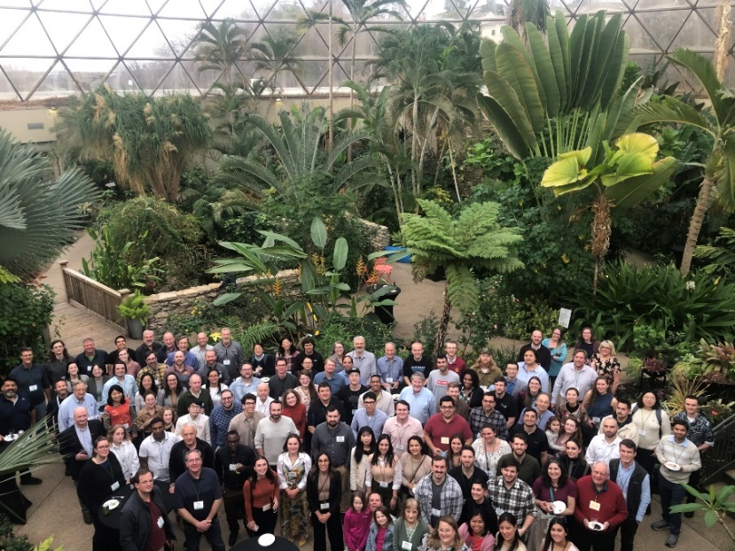
NCERA-101 committee members tour the Des Moines Botanical Gardens. Photo by the NCERA-101 Committee.
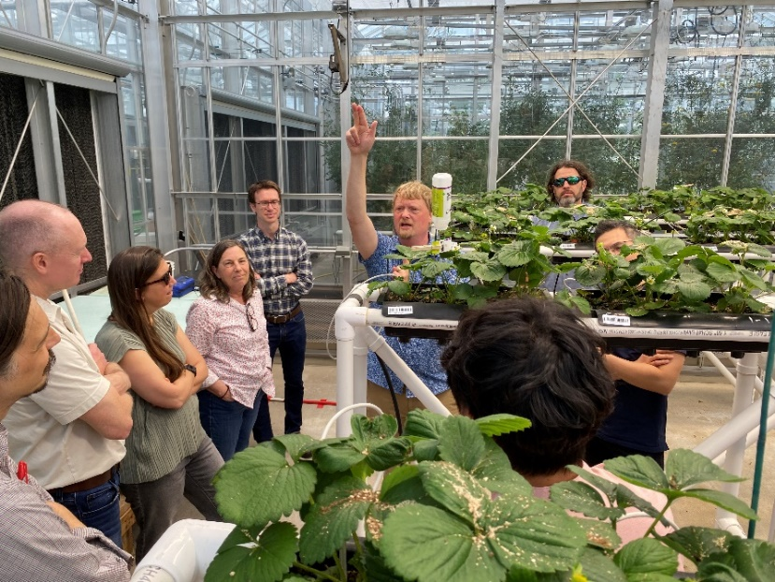
Committee member Neil Mattson demonstrates the new light emitting diodes and lighting control systems used in greenhouse strawberry growth trials at Cornell University. Photo by A.J. Both.

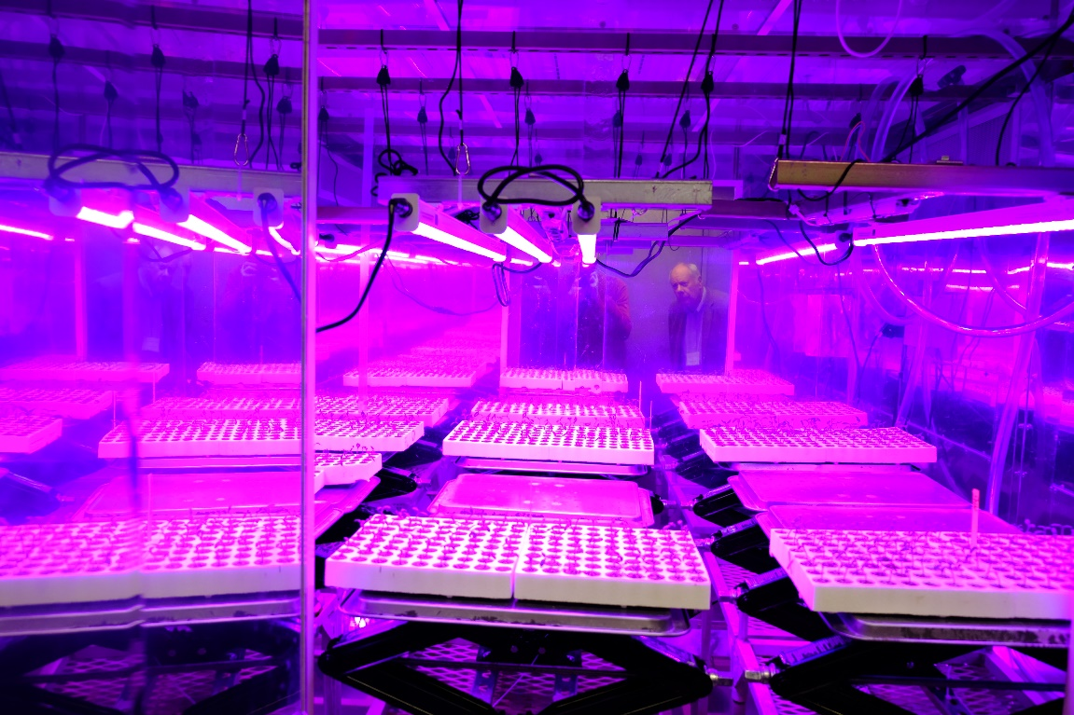
Committee member Cary Mitchell (Purdue University) looks at a plant growth chamber. Photo by A.J. Both.
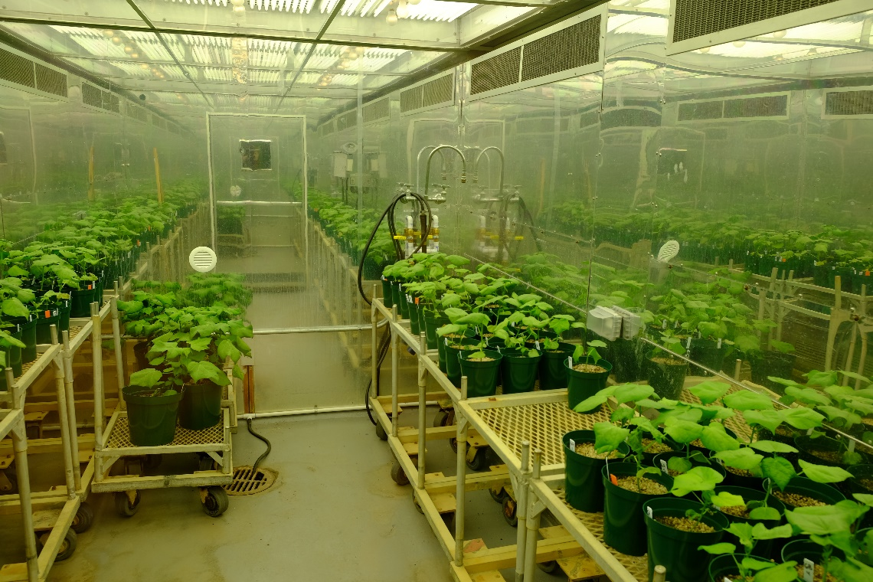
Growth chamber research at North Carolina State University in 2018. Photo by A.J. Both.

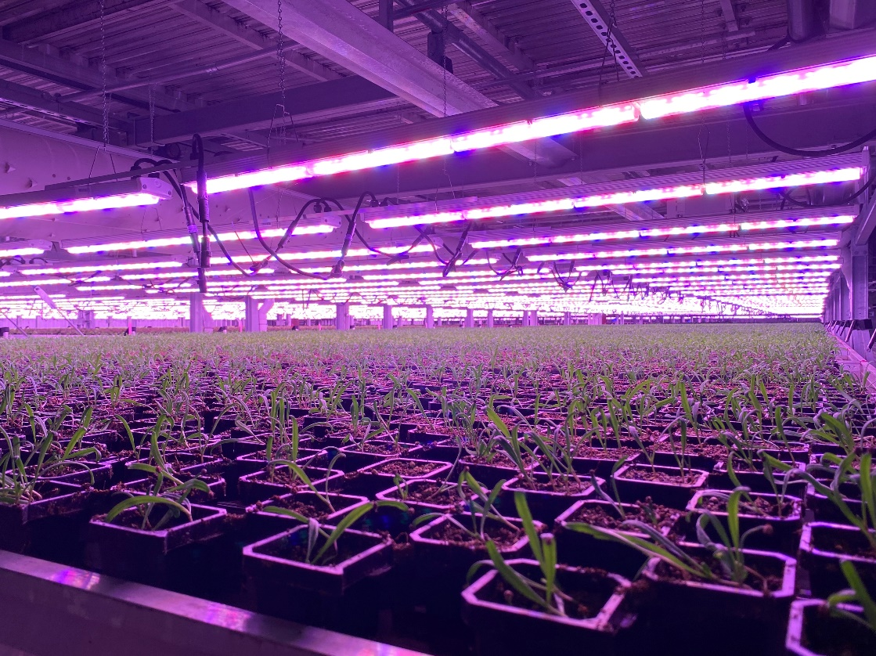
Spinach growing in a controlled environment. Photo by A.J. Both.

