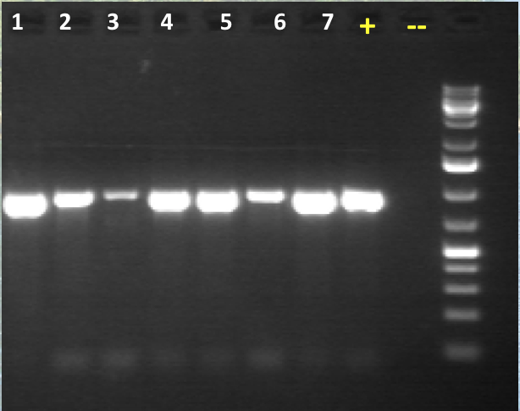

Figure 4: Expected results of PCR for OrNV Detection