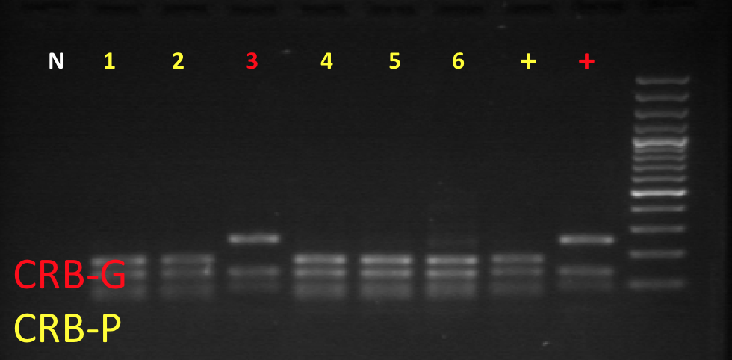

Figure 3: Part 2 of PCR-RFLP assay for CRB-G biotype.