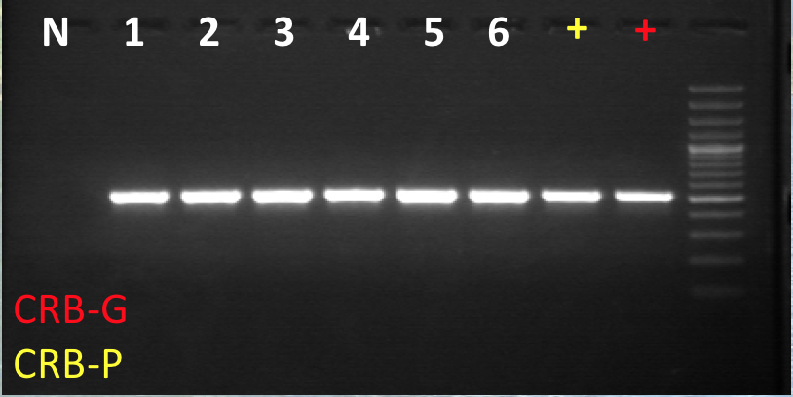

Figure 2: Part 1 of PCR-RFLP assay for CRB-G biotype.