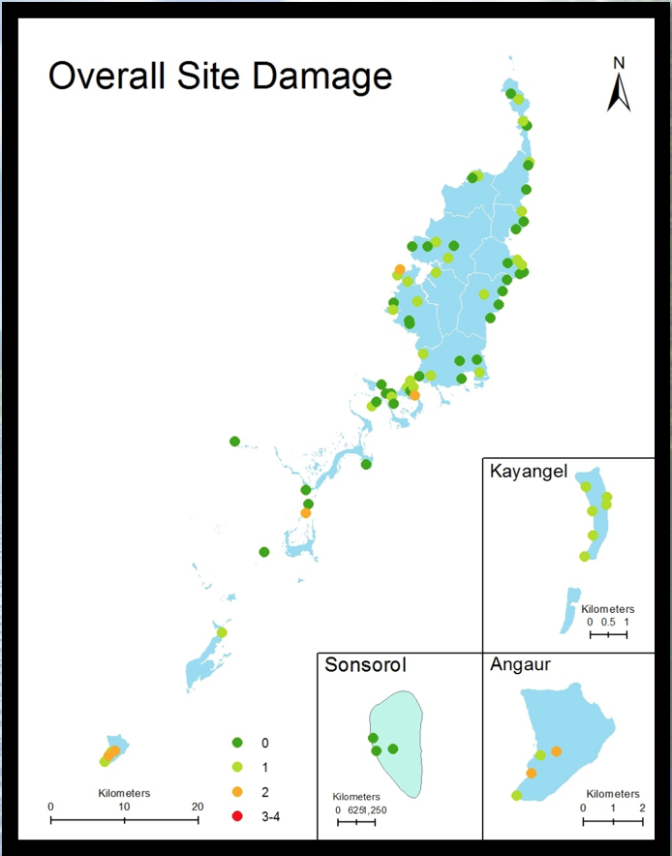

Map 1: Tree Damage Survey Locations