Final Program
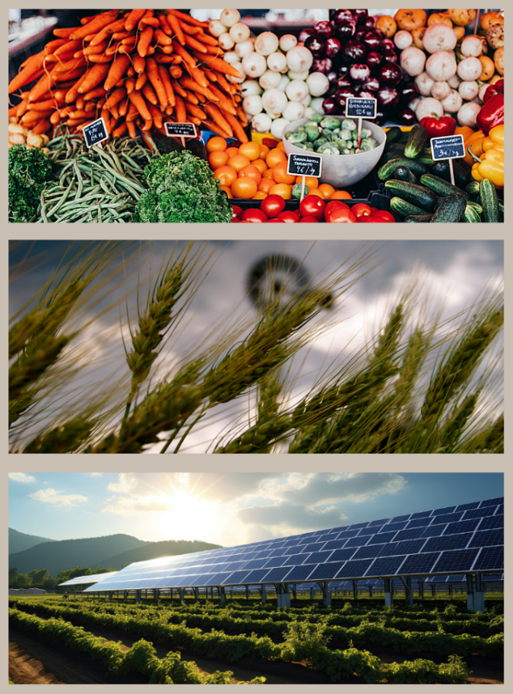

NC1034
Multistate Project:
Impact Analyses and Decision Strategies for Agricultural Research

March 29-30, 2024
Colorado State University

Welcome to the NC1034 Research Conference and Annual Meeting 2024 at Colorado State University in Fort Collins, CO, USA. This gathering of researchers, scholars, and professionals in the economics and social sciences of agricultural research and innovation includes a keynote speaker, research presentations, and networking opportunities.

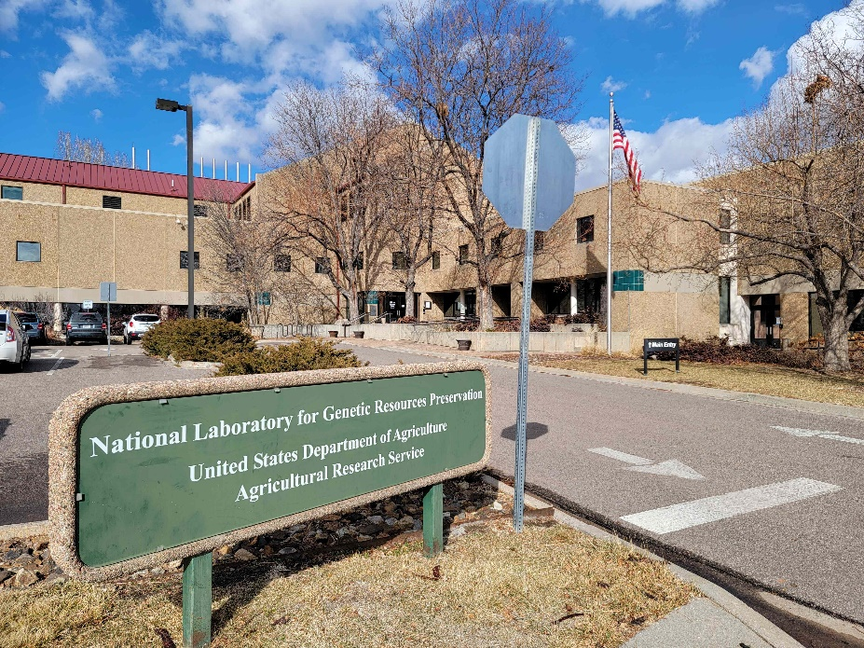
Thursday March 28
(for early arrivers)
5:00-6:00 happy hour at Equinox Brewing, 133 Remington St, Fort Collins, CO 80524
6:00-8:00 dinner at Avery Eatery, 100 North College Ave., Fort Collins, CO 80524
(Easily accessible via public transit from CSU campus and hotels on the MAX line. Or take an Uber.)

Friday March 29
(optional) 10:00-12:00 tour of National Laboratory for Genetic Resources Preservation, entrance from West A Street & Libbie Coy Way, Fort Collins, CO 80521 (meet in lobby)

12:00 Lunch and welcome. Animal Sciences Building, 350 W Pitkin St, Fort Collins, CO 80521 (Harris Wood Boardroom, 2nd floor)
12:15-1:45 Session 1. Global public goods of agricultural research and innovation
- Hiroyuki Takeshima, Dawit Mekonnen, David J Spielman (IFPRI), Global genetic resource policies and international exchanges of plant genetic resources for food and agriculture: Cross-country evidence on the effects of the 2014 Nagoya Protocol
- David Schimmelpfennig (USDA-APHIS) and Janie Chermak (University of New Mexico), The Economics of Plant and Animal Biosecurity
- Alejandro Nin-Pratt, Rui Benfica, and David J. Spielman (IFPRI), New Evidence on the Impacts of CGIAR Research: Conceptual, Methodological, and Data Considerations
1:45-3:15 Session 2. Innovations in animal agriculture
- David Zilberman (UC Berkeley) and Jonathan Tillinghast (Texas A&M University), The Evolution of Innovation and Product Supply Chains – case of Texas beef sector
- Victor Funes-Leal and Jared Hutchins (University of Illinois), Information provision and network externalities: The impact of genomic testing on the dairy industry
- Valerie Kilders (Purdue University) and Rodolfo M. Nayga (Texas A&M University), Motivation and Intended Use Transparency: Shaping Consumer Responses to a Red Meat Tax through Information Disclosure
3:15-3:30 Break
3:30-4:15 Session 3. Agricultural innovation systems
- Brian D. Wright (UC Berkeley), Innovation and Technical Change: Malthus, 'Empirical Regularities' and Reality
- Gregory Graff (Colorado State University), Charles deGrazia (Ecole de Management Léonard De Vinci), and Nicholas Rada (United States Patent and Trademark Office), The contribution of startups, venture finance, and patenting to innovation in U.S. agriculture

4:30-7:00 Reception with light dinner. Nutrien Agricultural Sciences Building, 301 University Ave, Fort Collins, CO 80521 (Aggie Commons, 1st floor)
Hosted by CSU’s Department of Agricultural and Resource Economics and the Colorado Agricultural Experiment Station:
- Hayley Chouinard, department head, Agricultural and Resource Economics, CSU
- Gene Kelley, director, Colorado Agricultural Experiment Station, CSU

Saturday March 30
8:00 Breakfast bar and coffee/tea service. Michael Smith Natural Resources Building, College of Natural Resources, 400 University Ave, Fort Collins, CO 80523, (Conference Room 402, 4th Floor).
8:15-8:45 Invited Keynote Speaker
John McKay, Professor, Soil and Crop Sciences, Colorado State University Genetic changes needed to create GHG-negative crops
8:45-9:45 Session 4. Innovation and the environment
- Ariel Ortiz-Bobea and Yurou He (Cornell University), R&D needs to offset climate change impacts on US agricultural productivity
- Gal Hochman (Rutgers University), David Zilberman (UC Berkeley), Madhu Khanna (University of Illinois), Bruno Basso (Michigan State University), Sustainable development and climate-smart circular bioeconomy practices
9:45-10:00 Break
10:00-11:30 Session 5. Market incentives and adoption of agricultural inputs
- Aisha Al Maamari and Gregory Graff (Colorado State University), Adoption of drought tolerant corn varieties in the U.S. Corn Belt: An exploration in the economics of agricultural technology adoption, soil health, and climate change
- Chengzheng Yu, Madhu Khanna (University of Illinois), Shady S. Atalla, Saurajyoti Kar, Muthukumar Bagavathiannan, Girish Chowdhary, Managing Herbicide-Resistant Weeds with Robots: A Weed Ecological Economic Model
- Ryo Sakamoto and Guanming Shi (University of Wisconsin), Detecting collusion in high-dimensional oligopoly models: The case of the U.S. corn seed industry

11:30-12:00 Session 3 (redux). Agricultural innovation systems
- Recep Ulucak (Tuskegee University) and Ruiqing Miao (Auburn University), Multi-dimensional role of agricultural innovation: A bibliometric analysis

12:00 – 1:00 Lunch and Annual Business meeting. With Tala Awada (University of Nebraska Lincoln), new AES advisor to NC1034.

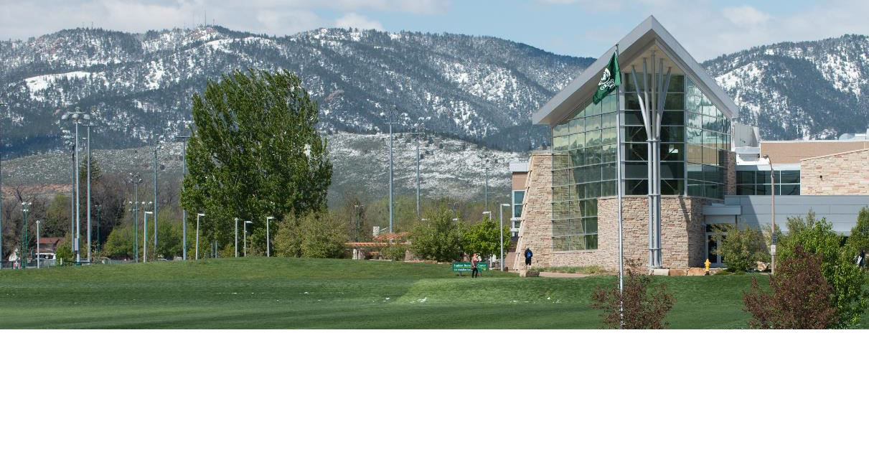

Participants:
Tala | Awada | University of Nebraska
Wojciech | Florkowski | University of Georgia
Lilyan | Fulginiti | University of Nebraska
Victor | Funes | University of Illinois
Konstantinos | Giannakas | University of Nebraska
Gregory | Graff | Colorado State University
Yorou | He | Cornell University
Gal | Hochman | Rutgers University
Madhu | Khanna | University of Illinois
Valerie | Kilders | Purdue University
Ruiqing | Miao | Auburn University
Richard | Perrin | University of Nebraska
David | Schimmelpfennig | USDA, APHIS
Guanming | Shi | University of Wisconsin
David | Spielman | IFPRI
Brian | Wright | University of California, Berkeley
David | Zilberman | University of California, Berkeley

