Figure 1: Conceptual framework of change in watersheds (Prokopy et al. 2014)

Table 1: Typology of Catalyst Events in Watersheds (Prokopy et al. 2014)
Intentional Events | Non-Intentional Events
Government action  - Regulation (including threat of)  - New data/information  - Recommendation/mandate for creation of new group  - Funding opportunities  Non-government action  - Funding opportunities  - Group reorganization | Incidental actions by either government or non-government  - Proposed (or actual) construction projects  Disasters  - Natural disasters  - Industrial accidents and other major point source discharge events

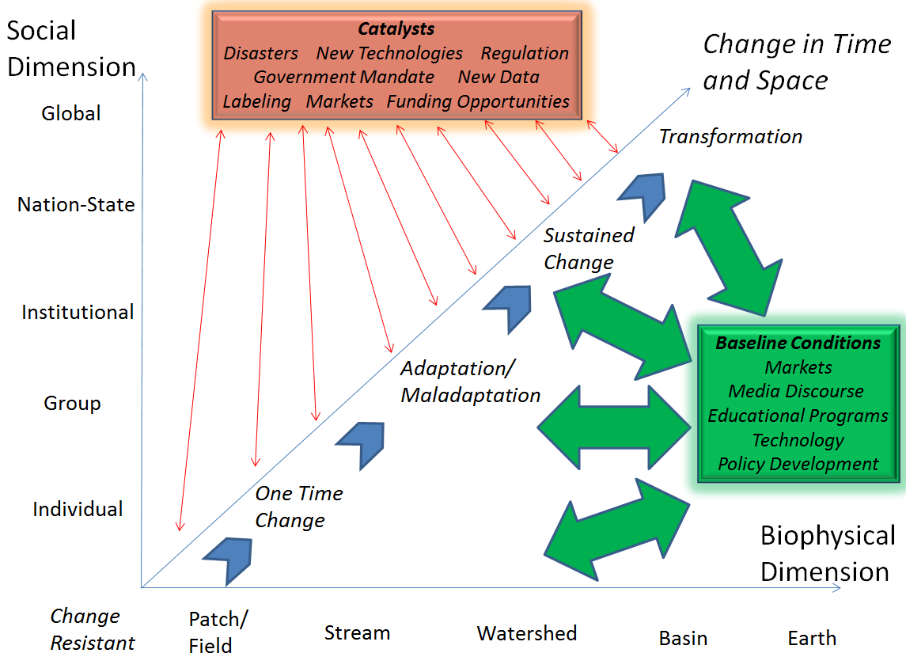

Figure 2: Catalytic Processes Framework

Table 2: Project Timeline
 | Year 1 |  |  |  | Year 2 |  |  |  | Year 3 |  |  |  |  | Year 4 |  |  |  | Year 5
 | 1st Qtr | 2nd Qtr | 3rd Qtr | 4th Qtr | 1st Qtr | 2nd Qtr | 3rd Qtr | 4th Qtr | 1st Qtr | 2nd Qtr | 3rd Qtr | 4th Qtr | 1st Qtr |  | 2nd Qtr | 3rd Qtr | 4th Qtr | 1st Qtr | 2nd Qtr | 3rd Qtr | 4th Qtr
Objective 1:  Test typologies of catalysts for change | X | X | X | X | X | X | X | X
Objective 2:  Understand and develop typologies of individual, institutional, and collective actions |  |  |  |  | X | X | X | X | X | X | X | X | X
Objective 3:  Synthesize and assess conceptual frameworks and analytical models of catalysts |  |  |  |  |  |  |  |  | X | X | X | X | X |  | X | X | X
Objective 4:  Identify, develop, and evaluate adaptive strategies |  |  |  |  |  |  |  |  |  |  |  |  | X |  | X | X | X | X | X | X | X

