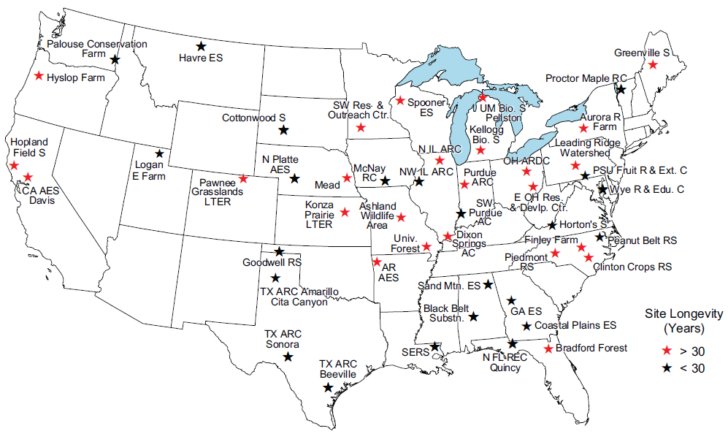
Figure 1. NADP sites currently sponsored and operated by Agricultural Experiment Stations or located on Agricultural or Forestry Experiment Station properties (as of 11/1/2013).

